**Nebraska Book Company Data Science Assignment**

**Data Set:**

You are working for Nebraska Book Company as a Data Scientist. Nebraska Book Company wants to develop a tool to optimize their marketing efforts. Marketing team has collected some data from previous marketing campaign. The data set includes customer information, described below, as a well as whether the customer responded to the marketing campaign or not. Here are the descriptions of each column in the data set:

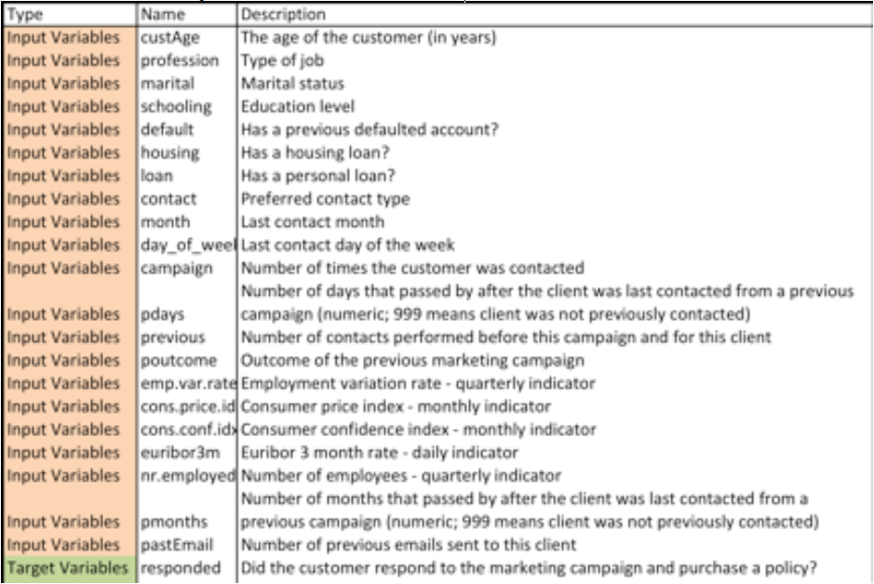

**Task:**

Design a model that will be able to predict whether a customer will respond to the

marketing campaign based on his/her information. In other words, predict the

‘responded’ target variable described above based on all the input variables

provided.

**Files:**

**marketing_training.csv** - contains the training set that you will use to build the

model. The target variable is ‘responded’

**Readme.pdf** – this document.

**Deliverables:**

Provide the following:

 The source code you used to build the model and make predictions. (You are

free to use any language and any open-source package/library)

 Briefly answer the following questions:

o Describe your model and why did you choose this model over other

types of models?

o Describe any other models you have tried and why do you think this

model preforms better?

o How did you handle missing data?

o How did you handle categorical (string) data?

o How did you handle unbalanced data?

o How did you test your model?