Dennis Chase

ITMD 455 Android Apps

Homework 1

PART ONE

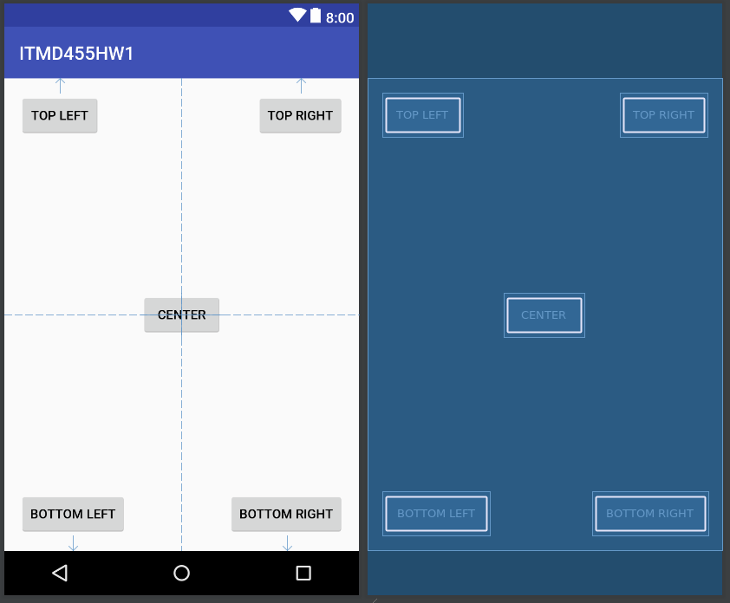

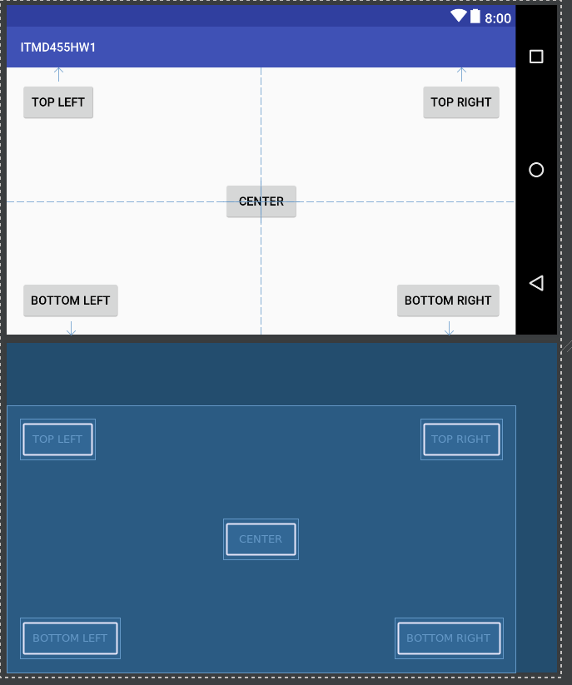

<?xml version="1.0" encoding="utf-8"?>

<android.widget.RelativeLayout xmlns:android="http://schemas.android.com/apk/res/android"

xmlns:tools="http://schemas.android.com/tools"

android:layout_width="match_parent"

android:layout_height="match_parent"

android:paddingLeft="16dp"

android:paddingRight="16dp"

android:paddingTop="16dp"

android:paddingBottom="16dp"

tools:context="com.example.ssiruuk.itmd455hw1.MainActivity">

<Button

android:id="@+id/button_center"

android:layout_width="wrap_content"

android:layout_height="wrap_content"

android:layout_centerHorizontal="true"

android:layout_centerVertical="true"

android:layout_weight=".20"

android:text="Center" />

<Button

android:id="@+id/button_top_left"

android:layout_width="wrap_content"

android:layout_height="wrap_content"

android:layout_alignParentStart="true"

android:layout_alignParentTop="true"

android:layout_weight=".20"

android:text="Top Left" />

<Button

android:id="@+id/button_top_right"

android:layout_width="wrap_content"

android:layout_height="wrap_content"

android:layout_alignParentEnd="true"

android:layout_alignParentTop="true"

android:layout_weight=".20"

android:text="Top Right" />

<Button

android:id="@+id/button_bottom_left"

android:layout_width="wrap_content"

android:layout_height="wrap_content"

android:layout_alignParentStart="true"

android:layout_alignParentBottom="true"

android:layout_weight=".20"

android:text="Bottom Left" />

<Button

android:id="@+id/button_bottom_right"

android:layout_width="wrap_content"

android:layout_height="wrap_content"

android:layout_alignParentBottom="true"

android:layout_alignParentEnd="true"

android:layout_weight=".20"

android:text="Bottom Right" />

</android.widget.RelativeLayout>

PART TWO

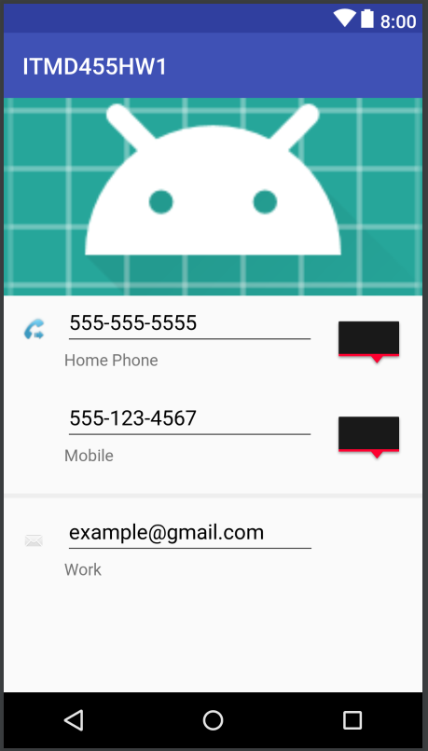

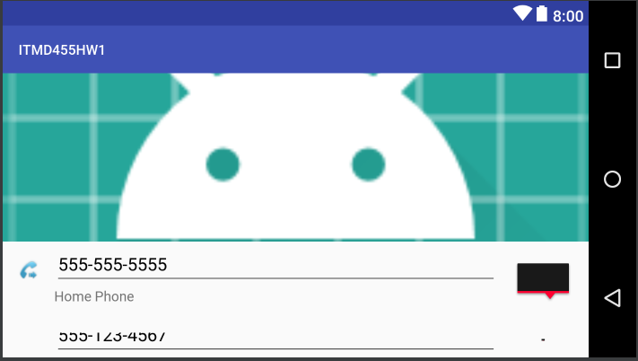

<?xml version="1.0" encoding="utf-8"?>

<android.widget.RelativeLayout xmlns:android="http://schemas.android.com/apk/res/android"

xmlns:app="http://schemas.android.com/apk/res-auto"

xmlns:tools="http://schemas.android.com/tools"

android:layout_width="match_parent"

android:layout_height="match_parent"

tools:context="com.example.ssiruuk.itmd455hw1.MainActivity">

<ImageView

android:id="@+id/imageView"

android:layout_width="wrap_content"

android:layout_height="170dp"

android:layout_weight="0.6"

android:scaleType="centerCrop"

android:layout_alignParentStart="true"

android:layout_alignParentEnd="true"

android:layout_alignParentTop="true"

android:layout_centerHorizontal="true"

app:srcCompat="@mipmap/ic_launcher_round" />

<ImageView

android:id="@+id/imageView2"

android:layout_width="wrap_content"

android:layout_height="wrap_content"

android:padding="16dp"

android:layout_alignParentStart="true"

android:layout_below="@+id/imageView"

app:srcCompat="@android:drawable/stat_sys_phone_call_forward" />

<EditText

android:id="@+id/editText"

android:layout_width="wrap_content"

android:layout_height="wrap_content"

android:layout_below="@+id/imageView"

android:layout_toEndOf="@+id/imageView2"

android:layout_toStartOf="@id/imageView3"

android:contentDescription="Home Phone"

android:ems="10"

android:inputType="phone"

android:selectAllOnFocus="false"

android:singleLine="false"

android:text="555-555-5555" />

<ImageView

android:id="@+id/imageView3"

android:layout_width="wrap_content"

android:layout_height="wrap_content"

android:padding="16dp"

android:layout_below="@+id/imageView"

android:layout_alignParentEnd="true"

app:srcCompat="?android:attr/errorMessageAboveBackground" />

<TextView

android:id="@+id/textView"

android:layout_width="wrap_content"

android:layout_height="wrap_content"

android:layout_below="@+id/editText"

android:layout_toEndOf="@+id/imageView2"

android:text="Home Phone" />

<ImageView

android:id="@+id/imageView4"

android:layout_width="wrap_content"

android:layout_height="wrap_content"

android:padding="16dp"

android:layout_alignParentEnd="true"

android:layout_alignStart="@id/imageView3"

android:layout_below="@+id/imageView3"

app:srcCompat="?android:attr/errorMessageAboveBackground" />

<EditText

android:id="@+id/editText2"

android:layout_width="wrap_content"

android:layout_height="wrap_content"

android:layout_below="@+id/imageView3"

android:layout_alignStart="@id/editText"

android:layout_toStartOf="@+id/imageView4"

android:ems="10"

android:inputType="phone"

android:text="555-123-4567" />

<TextView

android:id="@+id/textView2"

android:layout_width="wrap_content"

android:layout_height="wrap_content"

android:layout_alignStart="@+id/editText2"

android:layout_below="@+id/editText2"

android:text="Mobile" />

<ProgressBar

android:id="@+id/progressBar"

style="@style/Widget.AppCompat.ProgressBar.Horizontal"

android:layout_width="match_parent"

android:layout_height="wrap_content"

android:layout_alignParentEnd="true"

android:layout_below="@+id/imageView4"

android:visibility="visible"

tools:visibility="visible" />

<EditText

android:id="@+id/editText3"

android:layout_width="wrap_content"

android:layout_height="wrap_content"

android:layout_alignStart="@+id/textView2"

android:layout_below="@+id/progressBar"

android:ems="10"

android:inputType="textEmailAddress"

android:text="example@gmail.com" />

<TextView

android:id="@+id/textView3"

android:layout_width="wrap_content"

android:layout_height="wrap_content"

android:layout_alignStart="@+id/editText3"

android:layout_below="@+id/editText3"

android:text="Work" />

<ImageView

android:id="@+id/imageView5"

android:layout_width="wrap_content"

android:layout_height="wrap_content"

android:layout_below="@+id/progressBar"

android:layout_toStartOf="@+id/editText3"

android:layout_alignParentLeft="true"

android:padding="16dp"

app:srcCompat="@android:drawable/sym_action_email" />

</android.widget.RelativeLayout>