ITMD455HW2

Dennis Chase

Screenshots:

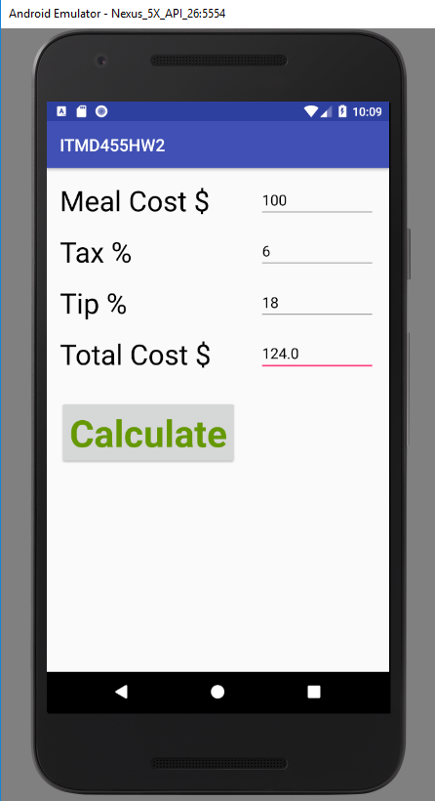

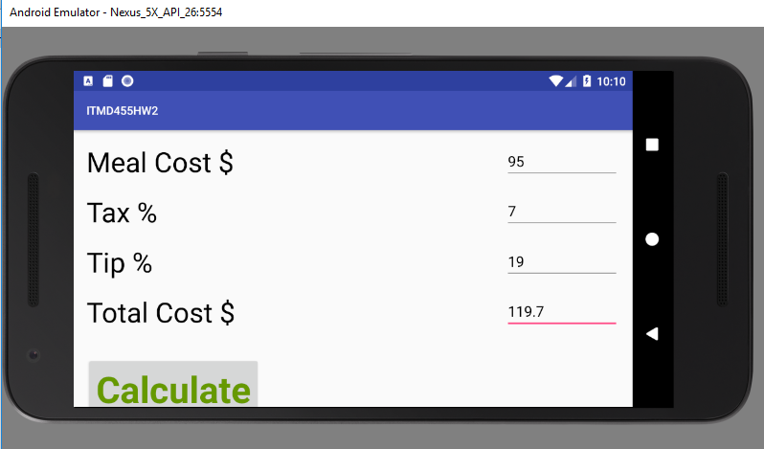

XML Code:

*<?***xml version="1.0" encoding="utf-8"***?>*<**android.support.constraint.ConstraintLayout xmlns:android="http://schemas.android.com/apk/res/android"  
 xmlns:app="http://schemas.android.com/apk/res-auto"  
 xmlns:tools="http://schemas.android.com/tools"  
 android:layout_width="match_parent"  
 android:layout_height="match_parent"  
 tools:context="com.example.ssiruuk.itmd455hw2.MainActivity"**>  
  
 <**TextView  
 android:id="@+id/MealCost"  
 android:layout_width="wrap_content"  
 android:layout_height="wrap_content"  
 android:layout_marginStart="16dp"  
 android:layout_marginTop="16dp"  
 android:text="Meal Cost $"  
 android:textAppearance="@style/TextAppearance.AppCompat.Display1"  
 android:textColor="@android:color/black"  
 app:layout_constraintStart_toStartOf="parent"  
 app:layout_constraintTop_toTopOf="parent"** />  
  
 <**TextView  
 android:id="@+id/Tax"  
 android:layout_width="wrap_content"  
 android:layout_height="wrap_content"  
 android:layout_marginStart="16dp"  
 android:layout_marginTop="16dp"  
 android:text="Tax %"  
 android:textAppearance="@style/TextAppearance.AppCompat.Display1"  
 android:textColor="@android:color/black"  
 app:layout_constraintStart_toStartOf="parent"  
 app:layout_constraintTop_toBottomOf="@+id/MealCost"** />  
  
 <**TextView  
 android:id="@+id/Tip"  
 android:layout_width="wrap_content"  
 android:layout_height="wrap_content"  
 android:layout_marginStart="16dp"  
 android:layout_marginTop="16dp"  
 android:text="Tip %"  
 android:textAppearance="@style/TextAppearance.AppCompat.Display1"  
 android:textColor="@android:color/black"  
 app:layout_constraintStart_toStartOf="parent"  
 app:layout_constraintTop_toBottomOf="@+id/Tax"** />  
  
 <**TextView  
 android:id="@+id/TotalCost"  
 android:layout_width="wrap_content"  
 android:layout_height="wrap_content"  
 android:layout_marginStart="16dp"  
 android:layout_marginTop="16dp"  
 android:text="Total Cost $"  
 android:textAppearance="@style/TextAppearance.AppCompat.Display1"  
 android:textColor="@android:color/black"  
 app:layout_constraintStart_toStartOf="parent"  
 app:layout_constraintTop_toBottomOf="@+id/Tip"** />  
  
 <**EditText  
 android:id="@+id/MealCostInput"  
 android:layout_width="140dp"  
 android:layout_height="wrap_content"  
 android:layout_marginEnd="16dp"  
 android:layout_marginTop="16dp"  
 android:ems="10"  
 android:inputType="number"  
 android:hint="0.00"  
 android:textColor="@android:color/black"  
 app:layout_constraintEnd_toEndOf="parent"  
 app:layout_constraintTop_toTopOf="parent"** />  
  
 <**EditText  
 android:id="@+id/TaxInput"  
 android:layout_width="140dp"  
 android:layout_height="wrap_content"  
 android:layout_marginEnd="16dp"  
 android:layout_marginTop="16dp"  
 android:ems="10"  
 android:inputType="number"  
 android:hint="0"  
 android:textColor="@android:color/black"  
 app:layout_constraintEnd_toEndOf="parent"  
 app:layout_constraintTop_toBottomOf="@+id/MealCostInput"** />  
  
 <**EditText  
 android:id="@+id/TipInput"  
 android:layout_width="140dp"  
 android:layout_height="wrap_content"  
 android:layout_marginBottom="16dp"  
 android:layout_marginEnd="16dp"  
 android:layout_marginTop="16dp"  
 android:ems="10"  
 android:inputType="number"  
 android:hint="0"  
 android:textColor="@android:color/black"  
 app:layout_constraintBottom_toTopOf="@+id/TotalCost"  
 app:layout_constraintEnd_toEndOf="parent"  
 app:layout_constraintTop_toBottomOf="@+id/TaxInput"** />  
  
 <**EditText  
 android:id="@+id/TotalOutput"  
 android:layout_width="140dp"  
 android:layout_height="wrap_content"  
 android:layout_marginEnd="16dp"  
 android:layout_marginTop="16dp"  
 android:ems="10"  
 android:inputType="number"  
 android:hint="0.00"  
 android:textColor="@android:color/black"  
 app:layout_constraintEnd_toEndOf="parent"  
 app:layout_constraintTop_toBottomOf="@+id/TipInput"** />  
  
 <**Button  
 android:id="@+id/CalculateTotalCost"  
 android:layout_width="wrap_content"  
 android:layout_height="wrap_content"  
 android:layout_marginStart="16dp"  
 android:layout_marginTop="32dp"  
 android:text="Calculate"  
 android:textAllCaps="false"  
 android:textAppearance="@style/TextAppearance.AppCompat.Display2"  
 android:textColor="@android:color/holo_green_dark"  
 android:textStyle="bold"  
 android:visibility="visible"  
 app:layout_constraintStart_toStartOf="parent"  
 app:layout_constraintTop_toBottomOf="@+id/TotalCost"** />  
  
</**android.support.constraint.ConstraintLayout**>

Java Code:

**package** com.example.densi.itmd455hw2;  
  
**import** android.support.v7.app.AppCompatActivity;  
**import** android.os.Bundle;  
**import** android.view.View;  
**import** android.widget.Button;  
**import** android.widget.EditText;  
  
**public class** MainActivity **extends** AppCompatActivity {  
  
 **private** Button **calculate**;  
 **private** EditText **meal**;  
 **private** EditText **tax**;  
 **private** EditText **tip**;  
 **private** EditText **totalCost**;  
  
 @Override  
 **protected void** onCreate(Bundle savedInstanceState) {  
 **super**.onCreate(savedInstanceState);  
 setContentView(R.layout.***activity_main***);  
  
 **calculate** = findViewById(R.id.***CalculateTotalCost***);  
 **meal** = findViewById(R.id.***MealCostInput***);  
 **tax** = findViewById(R.id.***TaxInput***);  
 **tip** = findViewById(R.id.***TipInput***);  
 **totalCost** = findViewById(R.id.***TotalOutput***);  
  
 **calculate**.setOnClickListener(**new** View.OnClickListener() {  
 **public void** onClick(View v) {  
 makeCalculation();  
 }  
 });  
 }  
  
 **private void** makeCalculation() {  
 **double** ml = Double.*valueOf*(**meal**.getText().toString());  
 **double** tx = Double.*valueOf*(**tax**.getText().toString());  
 **double** tp = Double.*valueOf*(**tip**.getText().toString());  
 **double** result = ml+(ml*(tx/100))+(ml*(tp/100));  
 **totalCost**.setText(Double.*toString*(result));  
 }  
  
}