ITMD455

Homework 4

Dennis Chase

**Screenshots**(Scrolled all the way up and all the way down, in both orientations)**:**

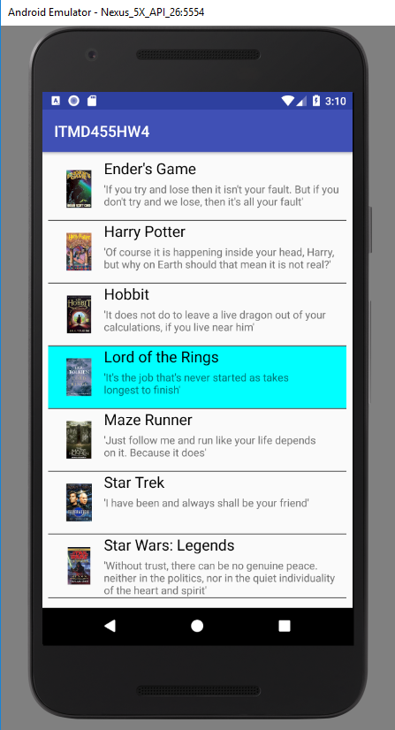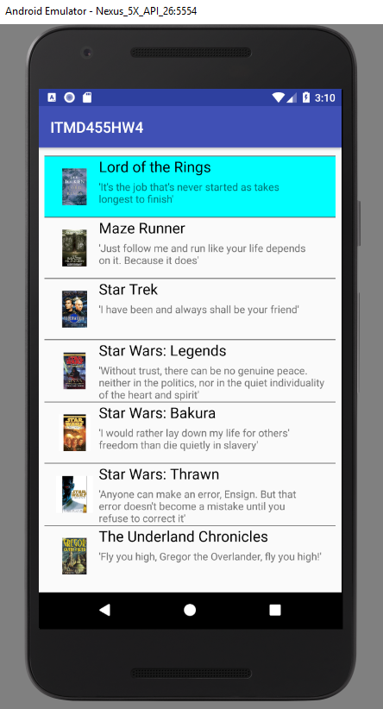

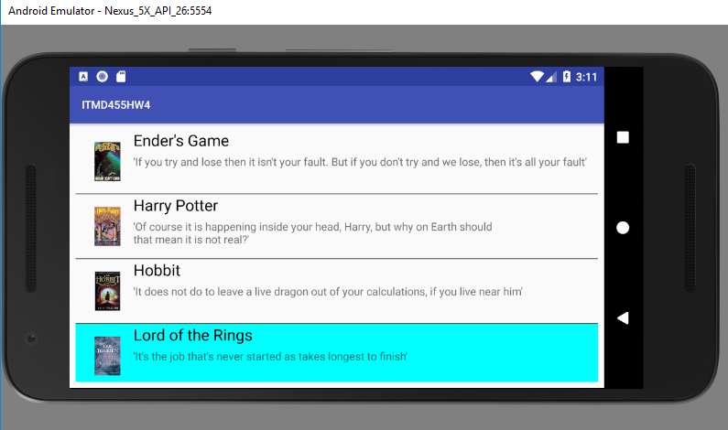

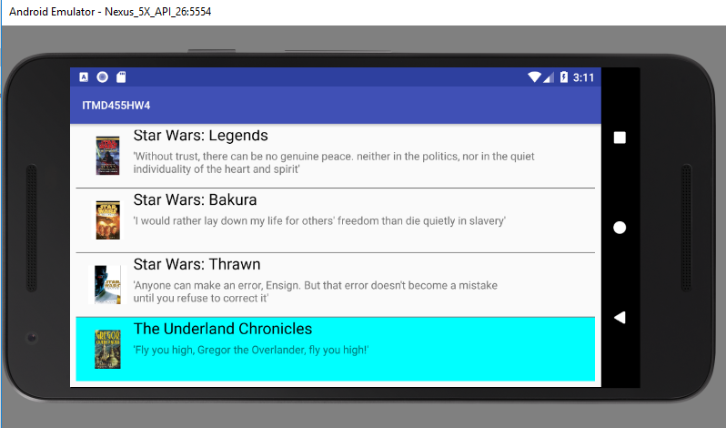

**XML Files**(First for ListView in main, second for how each item in ListView would look)**:**

**(first)**

*<?***xml version="1.0" encoding="utf-8"***?>*<**android.support.constraint.ConstraintLayout xmlns:android="http://schemas.android.com/apk/res/android"  
xmlns:app="http://schemas.android.com/apk/res-auto"  
xmlns:tools="http://schemas.android.com/tools"  
android:layout_width="match_parent"  
android:layout_height="match_parent"  
tools:context="com.example.densi.itmd455hw4.MainActivity"**>  
  
<**ListView  
 android:id="@+id/bookListView"  
 android:layout_width="match_parent"  
 android:layout_height="match_parent"  
 android:layout_marginBottom="8dp"  
 android:layout_marginEnd="8dp"  
 android:layout_marginStart="8dp"  
 android:layout_marginTop="8dp"  
 android:divider="#535353"  
 android:dividerHeight="1dp"  
 android:listSelector="#00ffff"  
 app:layout_constraintBottom_toBottomOf="parent"  
 app:layout_constraintEnd_toEndOf="parent"  
 app:layout_constraintStart_toStartOf="parent"  
 app:layout_constraintTop_toTopOf="parent"** />  
  
</**android.support.constraint.ConstraintLayout**>

**(second)**

*<?***xml version="1.0" encoding="utf-8"***?>*<**android.support.constraint.ConstraintLayout  
 xmlns:android="http://schemas.android.com/apk/res/android"  
 xmlns:app="http://schemas.android.com/apk/res-auto"  
 xmlns:tools="http://schemas.android.com/tools"  
 android:layout_width="match_parent"  
 android:layout_height="match_parent"**>  
  
 <**ImageView  
 android:id="@+id/imageView"  
 android:layout_width="50dp"  
 android:layout_height="50dp"  
 android:layout_marginBottom="16dp"  
 android:layout_marginStart="16dp"  
 android:layout_marginTop="16dp"  
 app:layout_constraintBottom_toBottomOf="parent"  
 app:layout_constraintStart_toStartOf="parent"  
 app:layout_constraintTop_toTopOf="parent"  
 app:srcCompat="@mipmap/ic_launcher"** />  
  
 <**TextView  
 android:id="@+id/textViewHead"  
 android:layout_width="wrap_content"  
 android:layout_height="wrap_content"  
 android:layout_marginStart="8dp"  
 android:text="ListViewHeader"  
 android:textColor="#000000"  
 android:textSize="20dp"  
 app:layout_constraintStart_toEndOf="@+id/imageView"  
 tools:layout_editor_absoluteY="231dp"** />  
  
 <**TextView  
 android:id="@+id/textViewBody"  
 android:layout_width="0dp"  
 android:layout_height="wrap_content"  
 android:layout_marginEnd="8dp"  
 android:layout_marginStart="8dp"  
 android:layout_marginTop="4dp"  
 android:text="TextViewBody"  
 android:textSize="14dp"  
 app:layout_constraintEnd_toEndOf="parent"  
 app:layout_constraintStart_toEndOf="@+id/imageView"  
 app:layout_constraintTop_toBottomOf="@+id/textViewHead"** />  
  
</**android.support.constraint.ConstraintLayout**>

**Java Code**(First for the main, second for a custom adapter to fill in the ListView items)**:**

**(first)**

**package** com.example.densi.itmd455hw4;  
  
**import** android.support.v7.app.AppCompatActivity;  
**import** android.os.Bundle;  
**import** android.widget.ListView;  
  
**public class** MainActivity **extends** AppCompatActivity {  
  
 ListView **bookList**;  
 String **bookNames**[] = {**"Ender's Game"**, **"Harry Potter"**, **"Hobbit"**, **"Lord of the Rings"**,  
 **"Maze Runner"**, **"Star Trek"**, **"Star Wars: Legends"**, **"Star Wars: Bakura"**,  
 **"Star Wars: Thrawn"**, **"The Underland Chronicles"**};  
 String **bookCaption**[] = {**"'If you try and lose then it isn't your fault. But if you don't try and we lose, then it's all your fault'"**,  
 **"'Of course it is happening inside your head, Harry, but why on Earth should that mean it is not real?'"**,  
 **"'It does not do to leave a live dragon out of your calculations, if you live near him'"**,  
 **"'It's the job that's never started as takes longest to finish'"**,  
 **"'Just follow me and run like your life depends on it. Because it does'"**,  
 **"'I have been and always shall be your friend'"**,  
 **"'Without trust, there can be no genuine peace. neither in the politics, nor in the quiet individuality of the heart and spirit'"**,  
 **"'I would rather lay down my life for others' freedom than die quietly in slavery'"**,  
 **"'Anyone can make an error, Ensign. But that error doesn't become a mistake until you refuse to correct it'"**,  
 **"'Fly you high, Gregor the Overlander, fly you high!'"**};  
 **int bookCovers**[] = {R.drawable.***eg***, R.drawable.***hp***, R.drawable.***hobbit***, R.drawable.***lotr***,  
 R.drawable.***mr***, R.drawable.***st***, R.drawable.***legends***, R.drawable.***tab***,  
 R.drawable.***thrawn***, R.drawable.***tuc***};  
  
 @Override  
 **protected void** onCreate(Bundle savedInstanceState) {  
 **super**.onCreate(savedInstanceState);  
 setContentView(R.layout.***activity_main***);  
 **bookList** = (ListView) findViewById(R.id.***bookListView***);  
 CustomAdapter customadapter = **new** CustomAdapter(getApplicationContext(), **bookNames**, **bookCaption**, **bookCovers**);  
 **bookList**.setAdapter(customadapter);  
 }  
}

**(**I realize the quotes look sloppy but some of them were decently sized**)**

**(second)**

**package** com.example.densi.itmd455hw4;  
  
**import** android.content.Context;  
**import** android.view.LayoutInflater;  
**import** android.view.View;  
**import** android.view.ViewGroup;  
**import** android.widget.BaseAdapter;  
**import** android.widget.ImageView;  
**import** android.widget.TextView;  
  
**public class** CustomAdapter **extends** BaseAdapter {  
  
 Context **context**;  
 String **bookNames**[];  
 String **bookCaptions**[];  
 **int bookCovers**[];  
 LayoutInflater **inflater**;  
  
 **public** CustomAdapter(Context appcon, String[] bookNames, String[] bookCaptions, **int**[] bookCovers) {  
 **this**.**context** = **context**;  
 **this**.**bookNames** = bookNames;  
 **this**.**bookCaptions** = bookCaptions;  
 **this**.**bookCovers** = bookCovers;  
 **inflater** = (LayoutInflater.*from*(appcon));  
 }  
  
 @Override  
 **public int** getCount() {  
 **return bookNames**.**length**;  
 }  
  
 @Override  
 **public** Object getItem(**int** i) {  
 **return null**;  
 }  
  
 @Override  
 **public long** getItemId(**int** i) {  
 **return** 0;  
 }  
  
 **public** View getView(**int** i, View view, ViewGroup viewGroup) {  
 view = **inflater**.inflate(R.layout.***activity_listview***, **null**);  
 TextView bookNamestv = (TextView) view.findViewById(R.id.***textViewHead***);  
 TextView bookCaptionstv = (TextView) view.findViewById(R.id.***textViewBody***);  
 ImageView bookCoveriv = (ImageView) view.findViewById(R.id.***imageView***);  
 bookNamestv.setText(**bookNames**[i]);  
 bookCaptionstv.setText(**bookCaptions**[i]);  
 bookCoveriv.setImageResource(**bookCovers**[i]);  
 **return** view;  
 }  
}