Problem Statement: Social Network Friend Recommendation System

Graph:-

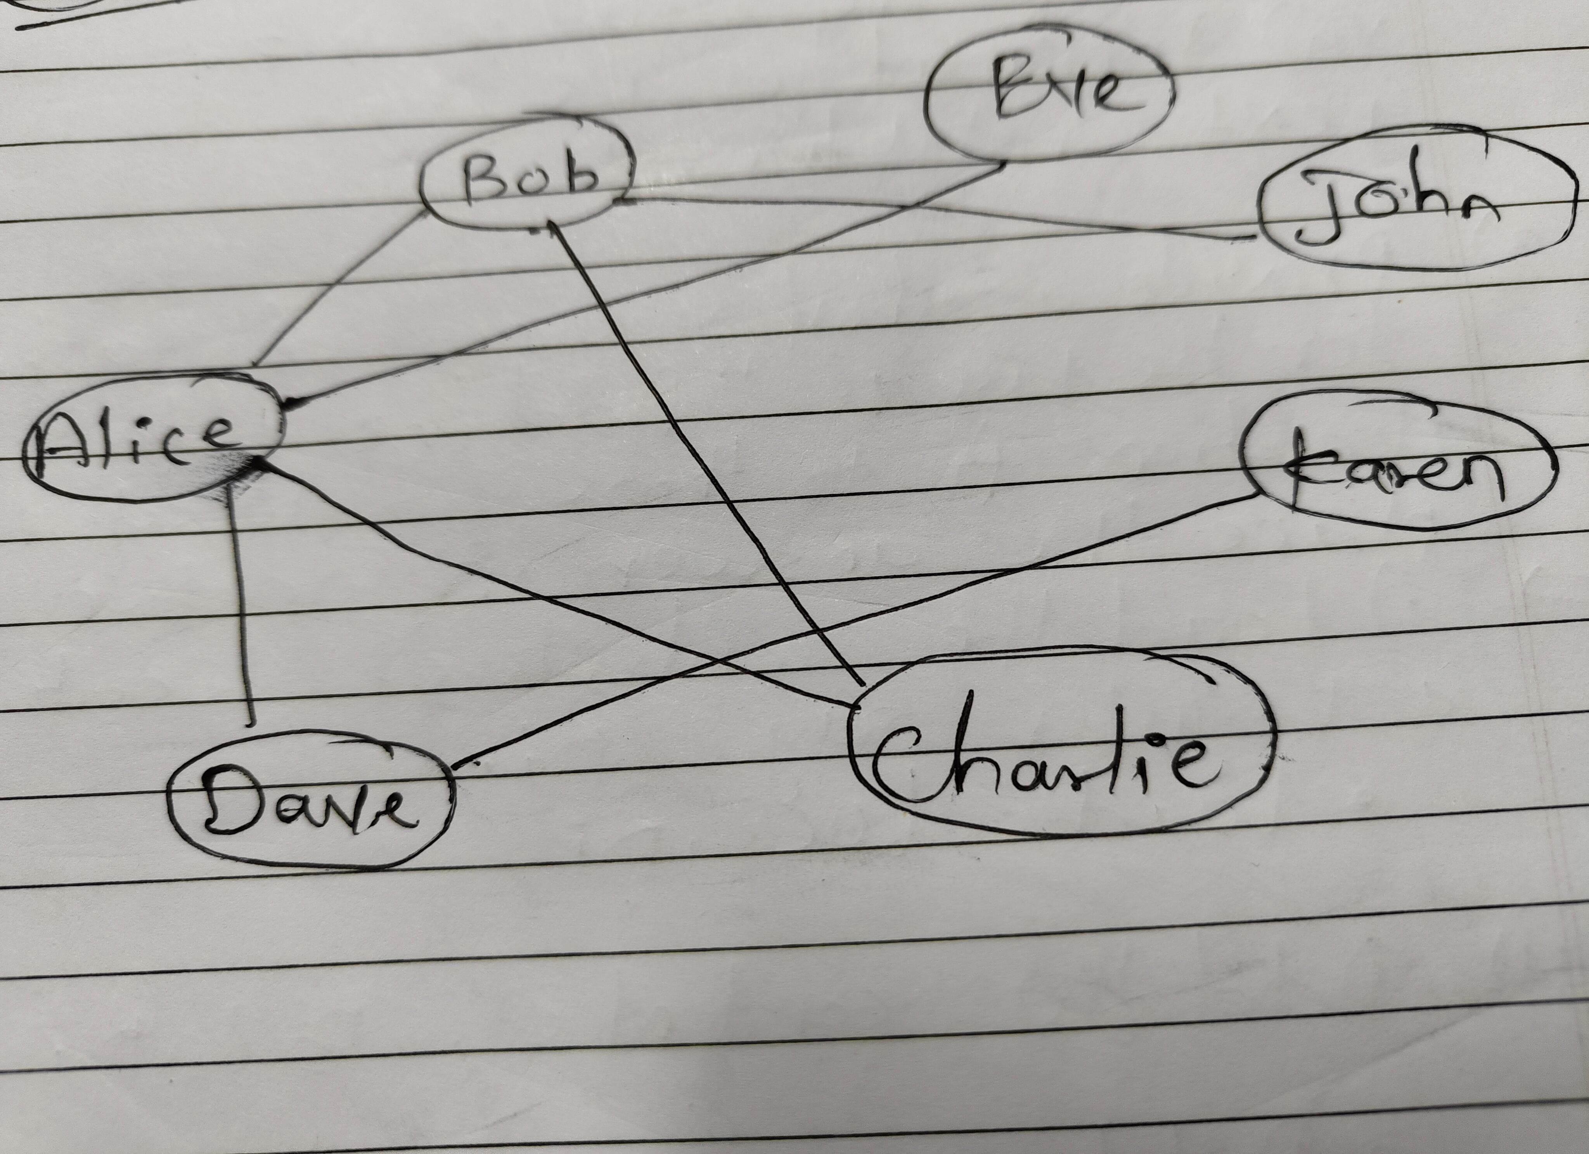

Explanation:-

1. initialize_network(&network, 7, user_names): Initializes the social network with 7 users, setting up their names.
2. add_friendship(&network, "Alice", "Bob"): Adds a friendship between Alice and Bob in the network.
3. print_network(&network): Prints the details of the entire social network.
4. list_friends(&network, user1): Lists all the friends of a specific user.
5. find_mutual_friends(&network, user1, user2): Finds and prints mutual friends between two users.
6. most_popular(&network): Identifies and prints the most popular user (the one with the most friends).
7. shortest_path(&network, user1, user2): Finds and prints the shortest path (if any) between two users in terms of friendships.
8. recommend_friends(&network, user1, degree): Recommends friends for a user based on a specified degree of separation.

Output: