Project: Student Mental Health & Counseling Support System
NAME | CHAUDHARI DIPAK RAJENDRA
SRN | PES1UG24CS804
SECTION | K

TRIGGERS:-
-- Trigger to log appointment status changes
DELIMITER //
CREATE TRIGGER after_appointment_status_change
AFTER UPDATE ON APPOINTMENT
FOR EACH ROW
BEGIN
IF OLD.status != NEW.status THEN
INSERT INTO APPOINTMENT_HISTORY (
appointment_id,
old_status,
new_status,
changed_at
) VALUES (
NEW.appointment_id,
OLD.status,
NEW.status,
NOW()
);
END IF;
END//

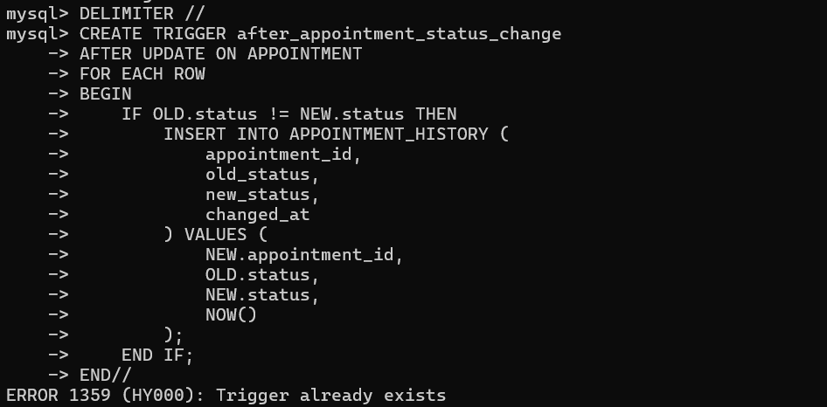
-- Trigger to create student profile after registration
CREATE TRIGGER after_student_registration
AFTER INSERT ON STUDENT
FOR EACH ROW
BEGIN
INSERT INTO STUDENT_PROFILE (
student_id,
last_session_date,
total_sessions,
created_at
) VALUES (
NEW.student_id,
NULL,
0,
NOW()
);
END//
DELIMITER ;

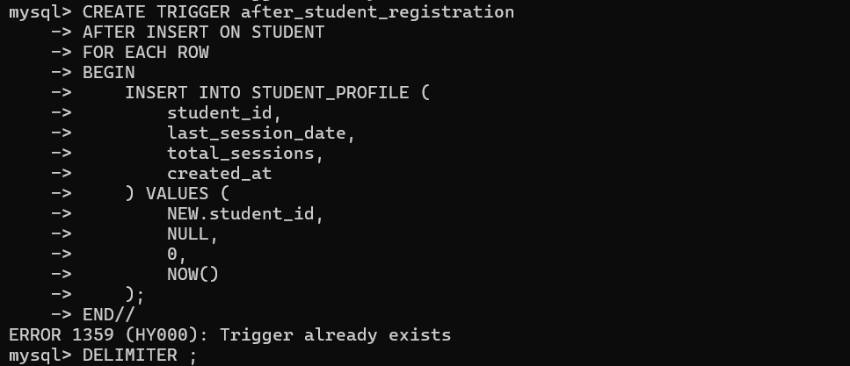
PROCEDURES:-
CREATE PROCEDURE BookAppointment(
IN p_student_id INT,
IN p_preferred_date DATE,
IN p_preferred_time TIME,
IN p_specialization_id INT
)
BEGIN
DECLARE v_counselor_id INT;
DECLARE v_appointment_id INT;

-- Find available counselor with the least appointments on that day
SELECT c.counselor_id INTO v_counselor_id
FROM COUNSELOR c
LEFT JOIN APPOINTMENT a ON c.counselor_id = a.counselor_id
AND DATE(a.appointment_date) = p_preferred_date
WHERE c.specialization_id = p_specialization_id
AND c.is_available = 1
GROUP BY c.counselor_id
ORDER BY COUNT(a.appointment_id) ASC
LIMIT 1;

-- Create the appointment
IF v_counselor_id IS NOT NULL THEN
INSERT INTO APPOINTMENT (
student_id,
counselor_id,
appointment_date,
appointment_time,
status,
created_at
) VALUES (
p_student_id,
v_counselor_id,
p_preferred_date,
p_preferred_time,
'pending',
NOW()
);

SET v_appointment_id = LAST_INSERT_ID();

-- Return the appointment details
SELECT
a.appointment_id,
a.appointment_date,
a.appointment_time,
c.name as counselor_name,
a.status
FROM APPOINTMENT a
JOIN COUNSELOR c ON a.counselor_id = c.counselor_id
WHERE a.appointment_id = v_appointment_id;
ELSE
SIGNAL SQLSTATE '45000'
SET MESSAGE_TEXT = 'No available counselor found for the specified specialization';
END IF;
END//

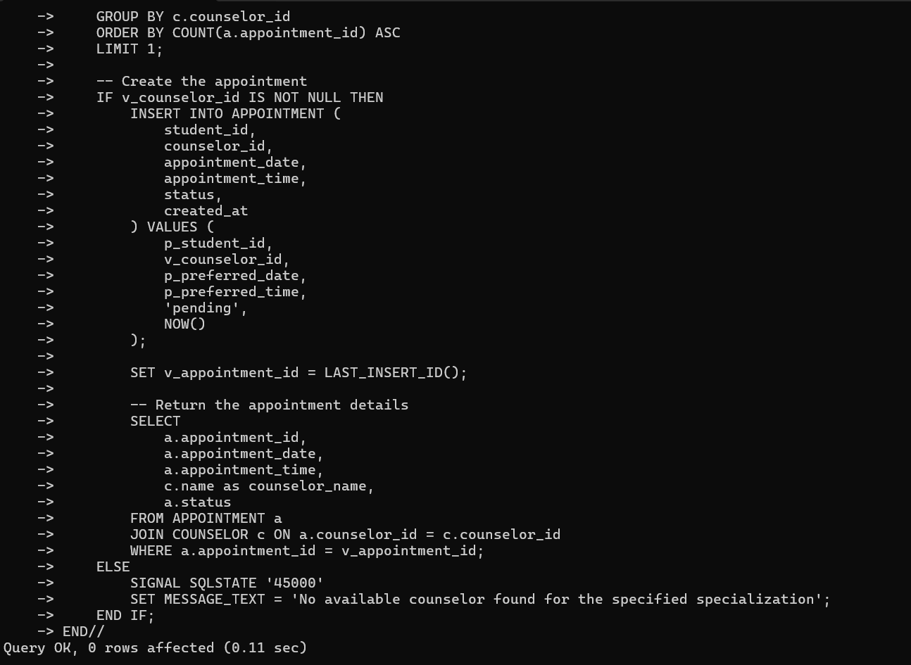

CREATE PROCEDURE GenerateCounselorWorkloadReport(
IN p_start_date DATE,
IN p_end_date DATE
)
BEGIN
SELECT
c.counselor_id,
c.name,
s.name as specialization,
COUNT(a.appointment_id) as total_appointments,
SUM(CASE WHEN a.status = 'completed' THEN 1 ELSE 0 END) as completed_sessions,
SUM(CASE WHEN a.status = 'cancelled' THEN 1 ELSE 0 END) as cancelled_sessions,
ROUND(AVG(CASE WHEN a.status = 'completed' THEN r.rating ELSE NULL END), 2) as avg_rating
FROM COUNSELOR c
LEFT JOIN APPOINTMENT a ON c.counselor_id = a.counselor_id
AND a.appointment_date BETWEEN p_start_date AND p_end_date
LEFT JOIN SPECIALIZATION s ON c.specialization_id = s.specialization_id
LEFT JOIN SESSION_RATING r ON a.appointment_id = r.appointment_id
GROUP BY c.counselor_id, c.name, s.name
ORDER BY total_appointments DESC;
END//

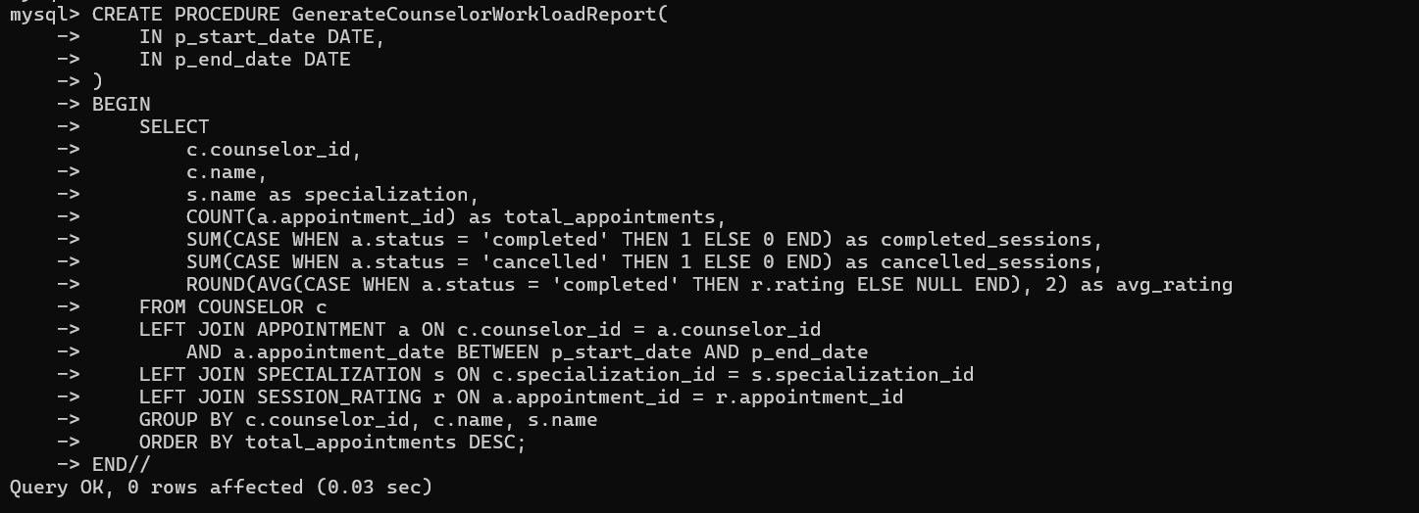
FUNCTIONS:-
-- Function to calculate counselor's current workload
CREATE FUNCTION CalculateCounselorWorkload(
p_counselor_id INT,
p_start_date DATE,
p_end_date DATE
)
RETURNS DECIMAL(5,2)
DETERMINISTIC
BEGIN
DECLARE v_total_hours DECIMAL(5,2);

SELECT COUNT(*) / 8.0 INTO v_total_hours
FROM APPOINTMENT
WHERE counselor_id = p_counselor_id
AND appointment_date BETWEEN p_start_date AND p_end_date
AND status != 'cancelled';

RETURN v_total_hours;
END//

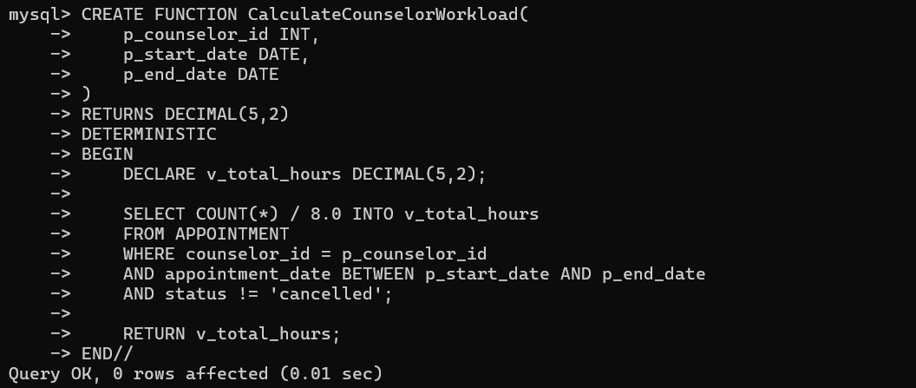
CREATE FUNCTION GetStudentSessionCount(
p_student_id INT
)
RETURNS INT
DETERMINISTIC
BEGIN
DECLARE v_session_count INT;

SELECT COUNT(*) INTO v_session_count
FROM APPOINTMENT
WHERE student_id = p_student_id
AND status = 'completed';

RETURN v_session_count;
END//

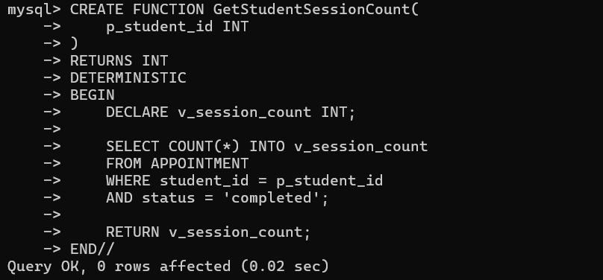

-- Function to calculate counselor rating
CREATE FUNCTION CalculateCounselorRating(
p_counselor_id INT
)
RETURNS DECIMAL(3,2)
DETERMINISTIC
BEGIN
DECLARE v_avg_rating DECIMAL(3,2);

SELECT AVG(r.rating) INTO v_avg_rating
FROM APPOINTMENT a
JOIN SESSION_RATING r ON a.appointment_id = r.appointment_id
WHERE a.counselor_id = p_counselor_id
AND a.status = 'completed';

RETURN COALESCE(v_avg_rating, 0.00);
END//

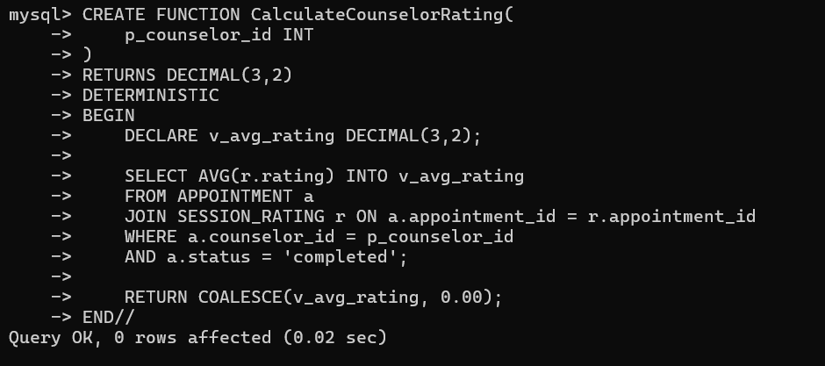

COMPLEX QUERIES:-
1.
-- Query 1: Get comprehensive appointment analytics
SELECT
d.name AS department,
s.name AS specialization,
COUNT(DISTINCT a.student_id) as unique_students,
COUNT(a.appointment_id) as total_appointments,
SUM(CASE WHEN a.status = 'completed' THEN 1 ELSE 0 END) as completed_sessions,
SUM(CASE WHEN a.status = 'cancelled' THEN 1 ELSE 0 END) as cancelled_sessions,
ROUND(AVG(CASE WHEN a.status = 'completed' THEN r.rating ELSE NULL END), 2) as avg_rating,
ROUND(COUNT(CASE WHEN a.status = 'cancelled' THEN 1 END) * 100.0 / COUNT(*), 2) as cancellation_rate
FROM APPOINTMENT a
JOIN STUDENT st ON a.student_id = st.student_id
JOIN COUNSELOR c ON a.counselor_id = c.counselor_id
JOIN DEPARTMENT d ON st.department_id = d.department_id
JOIN SPECIALIZATION s ON c.specialization_id = s.specialization_id
LEFT JOIN SESSION_RATING r ON a.appointment_id = r.appointment_id
GROUP BY d.name, s.name
ORDER BY total_appointments DESC;

2.
-- Query 2: Student mental health trend analysis
SELECT
st.student_id,
st.name as student_name,
d.name as department,
COUNT(a.appointment_id) as total_sessions,
MIN(a.appointment_date) as first_session,
MAX(a.appointment_date) as last_session,
ROUND(AVG(mh.stress_level), 2) as avg_stress_level,
ROUND(AVG(mh.anxiety_level), 2) as avg_anxiety_level,
STRING_AGG(DISTINCT sp.name, ', ') as specializations_consulted
FROM STUDENT st
JOIN DEPARTMENT d ON st.department_id = d.department_id
JOIN APPOINTMENT a ON st.student_id = a.student_id
JOIN COUNSELOR c ON a.counselor_id = c.counselor_id
JOIN SPECIALIZATION sp ON c.specialization_id = sp.specialization_id
LEFT JOIN MENTAL_HEALTH_ASSESSMENT mh ON a.appointment_id = mh.appointment_id
WHERE a.status = 'completed'
GROUP BY st.student_id, st.name, d.name
HAVING COUNT(a.appointment_id) > 1
ORDER BY avg_stress_level DESC;

3.
-- Query 3: Counselor performance and availability analysis
WITH CounselorStats AS (
SELECT
c.counselor_id,
c.name,
s.name as specialization,
COUNT(a.appointment_id) as total_appointments,
COUNT(DISTINCT a.student_id) as unique_students,
ROUND(AVG(CASE WHEN a.status = 'completed' THEN r.rating END), 2) as avg_rating,
SUM(CASE WHEN a.status = 'cancelled' THEN 1 ELSE 0 END) as cancellations,
c.is_available
FROM COUNSELOR c
LEFT JOIN APPOINTMENT a ON c.counselor_id = a.counselor_id
JOIN SPECIALIZATION s ON c.specialization_id = s.specialization_id
LEFT JOIN SESSION_RATING r ON a.appointment_id = r.appointment_id
GROUP BY c.counselor_id, c.name, s.name, c.is_available
)
SELECT
cs.*,
ROUND(cancellations * 100.0 / NULLIF(total_appointments, 0), 2) as cancellation_rate,
ROUND(unique_students * 100.0 / NULLIF(total_appointments, 0), 2) as student_retention_rate,
RANK() OVER (ORDER BY avg_rating DESC) as rating_rank,
RANK() OVER (ORDER BY total_appointments DESC) as workload_rank
FROM CounselorStats cs
ORDER BY avg_rating DESC;
``` These SQL features provide:

Above All Sql Features Provides:-
1. Triggers for:
- Logging appointment status changes
- Automatic student profile creation

2. Stored Procedures for:
- Smart appointment booking with counselor assignment
- Generating counselor workload reports

3. Functions for:
- Calculating counselor workload
- Tracking student session counts
- Computing counselor ratings

4. Complex Queries for:
- Department-wise appointment analytics
- Student mental health trend analysis
- Counselor performance metrics

