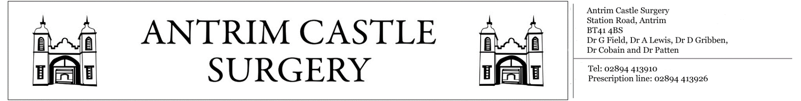

Station Road, Antrim, BT414BS General Enquiries: 02894413910 Prescription Line: 02894413926

«Title» «FIRST_INITIAL» «Surname»

«Housenumber» «Street_Name»

«Postcode»

«County»

«Country»

**«Long_Date»**

Dear «Firstname»,

The **«Year» «Clinic_Name»** has now begun and from your records we have noticed that you are eligible to attend. Due to the number of patients whom are eligible, we operate on a pre-allocated appointment basis.

Your appointment:

Date: **«Appointment_Date»**

Time: **«Appointment_Time»**

With: **«Clinician_Full_Name»**

At: **Antrim Castle Surgery, Station Road, Antrim, BT414BS**

If you cannot attend this appointment, please contact the surgery reception team on **028914413910** between the hours of **9-1 and 2-6 Monday-Friday**, in order to cancel or re-arrange. This means that your appointment can be allocated to another patient. In addition to this, the reception desk is open during these times for patients to attend in person. If you have any other questions regarding the clinic or (other issues in general) please contact the general enquires line on **02894413910**.

Yours sincerely,

«Staff_Title» «Staff_First_Initial» «Staff_Surname»

**Antrim Castle Surgery**