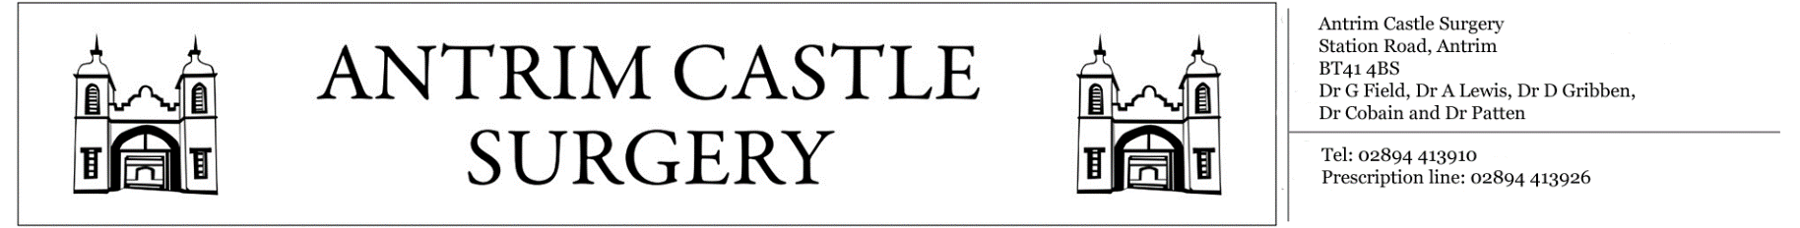

Station Road, Antrim, BT414BS General Enquiries: 02894413910 Prescription Line: 02894413926

«Title» «FIRST_INITIAL» «Surname»

«Housenumber» «Street_Name»

«Postcode»

«County»

«Country»

**«Long_Date»**

Dear «Firstname»,

We have received recent correspondence from **«Correspondence_Origin»**.At Antrim Castle Surgery we are dedicated to ensuring continuity of care is maintained at all times. Therefore, the doctor has asked that you attend the surgery in order to discuss the details of the correspondence, any concerns you may have and to make future plans regarding your healthcare treatment.

To make an appointment with the GP, please contact reception on **02894413910** between the hours of 9-1 and 2-6 on weekdays. Alternatively, the surgery is open during these times for patients to visit reception in person. If you have any questions, feel free to contact the reception general enquires line on **02894413910**.

Please beware that there is currently a wait time of approximately **2 weeks** for these routine appointments and this may be longer if you request to see a particular GP. We apologise in advance for the wait and are currently working to reduce this wait time and ensure that we can provide a service which is as efficient as possible for all patients.

Yours sincerely,

«Staff_Title» «Staff_First_Initial» «Staff_Surname»

**Antrim Castle Surgery**