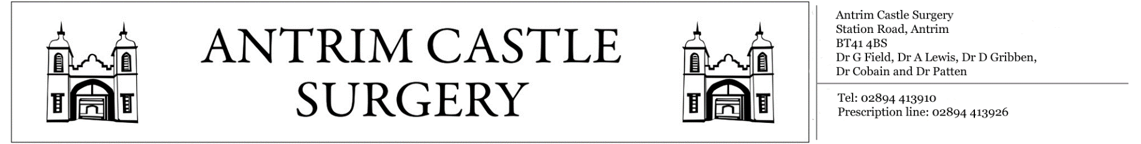

Station Road, Antrim, BT414BS General Enquiries: 02894413910 Prescription Line: 02894413926

«Title» «FIRST_INITIAL» «Surname»

«Housenumber» «Street_Name»

«Postcode»

«County»

«Country»

**«Long_Date»**

Dear «Firstname»,

The results of your recent tests/investigations have now come back to the surgery. The doctor has asked that you make an appointment to attend and discuss these results with them. Please beware that there is currently a waiting time of approximately **1-2 weeks** for these routine appointments.

To make an appointment, please contact the reception staff on **02894413910** between the hours of 9-1 and 2-6 on weekdays. Alternatively, the surgery is open during these times for patients to visit reception in person. If you have any questions, feel free to contact the reception general enquires line on **02894413910**.

Yours sincerely,

«Staff_Title» «Staff_First_Initial» «Staff_Surname»

**Antrim Castle Surgery**