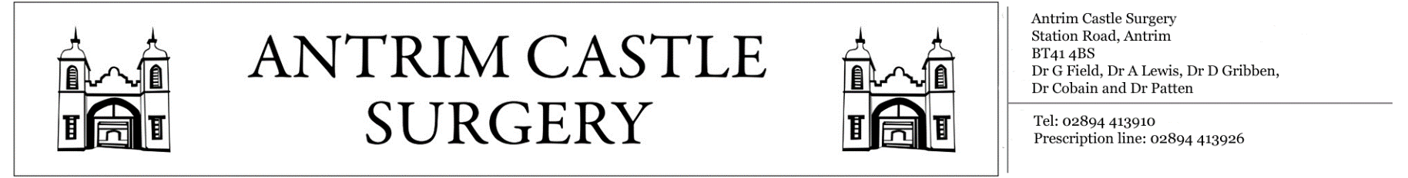

Station Road, Antrim, BT414BS General Enquiries: 02894413910 Prescription Line: 02894413926

«Title» «FIRST_INITIAL» «Surname»

«Housenumber» «Street_Name»

«Postcode»

«County»

«Country»

**«Long_Date»**

Dear «Firstname»,

The results of your recent tests/investigations have now come back to the surgery. The doctor has asked that you make an appointment to have these tests repeated in order to monitor changes in the results.

The following tests are required:

**«Tests_Required»**

To make an appointment with the Treatment Room Nursing Staff, please contact reception on **02894413910** between the hours of 9-1 and 2-6 on weekdays. Alternatively, the surgery is open during these times for patients to visit reception in person. If you have any questions, feel free to contact the reception general enquires line on **02894413910**.

Yours sincerely,

«Staff_Title» «Staff_First_Initial» «Staff_Surname»

**Antrim Castle Surgery**