CSE 483 Homework 1

Homework Objective: Provide students with the opportunity to write a basic WPF application, with data binding.

Due Date: See Blackboard

IntegerSet Class GUI Tester
- Using the IntegerSet class you developed in class, or the one I have provided, create a User Interface that demonstrates Set operations.
- You will develop a WPF application that allows the user to input set information. The IntegerSet class will then be used to perform the Union and Intersection operations. The results will be displayed in the UI.
- Your Window may look something like this. It does NOT have to be exactly like this.

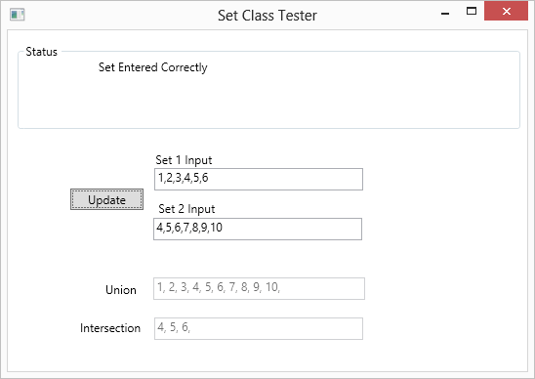

- You are to use data binding to bind all text boxes to properties in your Model.
- The design pattern used should be the same as in class. I.e. you will create a Model class that has the logic behind the View. This Model class will use IntegerSet class to do the operations.
- You must consider error cases. For example, what happens to the Union and Intersection box contents of the user enters an invalid set? What does my sample application do? Consider using Exception handling.
- I will be purposely entering in invalid data, so be sure you cover your error cases!
- As part of this assignment, you may need to use a tokenizer so that you can enter comma separated numbers into the text boxes above. You may use the approach I discussed in class, or you may find your own.
- Have fun. Use colors. Play around. You will notice that my solution has tooltips, so when you hover over the Set 1 and Set 2 Input boxes a tooltip tells you the format of the data. This is NOT required, but a simple thing you can do to learn a little more.

Format: Provide the information as follows:

- Zip project files.
- Upload the zip file via the web to the Blackboard.
- Please include your full name as part of the header in each source file.
- Please append _HW1 to the .zip file name (e.g. waclawski_HW1.zip).

