CSE 483
Final Project – Spring 2021

Final Project Objective: Provide the students an opportunity to demonstrate knowledge learned throughout the semester, specifically in the following area: C# Programming, WPF Application Development, Data Binding, Observable Collections, .NET Threads, .NET Timers, .NET UDP Sockets, .NET Events, 3rd Party DLL’s

Remotely Settable Digital Alarm Clock

- You are to develop a Digital Alarm Clock. This clock will display Hours, Minutes and Seconds
- The clock will increment each second, using a .NET timer. You will increment the clock by 1 second each time the .NET timer expires. Please note that you must increment the seconds on the clock, NOT simply display the currently TOD available through .NET.
- The clock will be initialized with the current time at application startup, but will be incremented manually by the 1 second timer. As the seconds roll over, you will increment the minutes. As the minutes roll over, you will increment the hours.
- Your Alarm Clock will have the ability to set an Alarm time. When the clock time equals the alarm time, an Event will be published to cause an Alarm indication, similar to the picture below.
- Your Digital Alarm Clock may look something like this for 24 Hour time:

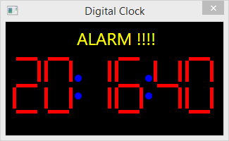

- Your Digital Alarm Clock may look something like this for 12 Hour Time:
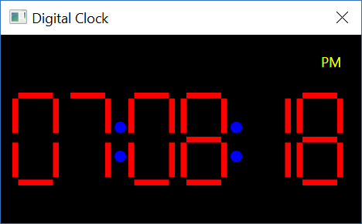

- You will also develop another WPF application that will allow the user to set the time.
- The user can manually enter hour, minute, and second, or they can just update the Digital Clock to the current time (i.e. NOW Time).
- The Alarm is set by the Set Alarm button, and will use the Hour, Min and Sec currently provided in the text boxies.
- This application may look something like this:
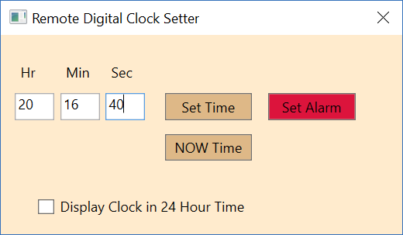

- When the Set Time button is pressed, the clock will be updated to the time entered. Input must be checked! That is, if the user enters an invalid time, it must be ignored.
- When the NOW Time button is pressed, the clock will be updated with the current time.
- When the Set Alarm button is pressed, the alarm on the clock will be set to the Hour, Minute and Second entered.
- When the “Display Clock in 24 Hour Time” is checked, the next time update will cause the Alarm Clock to display in 24 Hour Time. If it is not checked, the next time update will cause the Alarm Clock to display in 12 Hour Time.
- To receive full credit, your applications, cumulatively, must demonstrate all required components outlined in the statements above, including the following:

  - .NET Threads
  - .NET Events
  - .NET UDP Sockets
  - .NET Timer
  - Data Binding
  - Observable Collection
  - Use of a 3rd Party DLL
Provided Materials:

To help you complete this project, the following materials are provided for you on the Blackboard. These materials can be found on the Content page, under Final Project Supplements.

- XAML for the Digital Clock application. This XAML provides you with the basic window, and the ItemsControl required for a single 7-Segment LED. Note that in the sample shown above, there are 6, 7-Segement LEDs. This XAML may need to be adapted for your application to include additional required UI elements.
- LED.cs. This contains the data values that are data bound to the ItemsControl in the XAML provided. It also contains some useful methods to help set the value of each LED.
- TimeDataDLL. This DLL provides an object which contains the data that can be sent over a UDP socket by the Remote Digital Clock Setter application. In terms of an in-class example, this data would take the place of the GameData structure that was defined in the UDP Peer sample project. The data MUST be located in a shared DLL in order for it to be serialized and de-serialized by 2 separate C# assemblies. This DLL can be used as-is. To use this DLL, simply add a Reference to the DLL in your projects, and refer to the data type as TimeData.StructTimeData. This data contains the following members:

- int StructTimeData.hour
- int StructTimeData.minute
- int StructTimeData.second
- bool StructTimeData.isAlarmTime
- bool StructTimeData.is24HourTime

Format: Provide the information as follows:

- Zip project files.
- Upload the zip file via the web to the Blackboard.
- Please include all team member names as part of the header in each source file.
- Please append _FinalProject_Group<#> to the .zip file name, where # is your Group letter.

