Dounglan Cheung

Sample for problem 1:

ID # minutes charge

A2453 129 9.9

Q9888 399 26.9

S7777 180 12.5

A4545 190 13.5

B9898 240 16.0

Total: 78.80

Sample outfile:

ID # minutes charge

Total: 78.80

My ParkingCharge example:

ID # minutes charge

A1983 100 9.5

Q8999 250 17.0

S6666 369 23.9

A1234 400 27.0

B8484 187 13.2

Total: 90.60

My outfile:

ID # minutes charge

Total: 90.60

Problem 2 output:

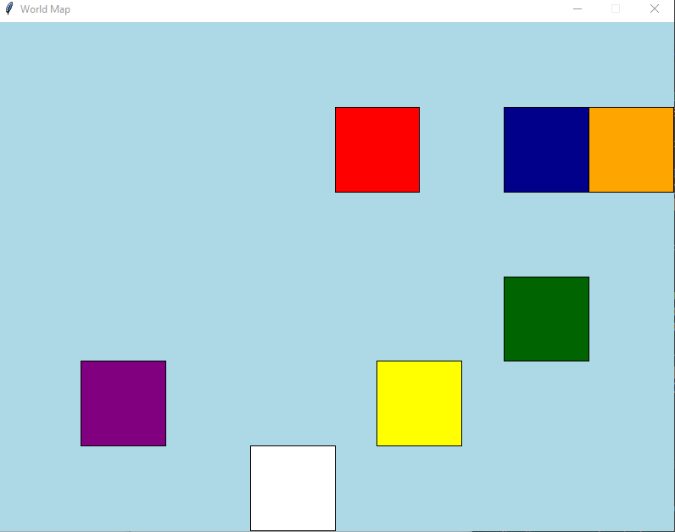

Problem 3 output:

