Template for ASB 2020 Abstracts, which are due March 13, 2020

Karen L. Troy.1, Moe2, Larry2, and Curley2

1You must put at least the presenting or corresponding author affiliation here

2Other affiliations are optional for the abstract, but will be entered into the submission portal and will be searchable

Email: *[ktroy@wpi.edu](mailto:ktroy@wpi.edu) *include just the corresponding author email

#### Introduction

We’re going to try something a bit new with ASB abstracts this year. The abstract will be 1 page only, and will emphasize the results, their context, and their significance. This is loosely based on the structured summary paragraph that Nature requires of authors. (you can google this to find Nature’s example)

***Abstracts are due by 5 PM EDT on Friday, March 13. We will NOT be pushing the deadline back. This deadline is for real.***

The introduction should provide basic information about the field, and additional background with more detail. Include background/context needed to support your hypotheses. Clearly state the general problem that you are addressing with this particular study. If you have hypotheses, state them here. It’s ok to use first person.

#### *(Between sections: keep the 10pt Times New Roman blank line)*

#### Methods

Briefly explain the methods that you used. If your methods are fairly standard, it is not necessary to explain these in exhaustive detail. Provide enough information that a reviewer in your general field could assess the validity of your methods. If this is a methods-focused abstract (ie, you are reporting on a new method that you have developed or validated) or if your methods are extremely novel/new, then this section could be expanded and you could even include sub-headers.

For most abstracts, methods should be less than one third of the total amount of text.

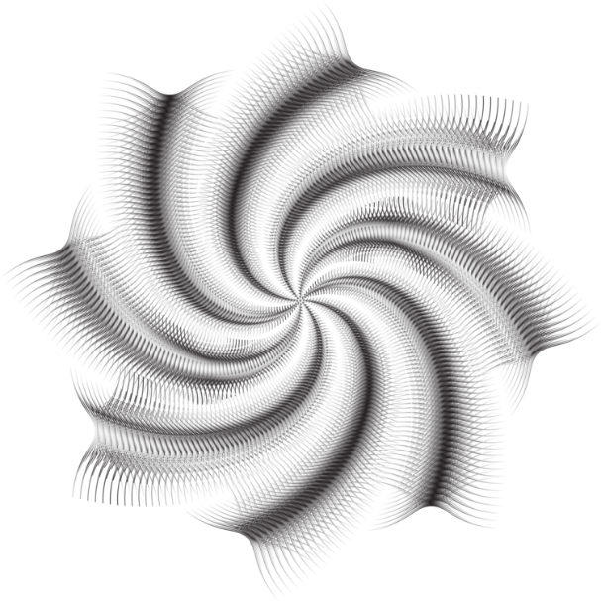

**Figure 1**: Figures or tables may be included. Please make sure all text is legible. Using a sans serif font (like Arial) for axis labels and tables looks nicer than using a serif font like Times. Please don’t go smaller than 9 point. **Tables** may span both columns.

#### *(Between sections: keep the 10pt Times New Roman blank line)*

Results and Discussion

#### In general, the results, and their context, importance, and significance should be the emphasis of the abstract. You can either structure this as a result – discussion, result – discussion (for each individual result), or you can summarize your key results/findings, and then have a discussion. Either way, be sure that you explain what your main result is, and how it adds to previous knowledge or compares to what was previously understood about the question that you are asking. If you had hypotheses, be sure to explain how your results support (or do not support) your hypotheses.

Remember the difference between data and results. Data are the information that you collected. In general, it’s good to present data in tables and figures. Results are your interpretation of the data (ie, what do they mean?), and can be written out.

Finish this section by including 2-3 sentences that summarize the main take home point(s) and put your results into a more general context.

#### *(Between sections: keep the 10pt Times New Roman blank line)*

**Significance**

Explain the significance of your research. Here are some questions you can think about when you write this section: How are your results relevant to your field? How are they potentially impactful outside of your field? What is possible now, that was not possible? Will this impact clinical care? Will it change how people think about a particular problem? Think about, and comment upon, the broader perspective on your work.

#### *(Between sections: keep the 10pt Times New Roman blank line)*

#### Acknowledgments

Acknowledge any sources of support or other important contributors here.

#### *(Between sections: keep the 10pt Times New Roman blank line)*

#### References

Reference citations can be brief, but must include the bare minimum amount of information to locate the reference.

**Formatting**

The font must remain 10 pt Times New Roman for the text

A sans serif font (e.g., Arial) is acceptable for figures and tables, but the font must be 9 pt or larger.

The first line of the first paragraph remain aligned with the left margin. Each paragraph after that, within the same section, is indented by 0.2”

There must be 0.5” margin around all edges.

Please ensure proper significant digits in all reported results.

Please keep all Section headings and do not change them. Section headings should have their own line and not be part of the first paragraph.

All other text in this template can be removed prior to starting your abstract

DO NOT include a second page. Your abstract is limited to one page only. Abstracts with text on page 2 will not be reviewed.