Compression of Human Movement Data

David P. Chiasson, Junkai Xu, Peter Shull

Shanghai Jiaotong University

Email: [pshull@sjtu.edu.cn](mailto:*pshull@sjtu.edu.cn)

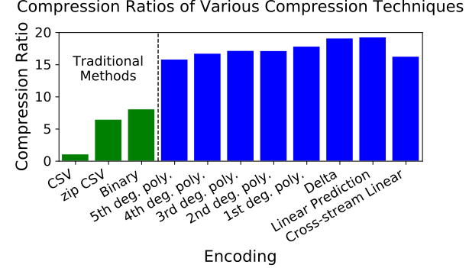

#### Introduction

There exists numerous applications for human movement information including virtual reality, wearable electronics, physical therapy and human performance. The utilization of biomechanical understanding to any human movement application depends on the efficient processing and representation of the kinematic data. Yet, techniques for dealing with this class of multimedia information has received little attention compared with the mature fields of image, audio, and text. In order to enable the applications listed above, efficient and standard techniques for processing and representing kinematic data are needed. This work addresses the second of those needs, the representation of kinematic data. Representation is more important than processing as processing cannot happen without representation, and consensus is required for useful representation while processing techniques can be customized. We apply an array of compression techniques borrowed from other fields of multimedia networks as well as several novel approaches to compress six-axis IMU data of various human movements and body segments. The authors hypothesise that the most efficient representation format will utilize a mechanical understanding of the relationship between rotation and orientation ie, cross-correlation between accelerometer and gyroscope information.

#### Methods

In order to meaningfully and repeatable demonstrate the performance of a compression algorithm, a public kinetic signal corpus must be selected. For this study, the Human Gait Database [Chereshnev] is used. HuGaDb is a public dataset of six-axis IMU signals collected from six different body segments of 18 healthy subjects performing 12 different movement activities. This database was selected because it allowed the comparison of compression techniques across body segment, subject, and activity in addition to sensor modality. The data collected from three random subjects was designated as training data, and only data from the remaining 15 subjects was used in our results.

Eight lossless compression techniques are selected and compared in this study. The first six techniques which fall under polynomial regression, are taken from the field of audio compression. The last two techniques are learned linear predictors derived from training data which considers past history, and the past history of other streams respectively.

Comma separated value (CSV) is selected as the baseline size when computing compression ratio (CR). CR is computed by dividing the size of the CSV file by the size of the compressed file. In addition to CSV, two other traditional techniques are included for further context: ZIP compression, and efficient binary representation. All compression techniques are implemented as FIR filters using 16.16 fixed point computation. This guarantees stability and reversible operations.

**Figure 1**: Compression ratios relative to CSV. Higher is better.

Results and Discussion

#### All tested compression techniques far outperformed traditional representation methods in size efficiency. Delta encoding proved to be the best performing polynomial regression technique (CR=19.016), with each additional degree performing worse. This is likely because higher degree polynomial predictors suffer from poor white noise attenuation [Tanskanen].

The linear prediction filter (CR=19.186) proved to be slightly better than delta encoding. Investigation of the coefficients showed that the per-stream FIR had learned an approximation of Delta encoding.

Cross-stream linear prediction (CR=16.183) unexpectedly performed significantly worse than linear prediction or delta encoding which failed to support our hypothesis. We expect that this was due to cumulation of error from 16.16 arithmatic. The cross-stream predictor involved two orders of magnitude more computation than delta encoding.

**Significance**

Using these techniques, kinematic data can be represented at almost one-twentieth the size of the current de-facto standard. This enables a range of applications which experience stringent requirements such as real-time data streaming, wireless communications, or limited storage space.

#### Acknowledgments

Do I have any acknowledgements?

#### References

Chereshnev, R., & Kertész-Farkas, A. (2017). Hugadb: Human gait database for activity recognition from wearable inertial sensor networks. In International Conference on Analysis of Images, Social Networks and Texts

Tanskanen, J. M. A. (2000). Polynomial Predictive Filters : Implementation and Applications. In Electronics.