Compression of Human Movement IMU Data

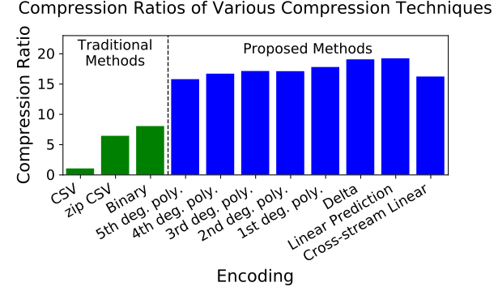  
**Figure 1**: Compression ratios relative to CSV. Higher is better.

David P. Chiasson1, Junkai Xu1, Peter B. Shull1

1State Key Laboratory of Mechanical System and Vibration, School of Mechanical Engineering, Shanghai Jiao Tong University

Email: dchiasso@sjtu.edu.cn

#### Introduction

Wearable human movement information from inertial measurement units (IMU) is critical for a variety of applications including virtual reality, wearable electronics, physical therapy and human performance. However, techniques for representing with this class of multimedia information has received little attention compared with the mature fields of image, audio, and text. Developing compressed representations of kinematic data will allow for higher sampling rates, greater data throughput, more nodes, and more data stored in a limited space. Compression is a key element to enabling previously unfeasible applications particularly those which experience limited transmission bandwidth or data storage. We hypothesised that the most efficient compressed representation format would utilize the interrelated nature of rotation and orientation information in accelerometer and gyroscope information.

#### Methods

For this study, the Human Gait Database (HuGaDb)[1] is used to meaningfully and repeatable demonstrate the performance of various compression techniques. HuGaDb is a public dataset of six-axis IMU signals collected from six different body segments of 18 healthy subjects performing 12 different movement activities.

Eight lossless compression techniques are proposed and compared with three traditional methods which are already in widespread use. The first six techniques which fall under polynomial regression, are borrowed from the field of audio compression. These techniques extrapolate a polynomial regression of the past n data samples where n is an integer greater than the polynomial degree. The last two techniques are the optimal linear predictors of training data which were computed via Lasso regression. The cross-stream linear compression technique additionally considers past samples of other dimensions and sensor modality. The data collected from three random subjects was designated as training data, and only data from the remaining 15 subjects was used in our results.

The traditional method of comma separated value (CSV) is selected as the baseline size when computing compression ratio (CR). CR is computed by dividing the size of the CSV file by the size of the compressed file. In addition to CSV, two other traditional techniques are included for further context: ZIP compression, and efficient binary representation. All proposed compression techniques are implemented as FIR filters using 16.16 fixed point computation.

Results and Discussion

All tested compression techniques far outperformed traditional representation methods in size efficiency (Fig. 1). This is likely due to the proposed methods’ ability to utilize time auto-correlation and sparsity of the sensor sample space. Delta encoding proved to be the best performing polynomial regression technique (CR=19.0), with each additional degree performing worse. This is likely because higher degree polynomial predictors suffer from poor white noise attenuation [2].

The linear prediction filter (CR=19.186) proved to be slightly better than delta encoding. Investigation of the coefficients showed that the per-stream FIR had learned an approximation of Delta encoding.

Cross-stream linear prediction (CR=16.183) unexpectedly performed significantly worse than linear prediction or delta encoding which fails to support our hypothesis. We expect that this was due to accumulation of error from 16.16 arithmetic. The cross-stream predictor involved two orders of magnitude more computation than delta encoding.

**Significance**

Using these techniques, kinematic data can be compressed to almost one-twentieth the size of the current de-facto standard. This enables a range of applications which experience stringent requirements such as real-time data streaming, wireless communications, or limited storage space.

#### Acknowledgments

This work was supported by the National Natural Science Foundation of China (51875347).

#### References

[1] Chereshnev, R., & Kertész-Farkas, A. (2017). Hugadb: Human gait database for activity recognition from wearable inertial sensor networks. In International Conference on Analysis of Images, Social Networks and Texts

[2] Tanskanen, J. M. A. (2000). Polynomial Predictive Filters : Implementation and Applications. In Electronics.