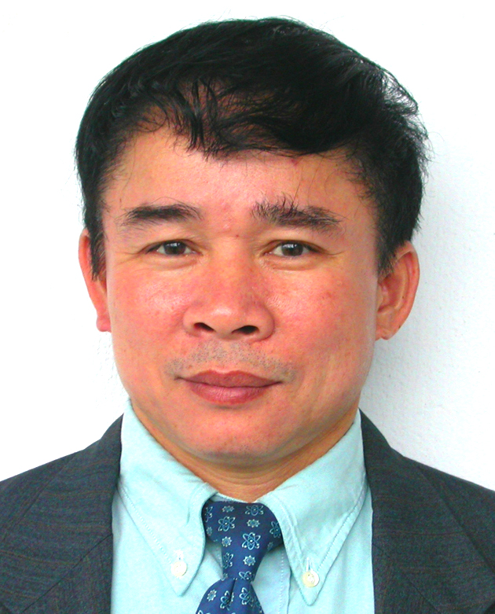
Professor BUI VAN GA
Full Name: BUI VAN GA
Academic Rank: Professor
Date of Birth: 1957
Place of Birth: Binh Dinh
Education: Bachelor of Science in Mechanical Engineering at Da Nang University of Technology in 1980; Ph.D. at Ecole Centrale de Lyon, France, in 1989; Doctor of Science in 2004; Associate Professor (1996) and Full Professor (2002) at the University of Da Nang.
Academic Highlights:
Director of Department of Science and Technology (1991-1994); Director of International Relations (1994-1998); Vice President (1998-2000) of the University of Da Nang; Director of Polytechnic College (2000-2004); Rector of Da Nang University of Technology (2004-2005); President of the University of Da Nang (2005-2010).
- Prize “Science and Technology” (2003) of French Speaking Universities Agency(AUF)
- First Prize “Science Technonology Initiative Competition” (2003) of Danang City
- Palmes Academiques (2001, Chevalier) of French Government
- Palmes Academiques (2005, Officer) of French Government
- The 3rd Labour Medal (2006) of The Nation
- National Competition Worker (2008) of The Government
- Doctor Honoris Causa, Université de Nantes (2012)
Visiting Professor to the University of Angers and University Joseph Fourier (France); Member of Editor Committee of Journal “Science and Technology” and “Vietnamese Journal of Mechanics”; Vice Chairman of Vietnamese Association of Mechanics; Member of Japanese Association of Combustion.
Teaching courses: Internal Combustion Engines, Turbulence, Combustion Modeling, Air Pollution;
Field of Research: Fluid Mechanics, Combustion Modelling, Air Pollution; Renewable Energy
Inventor and Patents:
- Inventor of LPG/Gasoline conversion kit for motorcycles
- Inventor of Biogas/Petroleum conversion kit for stationary engines
- Patents Owner No: 3692(2003), 5940(2006), 6643(2007), 8187(2010)
Publications: can be consulted at the website: www.dongcobiogas.com
Address/Contact:
Prof. Dr.Sc. BUI VAN GA
The University of Danang
41 Le Duan
Da Nang
Vietnam
Tel: +84 511 3840 260
Fax: +84 511 3823 683
Handphone: +84 913 402 278
Email: buivanga@ac.udn.vn
Website: www.dongcobiogas.com

