**PCA Scatter Plot 2 Dimensions**

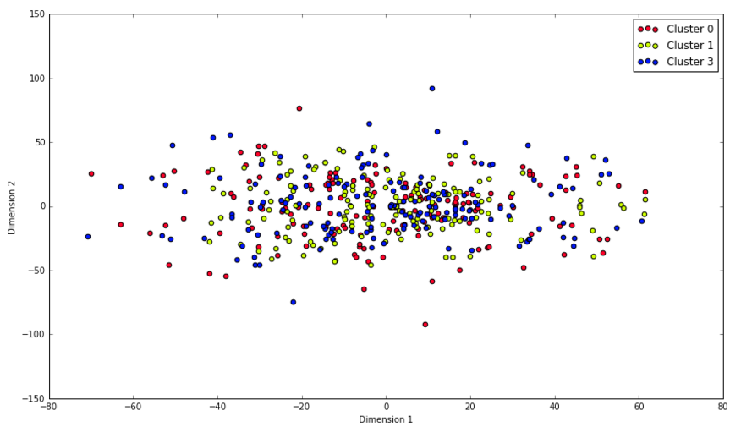

**Features Relationships**

Attacks vs. Possession

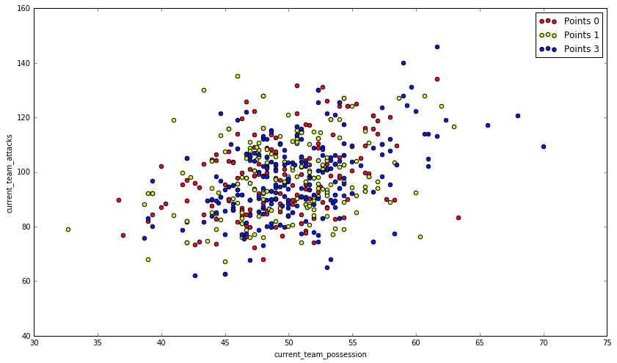

Dangerous Attacks vs. Possession

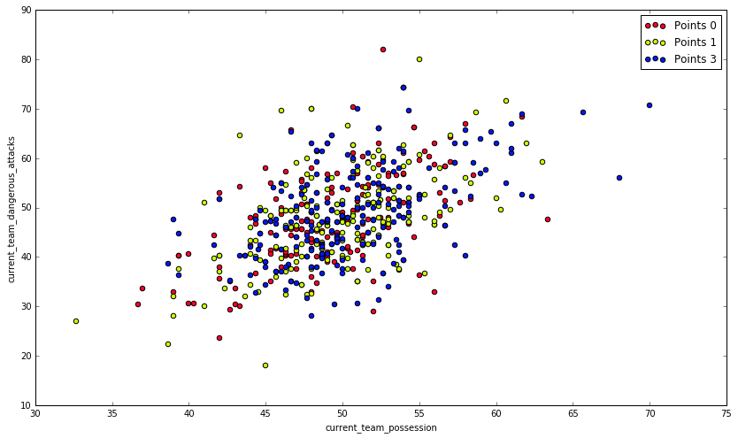

Corner Kicks vs. Possession

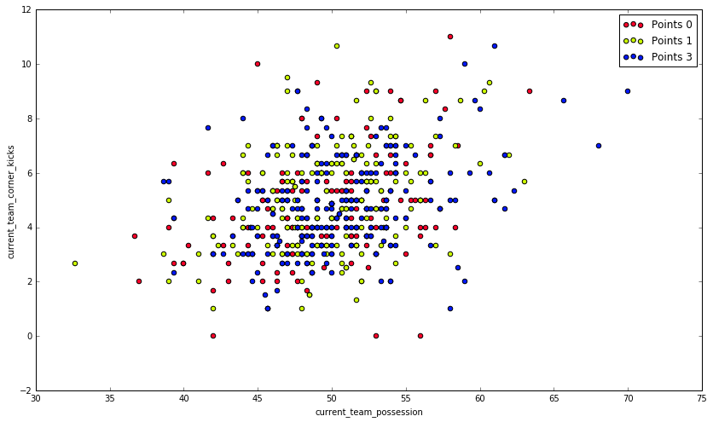

Shots on Target vs. Possession

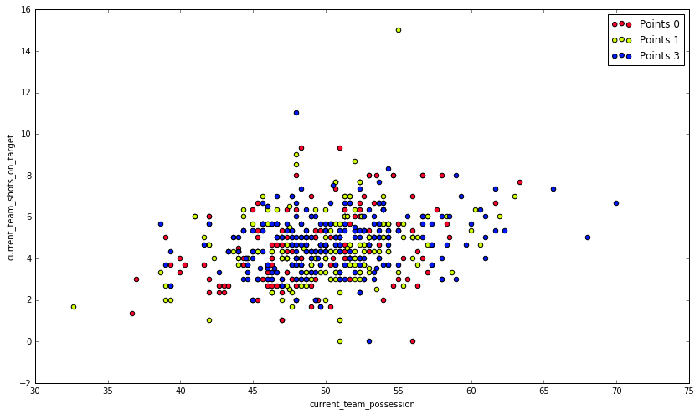

Ball Safe vs. Possession

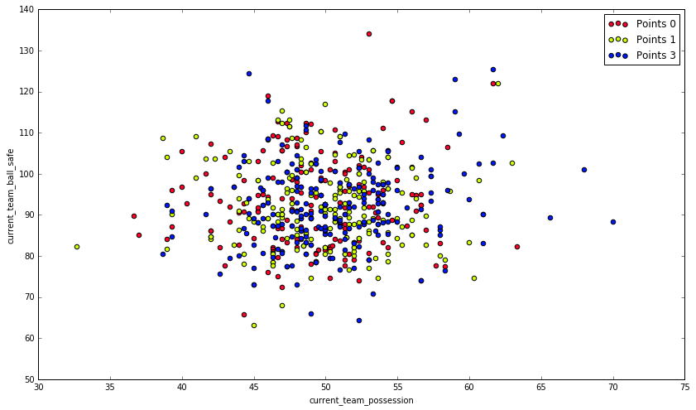

Goal Attempts vs. Possession

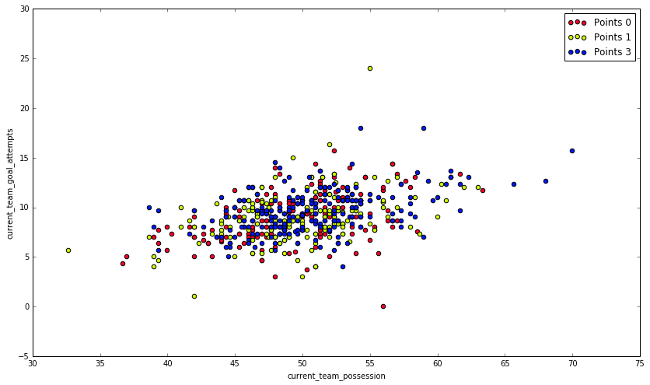

Saves vs. Possession

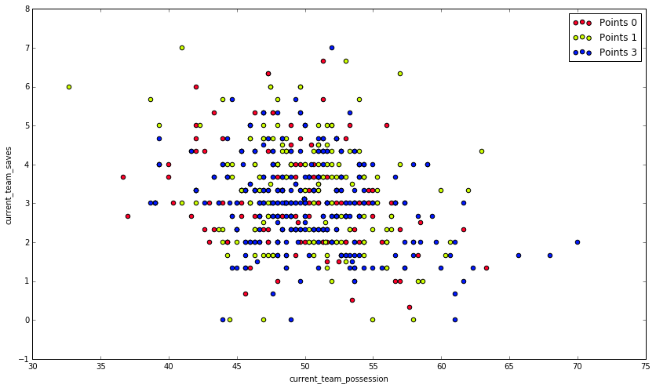

Goal Kicks vs. Possession

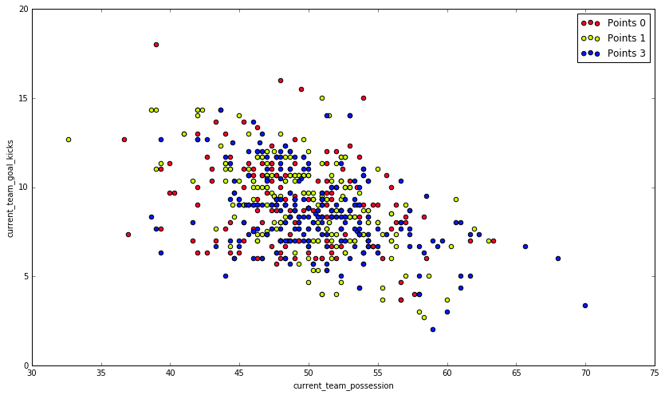

Dangerous Attacks vs. Attacks

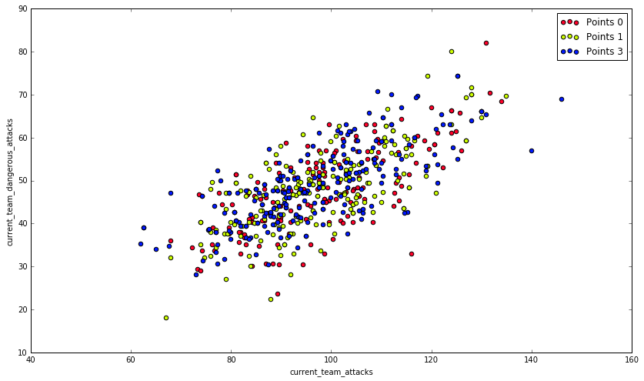

Corner Kicks vs. Attacks

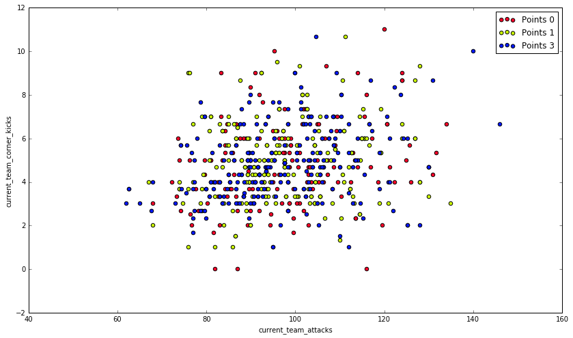

Shots on Target vs. Attacks

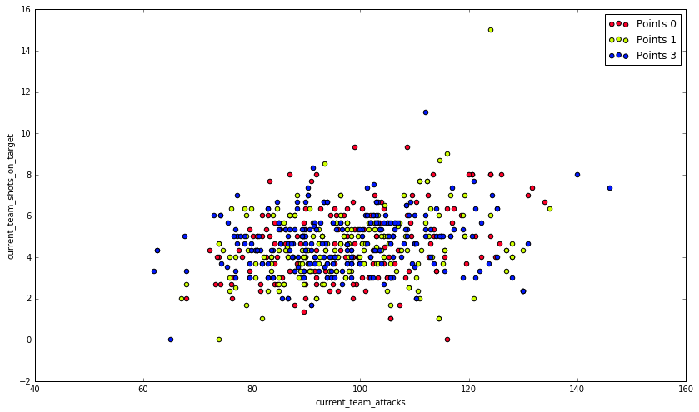

Ball Safe vs. Attacks

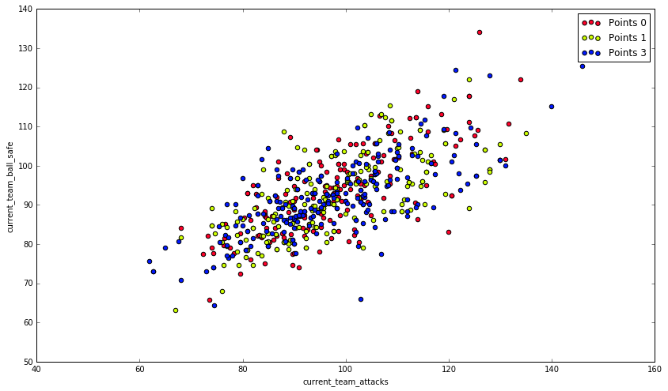

Goal Attempts vs. Attacks

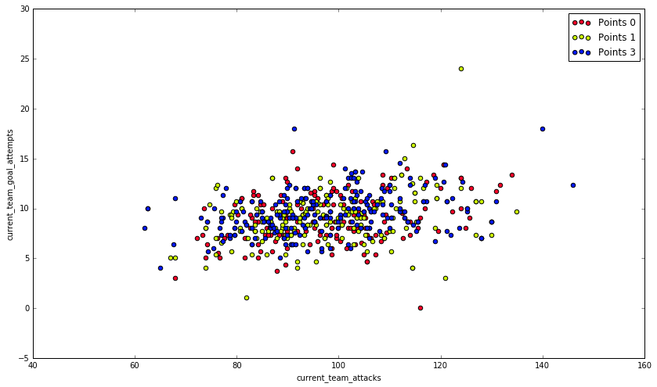

Goal Kicks vs. Attack

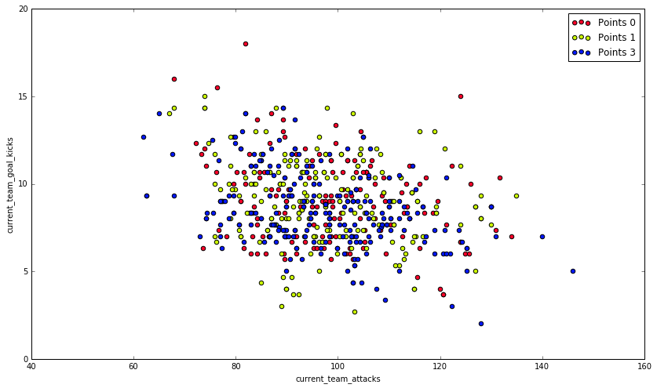

Shots on Target vs. Dangerous Attacks

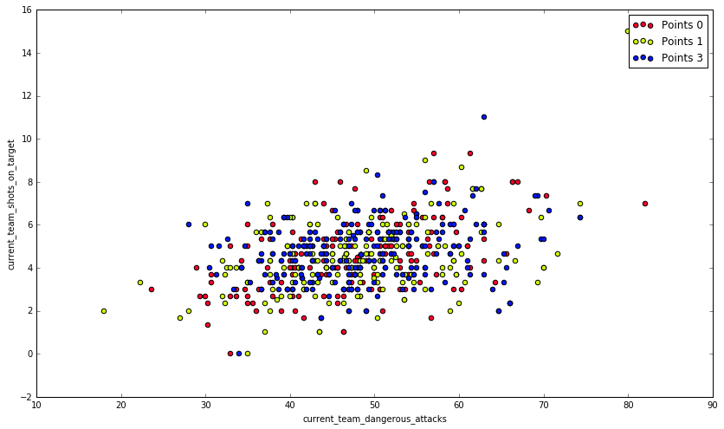

Ball Safe vs. Dangerous Attacks

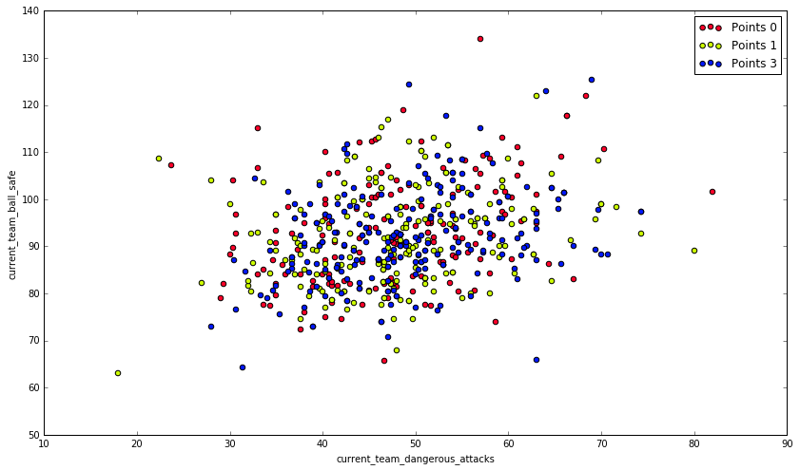

Goal Attempts vs. Dangerous Attacks

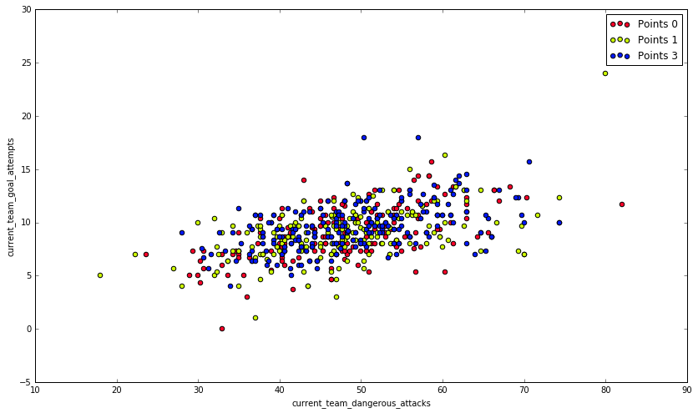

Goal Kicks vs. Dangerous Attacks

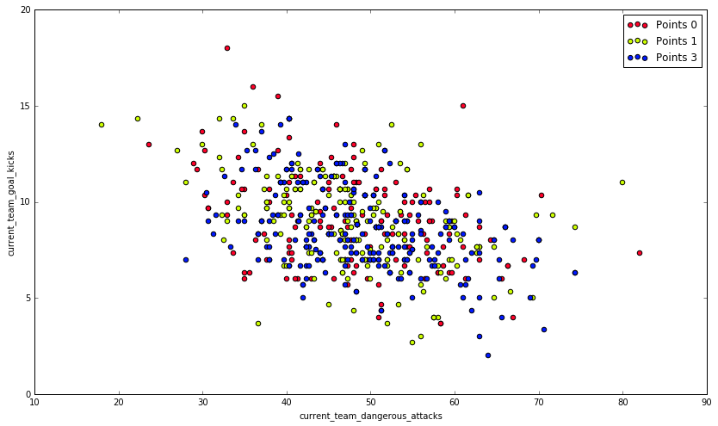

Goal Attempts vs. Corner Kicks

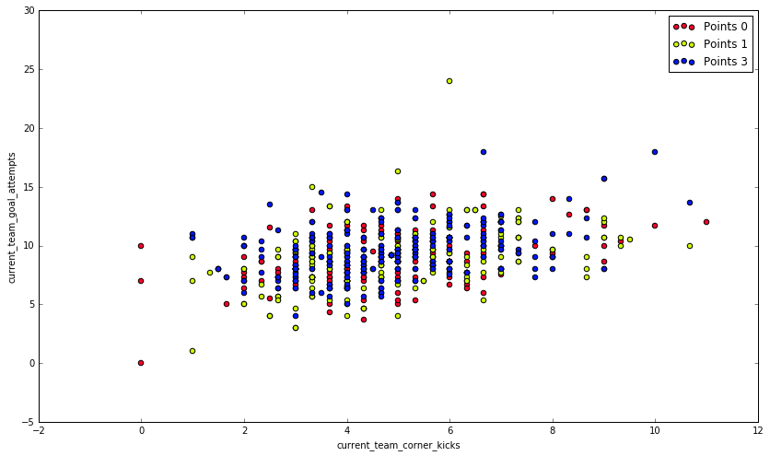

Goal Kicks vs. Corner Kicks

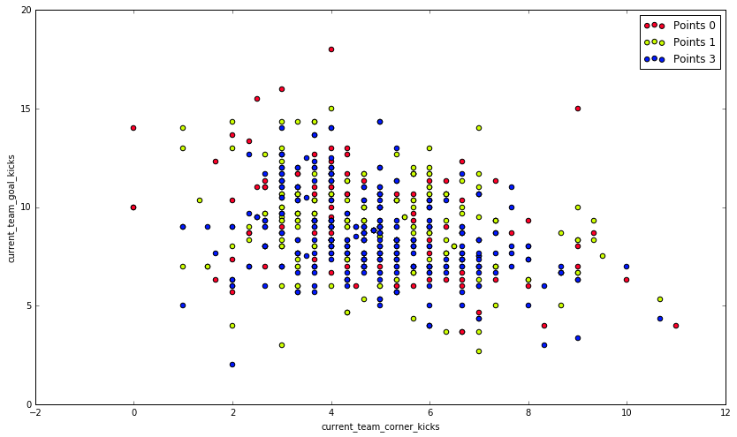

Goal Attempts vs. Shots on Target

