**PCA Scatter Plot 2 Dimensions**

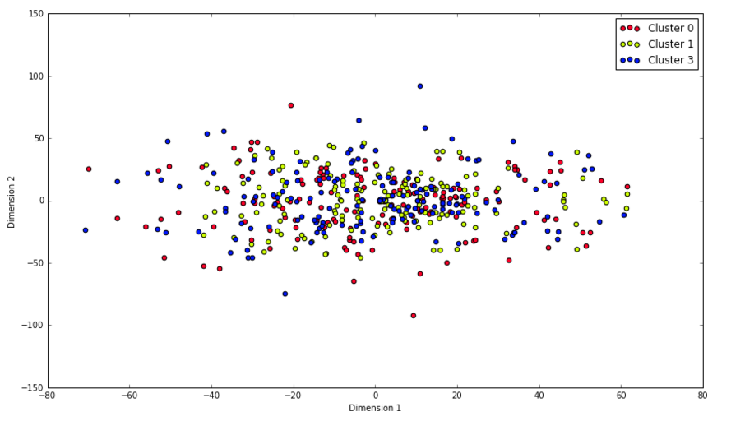

**Extended Features Relationships**

Possession vs. Ball Safe

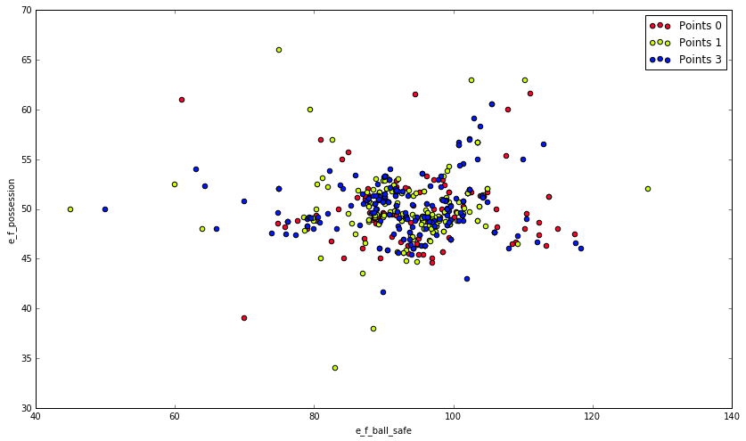

Dangerous Attacks vs. Ball Safe

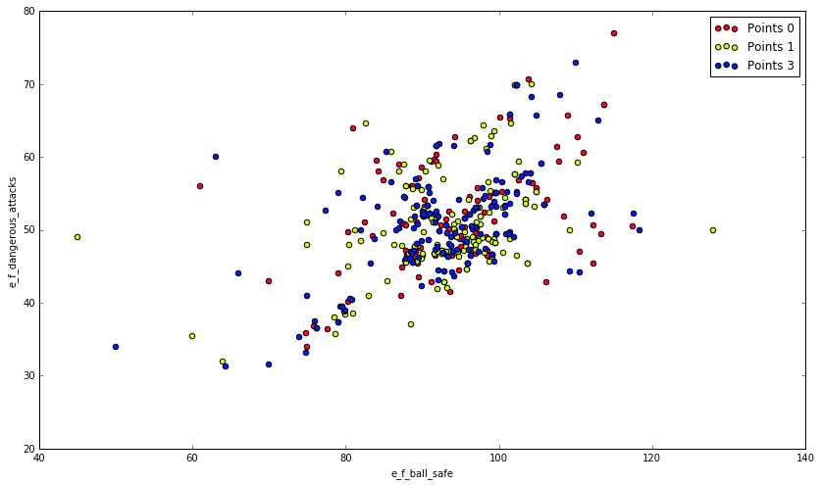

Attacks vs. Ball Safe

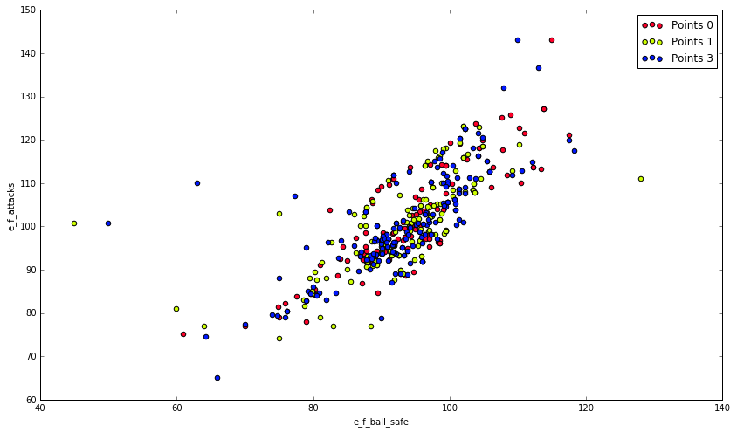

Attacks vs. Possession

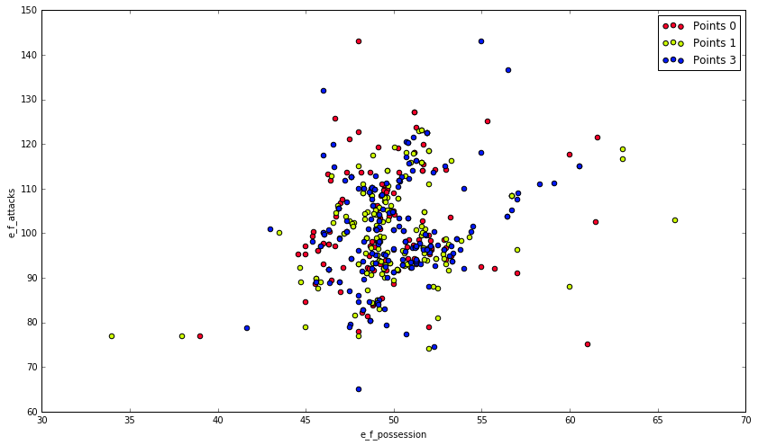

Dangerous Attacks vs. Possession

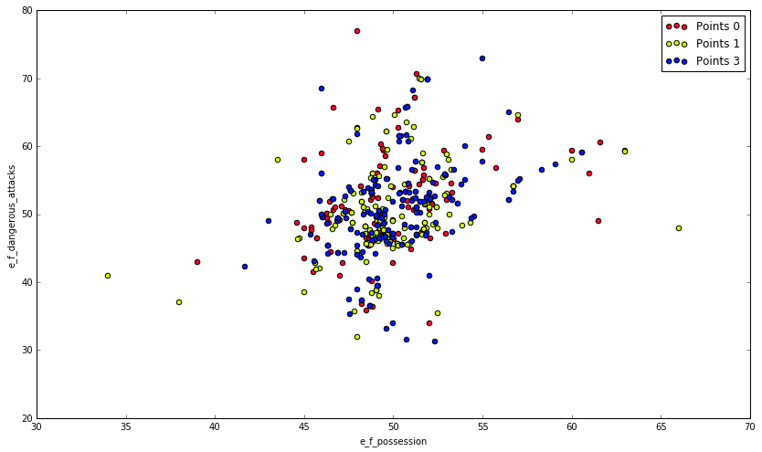

Shots Total vs. Ball Safe

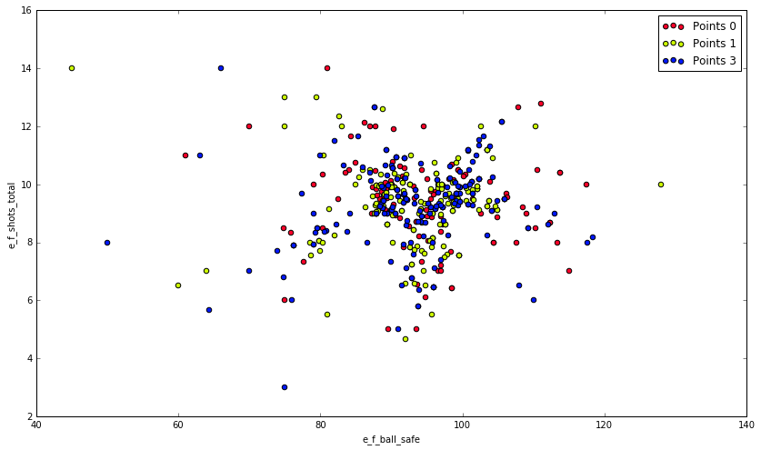

Shots Total vs. Possession

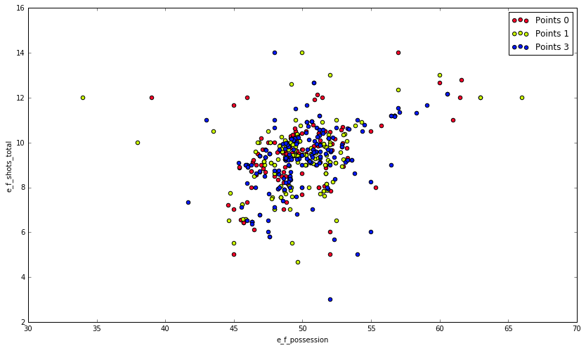

Dangerous Attacks vs. Attacks

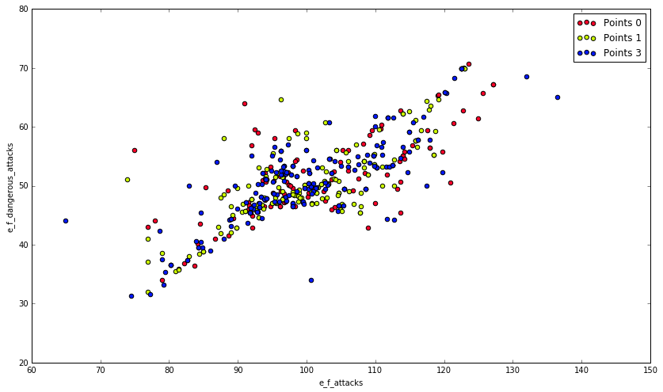

Shots Total vs. Attacks

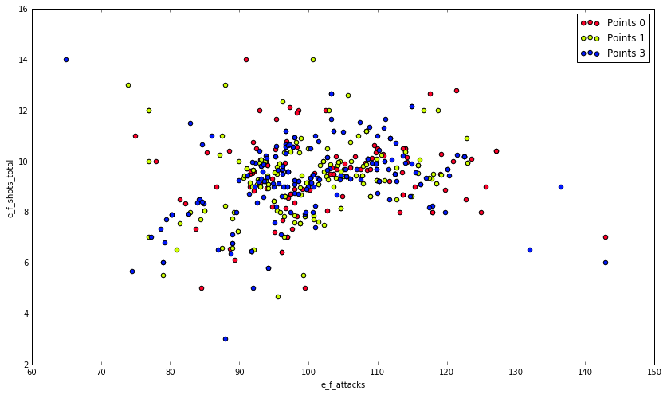

Shots Total vs. Dangerous Attacks

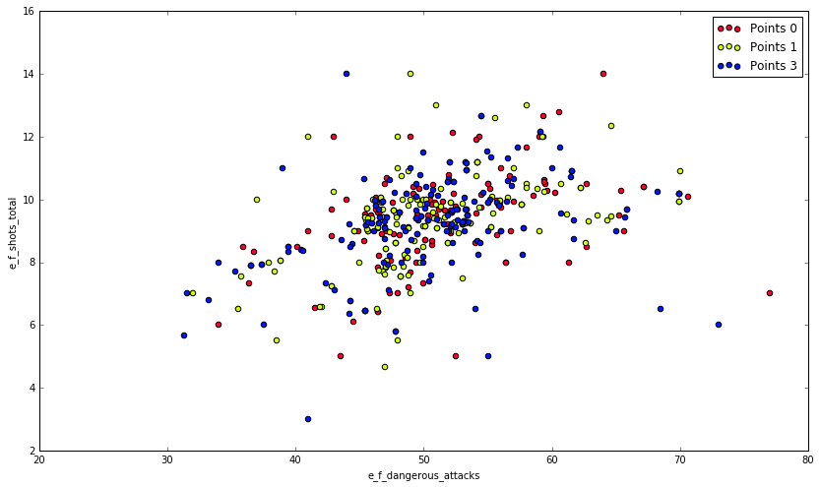

Shots on Target vs. Ball Safe

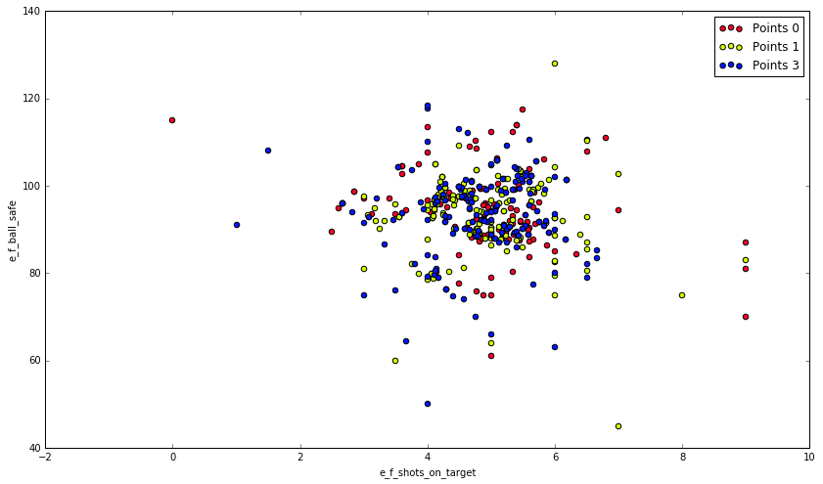

Possession vs. Shots on Target

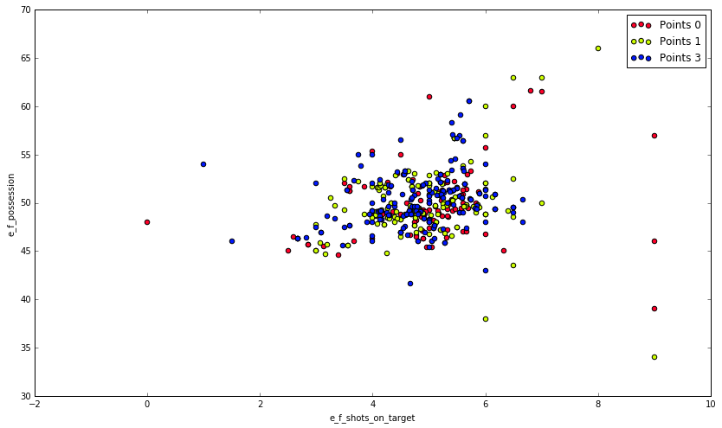

Shots on Target vs. Attacks

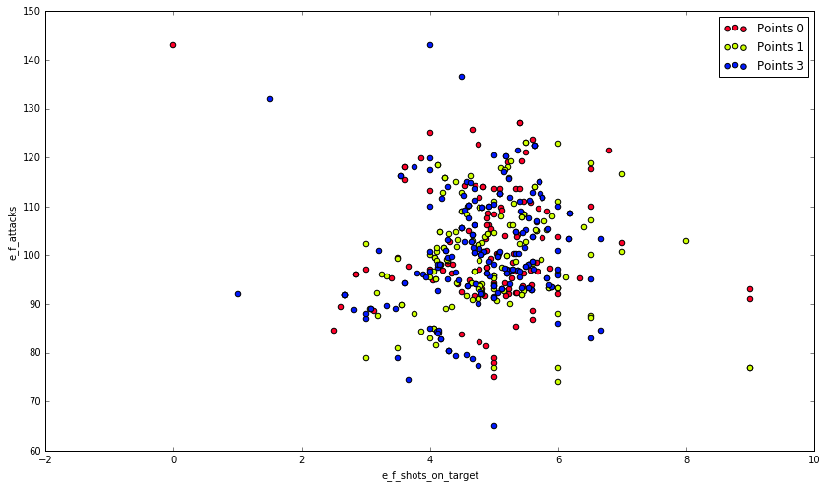

Shots on Target vs. Dangerous Attacks

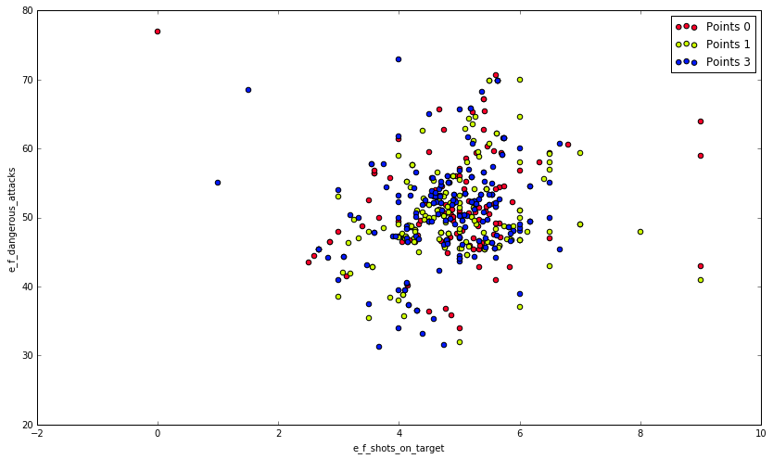

Shots on Target vs. Shots Total

