The Physical Price of Basketball Decisions
Closeouts, fatigue and matchup load from SkillCorner's open ACB tracking data
Chris Cothern, PT, CSCS, CPSS | October 2026 | Working report and LinkedIn drip plan

1. Summary
Three analyses, one theme: what basketball decisions cost the body, seen through a PT and CSCS lens. Public projects on this dataset focus on tactics (shot quality, expected possession value, space control, passing). None that we found measure physical load, so this angle is open.
Analysis | Headline | Use
1. Closeouts | Starting a closeout early (more than 0.4 s before the catch) adds about a third more hard braking for the defender and does not change the shot. | Post 1
2. Fatigue vs shooting | No fatigue signal in shooting: not in makes vs expected, release time, or a fatigue flag. Pros protect their shot. | Closing lines of Post 1 (force plates)
3. Chase Cost | Who you guard sets how much you run: chasing a guard off the ball costs about 18 ft/min more than guarding a spot-up wing. | Post 2

Data: SkillCorner Open Data (MIT license), Liga ACB 2025/26, 10 games, 25 fps broadcast tracking plus Dynamic Events, and the 293-game season aggregates for shooter context. Credit SkillCorner in every public post.
Sample caution: 10 games. Results are role-level and direction-level, not player rankings. All intervals are 95% from a bootstrap that resamples games.

2. Closeouts: early vs late vs none

Design
- Population: 2,076 catches that start in a three-point region. Each catch is one of three groups: closeout (SkillCorner recorded one), no closeout (defender 10+ ft away, none recorded), already guarded (defender under 10 ft, none needed).
- Closeouts split two ways: thirds of defender distance at the catch (near, middle, far), and lead time at its median (early: started more than 0.40 s before the catch; late: 0.40 s or less).
- Defender cost measured in the same window for every group: 1 s before to 2 s after the catch. The data's closeout end is fixed at catch + 0.8 s, before the real stop, so it is not used.
- Hard decels counted at 75% of each defender's own braking ceiling (99th percentile of their detected braking, pooled across games). 70% and 80% kept as sensitivity.
- Payoff: shot rate, SkillCorner shot quality, field goal points per 100 catches, defender distance at the release, drive blowbys.

Decisions made along the way
- A 6 ft cutoff for a late closeout was dropped: 97% of closeouts start beyond 6 ft, so it separated nothing.
- 10 ft for a no-closeout is a minimum, not a maximum: under 6 ft no closeout is needed, so those catches are good defense, not a choice.
- Lead-time thirds were lopsided (many ties at 0.40 s), so lead time is split at the median.

Results by distance at the catch
Group | n | Hard decels per catch | Peak braking (ft/s²) | Pts per 100 catches | Shot quality
Already guarded (under 10 ft) | 1,322 | 0.20 | 10.2 | 15 | 39
Closeout, near third | 171 | 0.26 | 12.1 | 33 | 34
Closeout, middle third | 170 | 0.31 | 12.9 | 66 | 37
Closeout, far third | 171 | 0.32 | 12.5 | 74 | 41
No closeout (10+ ft) | 242 | 0.17 | 9.9 | 28 | 39
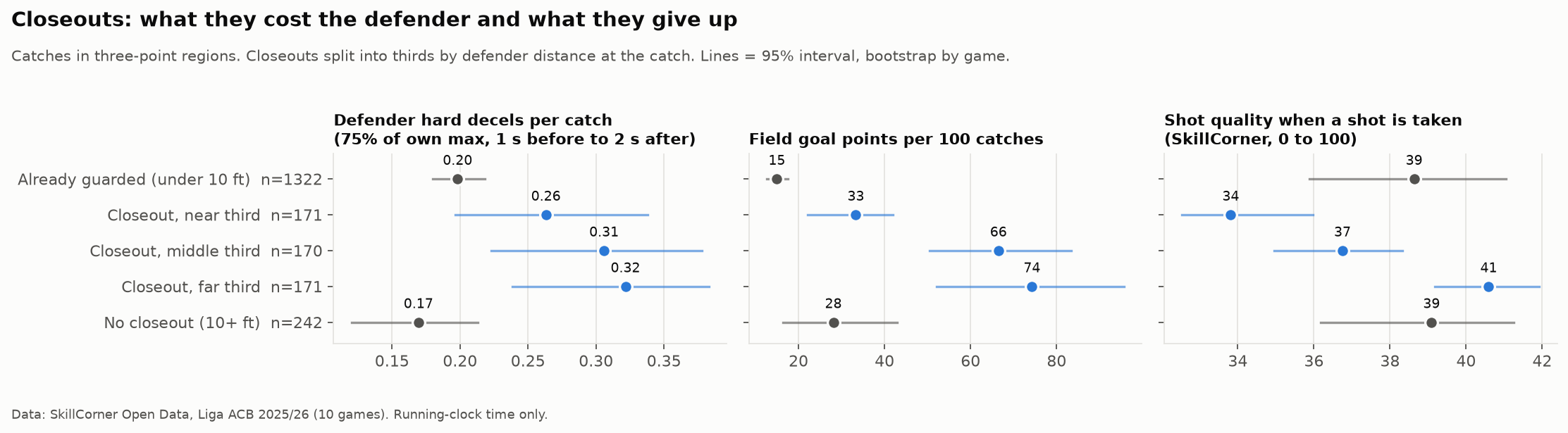
Figure 1. Closeout cost and payoff by distance at the catch.
Read: closing out costs the defender about 50% more braking than not closing out. Longer closeouts give up more, which is expected (the shooter is already open), so this is a sanity check rather than a post. Braking cost does not rise with distance (Spearman rho about 0).

Headline: early vs late start
Measure | Late start (n = 305) | Early start (n = 207)
Defender peak braking (ft/s²) | 12.1 | 13.0
Hard decels per closeout | 0.26 (0.22 to 0.30) | 0.35 (0.28 to 0.42)
Entry speed (ft/s) | 9.8 | 10.6
Shot quality when a shot is taken | 38 | 38
Field goal points per 100 catches | 59 | 57
Distance at the catch (ft) | 11.4 | 12.0
Catcher's season 3PA per game | 3.3 | 3.1
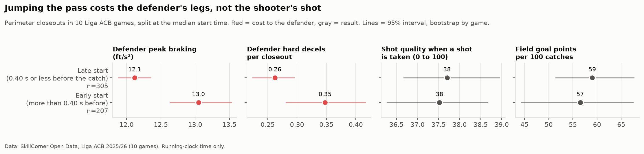
Figure 2. Early starters brake harder; the shooter's result does not change.
Read: defenders who jump the pass reach a higher speed and brake harder, but the shot is the same. The two groups cover the same distance and face the same shooters, so the difference is not tougher assignments. Coaching cue: close out on time and under control.

Shooter check for no-closeouts
Catcher (season 3PA per game) | Far closeout, pts/100 | No closeout, pts/100 | Share of catches left open
Low (0 to 2.3) | 53 | 10 | 12.5%
Mid (2.3 to 4.0) | 71 | 34 | 12.6%
High (4.0+) | 104 | 44 | 9.8%
Defenders skip closeouts more on non-shooters, but in every tier not closing out gave up half or less of a far closeout. Remaining confound: a far closeout is often a rotation after help, where the shooter is already open. Cells are 50 to 90 catches; treat as direction only.

Decel detail and fatigue drift
- Entry speed rises with closeout distance (9.5, 10.2, 10.7 ft/s) against 9.2 for already guarded.
- Stopping time and distance (about 1.1 to 1.3 s, 8 to 11 ft) do not separate groups and only resolve on about 40% of catches. Dropped from the story.
- Q1 vs Q4, same defender and game (42 pairs): no drop. Peak braking is +1.4 ft/s² in Q4 (-0.5 to +3.1).
- Detected share in defender windows is 95% to 99%, so braking numbers rest on seen positions.

3. Fatigue vs shot execution

Design
- 1,450 field goal attempts (heaves excluded). Shooter load in the 60 s and 120 s of running clock before the release, never crossing a bench stint.
- Load: distance per minute, and hard decels per minute at 75% of own ceiling.
- Outcomes: shot quality; selection (three, catch and shoot, contested, release time, distance); make vs expected (make minus a logistic fit on shot quality and 2 vs 3).
- Within-player tests: repeated-measures correlation with the player-game as the subject, 5 within-player load bins, and an Alert Yield table.

Results
Test | Result
Load vs make vs expected | r = -0.02 to +0.07, all intervals span zero
Load vs shot selection | Small hints (r about 0.1): slightly closer shots after more running, slower release after more braking. None survive correction for 28 tests.
Fatigue flag (load above own 80th percentile, 60 s) | Flagged shots made at or above expectation; AUC 0.48 to 0.52 (0.5 = no signal)
Catch-and-shoot release time by quarter | 0.87, 0.80, 0.83, 0.84 s; no within-player trend
Release time vs make vs expected | No relationship

Limits: only 64% of shots have a clean 60 s window (39% for 120 s); shots in a player's first minute or two after checking in drop out, and those are the freshest legs. Coaches sub tired players out, so the most fatigued shots may never happen.
Read: an honest null. Broadcast tracking sees players on the floor (z = 0), not in the air. The fatigue that affects a jump shot likely lives in the jump: jump height, contact time and RSI. Pre and post game force plate testing (CMJ, RSI) or IMU jump estimates are what would show it. Word it as "tracking shows the miles, force plates show the springs," not as in-floor plates during games.

4. Chase Cost: who you guard sets how much you run

Design
- Every matchup interval (SkillCorner matchups table): the defender's distance and hard decels per running-clock minute, minus that same defender's average in the same state (on or off the ball) in that game.
- On-ball = the player being guarded is in a touch. Grouped by the role of the player being guarded. Roles come from on-court behavior; positions are not in the data.

Results
Guarding a... | Off the ball, ft/min | With the ball, ft/min
Guard | +9 (6 to 13) | +2 (-1 to 6)
Wing | -9 (-11 to -6) | +17 (6 to 27)
Big | +1 (-1 to 4) | -35 (-47 to -21)
Minutes measured | 851 | 179
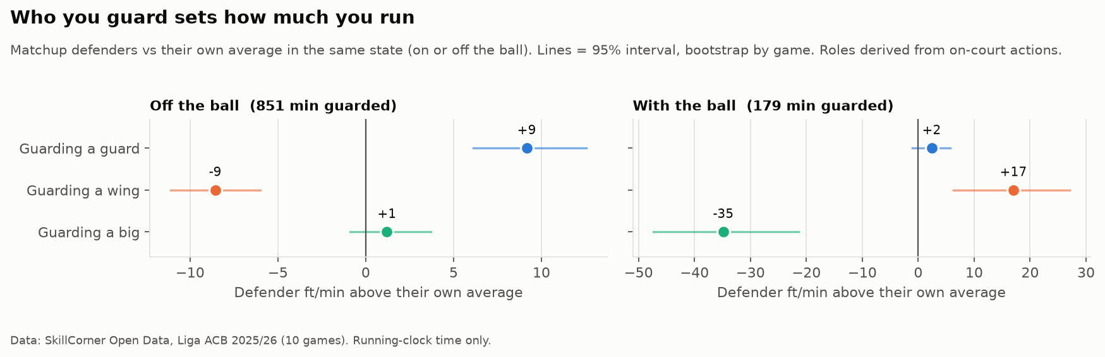
Figure 3. Defender running above their own average, by the role of the player guarded.
Read: off the ball, guards cut, relocate and come off screens while spot-up wings stand, and so do their defenders. With the ball it flips: a wing attacking is the most expensive matchup and a big posting up is the cheapest. Hard decel differences are near zero; the cost shows up as distance, not braking.

What does not work yet
- Player rankings: only 13 players have two games with 5+ minutes guarded; game-to-game agreement is weak (0.17 to 0.26 off the ball). Do not name a "most draining player."
- Gravity proxy (how tightly a player is guarded vs court position): explains 23% of the gap, unstable, unrelated to Chase Cost. Keep the 2x2 out of public posts.

5. Files, methods and open items

Where it lives
All three analyses are self-contained in waims-tracking-lab: not in the README findings, the WAIMS feed, build_all.py or the portfolio until you decide.
Analysis | Code | Run | Outputs
Closeouts | src/wtl/closeouts.py | python scripts/closeouts.py (about 40 s) | exports/closeouts/
Fatigue | src/wtl/fatigue.py | python scripts/fatigue.py (about 35 s) | exports/fatigue/
Chase Cost | src/wtl/chase.py | python scripts/chase.py (about 40 s) | exports/chase/

Shared methods
- Speed capped at 26 ft/s and smoothed (Savitzky Golay, 0.52 s) inside continuous segments; acceleration from smoothed speed.
- Running-clock time only. Units in feet and ft/s (100 ft = 30.5 m).
- Hoop at 40.75 ft from center (FIBA court, fitted from shot distances). Tracking is not normalized to one attacking direction, so hoop side is taken per interval.
- Stats: game-resampling bootstrap intervals, Spearman's rho, repeated-measures correlation, effect sizes with intervals ahead of p-values.

Open items
- Discard the worst-case curve files in GitHub Desktop (six modified files, exports/tables/, worst_case_curve.png).
- Decide whether to commit the three analyses (on disk, not in git).
- Future ideas: repeated closeout exposure (several hard closeouts in a short window), defensive effort chains (closeout, recover, second closeout), more games for player-level Chase Cost.

6. LinkedIn plan: two posts
Two posts, one week apart. Post Tuesday to Thursday morning (7:30 to 9:00 local), reply to every comment in the first hour, and tag SkillCorner in both. Never claim "first"; "I haven't seen this measured before" at most.
Date | Post | Asset | First comment
Tue Oct 6 | Post 1: Jumping the pass costs your legs, not their shot | Figure 2 | Method and limits
Tue Oct 13 | Post 2: Who you guard sets how much you run | Figure 3 | Method and limits

Post 1: closeouts (Tue Oct 6, attach Figure 2)
Jumping the pass costs your legs, not their shot.
I used SkillCorner's open tracking data (10 Liga ACB games, 25 fps) to measure what closeouts cost the defender's body.
I split 512 perimeter closeouts by when the defender started running: more than 0.4 s before the catch (early) or later.
Early starters:
- braked harder (13.0 vs 12.1 ft/s² peak)
- had about a third more hard decelerations per closeout
The shooter got the same result either way: same shot rate, same shot quality, same points per 100 catches. Both groups covered the same distance and faced the same shooters.
Takeaway: close out on time and under control. Anticipating the pass adds braking load without improving the contest.
I also looked for fatigue in the shooters: load in the minute before a shot, release time by quarter, a monitoring-style fatigue flag. Nothing showed up. Broadcast tracking sees players on the floor, not in the air. Jump height, contact time and RSI are where it would show, and that's force plate territory. Tracking shows the miles. Force plates show the springs.
Thanks to @SkillCorner for releasing the data.
#basketball #sportsscience #strengthandconditioning #performance

First comment
How I measured it: catches in three-point regions; defender load from 1 s before to 2 s after the catch; hard decels counted against each defender's own braking ceiling; 95% intervals from resampling games.
Limits: 10 games, broadcast tracking, players tracked on the floor only. Read it as a direction, not a law.

Post 2: Chase Cost (Tue Oct 13, attach Figure 3)
Who you guard sets how much you run.
Second look at SkillCorner's open tracking data (10 Liga ACB games): how much running each assignment forces on the defender, compared with that same defender's usual workload.
Off the ball:
- Guarding a guard: +9 ft/min above the defender's own average
- Guarding a spot-up wing: -9 ft/min
That's about an 18 ft/min swing from the assignment alone. Guards cut, relocate and come off screens. Spacers stand in the corner, and so does their defender.
With the ball, it flips. A wing attacking is the most expensive matchup (+17 ft/min). A big posting up is the cheapest (-35 ft/min): post defense is contact, not running, and tracking can't see contact.
Why it matters for load management: matchups are a lever. A defender on managed minutes, or late in a heavy stretch, can be put on a spacer instead of a mover without changing the scheme.
Thanks to @SkillCorner for the data.
#basketball #loadmanagement #sportsscience #coaching

First comment
Method: every matchup interval in the data, the defender's running compared with their own average in the same state (on or off the ball). Roles come from what players do on court, since positions aren't in the data. 95% intervals from resampling games.
Limits: 10 games, so these are role-level patterns, not player rankings.

What to track
- Comments from coaches and S&C staff (the target audience), not just reaction counts.
- Profile views and follows in the 48 hours after each post.
- Questions worth answering in the comments or in a later post.

