WORKING WITH RDS MYSQL

Overview

Amazon RDS is a web service that makes it easy to set up, operate, and scale a relational database in the cloud. It provides cost-efficient and resizable capacity while managing time-consuming database administration tasks, freeing you up to focus on your applications and business.

This lab has a prerequisite of Immersion Day – [EC2 Linux Hands-On Lab](https://general-immersionday.workshop.aws/en/ec2/ec2linux.html) in order to complete. This part of the lab will demonstrate configuring a previously created web server in Module1 with EC2 lab to use RDS for its Relational Database Management System (RDBMS) needs.

This lab will walk you through the following:

* Add a VPC Instance Security Group
* Launch an RDS Instance
* Configure Instance to Leverage RDS
* Create an RDS Snapshot (Optional)
* Modify RDS Instance Size (Optional)

Add a VPC Instance Security Group

Prerequisite: EC2 Linux Hands-On Lab

The RDS servers have the same security model as Amazon EC2 overall: trust nothing. A common use of an RDS instance in a VPC is to share data with an application server running in an EC2 instance in the same VPC and that is accessed by a client application outside the VPC.

To this end, we’ll need to utilize a VPC security group to allow this access. If you’ve already completed the instructions in the “Module1: Compute Basics, EC2 Linux Lab”, you’ll have an existing EC2 instance with an existing security group. The name will be “[Name] – Immersion Day Web Tier”. Let’s create a new VPC security group for our database tier that only allows traffic from our web tier.

1. In the VPC dashboard, click **Security Groups**, then the **Create Security Group** button.
2. Set Name tag and group name to “[Name] - Immersion Day DB Tier”
3. Write a short description, and keep the VPC setting to the same VPC you’ve launched your EC2 instance in.
4. Under **Inbound Rules**, click **Add rule** button.
5. Add a new inbound rule for the EC2 server(s) in our web tier. The type should be **MySQL/Aurora (3306)**, the protocol **TCP (6)**, and in the source box, type the name of the security group to which your EC2 instance belongs. While you’re typing, a list of security group(s) that match that name should be presented to you. Select your security group.[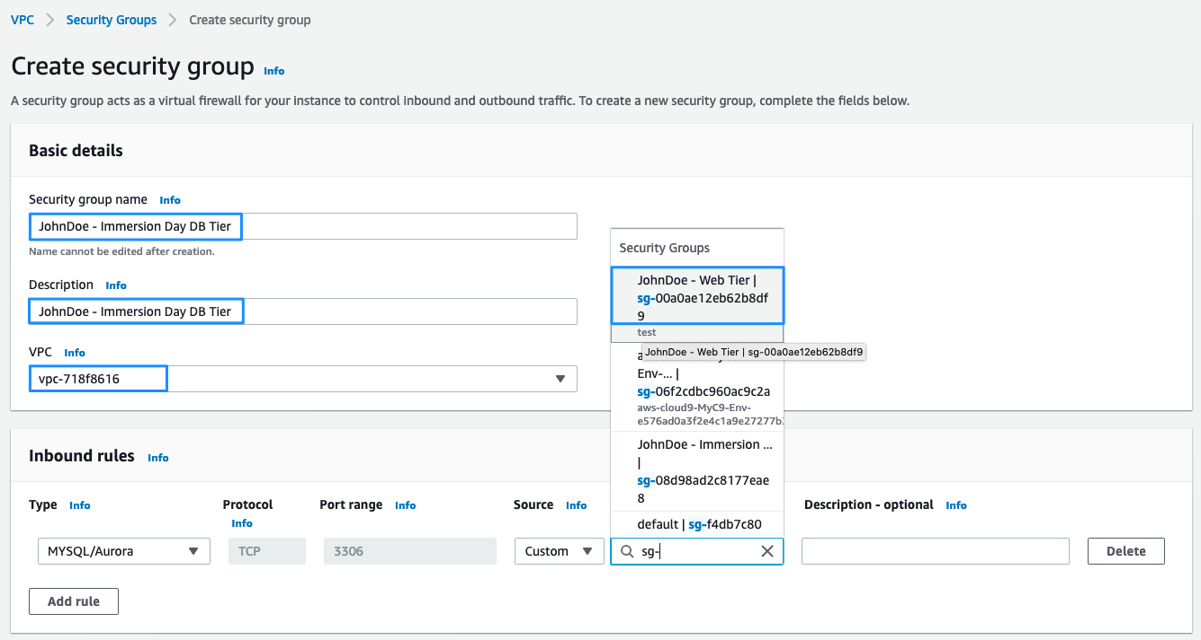](https://general-immersionday.workshop.aws/images/db/rds30.png)
6. Then, scroll down and click on Click **Create security group** button. This will create the Security group for your RDS instance.

Launch an RDS Instance

Now that our VPC security group is ready, let’s configure and launch a MySQL RDS Instance.

1. Sign into the AWS Management Console and open the [Amazon RDS console](https://console.aws.amazon.com/rds)
2. Click on **Create database**[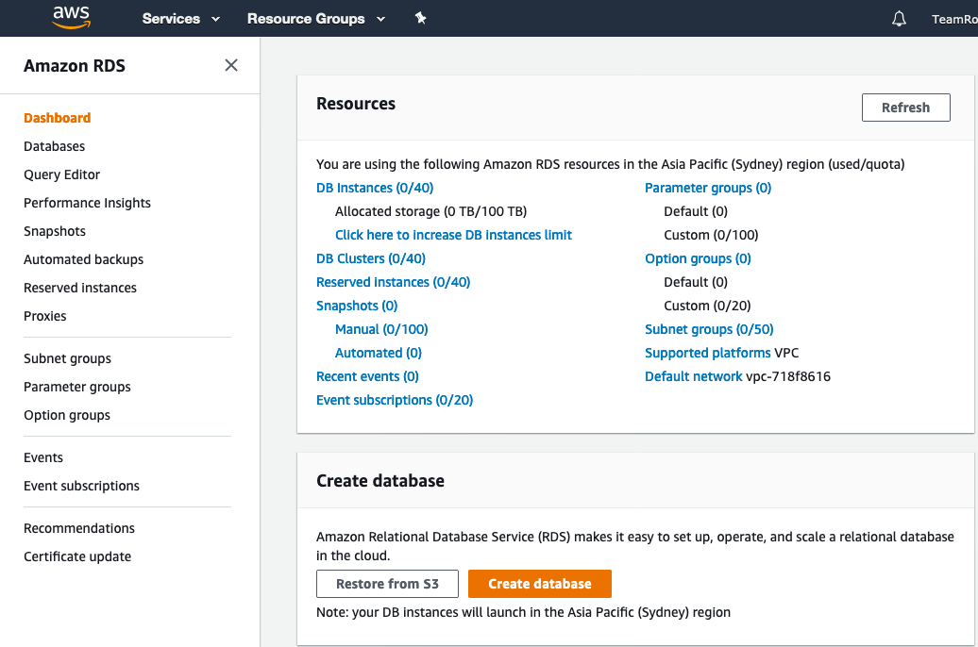](https://general-immersionday.workshop.aws/images/db/rds33.png)
3. For **Chose a database creation method**, select Standard option. With Standard Create, you setup the configurations for your database.

With Easy Create, you are given the recommended best-practices configurations to get you started with deploying databases.

1. We will be creating a MySQL Database, so select **MySQL** in **Engine Options**.[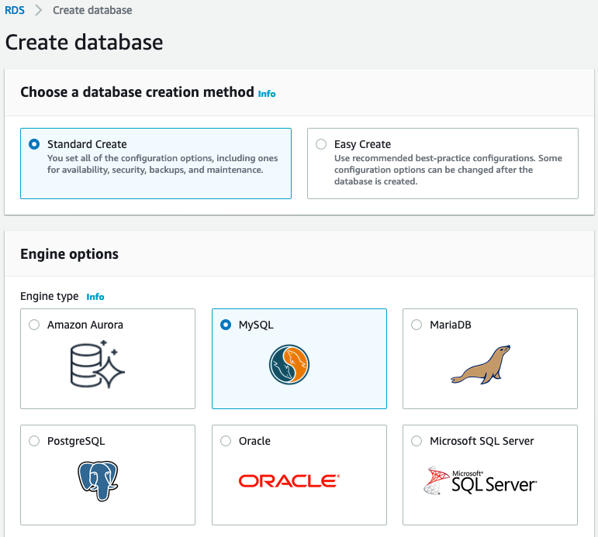](https://general-immersionday.workshop.aws/images/db/rds34.png)
2. When you select MySQL as your database engine, the version will be automatically selected for you, which might or might not be the latest version of MySQL. For this lab, select MySQL version 5.7.X.
3. For Template, there are three options available: Production, Dev/Test and Free Tier. For the lab purpose, we will select Free Tier.[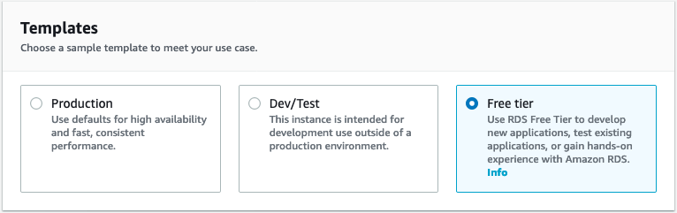](https://general-immersionday.workshop.aws/images/db/rds_template.png)
4. In **Settings** section, fill in the following for each field

| **Parameter** | **Value** |
| --- | --- |
| **DB Instance Identifier** | awsdb |
| **Master Username** | awsuser |
| **Master Password** | awspassword |

[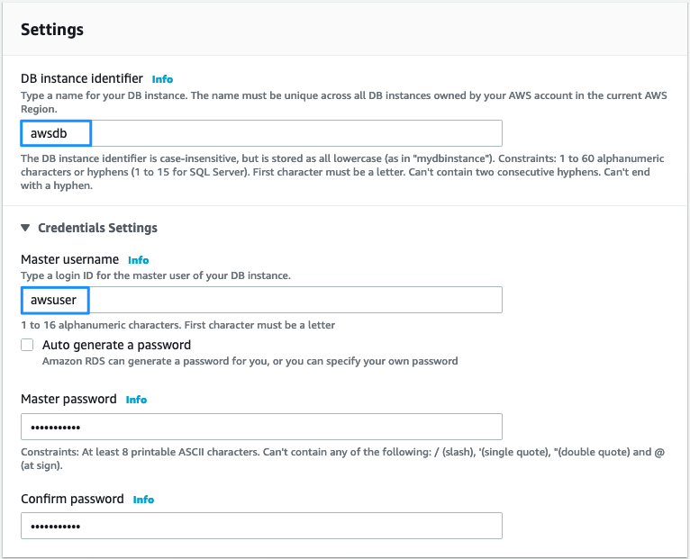](https://general-immersionday.workshop.aws/images/db/db_settings.png)

1. In **DB Instance size** section, for **DB instance class**, select **burstable classes-db.t2.micro**. This option will be automatically selected for you.[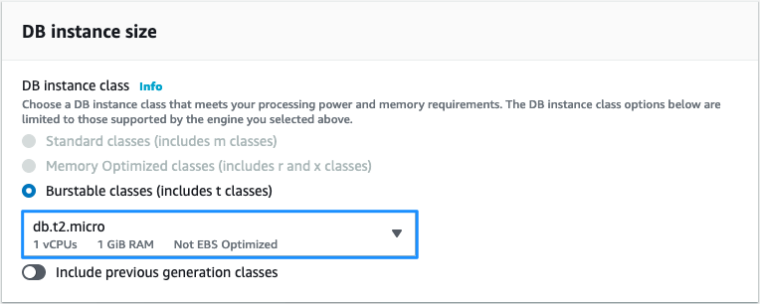](https://general-immersionday.workshop.aws/images/db/rds_instance_size.png)
2. In the **Storage** section, select the **Storage Type** as **General Purpose SSD** and **Allocated Storage** as **5 GiB**. You can select or deselect the option for Auto Scaling for the lab purposes.[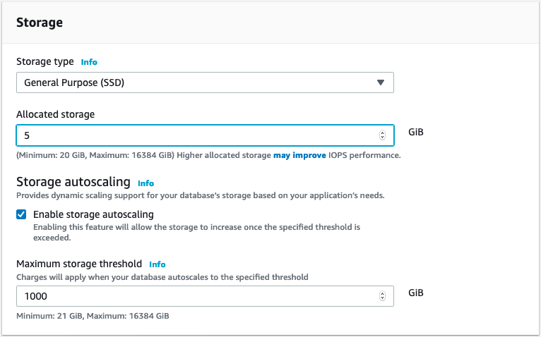](https://general-immersionday.workshop.aws/images/db/rds_storage.png)
3. Since we selected the Template option as Free Tier-used only for doing hands-on or testing the applications, Multi-AZ deployment is not required and hence, the Availability and Durability section will be disabled for you.

For a database used in Production and Dev/Test, we recommend using a **Multi-AZ Deployment**.

[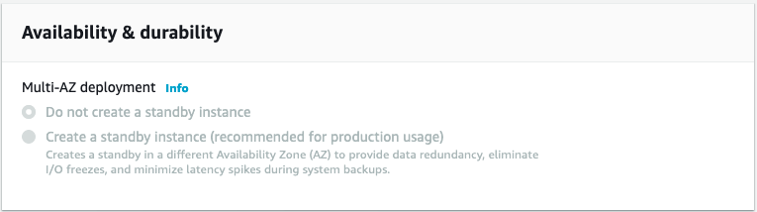](https://general-immersionday.workshop.aws/images/db/rds_multiAZ.png)

1. In the **Connectivity** section:

| **Parameter** | **Value** |
| --- | --- |
| **VPC** | Default VPC |
| ***Additional connectivity configuration*** |  |
| **Subnet Group** | default |
| **Publicly accessible** | No |
| **VPC Security Group(s)** | Select Choose existing VPC security groups, then pick [Initials] - Immersion Day DB Tier |
| **Availability Zone** | No preference |
| **Database port** | 3306 |

[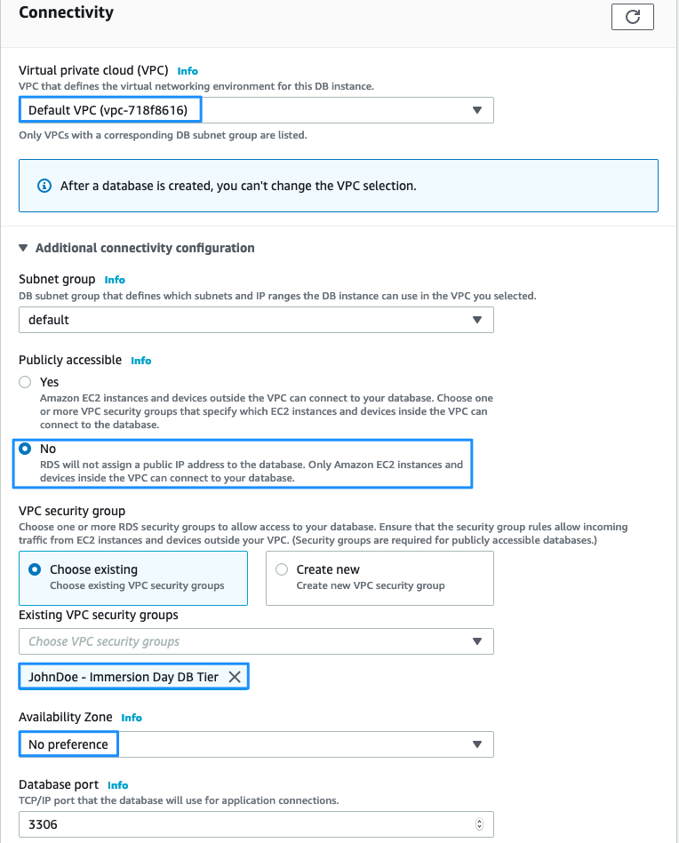](https://general-immersionday.workshop.aws/images/db/rds38.png)

1. For **Database authentication**, there are two options to select from. **Password Authentication** will authenticate the user only with the database password. With **Password and IAM Database authentication**, the user will be authenticated with the database password and also with the user credentials through IAM roles and policies. For this lab, we will select: **Password Authentication**.[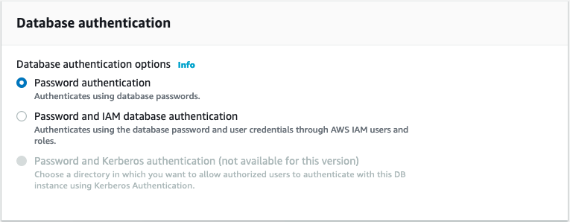](https://general-immersionday.workshop.aws/images/db/rds_authN.png)
2. Expand on **Additional Configuration**.

* For the Database options, provide the following:

a) Initial Database name: **immersionday**

b) DB Parameter group and Option group: default.mysql5.7[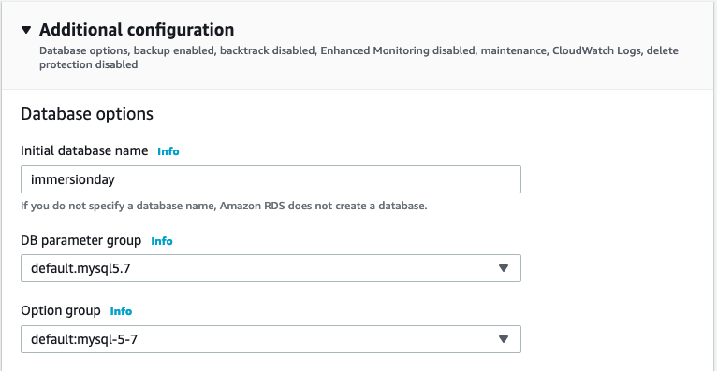](https://general-immersionday.workshop.aws/images/db/rds_db_options.png)

* For Backup:

a) Check on **enable automatic backups**.

b) Provide **Backup retention period** as **7 days**.

c) **Backup Window: No preference**

d) Leave rest as defaults[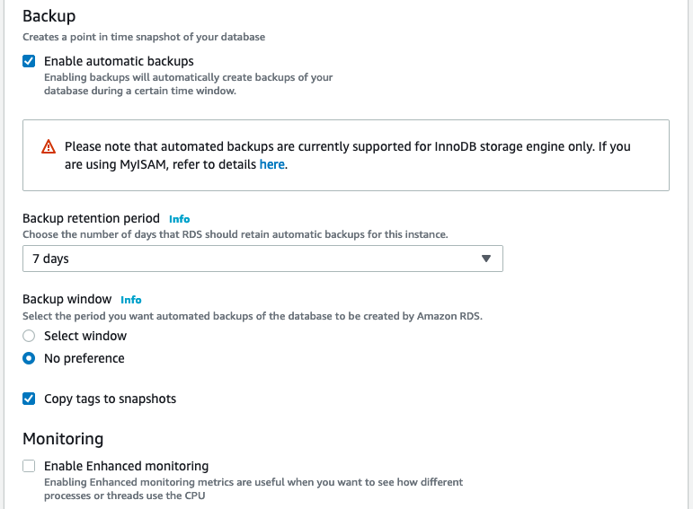](https://general-immersionday.workshop.aws/images/db/rds_backup_settings.png)

* For **Log exports**, you can select from various options that which type of logs you would like to analyze in CloudWatch. Leave as default.
* For **Maintenance**, leave as defaults. The default options will be auto check on enable auto minor version upgrade and maintenance window will be selected as No preference.
* For **Deletion protection**, if checked, it protects your database from accidental deletion and your database cannot be deleted as long as this option is checked. Leave as default.[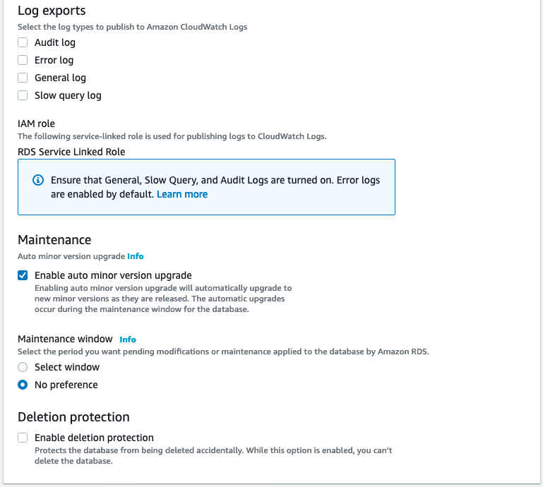](https://general-immersionday.workshop.aws/images/db/rds_misc.png)

1. At last, it will give you estimated costs for your selected configurations:[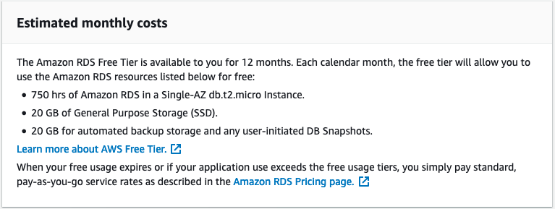](https://general-immersionday.workshop.aws/images/db/rds_cost_estimate.png)
2. Review your settings and click **Create database**.
3. In the RDS Dashboard, monitor your new DB instance until the status changes from “creating” to “backing up” to “available”.

This may take up to 5 minutes as the database is being created and backed up.

Configure EC2 Instance to Leverage RDS

We provided an example database table and sample code for creating a simple address book. Before configuring your instance, you will need to get the URL for your database endpoint.

1. In the RDS console, click on Instances and then select your database instance, awsdb.[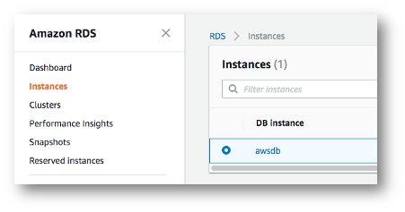](https://general-immersionday.workshop.aws/images/db/rds40.png)
2. Under connectivity & security section and check the value under Endpoint. Copy this in your clipboard, as you will need it in a minute (do NOT include the :3306 when you copy the URL).[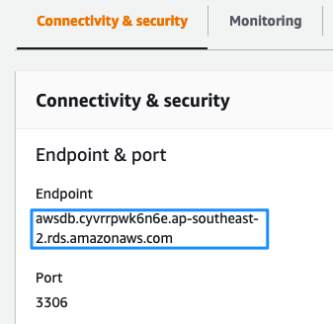](https://general-immersionday.workshop.aws/images/db/rds41.png)
3. Navigate to the browser tab connected to web application you launched previously in the Module1: Compute Basics, EC2 Linux Lab (or open a new tab and reconnect to your web server’s URL) and click on **RDS**.[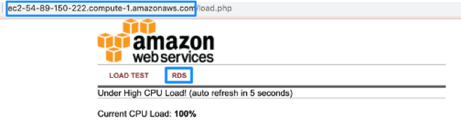](https://general-immersionday.workshop.aws/images/db/rds_connect1.png)You should see a prompt to enter:

* DB endpoint (do NOT include :3306 at the end of the DB endpoint)
* username (awsuser)
* password (awspassword)
* database (immersionday)

Click **Submit**.[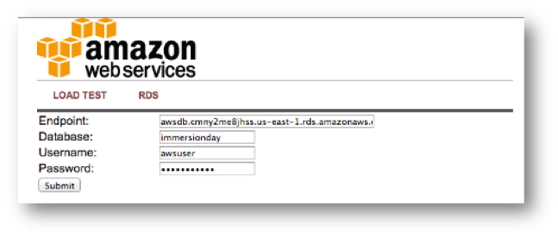](https://general-immersionday.workshop.aws/images/db/rds42.png)

1. When complete, you will be redirected to a simple page displaying all of the information from the database you just created.[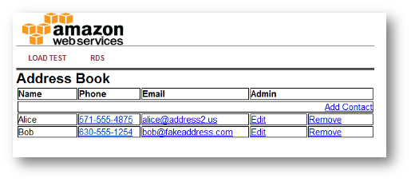](https://general-immersionday.workshop.aws/images/db/rds43.png)

This is a very basic example of a simple address book interacting with a MySQL database managed by AWS. RDS can support much more complicated relational database scenarios, but we hope this simple example will suffice to demonstrate the point.

Feel free to play around with the address book and add/edit/remove content from your RDS database by using the **Add Contact, Edit**, and **Remove** links in the Address Book.

Great Job: You have successfully deployed and utilized an AWS managed MySQL database!!!

Would you like to continue your learning? Below are some optional labs you can do to learn about additional RDS features.

Additional RDS Features

* Create an RDS Snapshot
* Modify RDS Instance Size

Create an RDS Snapshot

Now is a good time to take a snapshot of your RDS database. Taking a snapshot enables you to back up your DB Instance in a known state as frequently as you wish, and then restore to that specific state at any time. In the RDS section of the of the AWS management console, select your RDS instance, click on Instance actions and select **Take snapshot**[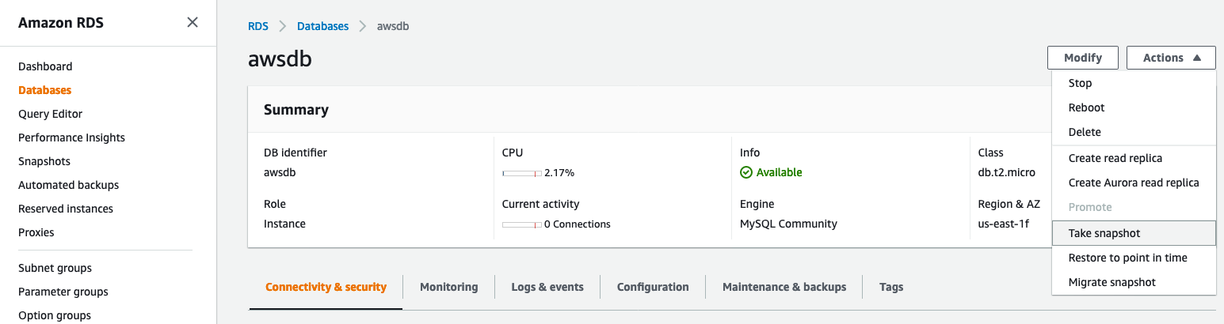](https://general-immersionday.workshop.aws/images/db/rds44.png)

Give the snapshot a name and click on **Take Snapshot**.[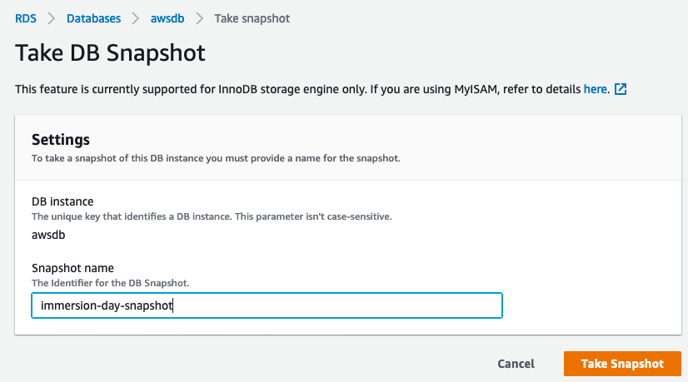](https://general-immersionday.workshop.aws/images/db/rds45.png)

Using single-instance RDS, you will incur downtime for as long as it takes to make a backup. Of course our example database is so small that total time to back up is very small too!

DB snapshots show up under the **Snapshots** link on the left side of the screen. Notice that you can easily launch new RDS instances from any previous snapshot by selecting **Restore Snapshot** from the Actions Menu.[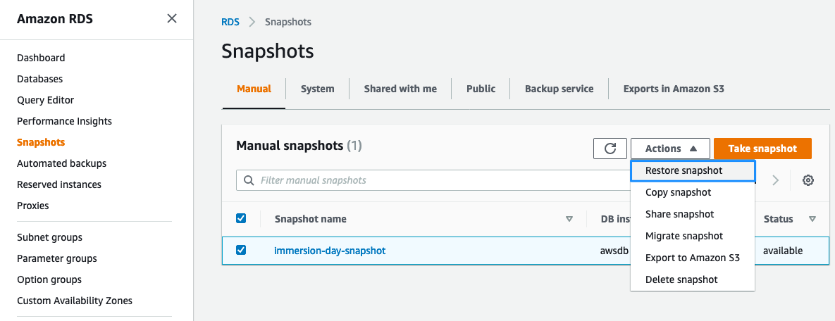](https://general-immersionday.workshop.aws/images/db/rds_snapshots1.png)

Modify RDS Instance Size

Scaling up and down with RDS is simple via the AWS Console. You can grow the database or change the underlying server size, etc. – all from the AWS Console. Select your RDS DB instance, click Instance actions and then Modify.[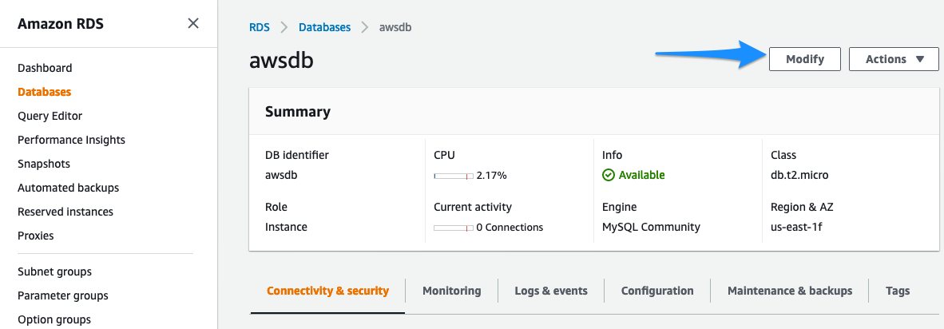](https://general-immersionday.workshop.aws/images/db/rds47.png)

Try changing to a Large instance, and if you want, also grow the database at the same time. Click **Next**.[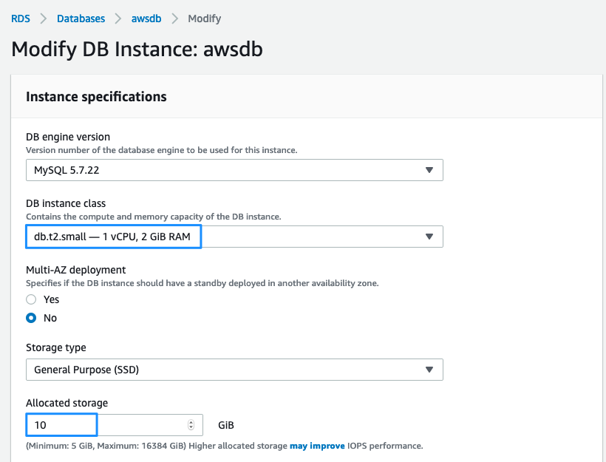](https://general-immersionday.workshop.aws/images/db/rds48.png)

In the next screen, don’t forget to click “**Apply Immediately**” – otherwise changes will be queued for the next maintenance window. Then, click on **Modify DB Instance**.[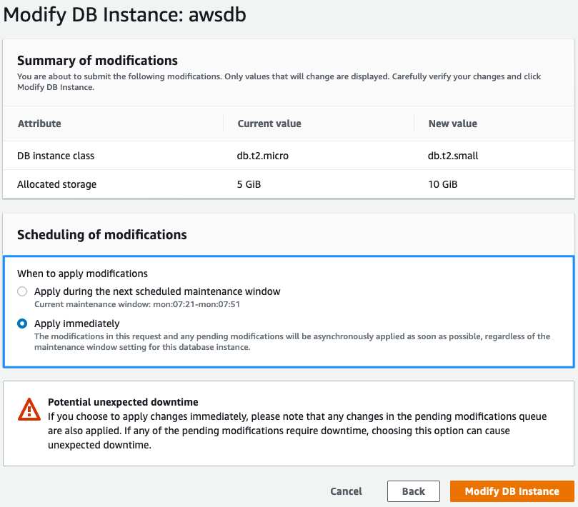](https://general-immersionday.workshop.aws/images/db/rds49.png)

You can change instance sizes up or down at any time. However you cannot shrink a database once you grow it. Just like backups, there will be an outage while you perform these operations. In general, major RDS reconfigurations such as scaling database sizes or machine size take between 4 and 12 minutes.

Congratulations!!! you have completed the RDS MySQL Lab.