# WORKING AMAZON SIMPLE STORAGE SERVICE (S3)

### Amazon S3 Overview

Amazon Simple Storage Service (S3) provides a simple web services interface that can be used to store and retrieve any amount of data, at any time, from anywhere on the web. This lab is designed to demonstrate how to interact with S3 to store, view, move and delete objects.

This lab will walk you through the following:

* Creating a bucket in S3
* Adding an object to the S3 bucket
* View the object in S3
* Move the object in S3
* Enable bucket versioning
* Delete the object and the bucket in S3

#### **Create a Bucket in S3**

Every object in Amazon S3 is stored in a bucket. Before you can store data in Amazon S3 you must create a bucket.

You are not charged for creating a bucket; you are only charged for storing objects in the bucket and for transferring objects in and out of the bucket.

1. Sign into the AWS Management Console and open the [Amazon S3 console](https://console.aws.amazon.com/s3)
2. Click **Create Bucket**. The **Create a Bucket** dialog box appears.[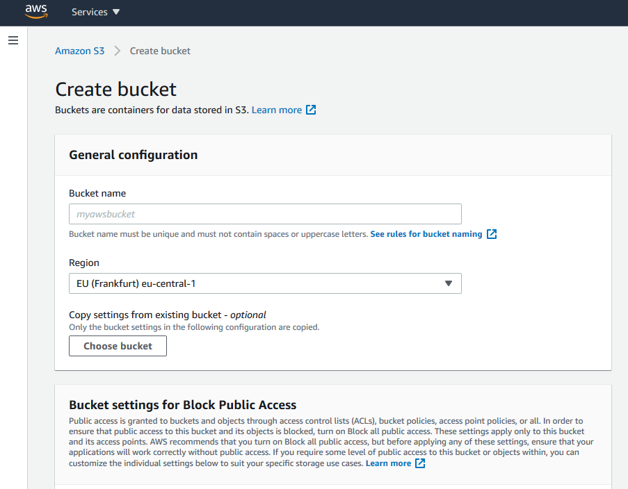](https://general-immersionday.workshop.aws/images/storage/storage11.png)
3. Enter a bucket name in the Bucket Name field. The bucket name you choose must be unique across all existing bucket names in Amazon S3. One way to do that is to prefix your bucket names with your organization’s name. Bucket names must comply with the following requirements.

**Bucket names:**

* + Must be unique across all of Amazon S3
  + Must be between 3 and 63 characters long
  + Must not contain uppercase characters
  + Can contain lowercase letters, numbers, periods (.) and dashes (-)
  + Must start with a lowercase letter or number
  + Must not contain underscores (_), end with a dash, have consecutive periods, or use dashes adjacent to periods.
  + Cannot be formatted as an IP address (e.g., 10.1.1.1).

There might be additional restrictions on bucket names based on the region your bucket is in or how you intend to access the object. Once you create a bucket, you cannot change its name. In addition, the bucket name is visible in the URL that points to the objects stored in the bucket. Make sure the bucket name you choose is appropriate.

1. In the Region drop-down list box, select a region (for example us-east-1). Choose the us-east-1 region. Objects stored in a Region never leave that Region unless you explicitly transfer them to another Region. Click **Next**.

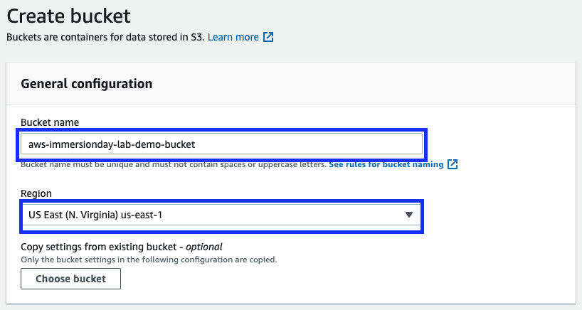

1. By default, all buckets are set to “block public access”. At this time, leave the default setting of block all public access. [Learn More](https://docs.aws.amazon.com/AmazonS3/latest/user-guide/block-public-access.html)
2. Under Tags, click Add tag. Then in the Key box, type Purpose, and in the Value box, enter Immersion Day.[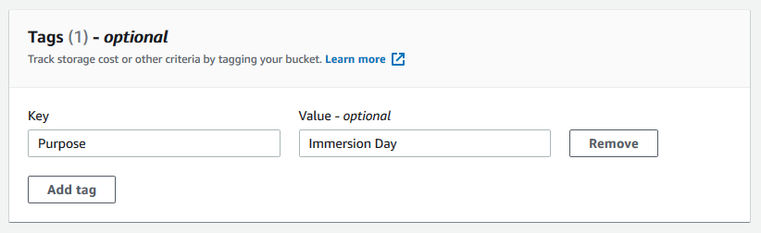](https://general-immersionday.workshop.aws/images/storage/storage12.png)
3. Have a good look at the other options, but leave them as default for this lab.
4. Finally, review your settings and click Create bucket. When Amazon S3 successfully creates your bucket, the console displays your empty bucket in the Buckets panel. You can also see the region your bucket is in along with the access type.[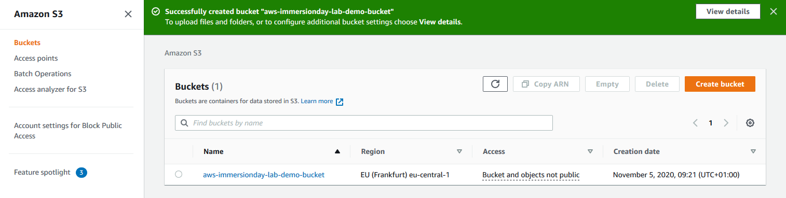](https://general-immersionday.workshop.aws/images/storage/storage14.png)

#### **Well done - you’ve created your first bucket in Amazon S3!**

### Add an Object to a Bucket

Now that you’ve created a bucket, you are ready to add an object to it. An object can be any kind of file: a text file, a photo, a video and so forth. When you upload a file to Amazon S3, it is stored as an S3 object. Objects consist of the file data and metadata that describes the object. You can have an unlimited number of objects in a bucket. [Learn More](https://docs.aws.amazon.com/AmazonS3/latest/user-guide/upload-objects.html)

1. In the Amazon S3 console, click on the name of the bucket to which you want to upload an object, and then click **Upload** in the Overview tab. You may also directly drag and drop a file you want to upload.[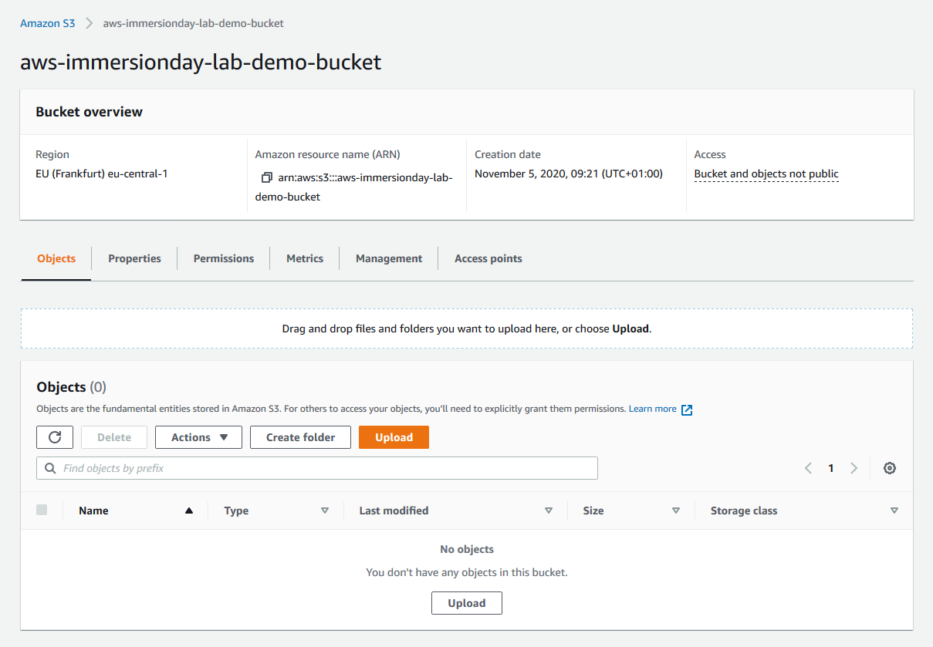](https://general-immersionday.workshop.aws/images/storage/storage15.png)
2. The Upload dialogue opens (its appearance may differ slightly between different browsers), click **Add Files** to select a file to upload. A file selection dialog box opens. Select a small file to upload and click Open. The Upload dialogue shows the files and folders you’ve selected to upload.[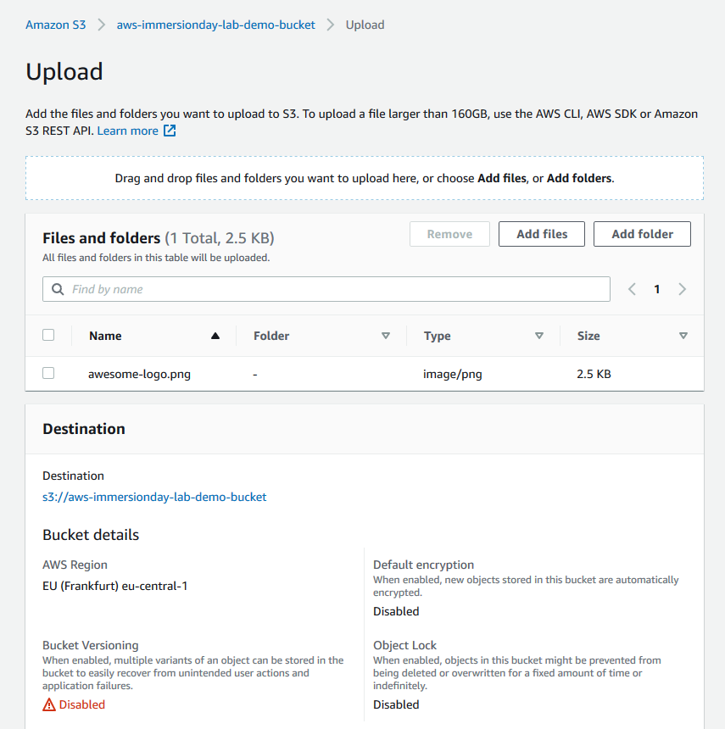](https://general-immersionday.workshop.aws/images/storage/s3_upload.png)

For this lab, you can choose any file or picture you have available on your laptop. Before clicking the final upload button, review the options that are available. For today’s lab, we will use the default permissions. We will be using the standard storage option. To learn more about Amazon S3 storage classes [Click Here](https://aws.amazon.com/s3/storage-classes/)

1. Click **Upload**. You can watch the progress of the upload at the top of the screen. This bar appears as soon as the upload begins. Once the object has been uploaded, you will see a confirmation message.[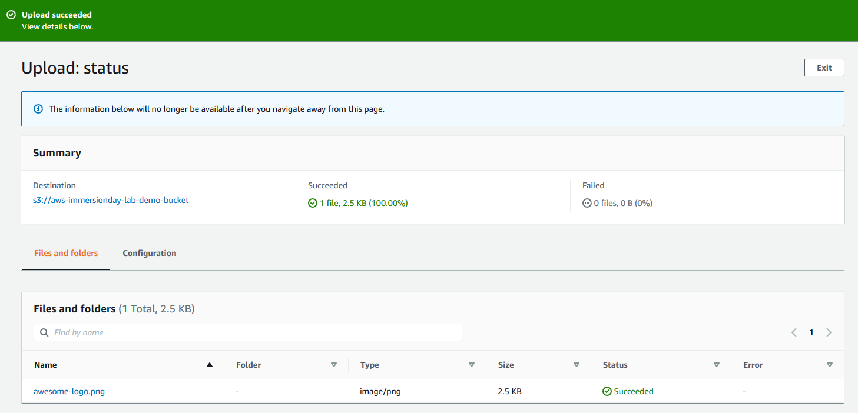](https://general-immersionday.workshop.aws/images/storage/upload_file_success.png)

#### **Good work - you have added a file to your bucket!**

### View an Object

Now that you’ve added an object to a bucket, you can try and open and view it in a browser.

By default, your Amazon S3 buckets and objects are private. To view an object using a URL, for example, <https://s3.amazonaws.com/Bucket/Object> the object must be publicly readable. Otherwise, you will need to create signed URL that includes a signature with authentication information.

Bucket access permissions specify which users are allowed access to the objects in a bucket and which types of access they have. Object access permissions specify which users are allowed access to the object and which types of access they have. For example, one user might have only read permission, while another might have read and write permissions.

Bucket and object permissions are independent of each other.

1. Click on the name of the file you uploaded. A detail window will appear. Click on the object URL. You will receive an error message that access is denied. That is because our bucket and our object are blocked from public access.

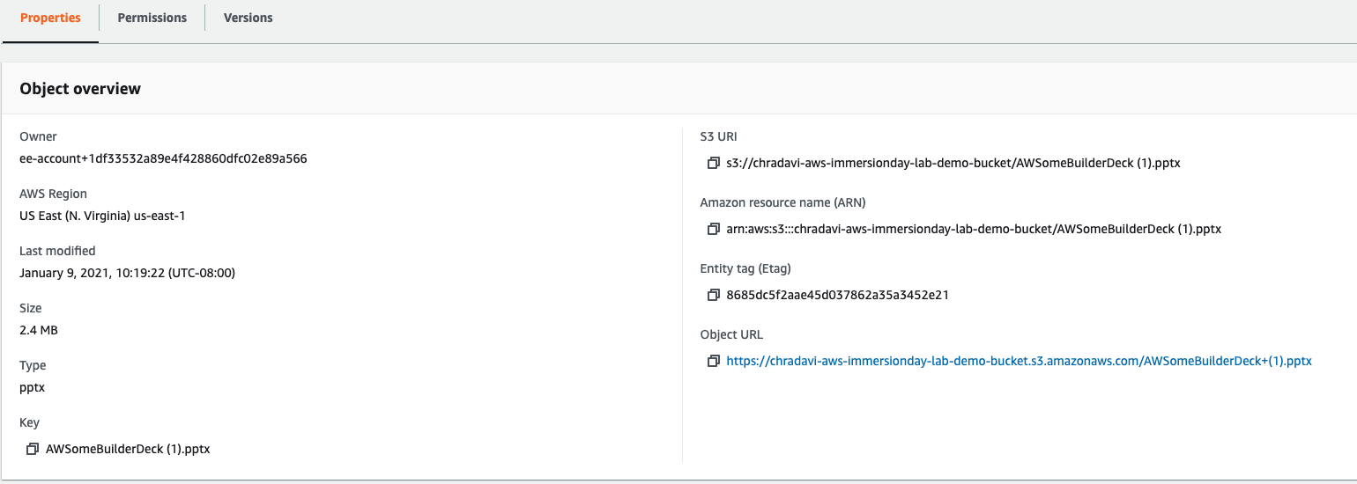

#### **What happens when you click on the Object Url?**

By default, your Amazon S3 buckets and objects are private. To view an object using a URL, for example, <https://s3.amazonaws.com/Bucket/Object> the object must be publicly readable. Otherwise, you will need to create signed URL that includes a signature with authentication information. You can optionally save the object locally.

It is a best practice to block public access to your buckets as they could hold sensitive data. Amazon S3 offers various layers of protection to help you implement this best practice. One such control is called **Block Public Access**. This control is available at an account level and even at bucket level. You can find more details [here](https://aws.amazon.com/s3/features/block-public-access/). For the purpose of this lab, we’ll allow public access and the next steps walk you through on allowing this access.

1. In the left hand pane, select “Account Settings for Block Public Access”.

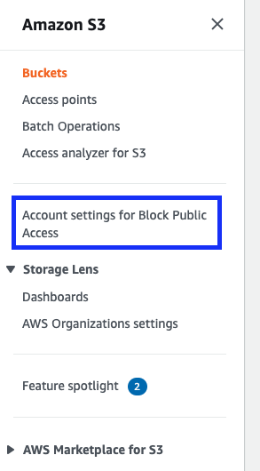

1. Make sure the settings are set to off. If not click **Edit** and uncheck “Block all public access”. Click Save Changes.[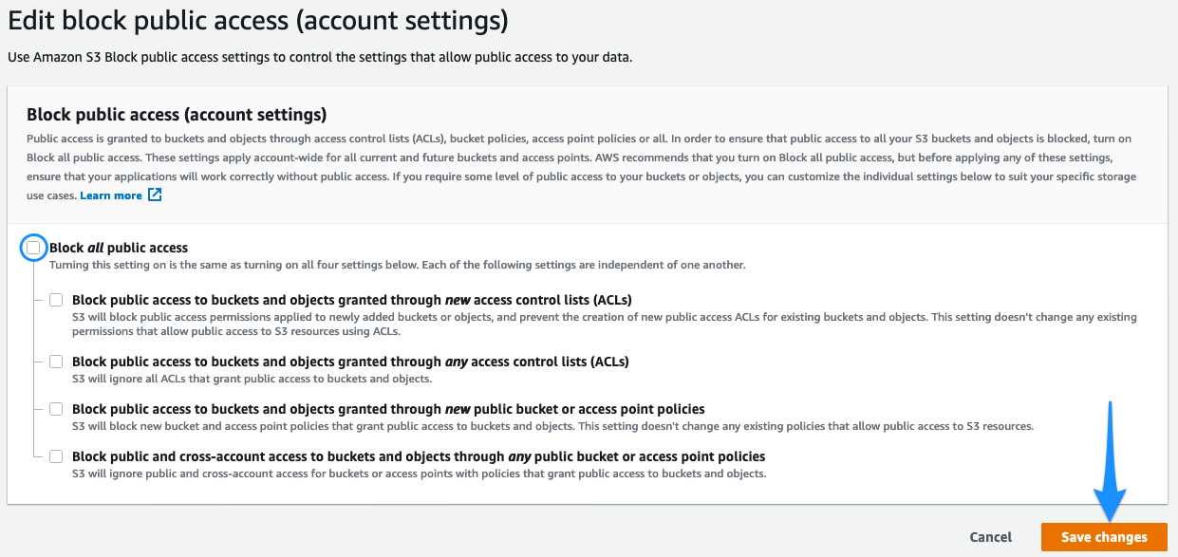](https://general-immersionday.workshop.aws/images/storage/s3_publicAccess_accountSettings1.png)
2. Select “Buckets” from the left pane and select your S3 bucket from the list.
3. Click on the bucket name and then select **Permissions**.[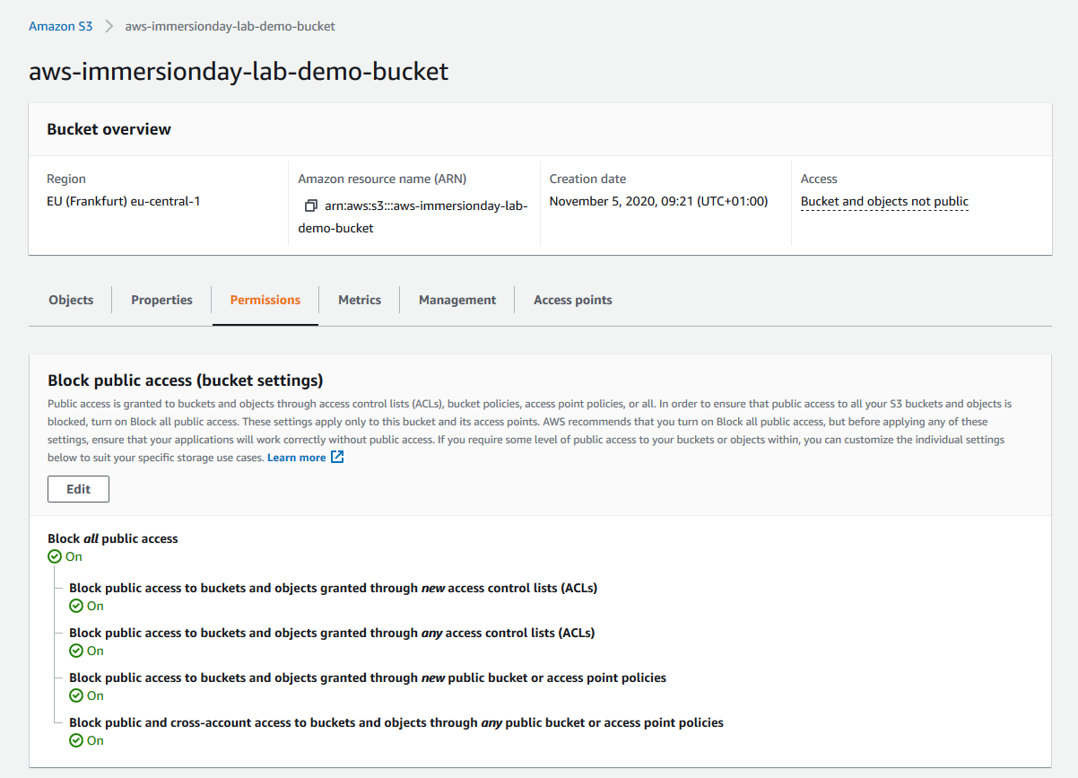](https://general-immersionday.workshop.aws/images/storage/s3_permissions.png)
4. Click **Edit**. Uncheck the box for Block all public access. Click **Save**.[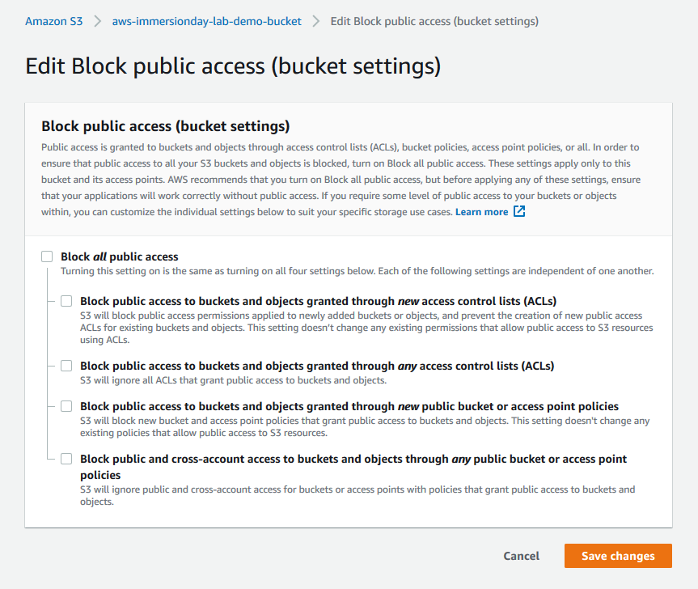](https://general-immersionday.workshop.aws/images/storage/s3_public_access.png)
5. Type “confirm” in the pop-up window to confirm this change. You should see a message appears that states “Successfully edited bucket settings for Block Public Access.”.
6. Go back to the object in your bucket. Click on the object name and go to the **Permissions** tab.
7. Scroll down and click on **Edit.**  Then select **Everyone** and **check** read object. Finally Click **Save**.

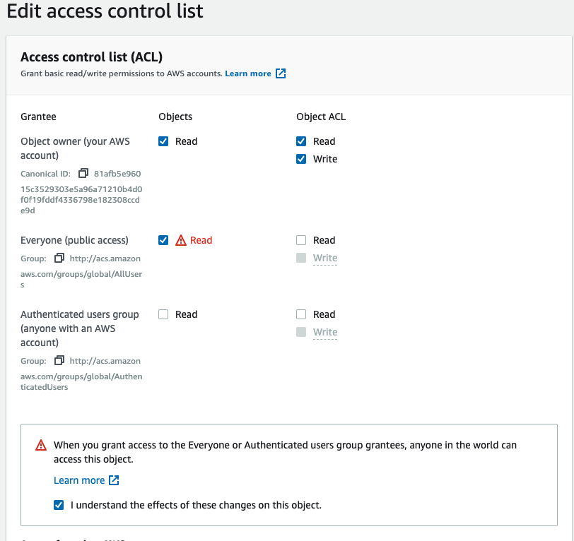

Instead of doing that you can also use the **Make public** button on the Overview tab as a shortcut.

1. Click on the **Overview** tab. Scroll down and click on the Object URL. You should now be able to see your object.

#### **Good job – you have retrieved your object from S3 via the web!**

### Move an Object

Now that you have added an object to a bucket and viewed it, you might like to move the object to a different bucket or folder. In this example, we will use the move operation to move one or more objects from one bucket to another bucket.

1. In the Amazon S3 console, create another bucket. Follow the same instructions you did earlier.
2. Select the first bucket you created. Under the **Permissions** tab, enable **Block all public access**. Follow the same instructions as earlier, instead this time, you will check the box to block all public access. Now the two buckets will have the same configuration.
3. Select the object(s) you want to move by clicking the selection box to their left.
4. Once you have selected your file, click on the **Actions** button, and then click **Move**[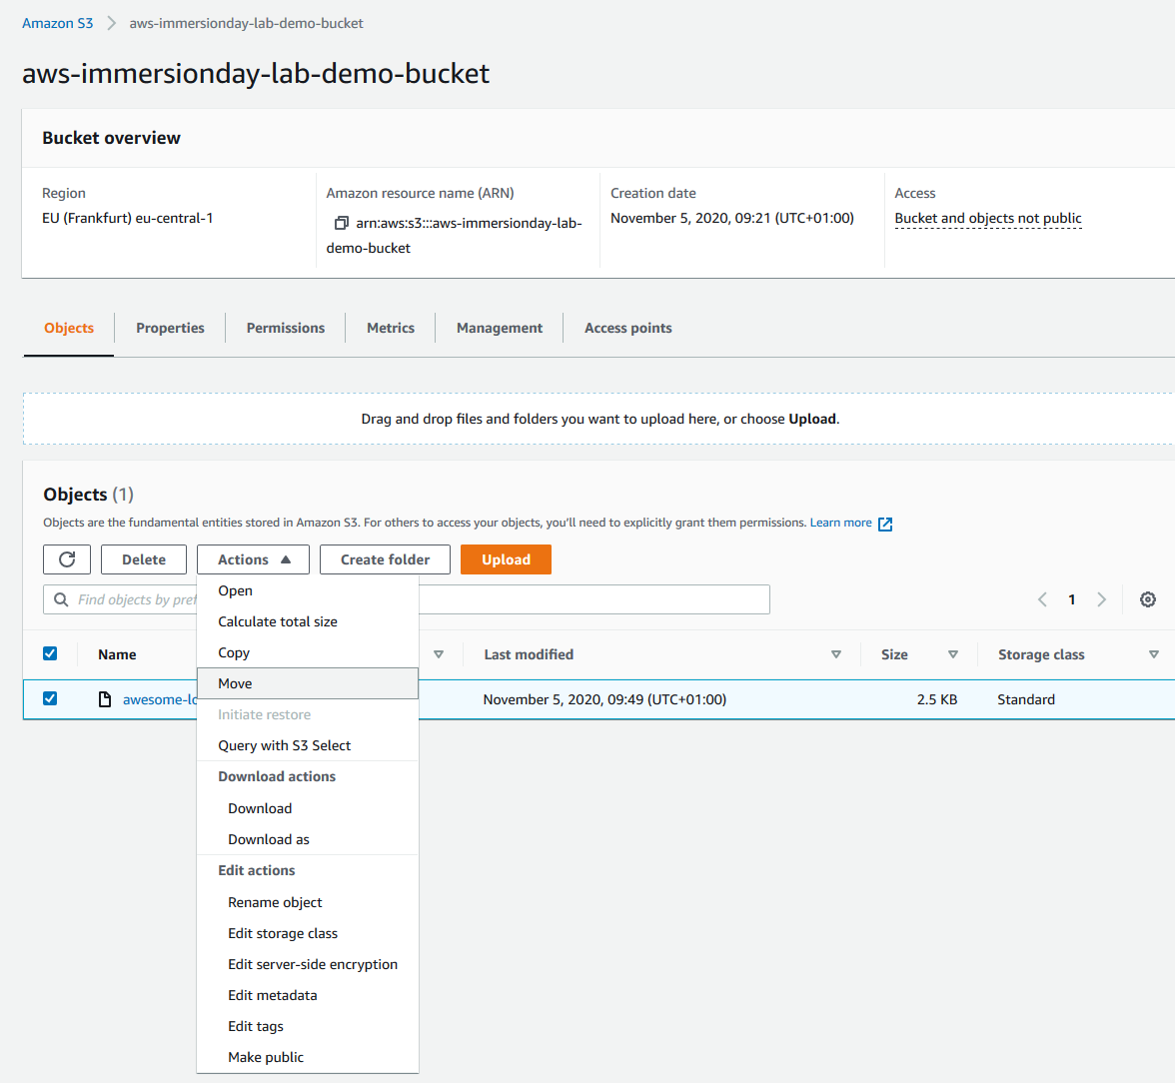](https://general-immersionday.workshop.aws/images/storage/s3_move_objects.png)
5. Select the bucket you created above, to which you want to move the object. Then Select Choose. Verify the information is correct. Then select Move.[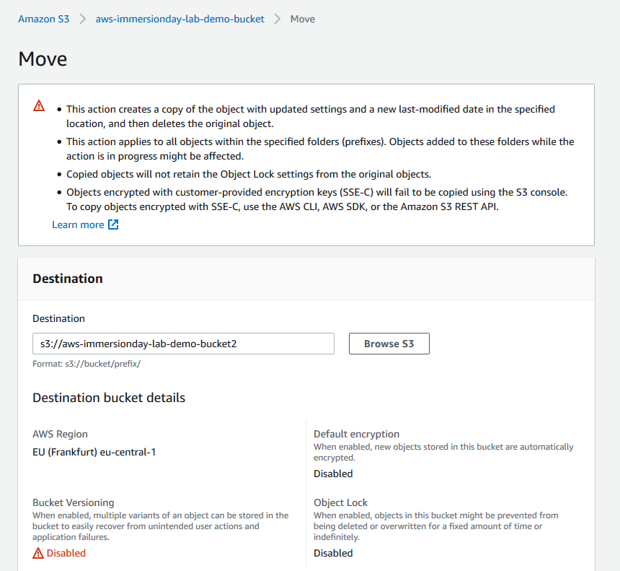](https://general-immersionday.workshop.aws/images/storage/s3_move_objects1.png)

When you move an object across buckets the previously set object permissions will persist by default. The bucket permissions will however change the object permissions accordingly.

You can verify that you original bucket is now empty. The file will be in the new bucket.

#### **Congratulations - you have now moved an object between buckets.**

### Enable Bucket Versioning

If you want to add new version of the object to the same bucket but want to retain the old version, you can turn on bucket versioning.

1. In the S3 Console, click on the link representing the bucket you created, and then select the **Properties** tab.[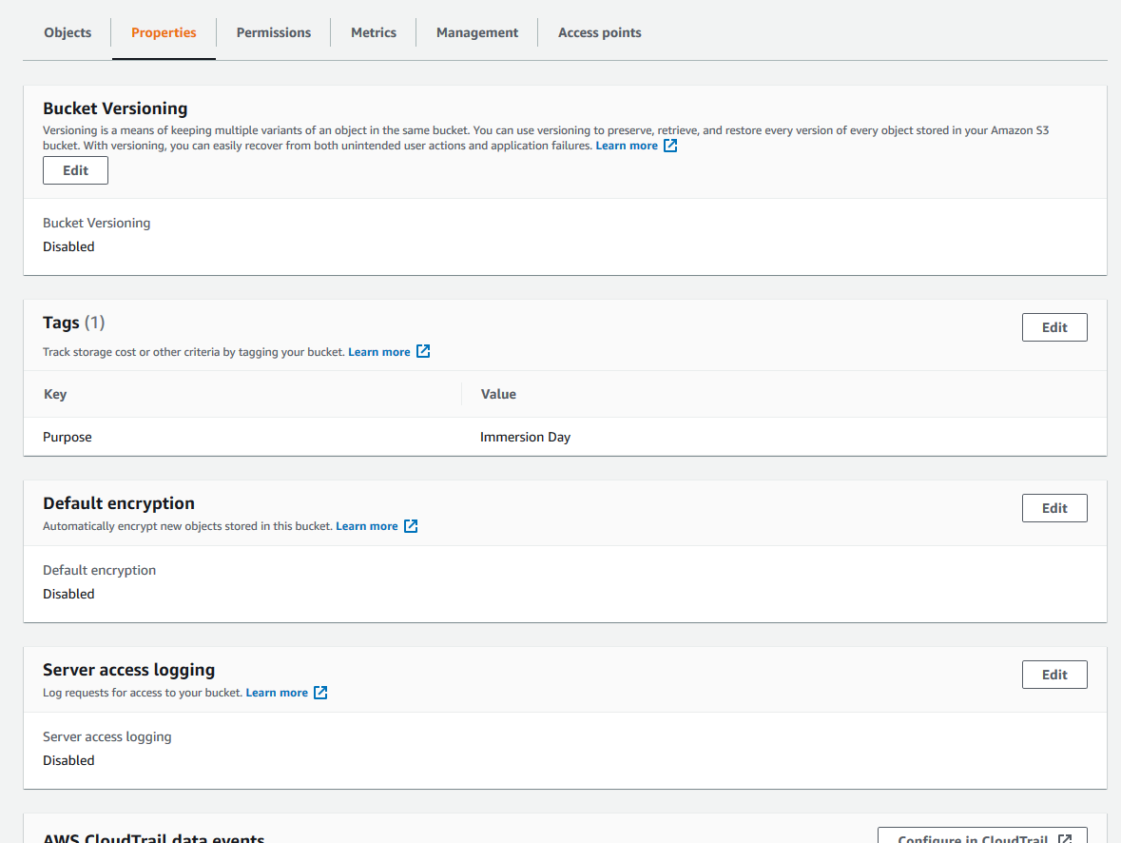](https://general-immersionday.workshop.aws/images/storage/storage18.png)
2. Click on **Edit** next to **Bucket versioning**, select **Enable** and then click **Save changes**.
3. Choose an object that you are able to edit on your computer, and upload it using the steps from the Add an Object to a Bucket section above.
4. Now open the original file on your computer and edit it, saving the updated version under the **same file name**.
5. Upload this updated file to the S3 bucket in the same way as before.
6. Now click on the object’s link in the S3 bucket and click on **Versions** tab.

This shows the different versions of the object in the bucket. You can click on the **download** icon next to each version of the object to download that version.

#### **Well done - you have now uploaded 2 different version of the same document.**

### Delete an Object and Bucket

You’ve added an object to a bucket, viewed it, and moved it. Now, you can delete it and the bucket it’s in. If you no longer need to store the objects you uploaded and moved while going through this lab, you should delete them so you do not incur further charges on those objects.

1. In the Amazon S3 console, click on the link representing the bucket containing the object(s) you want to delete. Then select the object(s).
2. Click the **Delete** button. To confirm the action in the **Delete objects** dialogue, type “delete” and click **Delete objects**.[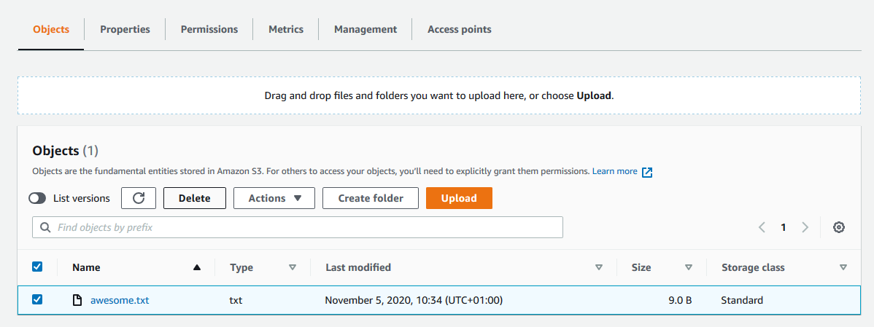](https://general-immersionday.workshop.aws/images/storage/s3_delete_object.png)
3. If you deleted one or more objects from a bucket in which versioning is enabled, select the **List versions** option to see that the older versions of the deleted objects still exist.[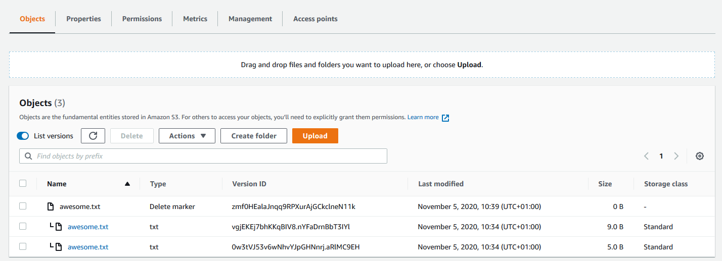](https://general-immersionday.workshop.aws/images/storage/s3_delete_objects1.png)
4. You can then select the checkboxes for the older versions of the objects, click **Delete** to delete the older versions.
5. Navigate back to the S3 console and select the bucket you want to delete (not the link to its right), and at the top of the page, click **Delete**. Confirm the deletion by typing its name verbatim at the Delete bucket prompt.[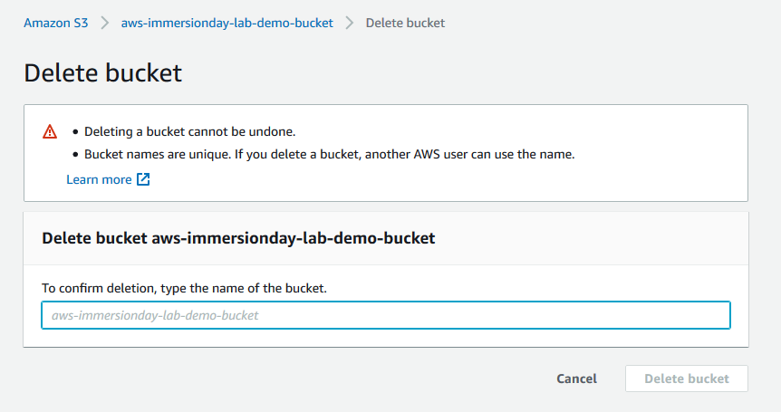](https://general-immersionday.workshop.aws/images/storage/s3_bucket_delete.png)

To delete a bucket, you must first delete all of the objects in it. If you haven’t deleted all of the objects in your bucket, do that now.

#### **Well done, your bucket is now deleted!**

### Conclusion

In this lab you have learned the basic operations to manage the lifecycle of an S3 object. First, you created a bucket, which is the logical container of objects. Then by uploading, viewing, moving an object, and enabling versioning, you learned the basic operations of the object itself. Finally, you learned how to delete both an object and a bucket.

You could continue exploring more [features of S3](https://aws.amazon.com/s3/features/)