Android EZ Tracker

Mobile App

Project Proposal

Group Members

Jonas Gamao, Delroy Christie, Ryan Maynard

# Executive Summary

This proposal request the approval to develop and implement an Android EZ Tracker Monitoring System Mobile App for a sector of the population that needs the use a tracking/Monitoring system but are not capable of navigating the complex interfaces of current systems, which are not suitable for older or non-tech savvy people. This app seeks to address that problem by introducing a simple but effective user interface in an app that will perform a pedometer/tracker for the aging population, bikers, and runners. The mobile app connected hardware will include a custom PCB with a 12 point capacitive touch sensor for controlling simple functions, an OLED monochrome display for displaying usage statistics, and an accelerometer and magenetometer for calculating those statistics. It involves aiding the aging population while also targeting cyclists by implementing an easy-to-use, simple interface. This app is different in that it can be worn as a watch or can be mounted a the handle bar of a bike to keep track of distance travelled, calories burned, and energy consumed. Older users are turned off by complex devices and user interfaces, and cyclists do not want to keep their expensive phones mounted to their handle bar to monitor distance and calories burned. Being able to monitor these statistics by implementing a simple and user-friendly interface can lead to a more active lifestyle.

## Courses related to the project

* TECH 153 – Technical C
* CENG 200 – Intro to UNIX
* CENG 212 – Programming techniques in Java
* CENG 215 – Digital and Interfacing Systems
* CENG 251 – UNIX Internals
* CENG 252 – Embedded Systems
* CENG 254 – Database Java
* CENG 256 – Internet Programming
* CENG 317 – Hardware Production
* CENG 319 – Software Project

# Software Design

The application will be used as a relay from the device to the web server to display more advanced views if the user desires, as well as view basic information in the application. The data will be collected from the magenetometer, processed by the app, and sent via Bluetooth or WiFi to the database on the Broadcom Development Platform internal storage (Raspberry Pi’s SD card), as well as on a web server. The device’s functionality will include the ability to see and interact with the current as well as past data.

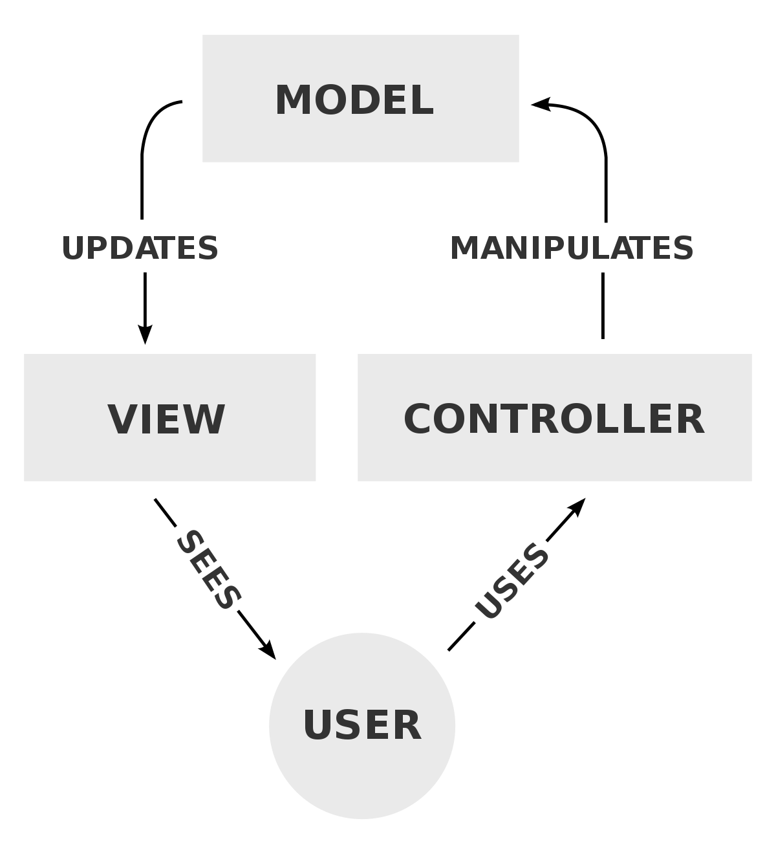

The workload of the project will be equally apportioned among each group member. The MVC architecture will be properly managed for a successful and efficient connecting of the user interface to the underlying data models. For example, Ryan Maynard will be responsible for the pure application data (Model), Delroy Christie for the user interface layout design (View), and Jonas Gamao will handle the project’s activities (Controller).

# Similar Applications

After making a decision on the nature of the project that we will pursue, we have come to appreciate that there are a number of similar apps already available in the app store. For example, *Pedometer 2018, Pedometer – Step Counter Free & Calorie Burner, and StepsApp Pedometer*—to name a few. All of which involve counting steps and calories and displaying information in a graph over the course of a week/month. Our project will be different from the others in that the layout will be offered in a simple format—mainly for older users, and an advanced layout for those that wish to see further details such as average speed, graphs, etc.

# Test cases

1. To validate that user login ID and password are correct.
2. To validate whether all the required mandatory fields are working as required.
3. To validate that the mandatory fields are displayed in the screen in a distinctive way than the non-mandatory fields.
4. To validate whether the application works as per the requirement.
5. To validate that the user Interface of the application is as per the screen size of the device, no text/control is partially invisible or inaccessible.
6. To ensure that the text is readable for all users of the application.
7. To validate whether the response time of the application is as per as the requirements.
8. To ensure that the buttons should have the required size and be suitable to big fingers.
9. To ensure that the buttons are placed in the same section of the screen to avoid confusion to the end users.
10. To ensure that the icons are natural and consistent with the application.
11. To ensure that the buttons, which have the same function should also have the same color.
12. To ensure that the keyboard input can be minimized in an appropriate manner.
13. To ensure that the application provides a method for going back or undoing an action, on touching the wrong item, within an acceptable duration.
14. To ensure that the text is kept simple and clear to be visible to the users.
15. To ensure that the short sentences and paragraphs are readable to the end users.
16. To ensure that the font size is big enough to be readable and not too big or too small.

# Future Plans

We are expected to complete all the project’s deliverables by the end of the semester. Each of our group members will work hard to complete his individual hardware project in CENG 319 this semester. As such, we will only need to refine and implement each piece of hardware for the next semester and work on the database and application. If any problems arise in the middle, we will take time out of our holidays to keep working to make up for lost time.

# Conclusion

This proposal presents a plan for providing an IoT solution to keep track of your health and activity for the aging population, cyclists, and runners. This is an opportunity to integrate the knowledge and skills developed in our program to create a capstone project as described in our background.