Assignment

SOFTWARE DOCUMENT

J.G.D.D.Chamith

2018-12-03

**Revision History**

|  |  |  |
| --- | --- | --- |
| **Date** | **Description** | **Author** |
| 2018-12-03 | Software Document | J.G.D.D.Chamith |
|  |  |  |

**Table Of Contents**

1 Introduction.............................................................................................................................4

2 Flow Chart………………………………………………………………………………..….5

3 ER Diagram…………………………………………………………………………...……..6

4 User Credentials……………………………………………………………………………..7

5 Special Features………………………………………………………………………….…..8

6 Deployment Methods………………………………………………………………………..9

7 Environment……………………………………………………………………………......10

1 Introduction

The Software Document is a document to provide documentation which will be used to aid in

software development by providing the details for how the software should be built. Within the Software

Document are narrative and graphical documentation of the software design for the project

including Flow chart, ER diagram, user credentials, special features,

deployment methods , environment.

Flow Chart

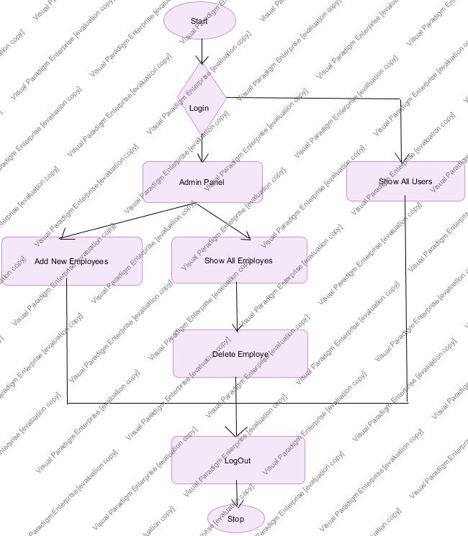

ER Diagram

ER Diagram for assignment

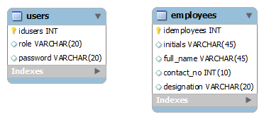

User Credentials

You can login <http://localhost:8080/AssignmentJava/index.jsp> in to web site.

You can use enter credentials (username- manager , password- mA123# ) for Admin page.

Then you can see Admin panel.

Admin panel have Add Employee and Show All Employee.

You can click Add New Employee. Then you can see Add new employee page. Because you can add new employees.

You can click Show All Employees. Then you can see all employees.

As well as you can delete employee in show all employees page.

As well as you can use enter credentials (username- developer , password- abc123) for User page.

You can see All Employees.

Special Features

You can login the system. Then you can logout the system.

You can’t use admin url for Login to Admin panel.

Deployment Methods

You can use <http://localhost:8080/AssignmentJava/index.jsp> URL login to the system.

You can copy that URL and Open any web browser use the login system.

Then you can use enter credentials (username- manager , password- mA123# ) for Admin page.

Then you can see Admin panel.

Admin panel have Add Employee and Show All Employee.

You can click Add New Employee. Then you can see Add new employee page. Because you can add new employees.

You can click Show All Employees. Then you can see all employees.

As well as you can delete employee in show all employees page.

As well as you can use enter credentials (username- developer , password- abc123) for User page.

You can see All Employees.

Environment