ACD_BDD2.1_Session_3_Assignment_1_Main (hdfs)
- Default Usage Scenario
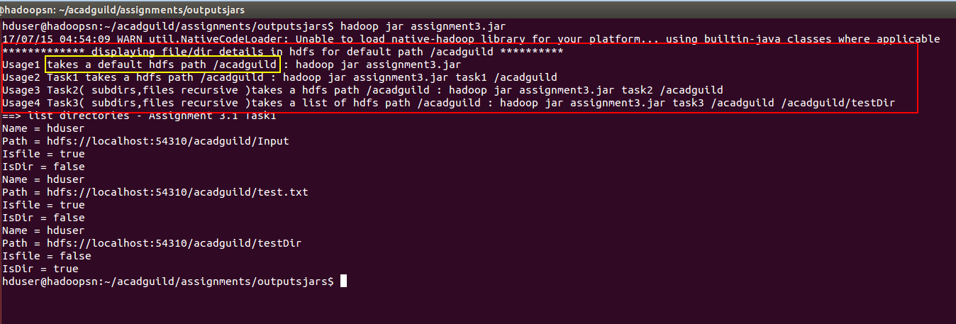
- Task 1:
Write a Java program, to take an HDFS Path as input and display all the files and sub-directories in that HDFS path.
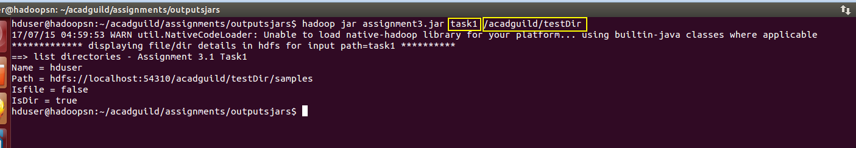
- Task 2:
Modify the previous program to list all the files and sub-directories in the HDFS path recursively.

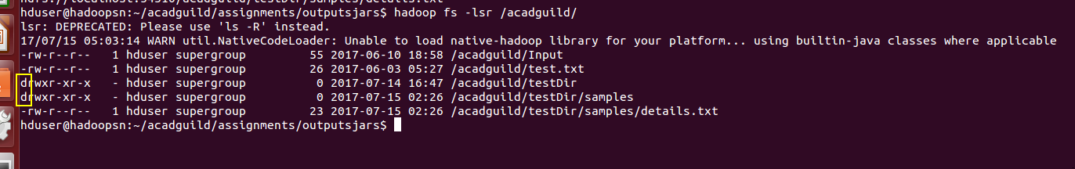

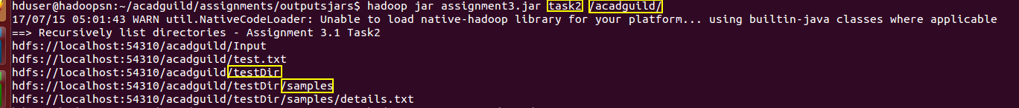

- Task 3:
Modify the previous program to take multiple HDFS paths (separated by space) and list all the files and sub-directories in those HDFS paths recursively.
