II)ACD_BDD2.1_Session_3_Assignment_2_Main
5. Problem Statement
Task 4:
Write a java program to list down all the files inside a directory and its sub-directories who have last modified timestamp between the start_ts and end_ts passed as an argument. The default value of start_ts is 0 and for end_ts is infinite.
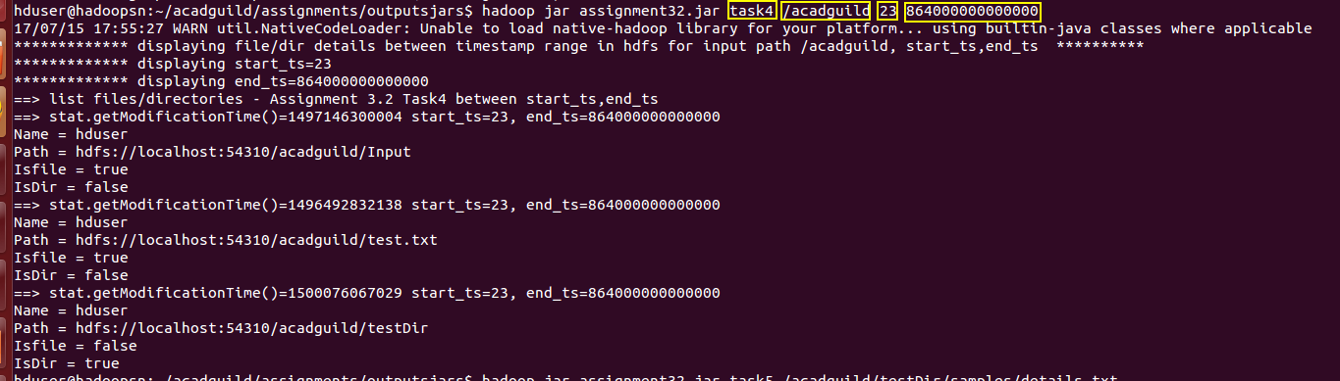
Task 5:
Write a Java program to display the content of a file in HDFS on screen.
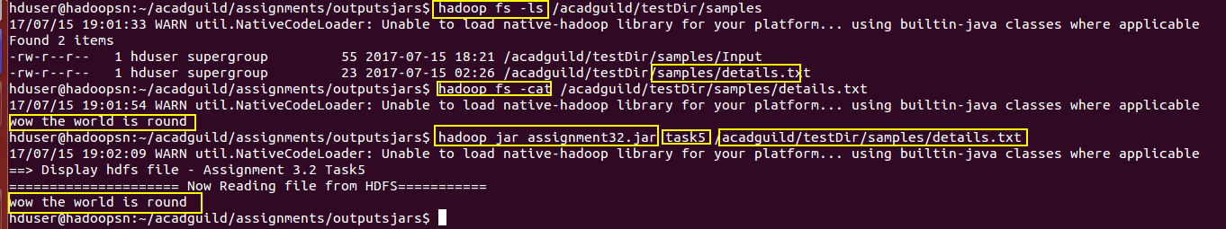

Task 6:
Write a Java program to copy a file from local filesystem to HDFS.
