ACD_BDD2.1_Session_5_Assignment_1_Main
5. Problem Statement
We have a dataset of sales of different TV sets across different locations.
Records look like:
Samsung|Optima|14|Madhya Pradesh|132401|14200
The fields are arranged like:
Company Name|Product Name|Size in inches|State|Pin Code|Price
4. Write a Map Reduce program to modify Task 2 (refer session 4, assignment 2) to use a custom partitioner with 4 reducers.
Make sure that all records whose company name starts with A-F (upper or lower case) should go to 1st reducer,
those starting with G-L to 2nd reducer, those starting with M-R to 3rd reducer and others to 4th reducer.

- hadoop jar assignment511.jar /television.txt /acadass511output
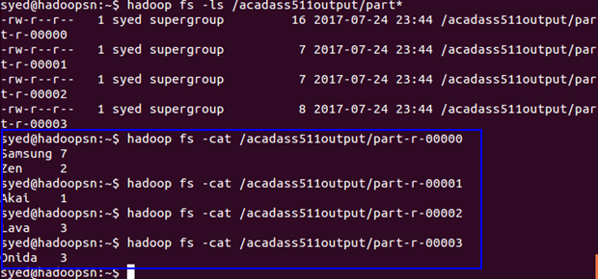

- syed@hadoopsn:~/acadgild/assignments/outputsjars$ hadoop jar assignment512Combiner.jar /television.txt /acadass512outputcombine
