DSC530 Final Project

Dong Lee
Bellevue University
DSC 530 Data Exploration and Analysis
Prof. Cary Jim
June 1, 2025

Introduction
The rapid expansion of rental housing platforms such as Airbnb has significantly reshaped the landscape of housing business in major urban areas. New York City, one of the most urbanized cities in the world, has thousands of Airbnb listings competing across boroughs, offering a wide variety of accommodation options in terms of price, availability, and amenities. As the city continues to struggle with housing affordability and tourism driven demand, understanding the dynamics of Airbnb listings becomes increasingly relevant from individual hosts to policymakers.
This project aims to explore and analyze key patterns in the NYC Airbnb market, focusing on listing prices, location-specific factors, and host behavior. By conducting exploratory data analysis with predictive modeling techniques, the goal is to bring insights that can help explain the pricing behavior of the listings and evaluate whether they can be meaningfully grouped or predicted based on observations.
These insights can give practical implications. For hosts, understanding which factors most strongly influence price could guide better listing strategies. For city policymakers, identifying high-density or high revenue generating zones may support urban planning efforts. For travelers, it can provide value-for-money considerations when booking Airbnb listings.
The dataset used in this analysis is retrieved from Kaggle, and comes from the publicly available Inside Airbnb project, specifically the 2019 dataset for New York City. It contains over 48,000 records, each representing an active Airbnb rental listing. Key variables examined include:
- Price – rental cost per night
- Room_type – entire home, private room, or shared room
- Neighbourhood_group – borough-level grouping
- Availability_365 – number of days available per year
- Number_of_reviews – number of reviews on listing
Initial data inspection revealed several issues:
- Missing values in variables such as ‘name’ and ‘last_review’
- Extreme outliers in ‘price’ variable
- Skewed distributions
To address this, ‘price’, ‘number_of_reviews’, and ‘reviews_per_month’ variables were log-transformed to reduce skewness. This step ensured the models meet normal distribution assumption and visualizations were not dominated by anomalies.

Exploratory Data Analysis
The EDA phase of this project aimed to review distribution patterns and relationships among the key variables. Visualizations and descriptive statistics were generated using Python libraries.
The distribution of listing prices was highly skewed to the right, with the majority of listing prices under $250, but a long tail extending to $1000. A log transformation of the price variable helped normalizes the skewness. Refer to the images below:
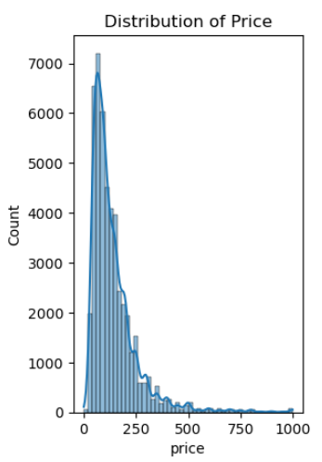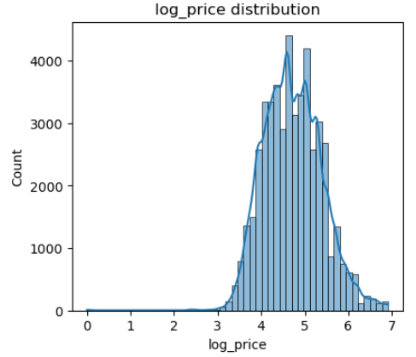
Analysis of room type variable revealed that the majority of listings were either entire homes or private rooms, with shared rooms forming a small minority. In terms of ‘neighbourhood_group’, Manhattan and Brooklyn dominated the listing volume.
Bivariate relationships were explored using correlation matrices visualized through heatmaps. A Pearson correlation heatmap was used to examine relationships among continuous variables such as ‘log_price’, ‘log_reviews_per_month’, ‘log_host_listings_count’, and ‘availability_365’. Most of the correlations were found to be weak. A Spearman correlation heatmap was created for ordinal associations between ‘log_price’ and encoded versions of ‘room_type’ and ‘neighbourhood_group’. This highlighted that room type had measurable association with pricing.

Statistical testing
To examine whether room type influences Airbnb listing prices in New York City, a formal hypothesis test was conducted using log-transformed price data. The goal was to determine if the mean price differs significantly across the three major room categories: entire homes/apartments, private rooms, and shared rooms.
An initial one-way ANOVA was used to test this hypothesis. Although the data met the assumptions of independence and approximate normality, Levene’s test revealed a significant violation of the equal variance assumption. To accommodate this, Welch’s ANOVA was applied for this. Both tests reached the same conclusion: the differences in average log-transformed prices across room types were statistically significant. Specifically, listings categorized as entire homes or apartments tend to command higher prices than private or shared rooms, even after adjusting for skewness in the data.
Moreover, the effect size observed was substantial, indicating that room type explains a meaningful portion of the variation in listing prices. This finding aligns with earlier observations from the exploratory analysis and provides strong justification for including room type as a key explanatory variable in the regression and classification models that follow.

Predictive Modeling
Several models were applied to explain and predict listing prices. A linear regression using log-transformed price showed that room type and borough were the most influential variables, with entire homes and listings in Manhattan priced higher on average. A decision tree classifier was used to categorize listings into high and low price groups. While interpretable, its performance was limited due to class imbalance and price variability.
K-means clustering was applied to uncover natural groupings among listings using features such as log-transformed price, availability, and review activity. After normalization, the algorithm grouped listings into four distinct clusters. These clusters revealed clear behavioral segments. The first cluster (Cluster 0) captured low-price, low availability with low review activity. Cluster 1 contained mid-price, high availability, with moderate reviews, suggesting hosts who keep their properties widely available but receive few bookings. Cluster 2 represents the most premium listings with high prices with low availability and limited reviews, likely luxury rentals. Cluster 4 featured moderately priced listings with high review activity and moderate availability, indicating highly active and popular listings. Below plots illustrate how these clusters separate across dimensions, providing visual evidence of distinct group patterns. These clusters may help define different market segments and could be leveraged for personalized marketing and host strategy.
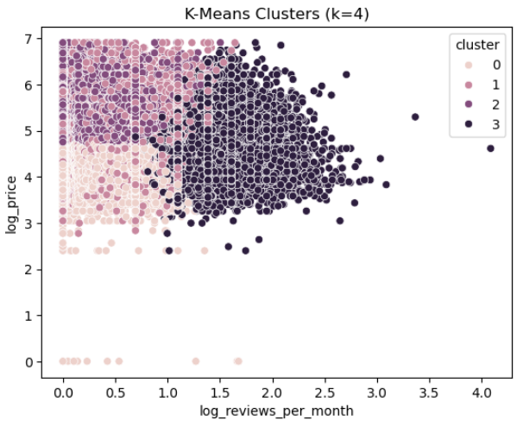
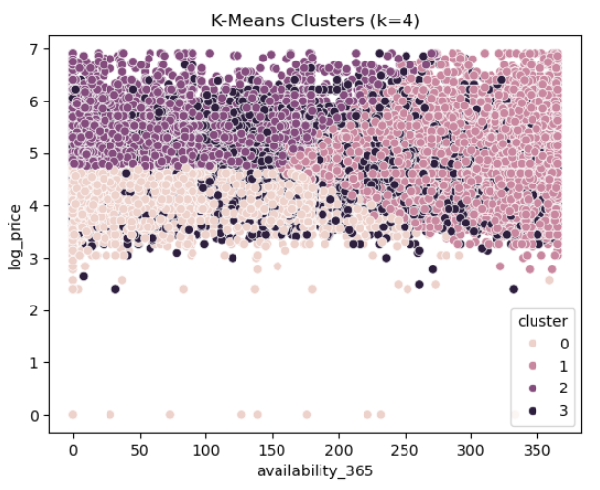
Finally, a Random Forest regression marginally improved prediction accuracy over linear regression. However, the most important features remained the same (room type and neighborhood group) indicating stable, largely linear relationships.

Actionable recommendations
Based on the analysis, several practical recommendations emerge for different stakeholders. For hosts, room type and location are the strongest determinants of price. Listings in popular boroughs consistently have higher prices. Hosts can leverage this insight by adjusting pricing and availability strategies to align with this.
For Airbnb as a platform, monitoring borough-level pricing trends can help detect irregularities in specific neighborhoods. Supporting dynamic pricing that accounts for room type and seasonal availability may enhance host earnings and user satisfaction.
City planners and policymakers can use these findings to better understand the geographic concentration of high revenue listings. This can inform decisions around regulation, zoning, or taxation aimed at balancing tourism with housing affordability.

Limitations
While the analysis provides several meaningful insights, there are limitations that must be considered. First, the dataset is a snapshot from 2019. The Airbnb market dynamics may have shifted since then, especially in response to the COVID-19 pandemic. Second, several variables exhibited skewness and required transformations. This preparation may reduce interpretability or exclude edge cases that could provide insights. Additionally, the analysis relied on structured data fields and excluded potentially rich information found in listing descriptions, amenities, or user reviews. Understanding these text-based data may further enhance model performance and insights. Lastly, although multiple models were tested, only a limited set of features were included. Future work could explore incorporating geospatial data, seasonality, or host-level performance metrics to refine predictions.

