Daniel Lopez

Greg Kilmer

Darshak Surti

Habeeb Olawin

CS 275 -- 003 Project Interim Status Report

jQuery Tic-Tac-Toe

**Status of individual components, requirements, and additions:**

Thus far for our project, development is going according to plan. As of Sunday, August 27th 2017, the game logic has been coded up, along with a message displaying the winner, a reset button, and some CSS to make the page for the game have a sleek appearance. The winner of a tic tac toe round is also set up to be recorded in a MySQL database through a NodeJS endpoint. All that said, we have currently fulfilled our requirements for including JavaScript, JQuery, Ajax, NodeJS, and tying in a MySQL database, and are considering adding an additional page to display a game record page, which would satisfy the requirement of parsing JSON data returned from the MySQL database.

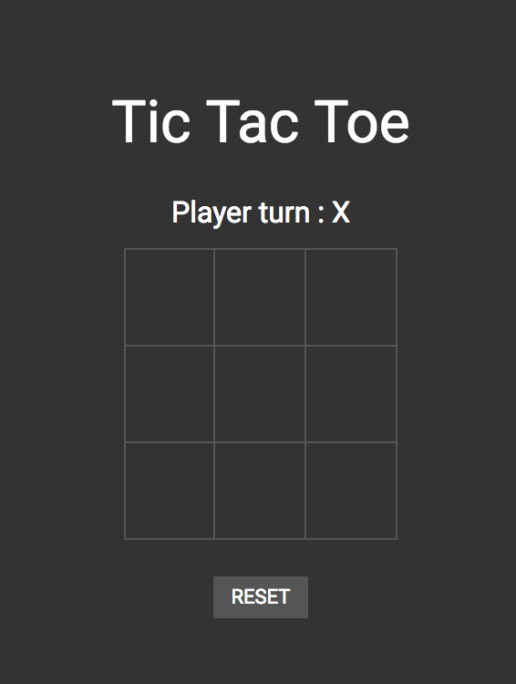

**Figure 1. The Tic-Tac-Toe interface running on localhost.**

Besides the additional page to parse the MySQL database, the one portion of the project that remains to be developed is passport.js portion and endpoint for Facebook authentication. As the project has progressed, clearer team-roles have become defined within our group, with Greg handling nearly all of the front-end HTML, CSS, and JavaScript. Darshak and Habeeb have handled the passport.js Facebook login integration and authentication, and Daniel oversaw creating the database, tying it into the NodeJS server file, and making AJAX calls to it after each round of Tic-Tac-Toe.

**Updated Gantt Chart and roles:**

The Gantt chart below shows the tasks necessary with updated start dates, completion dates, and additional tasks Figure 2.

**Figure 2. Gantt Chart with dates and tasks for completing the final project for CS 275.**

Thus, the project has been coming along almost according to plan except for the additional game record page and the longer duration for Passport.js. Again, Greg handled nearly all of the front-end HTML, CSS, and JavaScript. Darshak and Habeeb have handled the passport.js Facebook login integration and authentication, and Daniel oversaw creating the database, tying it into the NodeJS server file, and making AJAX calls to it after each round of Tic-Tac-Toe.

**MySQL Database:**

Lastly, the MySQL Schema has not been updated, and still records the name of the user logged in along with the log for which player won the round: X or O. This will likely remain the table layout for the final submission.