Portfolio Project Documentation

Daniel Landis
Colorado State University Global
CSC450: Programming III
Reginald Haseltine
09-15-2024

Portfolio Project Documentation
Pseudocode
Main Procedure:
Create countUp thread using CountUp class
Create countDown thread using CountDown class

Start countUp thread
Wait for countUp thread to complete

Start countDown thread

Class CountUp:
Procedure Run:
For i = 0 to 20:
Print "Count Up: " + i
Pause for 500ms

Class CountDown:
Procedure Run:
For i = 20 to 0:
Print "Count Down: " + i
Pause for 500ms

Source Code
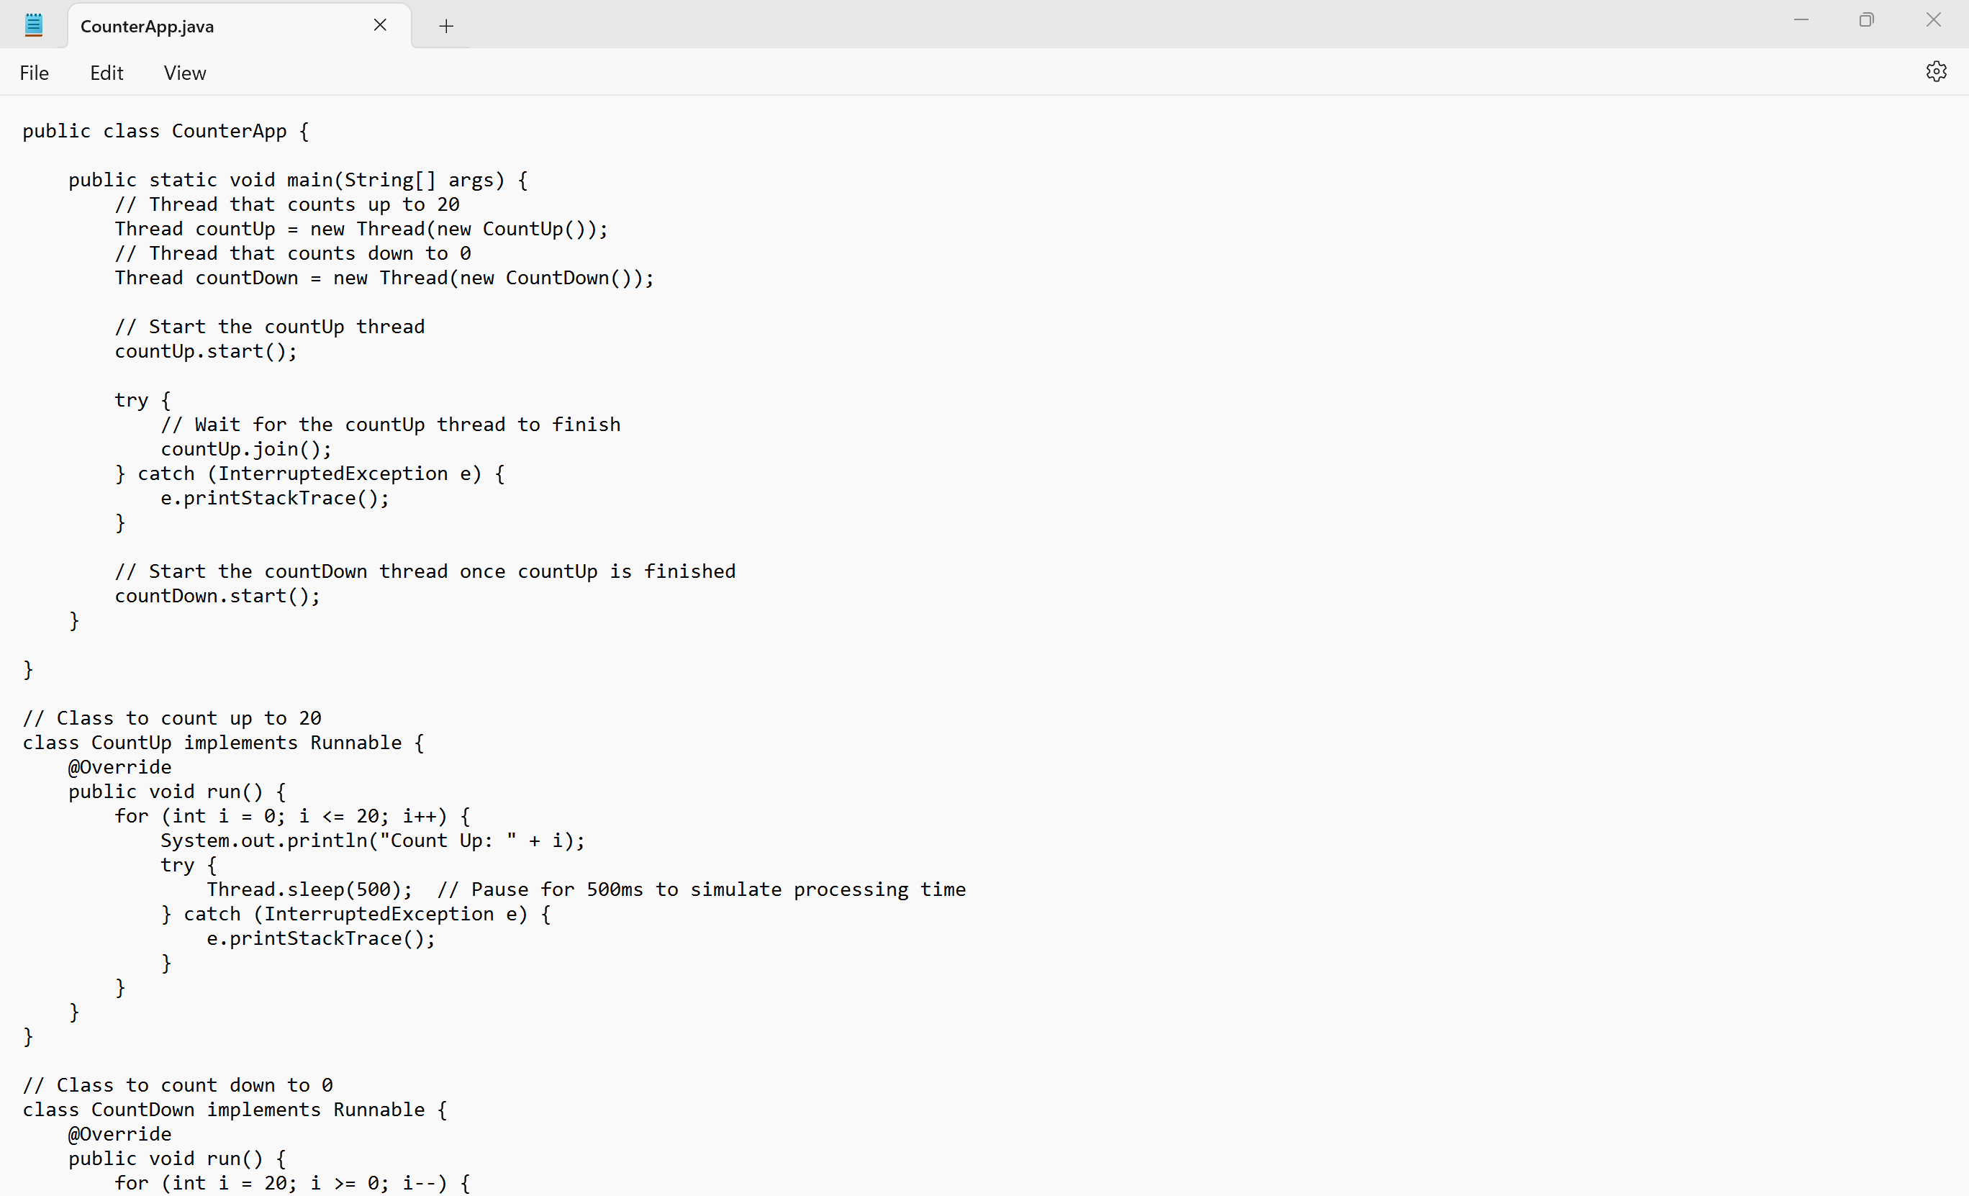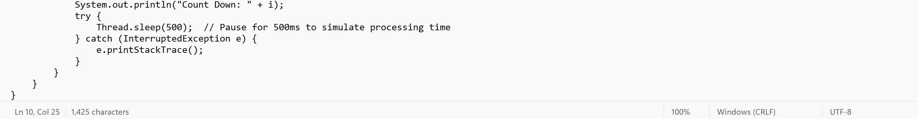

Output


GIT Repository

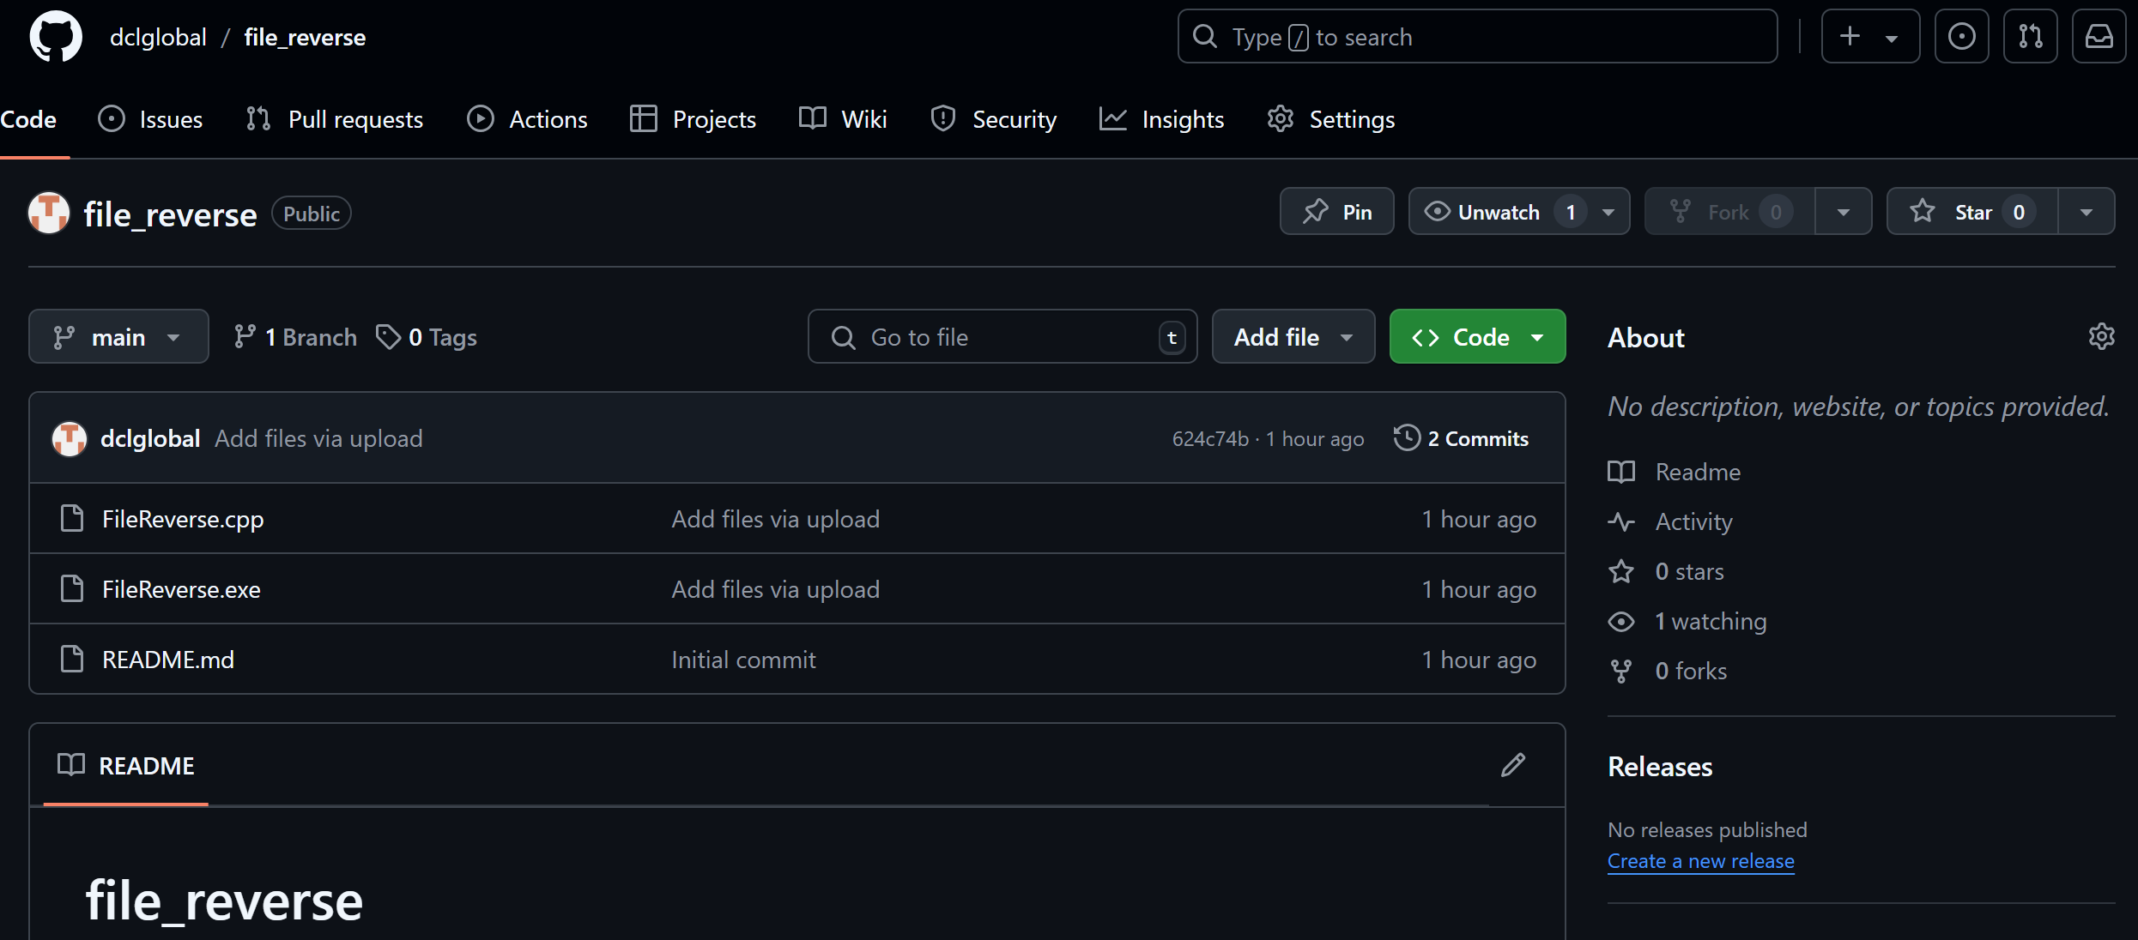
Comparison: Java and C++
Concurrency is an essential concept in modern software development, and both Java and C++ offer robust mechanisms for managing concurrent tasks. In this analysis, we will compare the performance and security of two simple programs—one written in Java and the other in C++—that use threads to count up to 20 and then count down to 0.
The Java code utilizes the Thread class and Runnable interface, while the C++ version uses the std::thread library and std::mutex for synchronization. The code structures, although similar in purpose, highlight key differences in how these two languages handle concurrency, thread safety, and performance.
1. Performance Considerations
Thread Creation Overhead:
- In C++, threads are created using the std::thread class, which is known for being lightweight and performant. Thread management in C++ typically involves low-level system calls and direct interaction with the operating system’s thread scheduler. This can result in better performance, especially in resource-constrained systems, because of the minimal overhead in thread creation and management (Ballman, 2016).
- Java, on the other hand, manages threads through its built-in Thread class. Java’s thread management is relatively abstracted from the underlying system, relying on the Java Virtual Machine (JVM). While this abstraction makes it easier to use, it introduces additional overhead in terms of thread management and memory consumption. The JVM's garbage collector, which helps manage memory, may impact performance unpredictably, especially in highly concurrent applications (Eck, 2015).
Thread Synchronization:
- In C++, the std::mutex and std::lock_guard are used to synchronize access to shared resources. In the given C++ code, the mutex ensures that only one thread at a time can access the std::cout object to print the count. This low-level control allows developers to optimize synchronization for specific use cases (Ballman, 2016).
- Java provides higher-level abstractions for thread synchronization, such as the synchronized keyword and classes like ReentrantLock. The Thread.sleep() method in Java introduces a fixed delay between each print operation, which simulates processing but can cause thread performance to suffer in real-time applications (Eck, 2015).
Context Switching:
- C++ benefits from direct interaction with the OS when handling context switches between threads. Context switching is the process of saving and restoring the state of a thread so that execution can be paused and resumed later. In C++, the process is efficient due to minimal overhead from abstraction layers. This can result in faster context switches, improving the performance of concurrent applications that require high responsiveness (Ballman, 2016).
- In Java, context switching is managed by the JVM, which adds an additional layer of complexity. The JVM abstracts thread management, including scheduling and switching, which can cause performance overhead, particularly in applications with a high number of threads. While this abstraction simplifies development, it may not be as performant as the native thread management provided by C++ (Eck, 2015).
Thread Pooling and Scalability:
- In C++, developers have more granular control over how threads are managed and pooled. In high-performance applications, custom thread pools can be created to optimize resource usage and minimize the overhead of thread creation and destruction. This flexibility can lead to improved scalability in multi-core systems (Ballman, 2016).
- Java provides built-in thread pooling mechanisms through the ExecutorService, which abstracts much of the complexity. While this makes scaling easier for many developers, the underlying performance is still managed by the JVM, and fine-tuning is less direct compared to C++. As a result, highly scalable applications in C++ might outperform their Java counterparts, especially in low-latency environments (Eck, 2015).
2. Security Considerations
Thread Safety and Synchronization Vulnerabilities:
- C++ offers low-level control over synchronization using mutexes, which gives developers direct control over how shared resources are accessed by threads. However, this flexibility can introduce vulnerabilities if not managed correctly (Ballman, 2016).
- In Java, thread synchronization is managed at a higher level, with built-in mechanisms like the synchronized keyword or the ReentrantLock class. While this abstraction reduces the likelihood of errors such as forgetting to unlock a mutex, it also introduces vulnerabilities such as deadlocks if not handled carefully (Eck, 2015).
Memory Management:
- C++ relies on manual memory management, meaning developers are responsible for allocating and deallocating memory. This gives more control but also increases the risk of memory-related vulnerabilities, such as buffer overflows, use-after-free errors, and memory leaks. In a multithreaded environment, improper memory management can lead to critical security vulnerabilities, especially when threads attempt to access memory that has already been freed (Ballman, 2016).
- Java benefits from automatic memory management through its garbage collector, which reduces the risk of memory leaks and buffer overflows. However, the JVM’s garbage collection process can introduce its own set of performance problems, especially in highly concurrent applications (Eck, 2015).
Data Type Safety:
- In C++, primitive data types (such as int in this example) are not inherently thread-safe, meaning that simultaneous access to shared data by multiple threads can lead to undefined behavior. Developers must explicitly synchronize access to shared variables using mutexes or atomic data types (std::atomic). Failure to do so can result in race conditions, where the outcome of a program depends on the unpredictable timing of thread execution (Ballman, 2016).
- Java, in contrast, provides safer default behavior for data types. Primitive data types like int are thread-safe when used locally within methods (Eck, 2015).

References
Ballman, A. (2016). SEI CERT C++ Coding standard: Rules for developing safe, reliable, and secure systems in C++. Hanscom, MA.
Eck, D. (2015). Introduction to programming using java, seventh edition (7th ed.). Pearson.
Long, F., Mohindra, D., Seacord, R., Sutherland, D., & Svoboda, D. (2014). Java coding guidelines: 75 recommendations for reliable and secure programs. Addison-Wesley.

