HCM360
User Documentation Guide
Municipality of Mariveles, Bataan · Metadata-driven HR platform

Volume 1 — Dashboard & Core Modules
All roles: Employee · Manager · HR Admin · Super Admin
Version 1.7 · April 2026

Table of Contents

1. Welcome to HCM360
HCM360 is the Municipality of Mariveles' end-to-end Human Capital Management platform. It centralises the full employee lifecycle — from recruitment and onboarding, through daily attendance and payroll, to performance reviews, learning, and retirement. The system is metadata-driven, which means the same screens can be tuned for different roles, departments, or workflows without redevelopment.

Who this guide is for
This guide is written for everyone who uses HCM360. Each chapter calls out the steps that apply to specific roles. If a section is marked 👤 Employee, 👥 Manager, 🛡 HR Admin, or ✦ Super Admin, the steps inside are scoped to that role.
ℹ Roles in HCM360
Employee (ESS) — view and update your own records, file leave, and download payslips. Manager — approve team requests, review team metrics, run team reports. HR Admin — manage employees, payroll, configure reference data. Super Admin — system-wide access, including access matrix, audit logs, and metadata configuration.

Signing in
- Open the HCM360 portal in your browser (the URL is provided by HR-IT).
- Enter your username — usually your firstname.lastname.
- Enter your password. First-time users must change the temporary password on first login.
- Pick the role you want to sign in as. (Most users only see one role.)
- Click Sign in. You will land on your Dashboard.
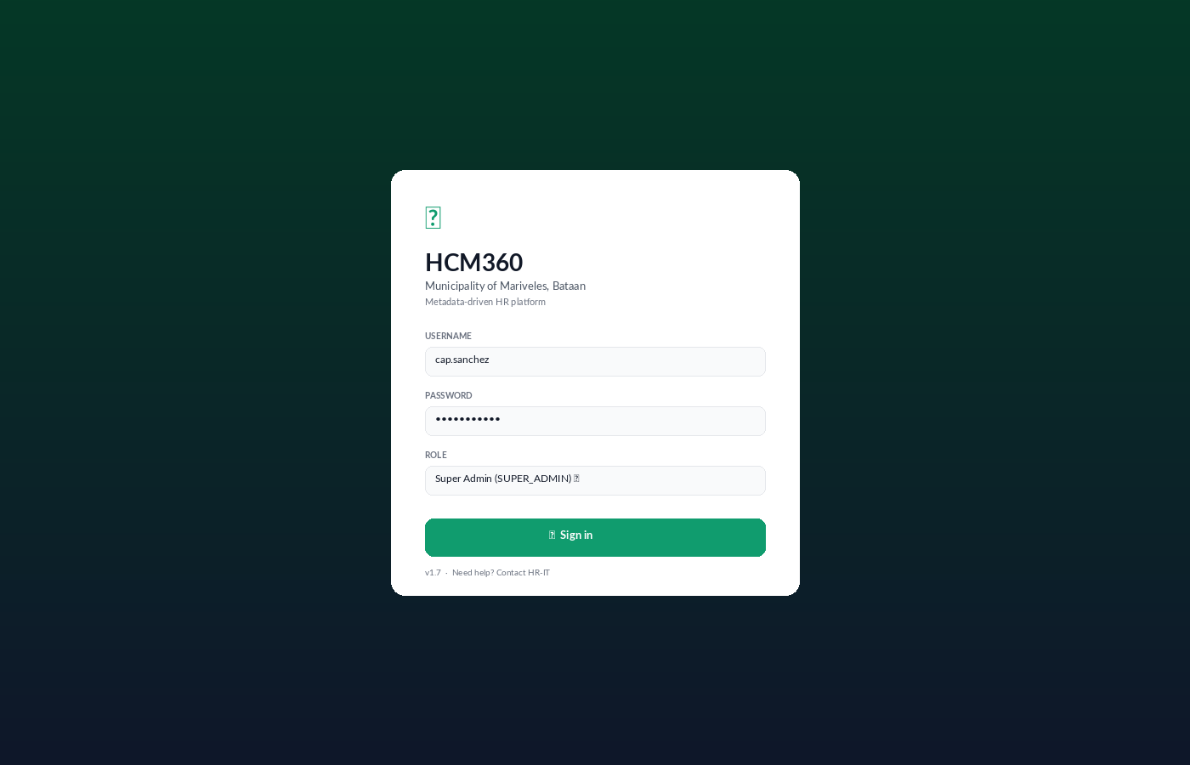
Figure: Sign-in screen for HCM360 (Mariveles instance).
⚠ Forgot password
Click "Need help?" on the login screen, or contact HR-IT directly. For security, the system locks an account after 5 failed attempts.

2. The Dashboard
The Dashboard is your home screen. It is curated to your role and shows three things at a glance: a personalised greeting, role-aware Quick Actions, and a grid of Key Metric tiles (KPIs) grouped by category. Below the KPIs, you'll find Widgets — compact panels that surface live operational data such as today's attendance and pending approvals.
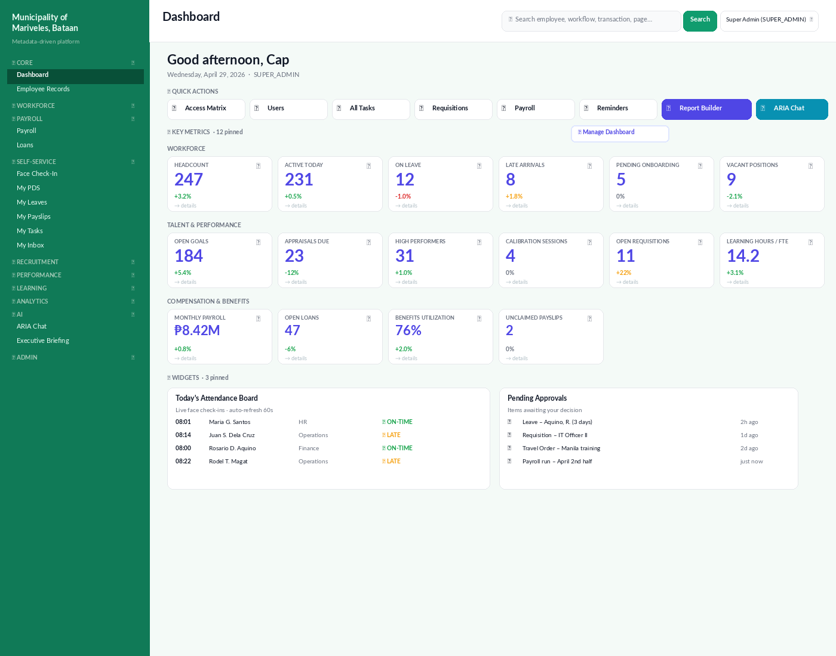
Figure: Dashboard for a Super Admin role. Layout adapts per role.

2.1 Anatomy of the Dashboard
Each Dashboard has six clearly delimited regions:
- Sidebar (left). Module navigation, grouped by Core, Workforce, Payroll, Self-Service, Recruitment, Performance, Learning, Analytics, AI, and Admin.
- Topbar. Page title, global search, role switcher (for users with more than one role), and Logout.
- Greeting. Time-of-day greeting plus today's date and your active role.
- Quick Actions. Role-aware shortcuts. ARIA Chat and Report Builder are always pinned for Manager and above.
- Key Metrics. KPI tiles grouped into Workforce, Talent & Performance, Compensation & Benefits, Compliance & Risk, and Operations. Click any tile to drill into the underlying list.
- Widgets. Live panels powered by SQL — examples include Today's Attendance Board and Pending Approvals.

2.2 Quick Actions per role
Role | Pinned actions
✦ Super Admin | Access Matrix · Users · All Tasks · Requisitions · Payroll · Reminders
🛡 HR Admin | Employees · Requisitions · Task Templates · Payroll · Leave Requests · All Tasks
👔 Executive | Approvals · My Inbox · Requisitions · Workforce Planning
👥 Manager | Team Tasks · My Team · Leave Approvals · My Inbox
👤 Employee (ESS) | (Quick Actions hidden — landing page is My Profile + My Inbox)

✓ Always-pinned for Manager and above
Two buttons appear on every login regardless of role-specific shortcuts: 📊 Report Builder (drag-and-drop reports across 32 data sources) and 🤖 ARIA Chat (natural-language assistant). They are highlighted in the Quick Actions bar.

2.3 Working with KPI tiles
Each tile shows a label, the current value, an optional trend arrow comparing to the previous period, and a footer that links to the underlying detail.
- Click any tile to open a filtered list of the records behind that number.
- Hover a tile to see a tooltip with the metric definition and source query.
- Tiles refresh automatically every 5 minutes. Force a reload with the browser refresh.

Pinning your own tiles
- Click ⚙ Manage Dashboard at the top right of the Key Metrics row.
- In the KPI Library, browse by category or search by keyword.
- Click the pin icon on each tile you want on your Dashboard.
- Drag tiles to reorder them. Click Save to apply.
ℹ Defaults vs. pinned
If you have not pinned anything, the Dashboard shows your role's defaults. As soon as you pin even one tile, the Dashboard switches to your custom set and remembers your choices across sessions.

2.4 Widgets
Widgets are larger, panel-style components. Two are pinned by default for HR Admin and Manager:
- Today's Attendance Board — live face check-ins, biometric scans, and manual punches with on-time / late status.
- Pending Approvals — aggregated queue of leave, travel, requisition, and payroll items awaiting your decision.
Open the Widget Library from the 🧩 Widgets bar to pin additional ones, including Birthdays This Week, Step Increment Reminders, and Compliance Watchlist.

3. Employee Records
The Employee Directory is the master list of every person on the plantilla and every active Job Order, Contract of Service, Barangay Health Worker, and Lupon volunteer. It is the entry point for editing PDS, 201 file documents, and contract data.
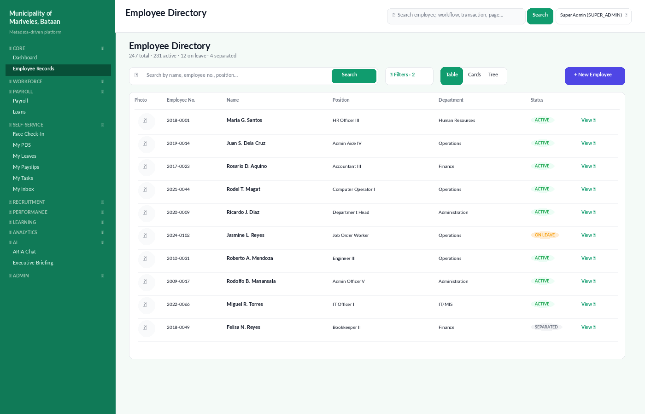
Figure: Employee Directory in Table view, with search, filters, and view toggle.

3.1 Three ways to look at employees
View | Best for | How to switch
Table | Bulk auditing, exporting, sorting by tenure or department | Toolbar → Table
Cards | Visual scan with photos, useful for orientation and meet-the-team | Toolbar → Cards
Tree | Org-chart navigation by department and reporting line | Toolbar → Tree

3.2 Adding a new employee · 🛡 HR Admin
- From the Directory, click + New Employee at the top right.
- Fill in the Personal Data Sheet (PDS) wizard: personal, family, education, eligibility, work experience, training, and references.
- Attach supporting documents to the 201 File panel (birth certificate, NBI clearance, medical, etc.).
- Save as Draft to come back later, or Submit to create the record and start onboarding tasks.
⚠ Before submitting
The system enforces uniqueness on Government IDs (TIN, SSS, GSIS, PhilHealth, Pag-IBIG). If a duplicate exists, the form blocks submission and surfaces the conflicting employee.

3.3 Editing an employee · 🛡 HR Admin
- Click any row to open the Employee Detail page.
- Use the left tabs: Profile, Employment, Compensation, Documents, Leave Balances, Training, Performance, Disciplinary, Health.
- Click ✏ Edit on the relevant section, make your changes, and click Save.
- All edits are versioned. The Audit tab shows every change with the editor, timestamp, and before/after values.

4. Leave Management
Leave Management covers your balances, requests, approvals, and CS Form No. 6 generation. Balances follow Civil Service Commission rules: vacation and sick credits are accrued at 1.25 days per month and roll over.
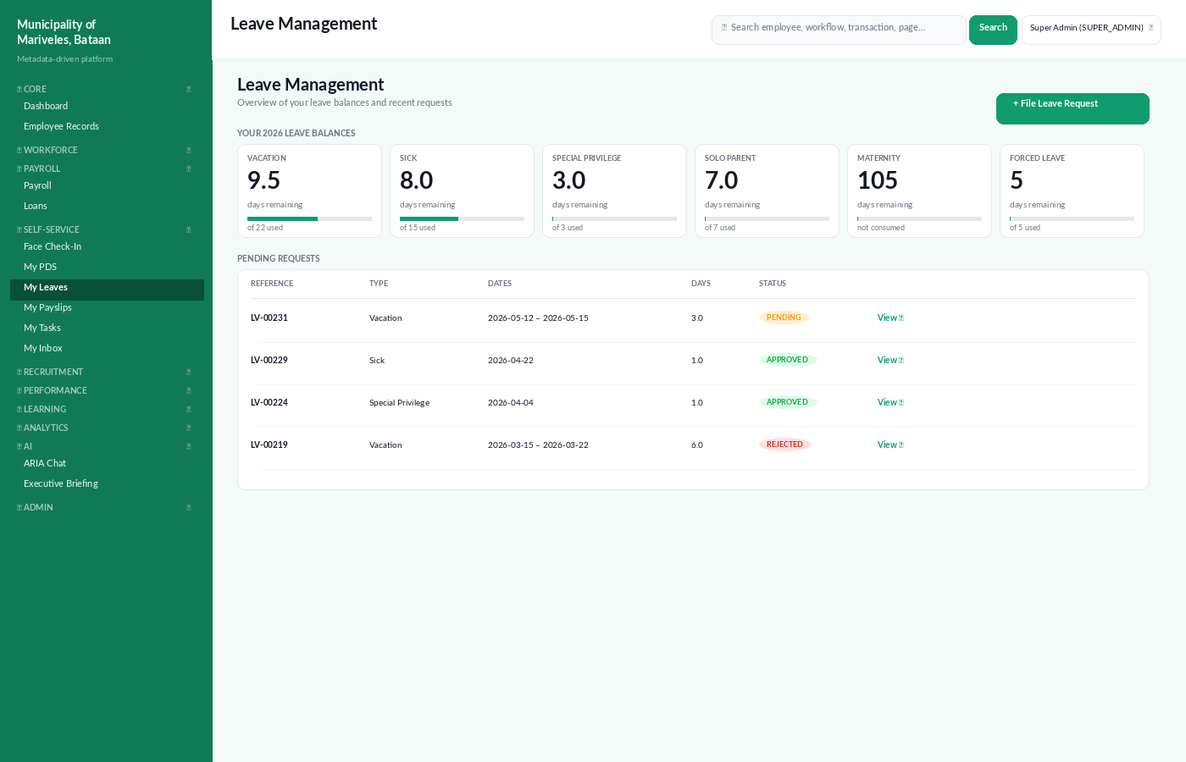
Figure: My Leaves — balances and pending requests for the current employee.

4.1 Filing a leave request · 👤 Employee
- From the Dashboard or sidebar, open My Leaves.
- Click + File Leave Request.
- Pick the leave type. The system shows your remaining balance for that type.
- Select date from and date to. Half-day requests are supported.
- Provide the reason. For Sick leave longer than 5 days, attach a medical certificate.
- Choose where you'll be reachable (locator slip), then click Submit.
✓ What happens after you submit
Your immediate supervisor receives a workflow task. If approved at the supervisor level, HR receives the request for final endorsement. You'll see status updates in My Inbox and receive an email at each transition.

4.2 Approving leave · 👥 Manager
- Open Leave Requests from your Dashboard's Quick Actions, or from My Inbox.
- Click the request to review dates, balance, and supporting attachments.
- Click ✓ Approve, ↩ Send Back (with comment), or ✖ Reject.
- Decisions are immediately reflected in the requester's balance and a CS Form No. 6 is auto-generated for the file.

5. Payroll
Payroll in HCM360 is organised as an 8-stage end-to-end pipeline that maps directly to Philippine government payroll practice. The pipeline header on the Payroll Dashboard is the canonical map — every stage has a direct jump-link.
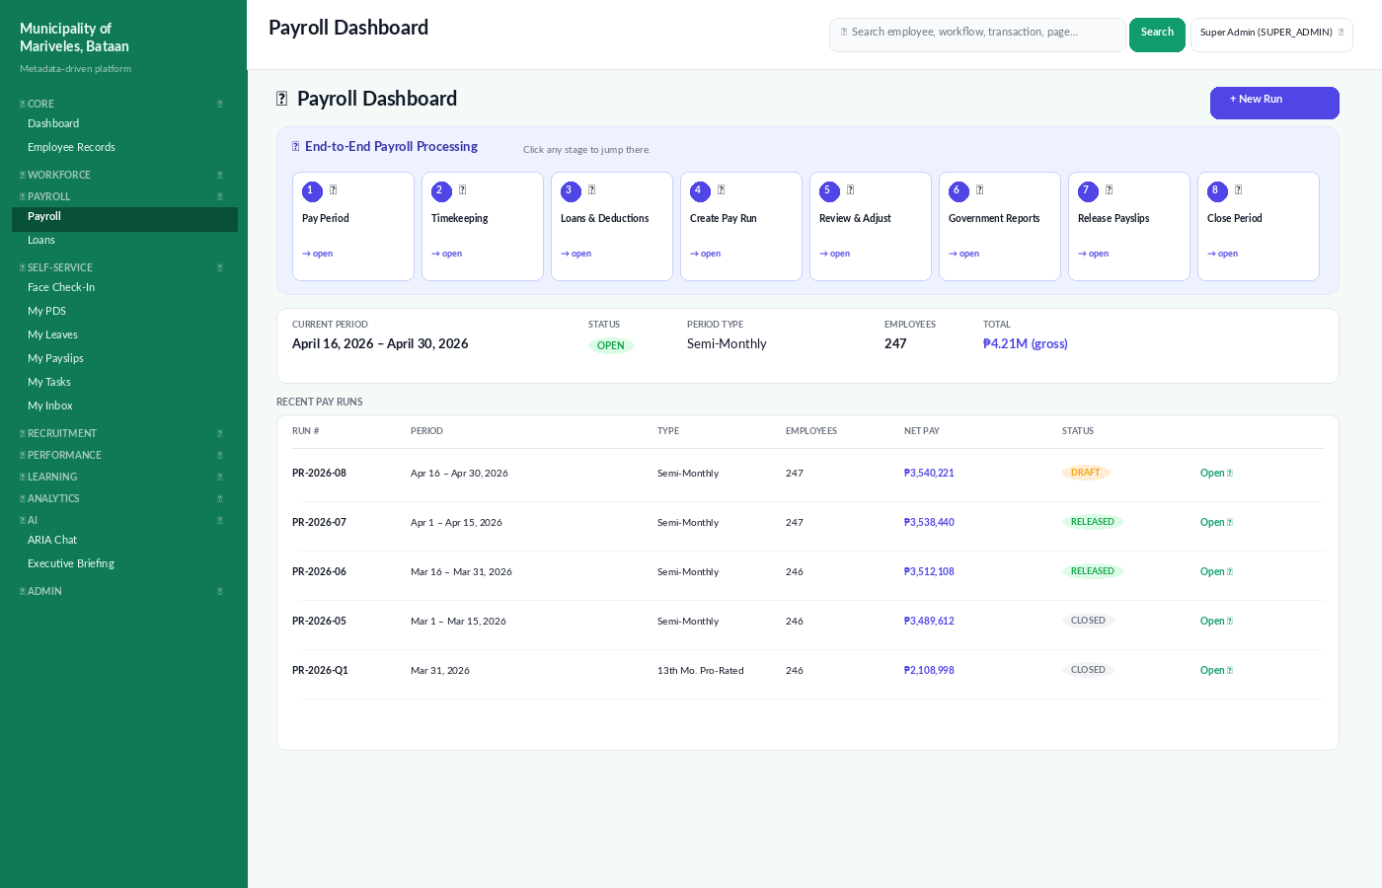
Figure: Payroll Dashboard with the 8-stage pipeline and current period summary.

5.1 The 8 stages
# | Stage | What happens | Who does it
1 | Pay Period | Open or configure the cutoff window | 🛡 HR Admin
2 | Timekeeping | Verify DTR, OT filings, leave balances | 🛡 HR Admin
3 | Loans & Deductions | Register active SSS / Pag-IBIG / company loans | 🛡 HR Admin
4 | Create Pay Run | Generate payslips per employee | 🛡 HR Admin
5 | Review & Adjust | Edit line items per employee before locking | 🛡 HR Admin
6 | Government Reports | Export SSS R3, PhilHealth RF1, HDMF MCRF, BIR 1601-C | 🛡 HR Admin
7 | Release Payslips | Notify employees; payslips appear under My Payslips | 🛡 HR Admin
8 | Close Period | Lock the period; auto-generate BIR 2316 at year-end | ✦ Super Admin

5.2 Reading a payslip · 👤 Employee
- Open My Payslips from the sidebar.
- Each row is one cutoff period. Click to open.
- Earnings, deductions, government contributions, and net pay are itemised.
- Click 📄 Download PDF to save a copy. Payslips are signed with a digital seal for audit.

6. Attendance / DTR
The Attendance module captures Daily Time Records (DTR) from three sources: face check-in (via the Face Check-In camera kiosks), biometric devices, and manual entries. The DTR page lets you filter, audit, and export attendance for any date range.
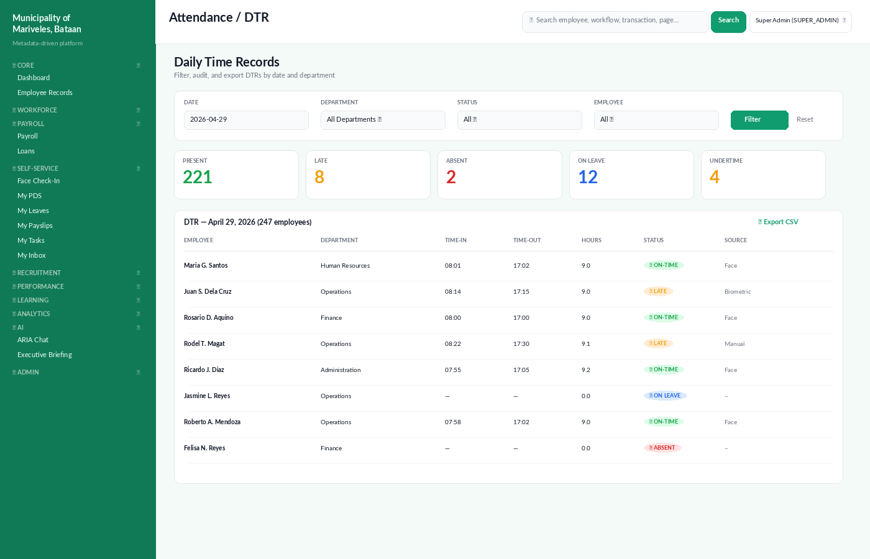
Figure: DTR for a single day, with KPIs and per-employee detail.

6.1 Filing my own attendance · 👤 Employee
- Walk up to a Face Check-In kiosk and look at the camera; the system auto-captures your timestamp.
- If a kiosk isn't available, log in and click Face Check-In on the Self-Service menu.
- If you forgot to check in, file a Manual DTR Adjustment from My Attendance with a reason.

6.2 Auditing the team's DTR · 🛡 HR Admin
- Open Attendance → DTR from the sidebar.
- Use the filters to scope by date, department, status, or employee.
- Click any row to open the per-day detail with raw scan timestamps and source device.
- Use 📤 Export CSV for further offline analysis.
⚠ About the LATE classification
Default tolerance is 15 minutes after the scheduled start time. If the official tolerance changes, update it in Admin → Reference Data → Attendance Rules — the change applies forward, never retroactively.

7. Performance Management
Performance Management implements the CSC's Strategic Performance Management System (SPMS). An IPCR (Individual Performance Commitment & Review) cycle runs every six months, with targets agreed up-front and rated against Q (Quality), E (Efficiency), T (Timeliness), and A (Average).
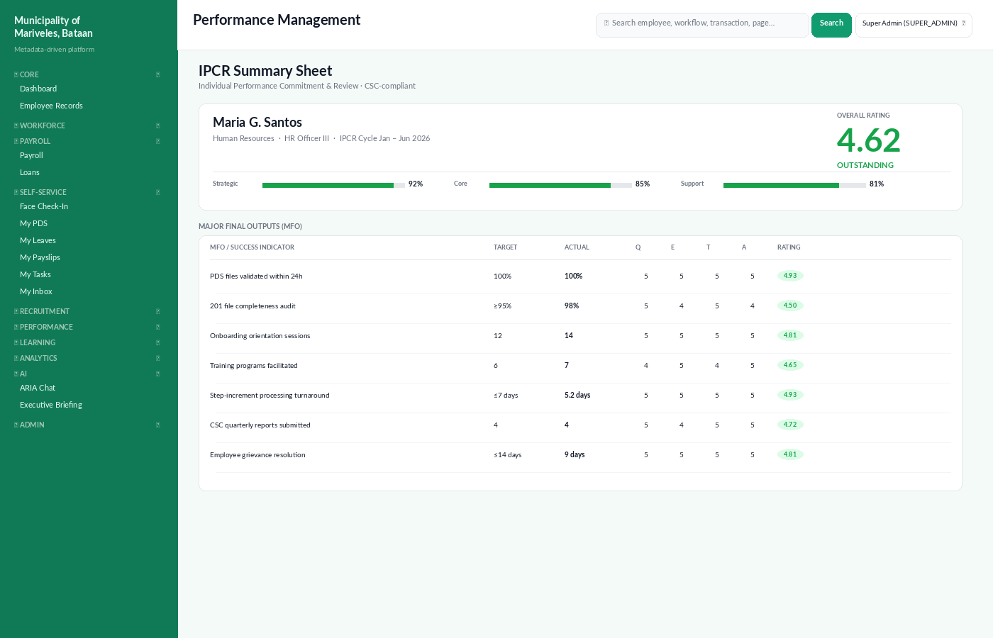
Figure: IPCR Summary Sheet for the current cycle.

7.1 Setting your IPCR commitments · 👤 Employee
- Open Performance → My IPCR.
- At the start of the cycle, click + Add MFO to register each Major Final Output.
- For each MFO, enter the Success Indicator (Target), and supporting OPCR alignment.
- Submit for supervisor approval. Once approved, the targets are locked.

7.2 Rating direct reports · 👥 Manager
- Open Performance → Cycles → current cycle → My Team's IPCR.
- Click each subordinate to open their IPCR Summary.
- For each MFO, rate Q, E, T on a 1–5 scale. The system computes A automatically.
- Add justification comments where appropriate, especially for ratings of 4.0 and above.
- Submit for calibration.

7.3 Calibration · ✦ Super Admin
Calibration sessions are facilitated under Performance → Calibration. The system flags rating distributions that deviate from the office's expected curve and lets the panel adjust outliers before final ratings are locked.

8. ARIA — AI Assistant
ARIA is the natural-language assistant built into HCM360. Ask in plain English — ARIA fetches LIVE data from the database and Reports sources, and every number it returns is traceable to the source query that produced it.
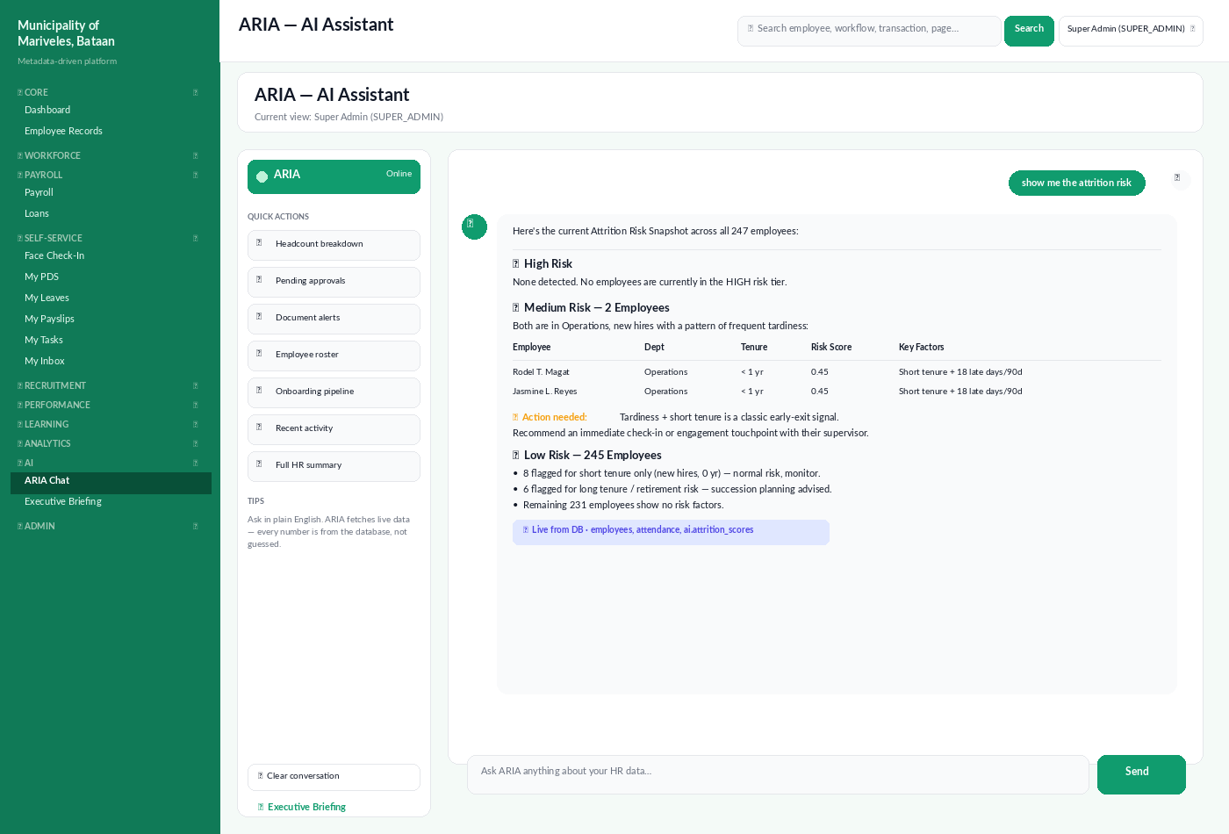
Figure: ARIA Chat — a Super Admin asking for an attrition risk snapshot.

8.1 Opening ARIA
- Click 🤖 ARIA Chat in the Quick Actions bar (always pinned for Manager and above), or use the sidebar AI → ARIA Chat.
- The chat opens with a Quick Actions panel on the left. Click any quick action to run a pre-built query, or type your own question in the input box.
- ARIA is conversational — follow-up questions like "how about certifications?" or "break that down by department" will use the previous answer as context.

8.2 What ARIA can read
ARIA is wired to 32 live data sources, organised into module groups. Two source kinds are supported: live database queries (DB) and curated analytic reports (REPORT). The taxonomy is shown below.
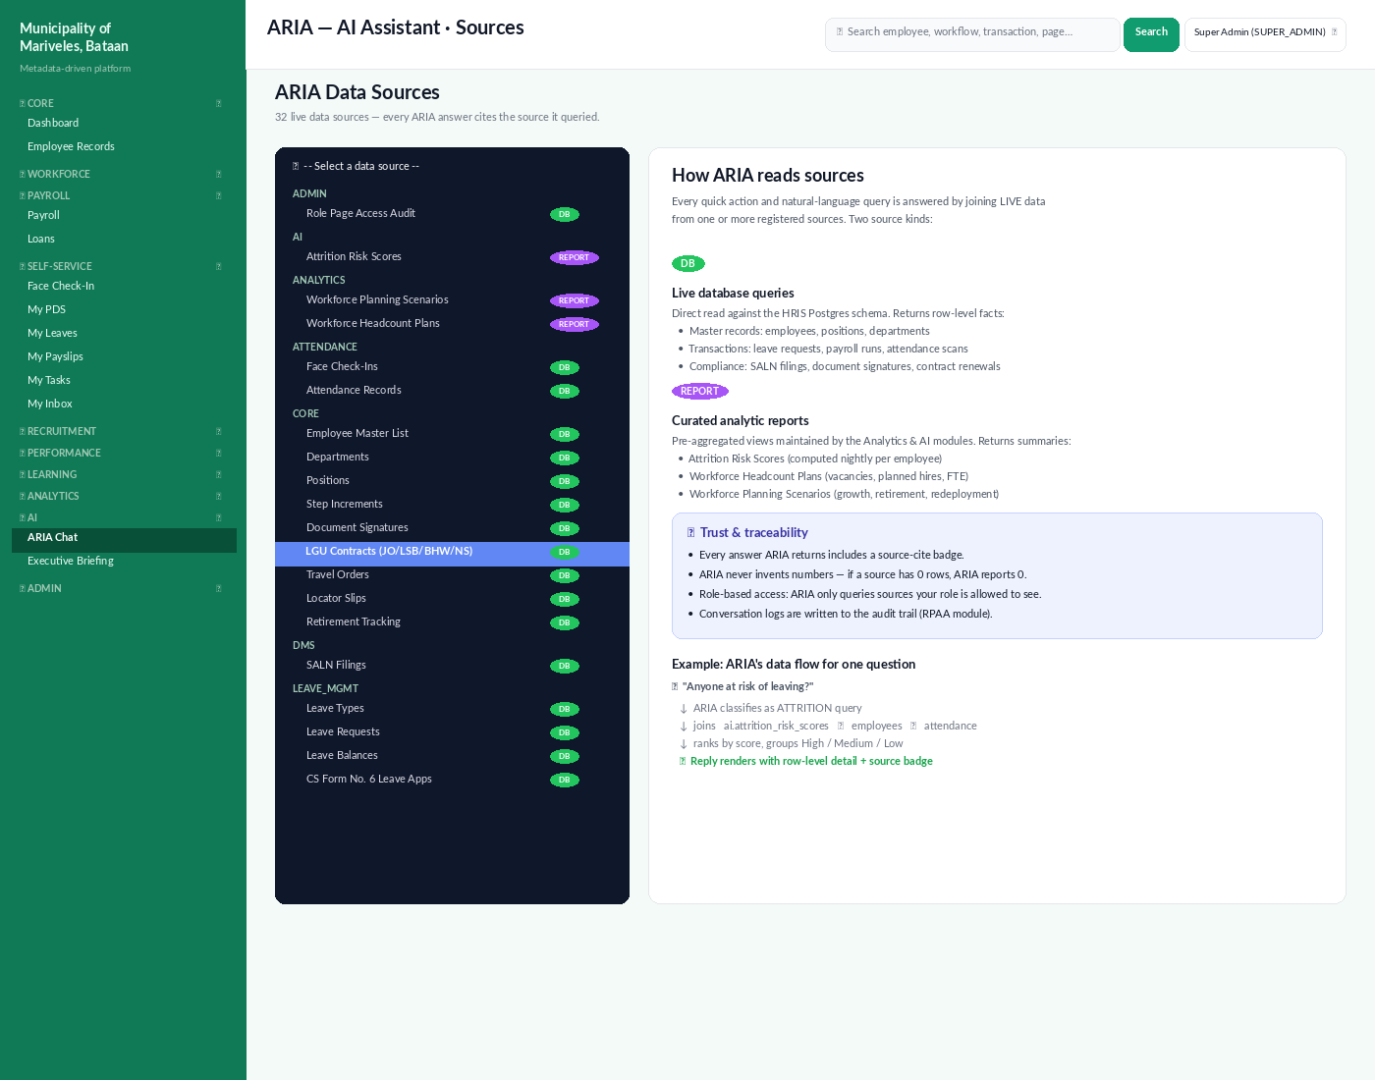
Figure: ARIA data-source picker. The badge on each source indicates DB (live row queries) or REPORT (pre-aggregated).
🗄 DB sources — direct database reads
Master records and transactions: employees, departments, positions, attendance, leave, payroll, SALN filings, document signatures, contracts, travel orders, locator slips, retirement tracking, and recruitment items. ARIA reads the live HRIS Postgres schema and returns row-level facts.
📊 REPORT sources — curated analytic views
Pre-aggregated views maintained by the Analytics & AI modules: Attrition Risk Scores (computed nightly per employee), Workforce Headcount Plans, and Workforce Planning Scenarios. These are summaries optimised for trend analysis, not row-level lookups.

8.2.1 Full source taxonomy
Module group | Source | Kind | Typical question
Admin | Role Page Access Audit | DB | Who has access to /admin/payroll?
AI | Attrition Risk Scores | REPORT | Anyone at risk of leaving?
Analytics | Workforce Planning Scenarios | REPORT | What does the 5-year retirement scenario look like?
Analytics | Workforce Headcount Plans | REPORT | How many vacancies are budgeted for Q3?
Attendance | Face Check-Ins | DB | Who hasn't checked in today?
Attendance | Attendance Records | DB | Top 10 latest-arriving employees this month.
Core | Employee Master List | DB | Headcount by department.
Core | Departments | DB | List active departments and heads.
Core | Positions | DB | Vacant plantilla positions.
Core | Step Increments | DB | Step increments due in the next 90 days.
Core | Document Signatures | DB | Pending Mayor's signatures.
Core | LGU Contracts (JO/LSB/BHW/NS) | DB | Job Orders expiring this month.
Core | Travel Orders | DB | Travel orders pending approval.
Core | Locator Slips | DB | Who's out of office right now?
Core | Retirement Tracking | DB | Compulsory retirees in the next 12 months.
DMS | SALN Filings | DB | Outstanding SALN filings for 2026.
ESS_MSS | Task Inbox | DB | Pending tasks across all approvers.
Learning | Training Records | DB | Trainings completed this quarter.
Learning | Training Attendance (Geotag) | DB | Geotagged check-ins for the GAD seminar.
Learning | Narrative Reports (NRF) | DB | Pending narrative reports.
Leave | Leave Types | DB | List all configured leave types.
Leave | Leave Requests | DB | Leave requests pending my approval.
Leave | Leave Balances | DB | Employees over their VL/SL credit cap.
Leave | CS Form No. 6 Apps | DB | Recent CSC Form 6 applications.
Payroll | Payslips Detail | DB | Payslip total for last cutoff.
Payroll | Payroll Register | DB | Net pay variance vs previous period.
Payroll | Employee Loans | DB | Active SSS salary loans.
Performance | IPCR Ratings | DB | Outstanding ratings for the last cycle.
Performance | OPCR Ratings | DB | Office performance summary.

8.3 Ask ARIA — recipes
ARIA performs best with concrete questions. Below are tested phrasings. Each one names the sources ARIA will join under the hood.
Question | Sources joined
"Show me the attrition risk" | ai.attrition_risk_scores ✦ employees ✦ attendance
"Who's pending approvals on me?" | task_inbox ✦ workflow_state
"Anything for me to be alarmed of?" | attendance ✦ leave ✦ ai.attrition ✦ dms ✦ workflow
"Headcount breakdown" | employees ✦ departments ✦ positions
"Onboarding pipeline" | onboarding_tasks ✦ workflow_state ✦ employees
"Document alerts" | document_signatures ✦ saln_filings ✦ contracts
"Who hasn't filed their SALN this year?" | saln_filings ✦ employees
"Step increments due next quarter" | step_increments ✦ employees
"Job Orders expiring in 30 days" | lgu_contracts ✦ employees
"Compare net pay this period vs last" | payroll_register (current) ✦ payroll_register (prior)

8.4 Sample answer — Alarm Scan
The Full HR Summary quick action runs a multi-source scan and returns a colour-coded report of cleared, watch, and alarm items. Use it daily as a 30-second risk pulse.
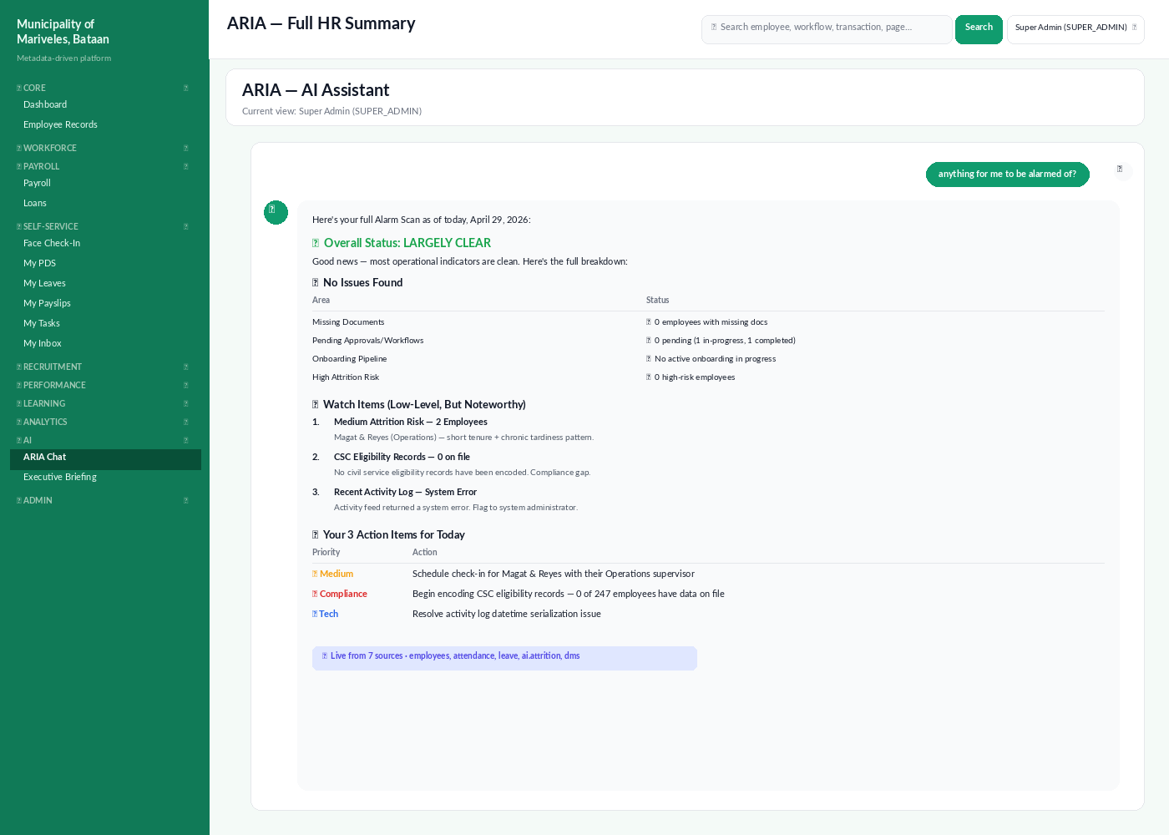
Figure: ARIA's Alarm Scan response, sourced from 7 modules in one pass.

8.5 Trust, traceability, and access
- Every ARIA answer ends with a 📊 source-cite badge listing the underlying sources. Click the badge to open the raw query.
- ARIA never invents numbers. If a source has 0 rows, ARIA reports 0 and tells you the source is empty.
- Role-based access: ARIA only queries sources your role is allowed to see. An Employee asking an HR-Admin question gets a polite refusal.
- Conversation logs are written to the Role-Page Access Audit (RPAA) module for compliance.
- ARIA does not write data. To make changes (file leave, edit an employee, run payroll), it directs you to the right page.
⚠ When ARIA gets it wrong
Use the 👍 / 👎 buttons under any reply. Down-votes are routed to the AI module owners for review. ARIA also logs the SQL it generated so the team can reproduce and fix any mismatch between your question and the underlying query.

8.6 Executive Briefing
Click ✦ Executive Briefing at the bottom of the ARIA panel to generate a one-page narrative summary suitable for the Mayor's morning brief or a Department Heads meeting. The briefing covers headcount, attrition, payroll, top compliance items, and a 3-bullet "what to watch" outlook.

9. Roles at a glance
Capability | 👤 Employee | 👥 Manager | 🛡 HR Admin | ✦ Super Admin
View own dashboard | ✓ | ✓ | ✓ | ✓
File own leave / DTR | ✓ | ✓ | ✓ | ✓
View team dashboard | — | ✓ | ✓ | ✓
Approve team leave | — | ✓ | ✓ | ✓
Run payroll | — | — | ✓ | ✓
Edit any employee's PDS | — | — | ✓ | ✓
Configure metadata | — | — | — | ✓
Use ARIA | scoped to self | scoped to team | all HR sources | all sources + admin
Access Matrix / RPAA | — | — | — | ✓

10. Where to go next
- Volume 2 (forthcoming) covers Recruitment, Selection, and Placement — including the requisition workflow and the LGU-specific Civil Service eligibility checks.
- Volume 3 (forthcoming) covers Learning & Development, the Awards & Recognition module, and the Discipline & Grievance flow.
- For administrators, see the companion Admin Guide (09_admin_guide.docx) for reference data, access matrix, and metadata tooling.
- For developers, the technical doc set under doc/technical/ explains the metadata schema, the workflow engine, and the KPI / Form / Orchestration registries.
ℹ Feedback
We treat this guide as living documentation. If a step in the system has changed or a screenshot is out of date, raise a ticket in the HR-IT helpdesk and the doc team will refresh the affected section in the next release.

