HCM360
User Documentation Guide
Municipality of Mariveles, Bataan · Metadata-driven HR platform

Volume 2 — Recruitment, Selection, and Placement
All roles: Employee · Manager · HR Admin · Super Admin
Version 1.7 · April 2026

Table of Contents

1. Overview
Recruitment, Selection, and Placement (RSP) is the lifecycle that takes a vacant plantilla position from internal request through posting, application, screening, Personnel Selection Board (PSB) deliberation, appointment, and onboarding. HCM360 implements every step in compliance with CSC MC 24, s. 2017 (RA 7041) and the LGU's locally-approved merit selection plan.

The 6 stages, end-to-end
# | Stage | What happens | Reference
1 | Requisition | Department head requests a fill; HR validates the plantilla. | RA 7160 §12
2 | Vacancy posting | Position published internally and on CSC bulletin / website. | CSC MC 24, s. 2017
3 | Application | Applicants apply, submit PDS and supporting documents. | CS Form 212
4 | Screening & Eligibility | HR validates eligibility against CSC, PRC, DICT registries. | RA 1080, RA 8981
5 | PSB Deliberation | Personnel Selection Board interviews and ranks the shortlist. | Local PSB Resolution
6 | Appointment & Onboarding | Mayor signs CS Form 33; onboarding checklist starts. | CSC MC 24, s. 2017
🛡 CSC compliance
Every step writes an audit trail with timestamps and the role that performed the action. The CSC Audit pack — every form, signature, and decision — can be exported in one click from the requisition's audit drawer.

2. Requisition workflow
A requisition is the formal request to fill a vacant plantilla position. Every requisition flows through three approval gates: Department Head → HRMO → Mayor's Office. Status is visible at a glance through the four KPI cards and the status pills on the list view.
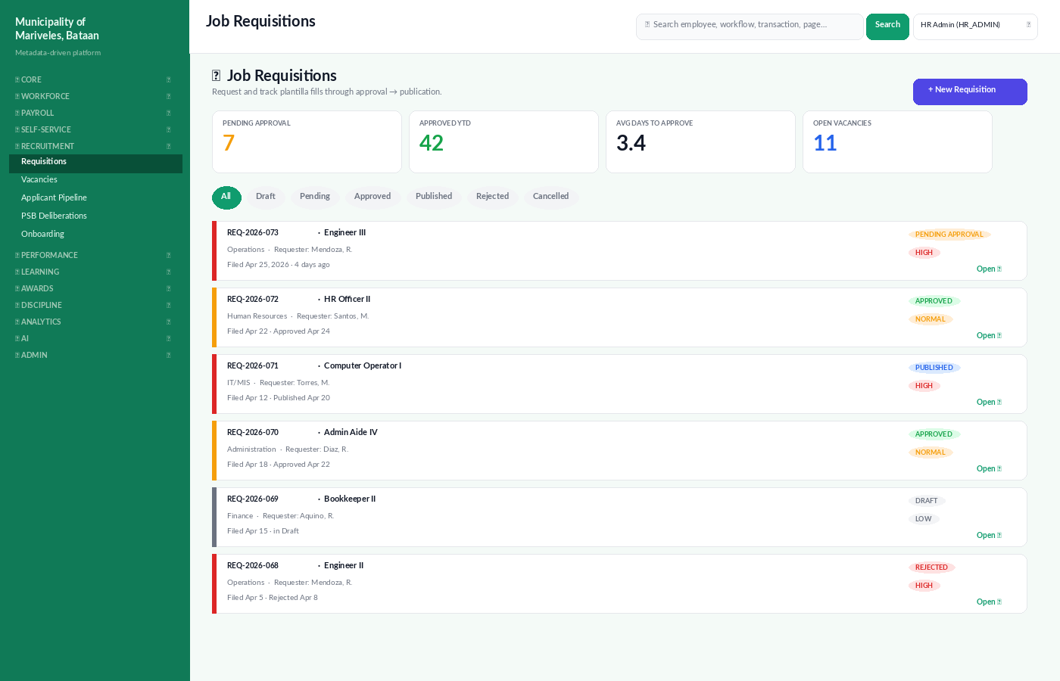
Figure: Job Requisitions — KPIs, status filter pills, and prioritised list.

2.1 Filing a new requisition · 🛡 HR Admin or 👥 Department Head
- From the sidebar, open Recruitment → Requisitions, then click + New Requisition.
- Pick the plantilla position. The system auto-loads salary grade, qualification standards, eligibility, and the funding source.
- Provide the justification: replacement, expansion, or temporary (e.g., maternity coverage).
- Set priority (LOW · NORMAL · HIGH) and the desired posting date.
- Attach supporting docs: budget certification (LBP Form), department memo, organisational chart annotation.
- Click Save as Draft to keep working, or Submit for Approval to start the workflow.

2.2 Approval workflow
Once submitted, the requisition routes automatically to:
- Department Head — endorsement of the operational need.
- HRMO — validation against the plantilla, qualification standards, and the LGU's merit plan.
- Mayor's Office — final approval and authority to post.
Each approver can ✓ Approve, ↩ Send Back (with mandatory comment), or ✖ Reject. If sent back, the originator receives a task in My Inbox to revise. Decisions and comments are timestamped and form part of the requisition's audit log.
⚠ SLA: 5 business days at each gate
If a gate exceeds 5 business days, the requisition is highlighted in red on the dashboard and the next-level approver is automatically notified. ARIA's daily Alarm Scan flags long-pending requisitions in the morning briefing.

2.3 Publishing the vacancy
- Once the requisition is APPROVED, click Publish on the requisition detail page.
- Set the closing date (minimum 10 calendar days from publication, per CSC MC 24).
- The system pushes the posting to the LGU public website, the CSC Bulletin, and an internal email digest.
- A unique CSC Reference No. is generated and stamped on every CS Form 9 derived from the posting.

3. Application pipeline
The Applicant Pipeline is a Kanban-style board organised into 8 stages: APPLIED, SCREENING, ELIGIBILITY, SHORTLIST, PSB, OFFER, HIRED, REJECTED. Each card shows the candidate's name, position, and current PSB score. Move a card by clicking its action button — the system enforces stage transitions and writes the audit trail.
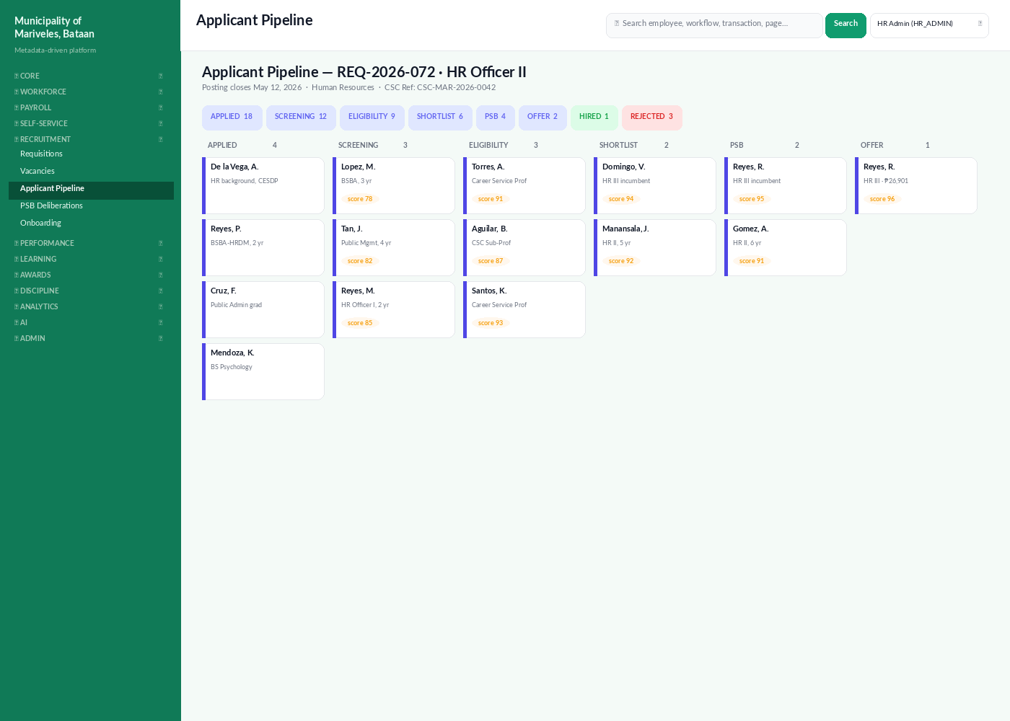
Figure: Applicant Pipeline — Kanban view by stage.

3.1 Receiving an application
Applicants can apply through the public portal or HR can encode a paper application on their behalf. Either way, the candidate's PDS, work experience, training, and eligibility are stored in a structured form for downstream scoring.

3.2 Screening · 🛡 HR Admin
- Click an applicant card to open the detail view.
- Review their PDS, transcripts, and supporting documents on the Documents tab.
- Run the Quick QS Check — the system compares the applicant's claims against the position's qualification standards and flags gaps.
- If the applicant meets the QS, click Move to ELIGIBILITY. Otherwise click Reject with a CSC-aligned reason code.

4. CSC Eligibility checks
Civil Service eligibility is a non-negotiable requirement for plantilla appointments. HCM360 verifies eligibility against three sources: the CSC's registry (Career Service Professional, Sub-Professional, and CSC-prescribed special eligibilities), the PRC registry (for licensed professions), and DICT (for ICT eligibilities). The Compliance Matrix shows, at a glance, whether each plantilla position has an incumbent with the right eligibility on file and whether anything is expiring.
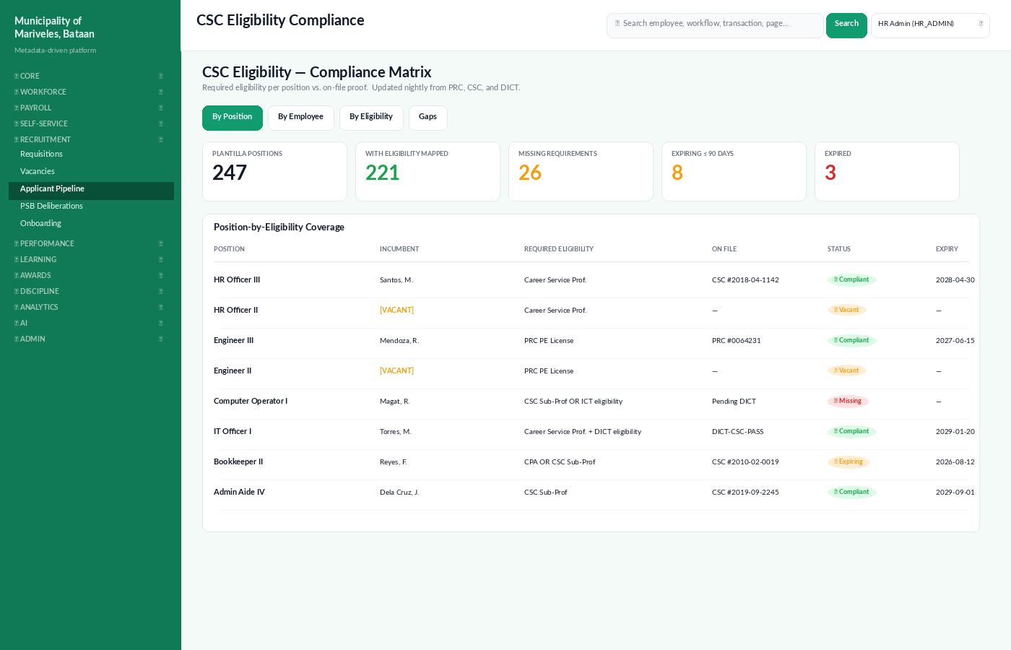
Figure: CSC Eligibility Compliance Matrix — by position, with on-file proof and expiry.

4.1 Eligibility kinds tracked
Eligibility | Source registry | Typical positions
Career Service Professional | CSC | Officer-level positions (SG 11+) requiring 2nd-level eligibility.
Career Service Sub-Professional | CSC | Clerical and aide positions (SG 1–10).
RA 1080 (Bar / Board) | CSC + PRC | Lawyers, engineers, accountants, doctors — eligibility derives from the licensure.
RA 6850 (Permanent) | CSC | Casuals/temp converted to permanent under RA 6850.
DICT-CSC ICT eligibility | DICT | ICT-related positions in IT/MIS.
Sangguniang Kabataan | CSC | SK-related officers.
Honor Graduate (PD 907) | CSC + School Registrar | Government scholars / honour graduates.
Veteran Preference | PVAO | Eligible veterans applying to LGU positions.

4.2 How an eligibility check is run
- On the applicant's detail page, scroll to the Eligibility section.
- Click 🔍 Verify with CSC Registry. The system calls the CSC API and returns one of three states: ✓ Verified, ⚠ Found but Expired, or ✗ Not Found.
- If the eligibility is licence-based (RA 1080), the system auto-calls PRC. The PRC reference, board passing date, and validity are imported.
- Verified results are stamped with the source registry, the timestamp, and the HR officer's user ID.
- If a registry call fails (network or registry outage), HR can attach a scanned copy of the certificate and tag it as Manually Verified — this is allowed but flagged in the audit log for periodic review.
🛡 Eligibility kinds the LGU must verify
Per CSC MC 11, s. 1996, all permanent appointments require eligibility appropriate to the position. Temporary / coterminous / casual appointments may be filled by non-eligibles subject to specific rules — HCM360 enforces these distinctions on the appointment form.

4.3 Compliance matrix views
- By Position — every plantilla item with its incumbent, required eligibility, and on-file proof.
- By Employee — pivot to see what each employee has and what's expiring.
- By Eligibility — count of incumbents per eligibility kind, useful for projections.
- Gaps — only positions with missing or expired eligibilities. This is the action queue HR works.

5. Personnel Selection Board (PSB)
The PSB is the deliberative body that interviews shortlisted candidates and ranks them by composite score across five criteria: Education, Experience, Training, Performance (if internal), and Interview. HCM360 produces the PSB Score Sheet, the Comparative Assessment table, and the PSB Resolution PDF for signatures.
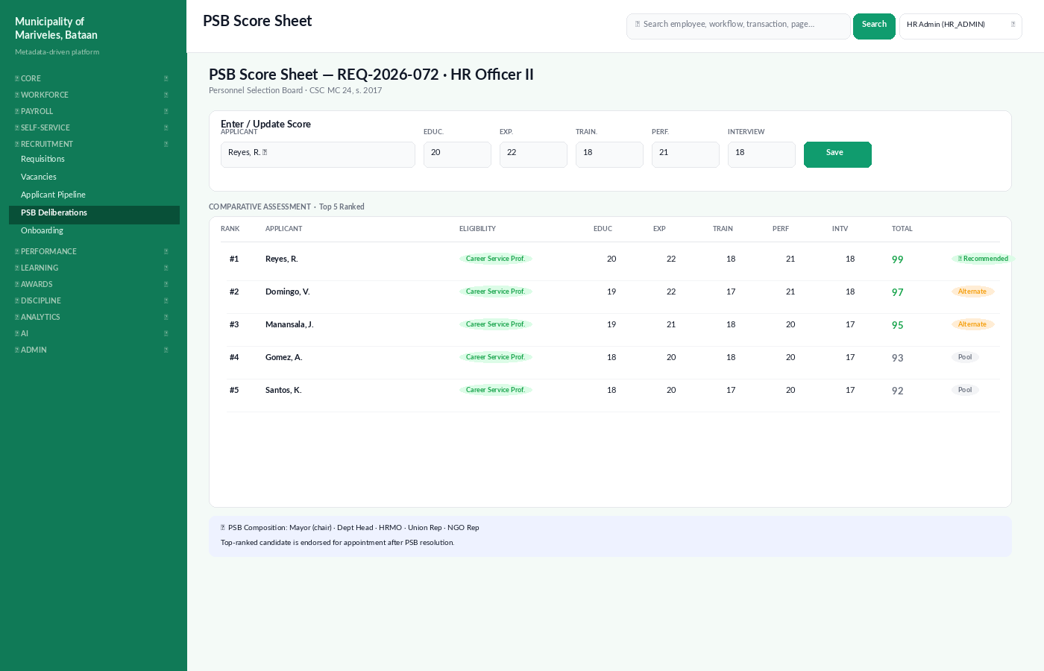
Figure: PSB Score Sheet with comparative ranking and recommendation.

5.1 Scoring criteria and weights
Criterion | Max points | Source
Education | 20 | Highest relevant degree completed.
Experience | 25 | Years of relevant work experience, with a multiplier for direct relevance.
Training | 20 | Training hours in the last 5 years that match the position's competency map.
Performance | 15 | Most recent IPCR rating (internal applicants only); applicants from outside LGU receive proxy points.
Interview | 20 | Average of PSB members' interview ratings.
The composite total caps at 100. The top-ranked candidate is endorsed for appointment; the next two ranked candidates are kept as alternates.

5.2 Running a PSB session · PSB Chair (Mayor or designate)
- Open Recruitment → PSB Deliberations and pick the requisition.
- Add PSB members for the session: Chair (Mayor), Vice-Chair, HRMO, Department Head of the requesting office, Union Rep, NGO Rep.
- For each shortlisted applicant, members enter their interview scores. The system blocks final lock-in until every member has scored every applicant.
- Once scoring is complete, click Generate PSB Resolution. The PDF is auto-filled and routed for digital signatures.
- On signature completion, the recommended candidate is moved to the OFFER stage.

6. Appointment & Placement
Once the PSB endorses a candidate, HR prepares the appointment paperwork. HCM360 auto-fills CS Form 33 (Appointment), CS Form 33-A (Position Description), and Oath of Office (CS Form 32). The Mayor signs digitally; the system locks the position once signed.

6.1 Drafting the appointment · 🛡 HR Admin
- From the OFFER stage card, click Prepare Appointment.
- The form is pre-populated from the requisition, the applicant's PDS, and the PSB resolution.
- Set the appointment kind: Original / Promotion / Reappointment / Transfer / Reemployment / Reclassification.
- Set the status: Permanent / Temporary / Coterminous / Casual / Contractual.
- Click Submit for Mayor's Signature.

6.2 Mayor's signature · ✦ Super Admin / Mayor
The Mayor or an authorised signatory reviews the appointment in the Mayor's Inbox (/me/inbox?role=MAYOR). On signature, the system stamps a SHA-256 hash and a digital seal on the PDF. The signed appointment becomes the source of truth for the new employee record.

6.3 Publication to CSC
The signed appointment is bundled with the supporting attachments (PSB resolution, PDS, qualification proof, eligibility verification result) and submitted to the CSC Field Office for attestation. The CSC's response (attested / disapproved / for compliance) is logged on the appointment record.

7. Placement & Onboarding
On Day 1 of the appointment effectivity, the new hire moves into Onboarding. HCM360 ships with a 6-stage onboarding pipeline that follows the CSC Onboarding Standard (REQUIREMENTS → WELCOME → TRANSITION → SIGNOFF → READY → ACTIVATED). HR or the buddy advances the stage as items are completed.
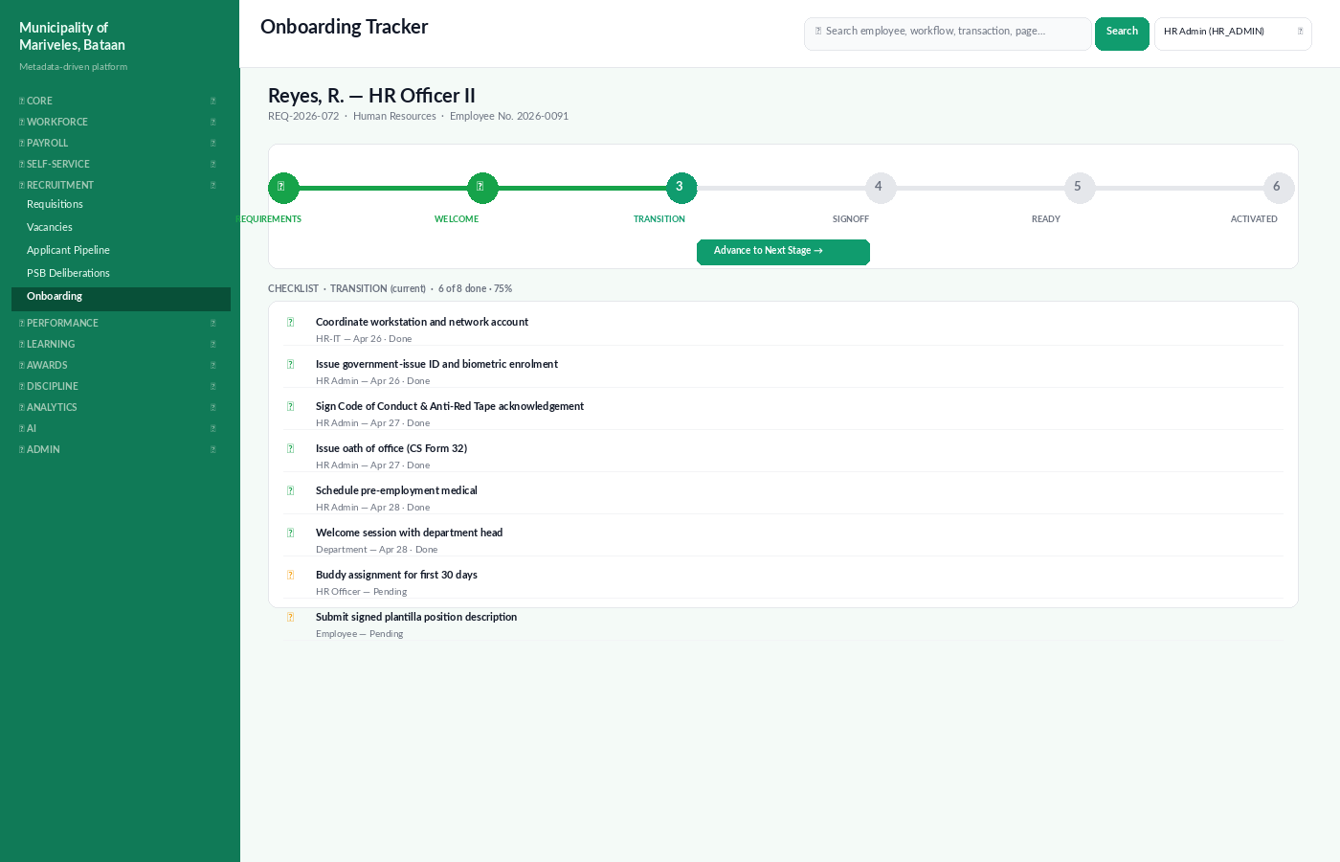
Figure: Onboarding Tracker showing stage progress and current-stage checklist.

7.1 Onboarding stages
Stage | Owner | Key checklist items
REQUIREMENTS | 🛡 HR Admin | PDS, Oath of Office (CS 32), pre-employment medical, NBI / police clearance, ITR for tax computation.
WELCOME | 🛡 HR Admin | Issue Government ID and biometric enrolment, employee handbook, orientation schedule.
TRANSITION | 🛡 HR + 👥 Manager | Workstation, network account, code-of-conduct sign-off, department welcome session, buddy assignment.
SIGNOFF | 🛡 HR Admin | Plantilla position description signed; payroll bank details captured.
READY | 👥 Manager | First-week goals discussed; DTR enrolment activated.
ACTIVATED | system | Status flips to active; first scheduled paydate is enrolled in payroll.

7.2 Advancing a stage
- Open Recruitment → Onboarding from the sidebar.
- Pick the new hire to open their tracker.
- Tick checklist items as they are completed; the progress bar updates immediately.
- When all required items in the current stage are ticked, click Advance to Next Stage.
- Once ACTIVATED, the new hire's Self-Service portal opens, ARIA welcomes them, and their first-cycle IPCR scaffold is created.
✓ Buddy programme
We pair every new hire with a buddy for the first 30 days. The buddy receives tasks in their inbox at Day 1, Day 7, Day 14, and Day 30 to check in and submit a short note that becomes part of the new hire's onboarding feedback record.

8. Where to go next
- Volume 1 covers the Dashboard, Employee Records, Leave, Payroll, Attendance, Performance Management, and the ARIA AI Assistant.
- Volume 3 covers Learning & Development, Awards & Recognition (PRAISE), and the Discipline & Grievance flow.
- For the technical schema behind requisitions, applicants, eligibilities, and appointments, see doc/technical/.
ℹ Government forms generated by Volume 2
CS Form 9 (Vacancy Announcement) · CS Form 12 (Notice of Promotion) · CS Form 32 (Oath of Office) · CS Form 33 / 33-A (Appointment) · CS Form 34 (PSB Resolution) · CSC Attestation Bundle.

