HCM360
User Documentation Guide
Municipality of Mariveles, Bataan · Metadata-driven HR platform

Volume 3 — Learning · Awards · Discipline
All roles: Employee · Manager · HR Admin · Super Admin
Version 1.7 · April 2026

Table of Contents

1. Overview
Volume 3 covers three modules that sit at the intersection of HR development and compliance: Learning & Development (L&D), Awards & Recognition under the PRAISE framework, and the Discipline & Grievance flow. Together they enforce the LGU's obligations under CSC MC 28, s. 2018 (PRAISE) and CSC MC 19, s. 2020 (Rules on Administrative Cases in the Civil Service / 2017 RACCS).

2. Learning & Development
L&D centralises the LGU's training catalog, scholarships, training need analysis (TNA), session scheduling, attendance, and post-training narrative reports. Programs can be flagged as CSC-accredited or mandatory. Training hours feed forward into the IPCR's Training points (PSB Volume 2 §5.1) and into the PRAISE eligibility calculations (this volume §6).

2.1 Training Catalog
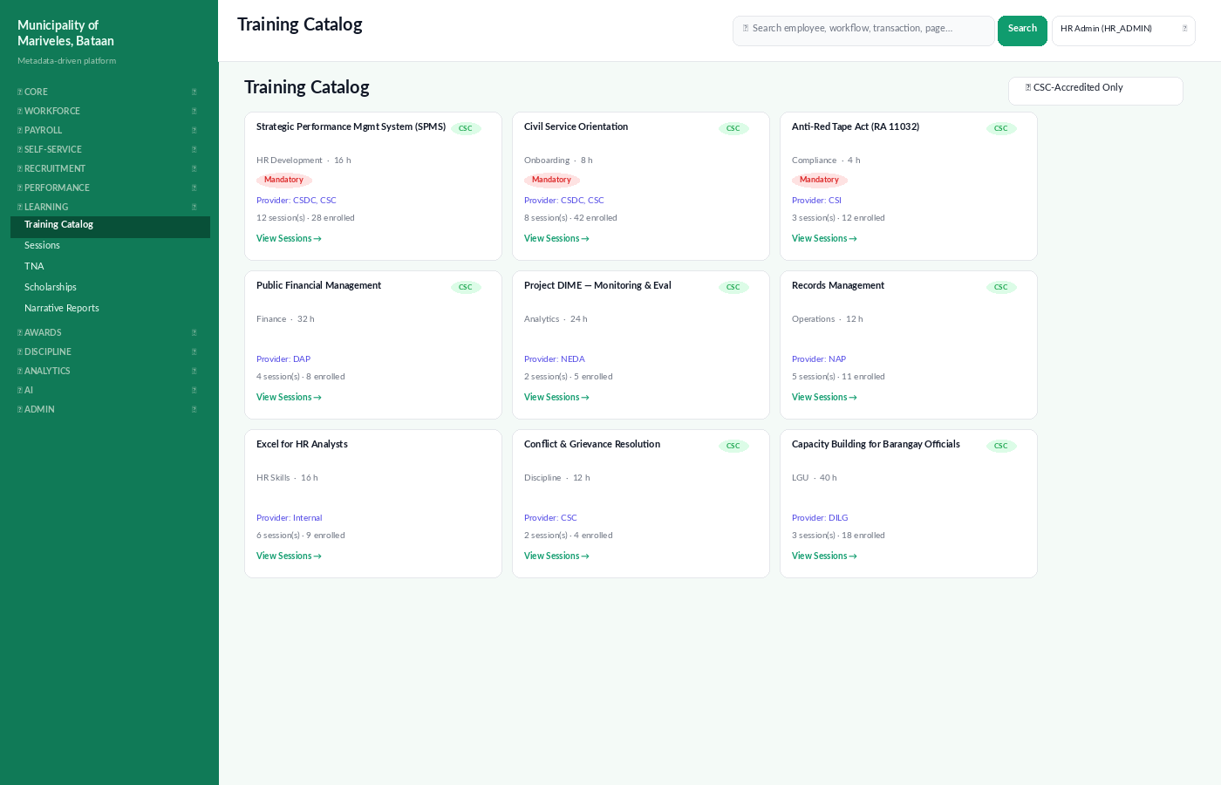
Figure: Training Catalog — programs grouped as cards; CSC and Mandatory badges.
The catalog is the master list of programs available to LGU staff. Each program card shows the title, category, duration, provider, and the count of upcoming sessions and current enrolments.

Adding a program · 🛡 HR Admin / Learning Officer
- Open Learning → Programs and click + New Program.
- Fill in title, category (HR Skills, Compliance, Finance, etc.), and total duration in hours.
- Pick the Learning Service Provider (LSP). Tick CSC-accredited if the program is on the CSC's accredited list.
- Tick Mandatory if every employee in scope must complete the program (e.g., Anti-Red Tape, Code of Conduct).
- Click Save. The program appears on the catalog and is selectable when scheduling sessions.

2.2 Sessions
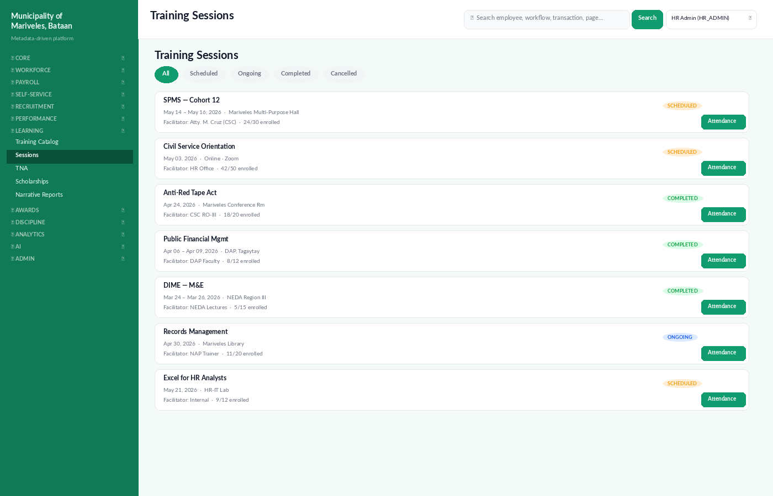
Figure: Training Sessions list — status pills, venue, facilitator, and attendance link.
A session is a concrete instance of a program — a date range, a venue, a facilitator, and an enrolment list. A program can have many sessions (cohorts). Sessions move through SCHEDULED → ONGOING → COMPLETED.

Scheduling a session · 🛡 HR Admin
- From the program detail page, click + New Session.
- Set the start and end dates, the venue, and the facilitator.
- Set the maximum participants. The system enforces this cap during enrolment.
- Open enrolments — employees can self-enrol, or HR can enrol them in batches by department.
- On the session day, click Open Attendance to record attendance via the Geotag Check-In or manual entry.

2.3 Training Needs Analysis (TNA)
TNA is the structured exercise that determines what training each unit needs in the next year. HCM360 builds a TNA matrix from three signals: (a) the gaps between the competency map of each position and the incumbent's recorded skills, (b) IPCR ratings with sub-3 scores on specific MFOs, and (c) self-nominations submitted by employees.

Generating the annual TNA · 🛡 HR Admin / L&D Officer
- Open Learning → TNA at the start of Q4 of the preceding year.
- Click Generate Matrix. The system produces a per-department, per-program needs count.
- Department heads receive a task to validate the matrix and add narrative justification.
- Approved TNA is the input into the next year's L&D Plan and budget.

2.4 Narrative Reports
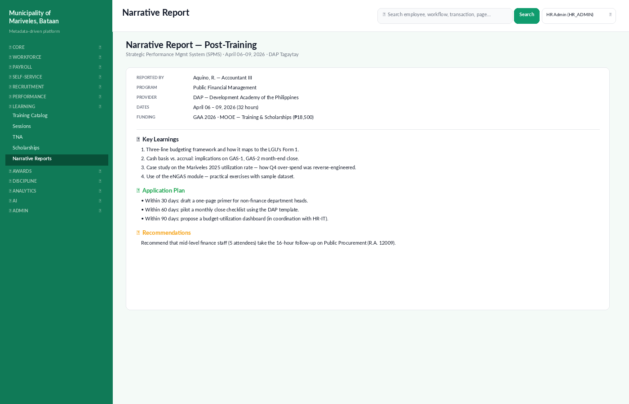
Figure: Narrative Report submitted by an attendee after a training event.
Per CSC and Commission on Audit (COA) requirements, every employee who attends a training paid for from public funds must submit a Narrative Report describing key learnings, an application plan (what they'll do with the learnings within 30 / 60 / 90 days), and recommendations. HCM360's Narrative Report template captures all three and pushes the application plan into the employee's IPCR for the cycle.

Filing a narrative report · 👤 Employee
- Open Learning → Narrative Reports → Pending and pick the training session.
- Fill in the three sections: Key Learnings, Application Plan, Recommendations.
- Attach photos / certificates of attendance.
- Submit. The report routes to the L&D Officer for review and is filed in the 201.
⚠ Within 30 days of attendance
Per LGU policy, the narrative report is due within 30 days of training completion. Overdue reports show on the L&D Officer's Compliance dashboard and on ARIA's morning Alarm Scan.

2.5 Scholarships
Scholarships (DAP, CSC, foreign-funded programmes) are tracked separately because they carry a service obligation period after completion. The Scholarships register stores the contract amount, the service obligation length, and the obligation balance after each year of post-scholarship service.

3. Awards & Recognition (PRAISE)
The Program on Awards and Incentives for Service Excellence (PRAISE) is the LGU's regulator-mandated recognition framework. It runs as a 6-monthly cycle aligned to the IPCR cycle, with categories defined in CSC MC 28, s. 2018. HCM360 manages the nomination workflow, the deliberation, and the awards register.
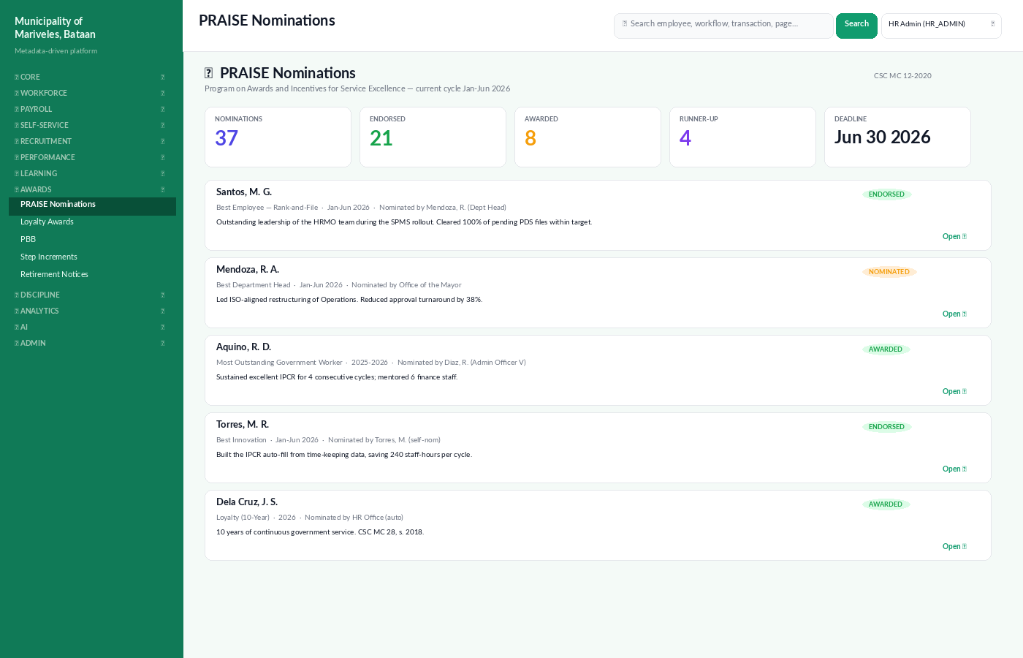
Figure: PRAISE Nominations — current cycle with status chips and category breakdown.

3.1 PRAISE categories
Category | Eligibility | Frequency
Best Employee — Rank-and-File | All rank-and-file plantilla, Outstanding IPCR. | Annually
Best Employee — Supervisory | Supervisory positions, Outstanding IPCR. | Annually
Best Department Head | Department Heads with team-wide outcomes. | Annually
Most Outstanding Government Worker | 2 consecutive Outstanding IPCRs minimum. | Biennially
Best Innovation | Documented innovation with measured impact. | Annually
Best Team / Tropa | Cross-functional teams with shared outcomes. | Annually
Loyalty Awards (5 / 10 / 15 / 20 / 25 / 30 / 35 / 40 yrs) | Continuous service in government. | Continuous · auto-detected
Service Award (retirement) | Eligible retirees (compulsory or optional). | Continuous · auto-detected

3.2 Filing a nomination · any role
- Open Awards → PRAISE Nominations and click + New Nomination.
- Pick the nominee from the employee directory.
- Pick the category and the cycle period.
- Provide the justification (200–500 words). Reference specific outcomes, dates, and beneficiaries.
- Optional: attach supporting evidence — testimonials, photos, output samples.
- Submit. The nomination routes to the PRAISE Committee for deliberation.
ℹ Self-nomination is allowed — but only for Innovation
PRAISE allows self-nomination only for the Best Innovation category, where the nominee is presumed to know the innovation best. All other categories require a third-party nominator.

3.3 PRAISE Committee deliberation · ✦ Super Admin / PRAISE Chair
The PRAISE Committee reviews nominations, scores them against published rubrics, and issues a resolution. HCM360 generates the final tally PDF and the awards certificate templates ready for the Mayor's signature.

Deliberation flow
- Open Awards → PRAISE → Deliberations and pick the cycle.
- For each nomination, members enter scores against the four rubric criteria: Performance, Impact, Innovation, Leadership.
- Once all members score every nomination, click Lock & Generate Resolution.
- The system produces the Awards List PDF and per-awardee Certificate of Recognition templates.

3.4 Loyalty Awards (auto-detected)
Loyalty awards are computed nightly from the employee's continuous-service date. When an employee crosses a 5-year multiple, HCM360 raises a task on the HR queue to prepare the certificate and incentive (cash gift / leave credit / pin). The Loyalty Awards register is the audit trail for COA review.

3.5 Other awards & recognition modules
- PBB — Performance-Based Bonus tracking. Computes eligible amounts per the DBM circular.
- Step Increments — Auto-detected at 3-year service intervals; HR confirms before posting.
- Retirement Notices — Auto-generated 12 / 6 / 3 / 1 months before compulsory retirement (CSC RA 8291).
- Salary Standardization Law (SSL) Table — current rates and step values per RA 11466 / DBM circulars.

4. Discipline & Grievance
The Discipline module manages the LGU's administrative cases under CSC MC 19, s. 2020 (Rules on Administrative Cases in the Civil Service / RACCS). The module enforces the prescribed timeline (NTE → Answer → Investigation → Formal Charge → Hearing → Decision → Appeal → Closed) and produces the required forms and signatures at every step.
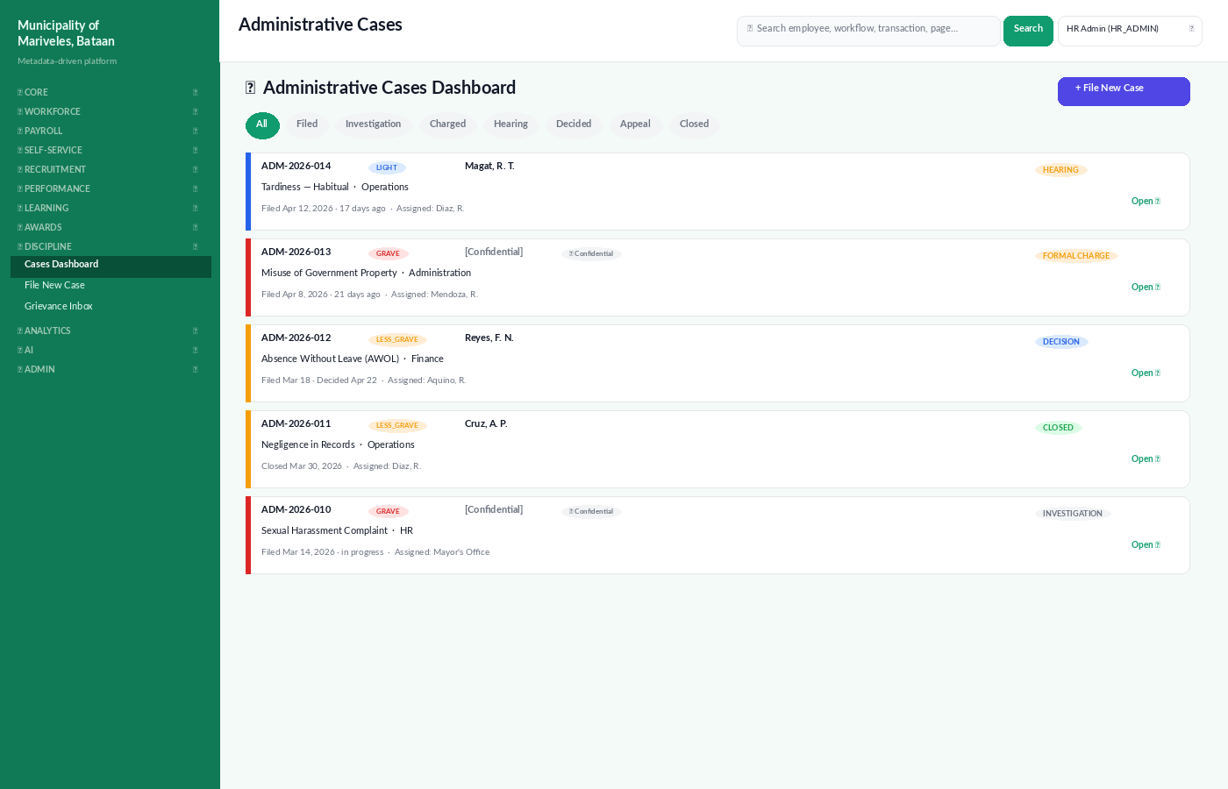
Figure: Administrative Cases Dashboard — gravity colour-coded, status pills, owner.

4.1 Offence gravity
Gravity | Examples | First-instance penalty (RACCS)
GRAVE | Dishonesty, grave misconduct, sexual harassment. | Dismissal, with forfeiture of benefits.
LESS GRAVE | Insubordination, simple misconduct, AWOL > 30 days. | Suspension 1 month 1 day to 6 months.
LIGHT | Habitual tardiness, simple negligence. | Reprimand. Repeat: suspension.

4.2 Filing a case · 🛡 HR Admin / Department Head / any complainant
- Open Discipline → File New Case.
- Identify the respondent and the offence type. Pick a Legal Basis from the dropdown (RACCS, RA 6713, RA 9485, etc.).
- Provide a detailed offence description with dates, witnesses, and impact.
- Attach evidence: documents, photos, biometric logs, timesheets, complaint letters.
- If the case is sensitive (harassment, whistleblower, minor involved), tick Confidential. The case will be visible only to PRAISE/Discipline officers and the Mayor.
- Submit. The case is assigned a case number (ADM-YYYY-NNN) and routed to the Disciplinary Committee.
⚠ Confidential cases
Confidential cases mask the respondent's name and the offence summary on dashboards. Only authorised users (PRAISE / Discipline officers, Mayor's Office) see the full record. All access is logged in the Role-Page Access Audit (RPAA) module.

4.3 Case timeline
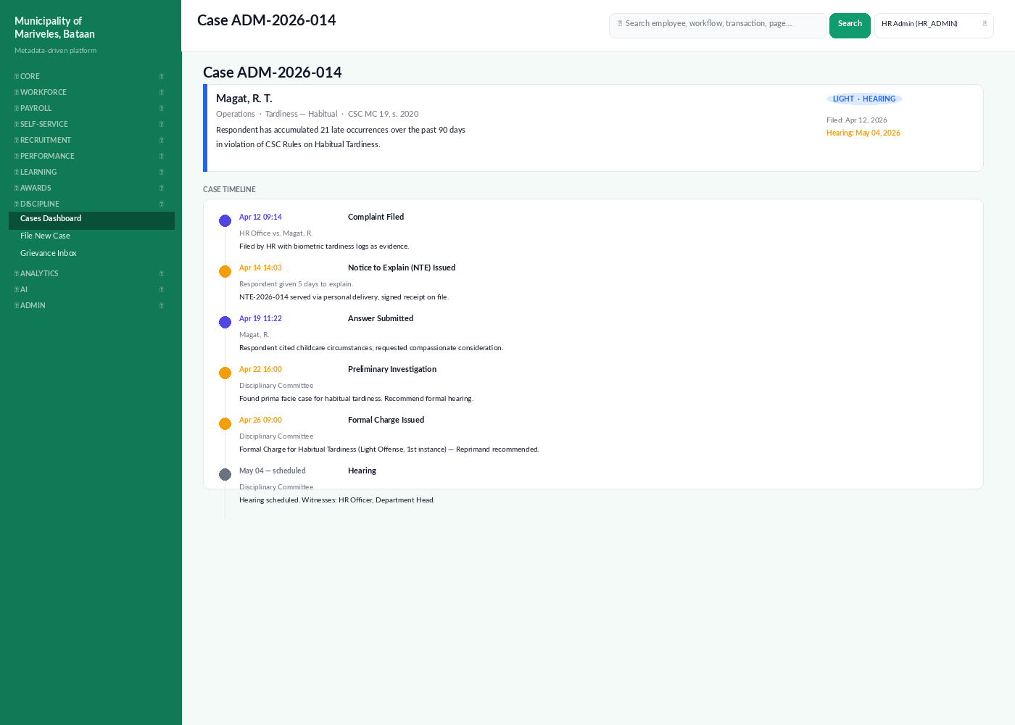
Figure: Case detail with timeline of complaints, NTE, answer, investigation, charge, and hearing.
The case detail page shows every event in chronological order. The system enforces the RACCS timeline: 5 days for the NTE, 5 days for the respondent's answer, 30 days for the preliminary investigation, and so on. The countdown is shown next to each open task; overdue items appear in red on the Disciplinary Committee's dashboard.

4.4 Decision and appeal
- After hearing, the Disciplinary Committee deliberates and drafts a Decision document.
- The Mayor reviews and signs the Decision. The system stamps it with a digital seal.
- The respondent receives the Decision via personal delivery and email; the system generates a proof-of-service record.
- The respondent has 15 calendar days to appeal to the CSC. HCM360 tracks the appeal window.
- On finality of the Decision (no appeal or CSC-final), the case status becomes CLOSED and the penalty is enforced (suspension, salary withholding, or dismissal).

4.5 Grievance vs. Discipline
A grievance is initiated by an employee against the LGU or a co-worker; a disciplinary case is initiated against an employee. They share the same workflow engine but use different forms and route to different bodies. Grievances follow CSC MC 02, s. 2001 (Revised Policies on Settlement of Grievances).
Aspect | Grievance | Discipline
Initiated by | Aggrieved employee. | HR / Department Head / external complainant.
Routed to | Grievance Committee. | Disciplinary Committee.
Confidential | Yes, by default for the complainant. | Optional, based on case sensitivity.
Outcome | Conciliation or formal resolution. | Penalty (Reprimand / Suspension / Dismissal) or Dismissed.
Appeal venue | CSC Regional Office. | CSC then Court of Appeals.

4.6 Continuous Feedback
Aside from formal grievance and discipline, HCM360 ships a Continuous Feedback module that supports peer, upward, and downward feedback. Feedback can be requested or volunteered, and is summarised on each employee's Performance tab. Feedback is advisory, not a substitute for formal grievance — but often resolves issues before they escalate.

5. Where to go next
- Volume 1 covers the Dashboard, Employee Records, Leave, Payroll, Attendance, Performance Management, and the ARIA AI Assistant.
- Volume 2 covers Recruitment, Selection, and Placement — including requisitions and CSC eligibility checks.
- For SSPs (Standard Operating Procedures) on each module, see the companion Process Flows document (07_process_flows.docx).
ℹ Government forms generated by Volume 3
L&D — Training Plan (per CSC), Narrative Report, Scholarship Bond. PRAISE — Awards Resolution, Certificate of Recognition, Loyalty Award certificate. Discipline — NTE (Notice to Explain), Formal Charge, Decision, Notice of Penalty, Proof of Service.

