Results
Table 1. Summary of ASV retention and taxonomic classification across five Illumina sequencing runs. ASV totals, retention rates, and taxonomic classification percentages are shown for each run. Classification sources include the constructed T1D and the GTDB r220 16S database.

When comparing the significantly enriched pathways between NS1 and S2 at weeks 9 and 10, we observed a total of 27 enriched pathways in NS1. When repeating the same analysis between NS6 and S5 at the same time point, we also observed 27 significantly enriched metabolic pathways. However, when comparing the specific pathways deemed to be enriched, 16 (42.1%) were overlapped by both NS1 and NS6, and 11 were unique for each community (Supplementary figure X).

In the unique pathways, NS1 has two pathways involved in methionine biosynthesis and teichoacid synthesis that are not present in NS6. However, propionate degradation (PWY0-1277) while unique in NS1, it shares some similarities in function terms with P281-PWY
3 Phenylpropanoate degradation two present in NS1, one in NS6
NAD salvage pathway only present in NS1
Phenylethylamine superpathway only present in NS1
Phenylacetate degradation only NS1
Gallate degradation only in NS1
Polyamine biosynthesis in NS1 (POLYAMINSYN3-PWY) but 4 pathways related to polyamine degradation in NS6.

Level 1 differences, six biosynthesis superpathways for NS1, for carbohydrate, 2 for tetrapyrrole, 1 for cofactor and vitamins, one for cell structure, and one for amine/amide biosynthesis
Another 8 for superpathway of which one is involved in antibiotic resistance and 7 in degradation. The seven in degradation are involved in aromatic, amide/amine (3), 2 amino acid,
Amongst the unique pathways of each NS consortium, NS1 had 1 cell structure biosynthesis (teichoic acid

Biosynthesis, is about the same. A bit higher in NS1 overall
Degradation is about the same
Metabolic clusters is about the same
One more in detoxification for NS6
Carbohydrate biosynthesis has one more in NS1 and not NS6, that extra one has a value near 7 Log2FC.
C1 compound utilization and assimilation higher by 1 in NS1
Inorganic nutrient metabolism in NS6 but not NS1
Nucleoside and nucleotide degradation not present in NS1 but yes in NS6
Cofactor carrier and biosynthesis higher in NS1 by 3? Pathways
Aromatic compound degradation about the same
None in carbohydrate degradation for NS6

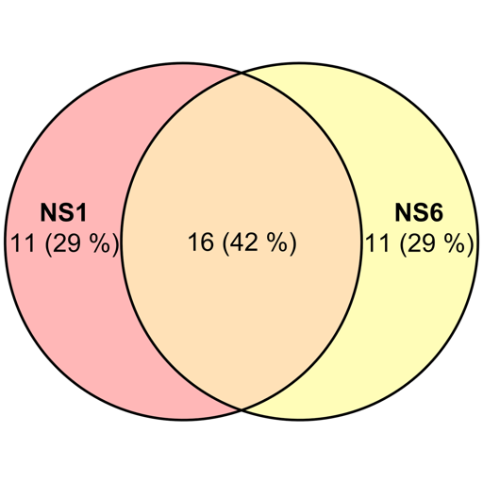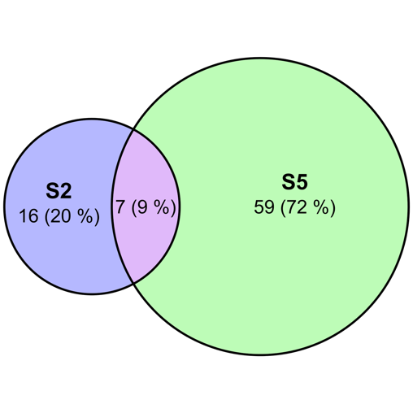
Supplementary figure x. Venn diagrams showing the number and percentages of significantly enriched pathways of NS1 when doing a pairwise comparison of NS1 vs S2 at weeks 9 and 10 vs the significantly enriched pathways of NS6 when doing a pairwise comparison of NS6 vs S5 at weeks 9 and 10. (b) Venn diagrams showing the number and percentages of significantly enriched pathways of S2 when doing a pairwise comparison of NS1 vs S2 at weeks 9 and 10, vs the significantly enriched pathways of S5 when doing a pairwise comparison of NS6 vs S5 at weeks 9 and 10.

Methods
Ethical Declaration
Sample processing and library preparation
Two independent approaches for NGS sequencing were carried out: bacterial whole-genome sequencing (WGS) and 16S rRNA v3v4 amplicon sequencing. For WGS, bacterial pellets were shipped to the University of Calgary (UofC) within XX days of collection and stored at -80 °C until sample processing. Each bacterial pellet was subjected to genomic DNA extraction using [Ask Bisi what type of kit she used for DNA extraction]. DNA library preparation was performed using Twist 96-Plex Library Preparation Protocol, following the manufacturer’s protocols with slight modifications. [LIST THE MODIFICATIONS FROM BISI HERE]. If the genome assembly yielded a medium or low-quality, then the corresponding bacterial pellets were subjected to a new DNA extraction process using the QIAGEN DNeasy PowerSoil Pro Kit following the manufacturer’s recommendations. Then, a library preparation protocol was carried out with the IDT xGen™ NGS DNA Library Preparation kit (confirm this with Bisi).
Paragraph for library prep in 16S v3v4 mice fecal samples and consortia here.
WGS and 16S rRNASequencing
The WGS samples of bacterial strains were sequenced using an Illumina NovaSeq instrument (San Diego, Ca) in paired-end mode (150x2). Genome assemblies with a medium or low quality were re-sequenced with an Illumina MiSeq instrument in paired-end mode (150x2).
The 16S rRNA v3v4 library prep was sequenced using a [TORONTO METHODOLOGY]
Each bacterial pellet was lysed, and the DNA was extracted and purified with XXX. A 16S PCR was carried out using XXX. Gene quality was assessed with their corresponding chromatograms, and visualized using Benchling [CITATION]. Only high-quality sequenced genes were kept for a 16S rRNA database construction.
Genome assembly and functional annotation
The paired-end sequence reads from the WGS run of 116 bacterial isolates were pre-processed for downstream analysis. Cutadapt v2.6 was used for Illumina adapter removal (cutadapt -a GATCGGAAGAGCACACGTCTGAACTCCAGTCAC…GTGACTGGAGTTCAGACGTGTGCTCTTCCGATC -A GTGTAGATCTCGGTGGTCGCCGTATCATT...AATGATACGGCGACCACCGAGATCTACAC -o <output file for trimmed read 1> -p <output file for trimmed read 2> -m 1 -j 14 <input file read 1> <input file read 2>), followed by read filtering and denoising with PRINSEQ-lite v0.20.4 (-fastq <input file read 1> -fastq2 <input file read 2> -trim_left 0 -trim_right 0 -trim_qual_type mean -trim_qual_window 10 -trim_qual_step 2 -trim_qual_rule lt -trim_qual_left 30 -trim_qual_right 30 -lc_method dust -lc_threshold 7 -derep 1 -min_len 60 -ns_max_n 15). Each filtered set of reads was quality assessed and visualized using FastQC v0.11.8. Genome assembly was done with Unicycler v0.4.8 (unicycler -1 <input file read 1> -2 <input file read 2 --mode normal --threads 80 --keep 2 --depth_filter 0.2 --min_fasta_length --out <genome output file>, assessed for assembly quality metrics with QUAST v5.0.2 (quast --output-dir <output directory –threads 28 <input genome assembly file>) and genome completeness and contamination with CheckM v1.2.2 (checkm lineage_wf -t 28 -x fasta --tab_table --file <input genome assembly file> <output file>). If a genome had a medium (completion of ≥ 50% and contamination <10%) or low (completion <50% and contamination <10%) genome assembly quality under the minimum information about a single amplified genome (MISAG) [CITATION], then new bacterial pellets corresponding to those samples were sent for a new round of sample processing, library preparation, sequencing, genome assembly, and annotation.
Genome functional and taxonomic annotations were carried out using Prokka v1.14.6 (prokka --outdir <output directory> --prefix <file prefix> --cpus 56 --kingdom Bacteria --rfam <input genome file>) and GTDBtk v2.4.1 (gtdbtk classify_wf --genome_dir <input genome directory> --extension fasta --cpus 28 --out_dir <output directory> --skip_ani_screen) with the r220 as database reference, respectively. EggNOG-mapper v2.1.12.1 with the eggNOG database 5.0.2 was used for orthology assignments and high-quality functional insight from the output files generated by Prokka (emapper.py -i <input prokka .faa file> -d Bacteria –database <eggNOG hmmer database directory> -o <output directory> --cpu 0 –itype proteins).
Genomic and pangenomic evaluation of functional capabilities
[Section for ANVI’O]
16S rRNA reference database construction
The high-quality sequenced 16S rRNA full-length genes were used as part of a local 16S rRNA database construction. The quality and directionality were determined and visualized in Benchling [CITATION]. In parallel, 16S rRNA gene sequences were identified and extracted in silico from the assembled genomes using Barrnap v0.9 [CITATION]. To confirm the annotation accuracy, each candidate sequence was aligned against the NCBI database using BLAST and retained if it matched the expected taxon. Each consortium had a 16S rRNA database corresponding to the sequenced and annotated genes. Due to the nature of short-read genome assembly and its limitation to distinguish different copy numbers of the same gene, 16S rRNA gene copy numbers were estimated using the Integrated Microbial Genomes (IMG) rrnDB-v5.1 database. Using a custom script (16S_CNV_IMG.py), the median 16S rRNA gene copy number was calculated per strain. When copy number data were unavailable, values from its closest sister taxon were used as a proxy.
Gut Microbiome Taxonomical Characterization
To minimize sequencing and batch effects, each of the five Illumina runs was profiled separately. The 16S rRNA v3-v4 reads were analyzed using a local Snakemake [CITATION] pipeline, FemMicro16S, for microbiome characterization [CITATION, IF ANY?]. This pipeline consists of four main steps: (i) adapter and primer removal, (ii) read quality control, (iii) amplicon sequence variant (ASV) inference, and (iv) taxonomy assignment. First, primers and Illumina adapters were removed with Cutadapt [VERSION, CITATION]. Read quality was then assessed across all samples using FastQC (VERSION, CITATION) and summarized and reported with MultiQC (VERSION, CITATION). The Divisive Amplicon Denoising Algorithm (DADA2) was used for ASV inference, including an additional read and trim filtering, dereplication, error estimation and denoising, chimera removal, and paired-end read merging.
Taxonomy assignment was performed with DADA2 and VSEARCH against the previously built 16S rRNA local database (hereafter referred to as ‘T1D database’) and the 16S rRNA Genome Taxonomy Database (GTDB) r220 (CHECK VERSION AND CITATION). ASVs were first aligned to the T1D database using VSEARCH global alignment. ASVs with ≥ 99.3% sequence identity were assigned to their corresponding taxon. ASVs not meeting this threshold were subsequently aligned against the GTDB database using the same criteria. For ASVs that could not be speciated with the previous approach, the taxonomic assignment was then performed at the genus level by using the DADA2 RDP Naïve Bayesian classifier with a 97% identity threshold, first against the T1D database, and then against the GTDB if necessary, if no match was previously found. In the event where two or more taxa shared identical sequence similarity ≤ 99.3%, FemMicro16S assigned taxonomy at the lowest taxonomic rank where a consensus was met across all candidates.

In the event of two distinct taxa having the same percentage of identity, FemMicro16S moves up one taxonomic rank until both taxa agree on the same classification. Finally, taxonomic and ASV count tables were generated and filtered using the inocula and controls as references. An ASV was discarded if it did not meet a minimum ASV prevalence of 20% across all samples, a length of ≥ 400 bp, and a total count of ≥ 600.
Functional prediction
An adapted version of the PICRUSt2 v2.5.3 software package (Phylogenetic Investigation of Communities by Reconstruction of Unobserved States) [CITATION] was run in local mode to estimate the functional potential of the gut microbiome across consortia and timepoints. This approach required four reference input files: (i) a multiple sequence alignment of the T1D database sequences, (ii) the matching phylogenetic tree, (iii) a model file of the tree’s parameters, and (iv) a hidden Markov model (HMM) profile derived from the 16S alignment. The T1D database sequences were aligned using MAFFT v(mafft –auto <unaligned _input_sequences> > < aligned_output_sequences) [CITATION] (PARAMETERS). The HMM profile was then generated with HMMER [VERSION, CITATION] (hmmbuild <hmm output file> <multiple sequence alignment file>. Each phylogenetic tree and its corresponding tree model were generated with RAxML v0.9.0 [CITATION] (raxml-ng --search --msa <input_16S_T1D_aligned_database> --model GTR+G --prefix <prefix_name> --seed 100 --threads 1). The functional predictions were generated independently for each community by using their corresponding ASV-filtered count tables. The PICRUSt2 workfow was executed stepwise by starting with the ASV engraftment into the 16S reference tree (place_seqs.py -s <ASV_sequences.fasta> -r <reference_files_directory> -p 10 --intermediate <intermediate_directory> --verbose -o <placement_sequence_tree_output>. Given the closed-system design of our experiment, the hidden state prediction step was modified to assign the 16S rRNA gene copy number, as well as the EggNOG-derived KOs and ECs count to each ASV based on its nearest neighbour in the reference tree (hsp.py -t <asv_placed_sequences_engrafted_tree.tre> --observed_trait_table <function_specific_file.tsv> --calculate_NSTI -m nearest_neighbour -p 32 --seed 23 --verbose -o <function_specific_nsti_predicted_file.tsv> (modified script available at: [INCLUDE REFERENCE FROM GITHUB]. Finally, the metagenome and pathway inference steps were run without any further modifications. The metagenome prediction step was performed using the metagenome_pipeline.py (metagenome_pipeline.py -i <community_specific_asv_count_table.tsv> -m <community_specific_16S_nsti_predicted_file.tsv> -f <function_specific_nsti_predicted.tsv> --strat_out --wide_table -p 32 -o <community_specific_and_function_specific_metagenome_prediction_directory>) , followed by the pathway inference using pathway_pipeline.py (pathway_pipeline.py -i <community_specific_EC_metagenome_stratified.tsv> -o <output_community_specific_pathway_inference_directory> --intermediate <output_community_specific_pathway_intermediate_files.tsv> -p 32 --coverage --per_sequence_contrib --per_sequence_abun <community_specific_EC_metagenome_seqtab_norm.tsv> --per_sequence_function <community_specific_EC_metagenome_nsti_predicted.tsv> --wide_table).
Data analysis
The metagenomic profile of the mice’s gut microbiomes was predicted based on the 16S rRNA v3v4 sequencing data. Using the 16S combined database as a reference, a maximum likelihood phylogenetic tree was generated for each consortium with RAxML (using the specified parameters).

bifido longum
collinsella sp1, sp2
eggerthella lenta
eisenbergiella tayi
enterocloster bolteae/
e. coli
f. plautii

First, create a file that has the ID of the genomes of interest, and the path to the database of the assembled genome:

Then, generate a genome storage database:

Then generate the pangenome analysis:
anvi-pan-genome -g COLLINSELLA_GENOMES.db --project-name "Collinsella_Pangenomes" -o Collinsella-PAN.db --num-threads 32 --minbit 0.5 --mcl-inflation 10 --use-ncbi-blast

Finally:
anvi-display-pan -g COLLINSELLA-PROJECT/COLLINSELLA_GENOMES.db -p COLLINSELLA-PROJECT/Collinsella-PAN.db

And choose the features you want to keep. I think these are useful:
Avg AAI
KOfam
Kegg Class
Kegg Module
SCG clusters

