DC SRAP meeting 49
Time: 2024-07-30, 15:00-16:00 UTC
Place: Zoom, https://helsinki.zoom.us/j/62368569596?pwd=UGQxenZFbjZQUlluRzdQQUM1UFhaUT09

Notes
- Opening of the meeting

Alasdair, Karen and Osma attending
- Appointment of the minutes taker

Alasdair to take minutes
- Approval of the agenda
- Minutes of previous meetings
Minutes of previous meetings are on GitHub:
https://github.com/dcmi/dc-srap/tree/main/meetings

Minutes approved; noted that minutes for all previous meetings are up to date on GitHub
- OR2024 conference
Osma presented the SRAP poster at the OR2024 conference in Göteborg, Sweden in early June.
Notes were posted by Osma to the mailing list on 7 June

Osma noted interest from delegates at the poster session. No follow up contacts as yet. Presentation from developers of Rioxx standard; uses exisitng DC terms with attributes in XML serialization

KC: useful to crosswalk between SRAP and Rioxx; includes first named author as an attribute.
Does Rioxx cover what we cover?
OS: Need to compare how Rioxx maps to SRAP
KC: Have compared SRAP to DSpace previously; metadata in DSpace 8 is significantly different.
OS: NLF using instance of DSpace 7; many institutions still on version 5
KC: Some date elements now removed from SRAP; retained embargoDateRange and retracted
OS: Rioxx includes public releasee date

Action: Karen to begin work on mapping Rioxx to SRAP

- ISO TC46/SC4 plenary and NISO Journal Article Versions
Osma presented the annual DCMI liaison report to the ISO TC46/SC4 plenary meeting in May. One of the major items in the report was the status of SRAP. TC46/SC4 was very pleased with the work.

Todd Carpenter suggested that we should take a look at the NISO Journal Article Versions standard, which is currently being revised. A new draft version was on public review from May to July 7. If and when there is overlap between the new JAV and SRAP, we should make sure that at least the terminology we use is aligned. More information can be found on https://www.niso.org/standards-committees/jav-revision

OS: Includes elements for lifecycle and terminology relating to different versions of a publication
KC: Assigns a status to a publication – not a date. No longer have date elements in SRAP; good to have standard ID for status
OS: NISO has namespace; currently draft and not final version; natural vocabulary for status values
OS: Pull request 44 – removal of publication statuses and dates from SRAP
KC: May have accepted PDF document but not exact date of acceptance
AM: Issue of carrier/formatting defining status?
KC: General date element would be aligned with status
OS: FinGreyLit includes versions at different stages

Action: Alasdair to discuss metadata and publication life cycle with Edinburgh University Open Access colleagues
- New FinGreyLit data model
Osma has been working on the FinGreyLit data set, a set of 800 grey literature PDF documents with accompanying "ground truth" metadata intended to be used for training and evaluating metadata extraction systems. One of the challenges is to verify that the metadata corresponds with what is stated in the publications themselves, as there are often subtle differences between what the cataloguer knows and what the publications actually say.

FinGreyLit has been using a flat, DC-HTML-ish metadata model which is based on what is used in the DSpace repositories where the documents were harvested, but this has been a bit difficult to work with. A new simpler, not explicitly DC-based JSON metadata model better aligned with the requirements for the metadata extraction task is under works. It also happens to align quite well with SRAP! Here is a screenshot from a draft JSON Schema:

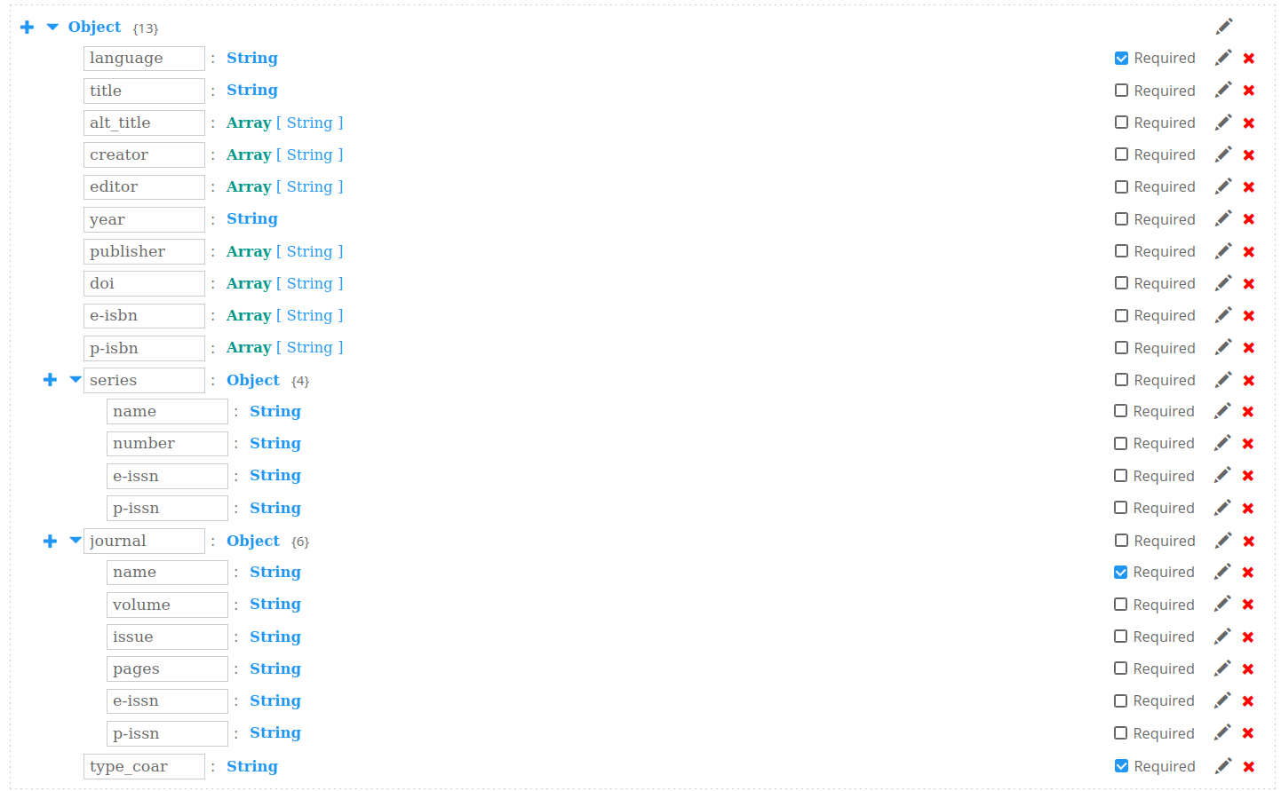

Some aspects are still missing from the model, e.g.
- other contributor roles, esp. related to academic theses (degree supervisor, reviewer, opponent…)
- organizational context e.g. organization, org. unit, faculty, department…
- study context e.g. discipline, degree program
- Flat model / dot syntax for SRAP
GitHub issue: https://github.com/dcmi/dc-srap/issues/53

See also the discussion at SRAP meeting 48.

OS: FinGreyLit JSON schema – some ‘flat’ while others have sub-elements. Not modelled contributor roles yet; still have issue of organisation/faculty
Trying to use machine learning/LLMs to extract metadata from PDFs

Postpone last two agenda items
KC: Will add comments to proposals for classes.
- Classes to be proposed to DCTerms
GitHub issue: https://github.com/dcmi/dc-srap/issues/54

Based on discussions at SRAP meeting 48, Karen created this issue about suggesting new classes for DCTerms.
- Any other business
- Closure of the meeting

