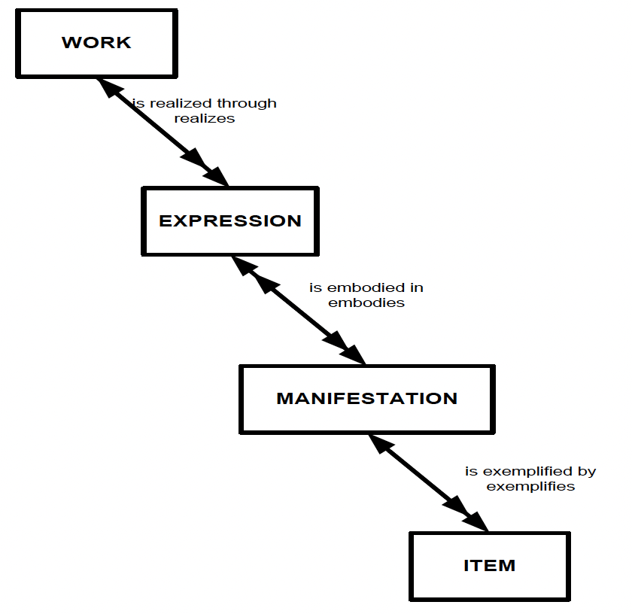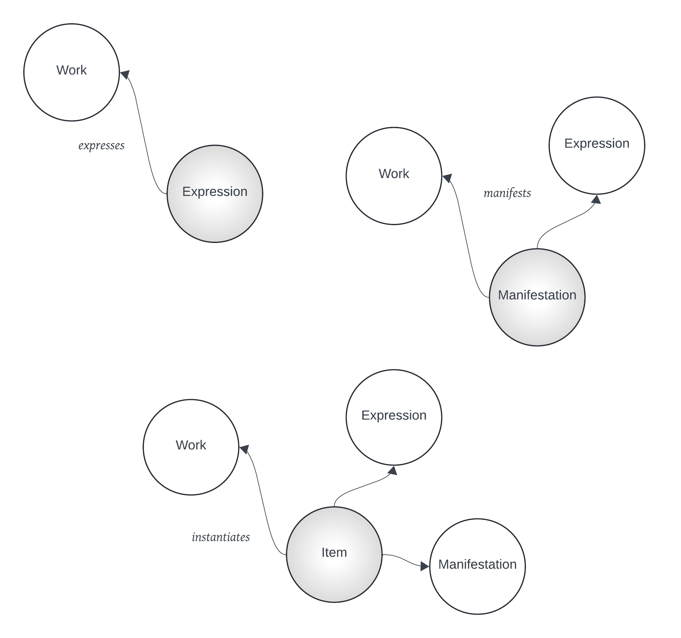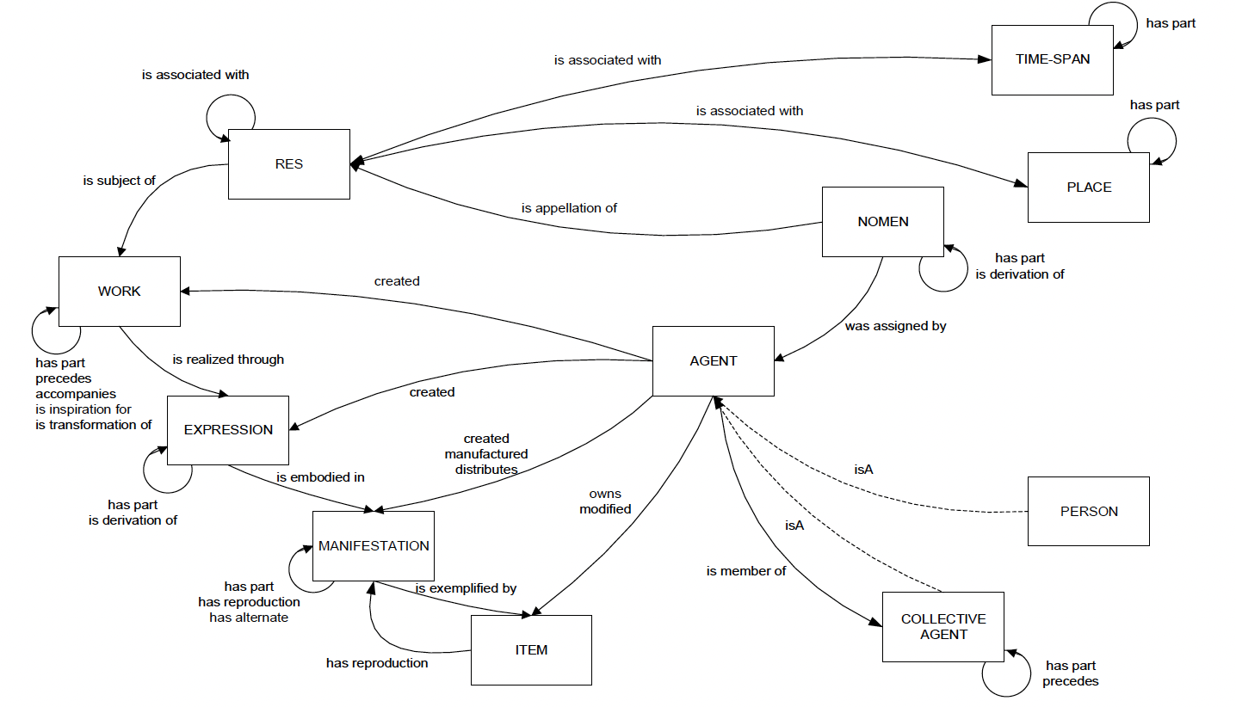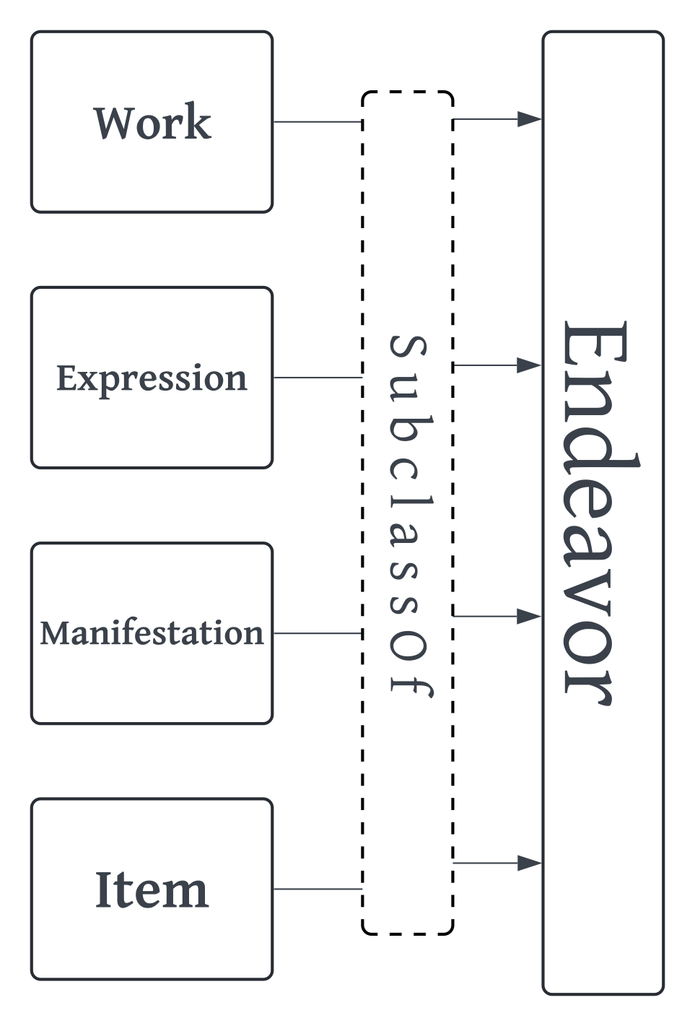Line Line

*A minimally constrained vocabulary for Work, Expression, Manifestation, Item*

A Dublin Core-supported vocabulary

Metadata creators and managers who are not creating library data have discovered WEMI through FRBR. They need a version of WEMI that has fewer constraints and is less oriented to library applications. They may create vocabularies that do not use all of the WEMI classes, or they may need to create new classes and subclasses for their applications. You can find more details at:



**OpenWEMI compared to FRBR/LRM**



**FRBR/LRM**



**OpenWEMI**



* **Res**: "Any entity in the universe of discourse"
* **Work**: "The intellectual or artistic content of a distinct creation"
* **Expression**: "A distinct combination of signs conveying intellectual or artistic content"
* **Manifestation**: "A set of all carriers that are assumed to share the same characteristics as to intellectual or artistic content and aspects of physical form. That set is defined by both the overall content and the production plan for its carrier or carriers"
* **Item**: "An object or objects carrying signs intended to convey intellectual or artistic content"
* **Endeavor**: "A creation"
* **Work**: "An abstract notion of an Endeavor."
* **Expression**: "A perceivable form of an Endeavor."
* **Manifestation**: "A realization of an Endeavor in physical, digital, or experiential form."
* **Item**: "An instantiation of an Endeavor."
* Linear linking only
* Entities are disjoint and required
* Allows all logical linking
* Classes are not disjoint
* None are required

Is an application profile for library catalog data with many entities and their attributes.

This is it. Just this. Not related to any specific application or type of resource.

**Why OpenWEMI?**



https://journal.code4lib.org/articles/16491

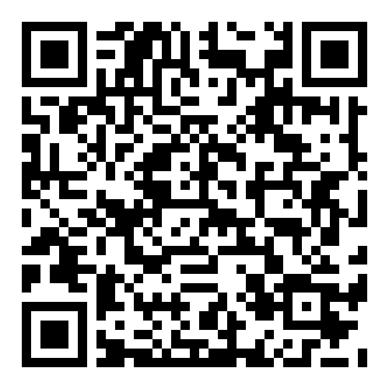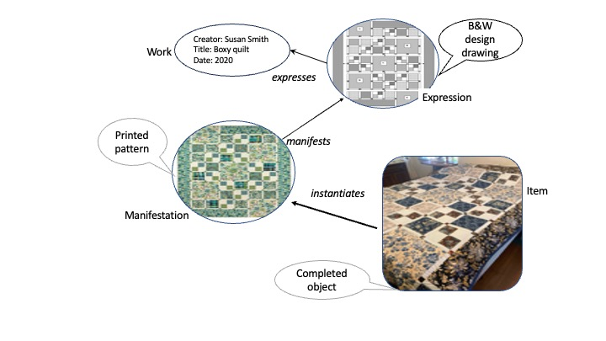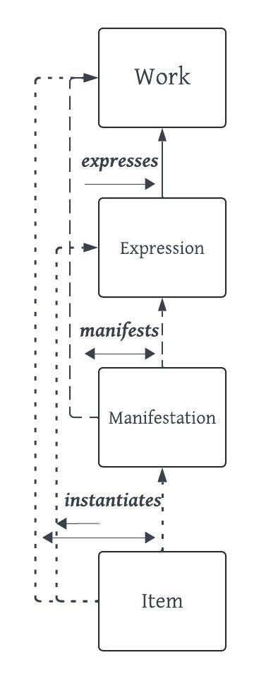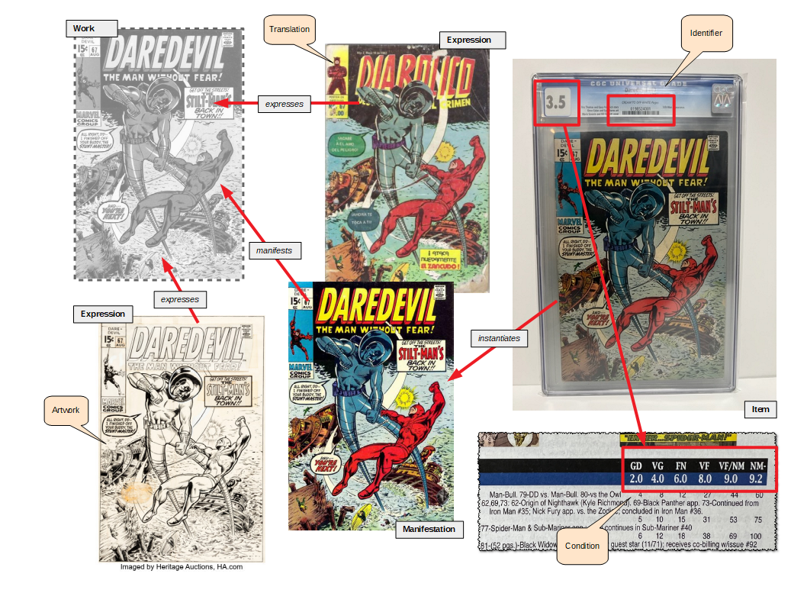

**Definitions**

Classes



* **Endeavor**: "A creation"
* **Work**: "An abstract notion of an Endeavor."
* **Expression**: "A perceivable form of an Endeavor."
* **Manifestation**: "A realization of an Endeavor in physical, digital, or experiential form."
* **Item**: "An instantiation of an Endeavor."

**OpenWEMI classes**

These are the four classes of FRBR Group1, with the addition of a super class, Endeavor, that serves to identify and group WEMI. The definitions are similar to the ones of the Library Reference Model (LRM) of IFLA, but at a higher level of abstraction.

* **expresses** (range: **Work**)
* **expressedBy** (range: **Expression**)
* **manifests** (range: **Work or Expression**)
* **manifestedBy** (range **Manifestation)**
* **instantiates** (range: **Work or Expression or Manifestation**)
* **instantiatedBy** (range: **Item**)

**Definitions**

Properties



**OpenWEMI properties**

The properties in OpenWEMI are as open as possible while still maintaining the key semantics that go from most abstract (Work) to most concrete (Item).

Namespace



* commonEndeavor
* commonWork
* commonExpression
* commonManifestation
* commonItem

Bonus properties!



*Can be used to link any two resources that have something in common.*

@prefix q: <https://example.org/quilt/vocab/> .

@prefix ex: <https://example.org/quilt/examples/> .

@prefix dct: <http://purl.org/dc/terms/> .

@prefix schema: <https://schema.org/> .

@prefix xsd: <http://www.w3.org/2001/XMLSchema#> .

ex:quilt1 a q:quiltWork ; #subclass of openwemi:Work

dct:title "Big EZ Quilt Pattern" ;

dct:creator <https://www.connectingthreads.com/Vicki%20Bellino> .

ex:quilt2 a q:quiltExpression ; #subclass of openwemi:Expression

q:qexpresses ex:quilt1 ; #subproperty of openwemi:expresses

q:quiltDesign <ccc.pdf> .

ex:quilt3 a q:quiltManifestation ; #subclass of openwemi:Manifestation

q:qmanifests ex:quilt2 ; #subproperty of openwemi:manifests

q:quiltPattern <ddd.pdf> .

ex:quilt4 a q:quiltItem ; #subclass of openwemi:Item

q:instantiates ex:quilt3 ; # subproperty of openwemi:instantiates

dct:creator "Karen Coyle" ;

schema:image <http://kcoyle.net/quilts/bigpattern.jpg> ;

dct:date "2022"^^xsd:gYear .

*A quilt pattern with WEMI relationships*



A minimally constrained vocabulary for Work, Expression, Manifestation, Item

@base <http://example.org/> .

@prefix dcterms: <http://purl.org/dc/terms/> .

@prefix gcd: <https://www.comics.org/issue/> .

@prefix openwemi: <https://ns.dublincore.org/openwemi/> .

@prefix rdf: <http://www.w3.org/1999/02/22-rdf-syntax-ns#> .

[

a openwemi:Work ;

dcterms:title "Daredevil (1964) #67" ;

openwemi:manifestedBy gcd:23651 ;

openwemi:expressedBy gcd:505288 ;

] .

gcd:23651 a openwemi:Work, openwemi:Manifestation ;

openwemi:instantiatedBy [

dcterms:identifier "0198524001" ;

rdf:type openwemi:Item ;

] .

gcd:505288 a openwemi:Work, openwemi:Expression ;

dcterms:title "Diabólico (1964) #67" .

https://ns.dublincore.org/openwemi/

Examples



https://www.dublincore.org/specifications/openwemi/

*Comics metadata using OpenWEMI*