/SC WG7 N 24751-3
Date: 2005-11-01

Document Type: | Final Committee Draft
Document Title: | Individualized Adaptability and Accessibility in E-learning, Education and Training  Part 3: Access For All Digital Resource Description
Document Source: | Project Editors:  Jutta Treviranus, Canada  Liddy Nevile, Australia  Andy Heath, UK
Project Number: | 24751
Document Status: | Proposal for FCD (part 3)
Action ID: | For FCD ballot by JTC1/SC36
Due Date:
Distribution: | P, O & L Members, WG Convenors & RG Rapporteurs
Medium:
Disk Serial No.:
No. of Pages:

ISO/IEC† /SC 36 WG7 N 24751-3
Date: 2005-11-01
ISO/IEC†
ISO/IEC†JTC1 SC 36/WG 7
Secretariat:
Individualized Adaptability and Accessibility in E-learning, Education and Training
Part 3: Access For All Digital Resource Description

Warning
This document is not an ISO International Standard. It is distributed for review and comment. It is subject to change without notice and may not be referred to as an International Standard.
Recipients of this draft are invited to submit, with their comments, notification of any relevant patent rights of which they are aware and to provide supporting documentation.

Copyright notice
This ISO document is a Draft International Standard and is copyright-protected by ISO. Except as permitted under the applicable laws of the user's country, neither this ISO draft nor any extract from it may be reproduced, stored in a retrieval system or transmitted in any form or by any means, electronic, photocopying, recording or otherwise, without prior written permission being secured.
Requests for permission to reproduce should be addressed to either ISO at the address below or ISO's member body in the country of the requester.
ISO copyright office
Case postale 56 • CH-1211 Geneva 20
Tel. + 41 22 749 01 11
Fax + 41 22 749 09 47
E-mail copyright@iso.org
Web www.iso.org
Reproduction may be subject to royalty payments or a licensing agreement.
Violators may be prosecuted.
Project Editors’ Notes
- Project editors notes on ballot resolution and WG1 input.

Contents Page
Introduction viii
1 Scope 1
Purpose 1
2 Normative reference(s) 1
2.1 ISO/IEC 2
2.2 Referenced Specifications 2
3 Terms and definitions 3
4 Abbreviation 5
5 Basic Principles 5
5.1 Assumptions Error! Bookmark not defined.
5.2 Original and Alternative Resources Error! Bookmark not defined.
5.3 Original Resource Metadata Error! Bookmark not defined.
5.4 Access Mode Error! Bookmark not defined.
5.5 Adaptability Error! Bookmark not defined.
5.5.1 Display Transformability Error! Bookmark not defined.
5.5.2 Control Flexibility Error! Bookmark not defined.
5.5.3 Pointer to Alternative in Original Error! Bookmark not defined.
5.5.4 Embedded Alternative Error! Bookmark not defined.
5.5.5 Alternative Resource Metadata Error! Bookmark not defined.
5.6 The Importance of Interoperability for Accessibility Error! Bookmark not defined.
6 Access For All Digital Resource Description (ADRD) Information Model 1
6.1 Access For All Resource 1
6.2 Is Adaptation 1
6.3 Adaptation Statement 1
6.4 Access Mode Statement 1
7 Extending the Standard 4
8 Conformance 4
9 Glossary Error! Bookmark not defined.
Annex A (normative) Vocabulary Codes 5
A.1 Access Mode Vocabulary Codes Error! Bookmark not defined.
A.2 Access Mode Usage Vocabulary Codes 5
A.3 Adaptation Coverage Vocabulary Codes 6
A.4 Adaptation Type Vocabulary Codes Error! Bookmark not defined.
A.5 Control Flexibility Vocabulary Codes Error! Bookmark not defined.
A.6 Display Transformability Vocabulary Codes 7
A.7 Obstacle Vocabulary Codes Error! Bookmark not defined.
A.8 Representative Form Vocabulary Codes Error! Bookmark not defined.
A.9 Support Tool Vocabulary Codes Error! Bookmark not defined.
Annex B (informative) Suggested Default Values 12
Annex C (informative) Bindings 13
Annex D (informative) Scenarios 14
D.1 Scenario 1: Discovery and Retrieval of Alternate Training Content 14
D.2 Scenario 2: Customization of Information about a Prescription 14
D.3 Scenario 3: Extreme Instructional Environments 14
Annex E (informative) Implementation Example 15
E.1 TILE Low Vision Example 15
E.2 TILE Caption Example 18

Foreword
ISO (the International Organization for Standardization) and IEC (the International Electrotechnical Commission) form the specialized system for worldwide standardization. National bodies that are members of ISO or IEC participate in the development of International Standards through technical committees established by the respective organization to deal with particular fields of technical activity. ISO and IEC technical committees collaborate in fields of mutual interest. Other international organizations, governmental and non-governmental, in liaison with ISO and IEC, also take part in the work. In the field of information technology, ISO and IEC have established a joint technical committee, ISO/IEC JTC 1.
International Standards are drafted in accordance with the rules given in the ISO/IEC Directives, Part 2.
The main task of the joint technical committee is to prepare International Standards. Draft International Standards adopted by the joint technical committee are circulated to national bodies for voting. Publication as an International Standard requires approval by at least 75 % of the national bodies casting a vote.
Attention is drawn to the possibility that some of the elements of this document may be the subject of patent rights. ISO and IEC shall not be held responsible for identifying any or all such patent rights.
ISO/IEC 24751 was prepared by Joint Technical Committee 1 ISO/IEC JTC 1, Subcommittee SC 36, Information Technology for Learning, Education, and Training.
ISO/IEC 24751 consists of the following parts, under the general title Individualized Adaptability and Accessibility in E-learning, Education and Training
Part 1: Framework and Reference Model
Part 2 Access For All Personal Needs and Preferences for Digital Delivery
Part 3: Access For All Digital Resource Description

Introduction
In this document, the term disability is defined as a mismatch between the needs of the user and the resource offered. It is therefore not a personal trait but an artifact of the relationship between the user and the resource environment or delivery. Accessible systems adjust the user interface of the learning environment, locate needed resources, evaluate the properties of the available resources to match the needs and preferences of the user, and deliver to the learner the most accessible content available.
The Access For All Digital Resource Description (DRD) defines accessibility metadata that is able to express a resource's ability to match the needs and preferences of a user, as described by their Access For All Personal Needs and Preferences (PNP), already defined in Part 2. The DRD is intended to benefit anyone experiencing a mismatch between needs and preferences and education delivered. For people with disabilities whose choice of access modalities is restricted the process of matching a resource with a user requirement is not a matter of convenience or refinement, but one of utmost importance in ensuring access. As a result, it is necessary for systems to agree upon well-defined interfaces and usage. This closely defined approach is taken by the Access For All Digital Resource Description (DRD) standard to support optimum interoperability.
The Access For All Digital Resource Description is not judgmental but informative; the purpose is to facilitate the discovery and use of the most appropriate content for each user. Users of alternative access systems need to know whether a resource is compatible with their required access method, e.g., a user who is blind may need audible access to a resource as opposed to visual access. It does not describe how to create accessible content; other work has been completed that describes how content and media objects can be made more accessible (e.g., W3C/WAI Web Content Accessibility Guidelines [W3C/WAI WCAG] for details).
Individualized Adaptability and Accessibility in E-learning, Education and Training
Part 3: Access For All Digital Resource Description

Scope
The scope of this part of the multi-part standard is to provide a common language for description of digital learning resources to facilitate matching of those resources to learners’ accessibility needs and preferences.
Metadata can be used for two accessibility related purposes: to record compliance to an accessibility specification or standard (e.g., for adherence to legislated procurement policies) or to enable the delivery of resources that meet a user's needs and preferences. The Access For All Digital Resource Description (DRD) specification addresses the latter purpose. Metadata to assert compliance to an accessibility specification or standard is not within the scope of this specification.
The Digital Resource Description is intended to be applied in combination with the Access For All Personal Needs and Preferences (Part 2) that provides a means to describe how a user desires to access online learning content and related applications. The Digital Resource description in this part of the multipart standard is intended to describe aspects of a computer system (including networked systems) that can be adjusted to improve accessibility. They are not intended to address non-digital systems that may include physical location, other people, external processes, etc.
This part focuses on the description of the characteristics of the resource that affect how it can be perceived, understood or interacted with by users including:
a) what sensory modalities are used in the resource,
b) ways in which the resource is adaptable (i.e. whether text can be transformed automatically),
c) which methods of input the resource accepts , and
d) what alternatives are available.

Purpose
The Access For All Digital Resource Description, Part 3 of the multi-part standard provides an information model for describing learning resources so that individual learner preferences and needs (described according to Part 2 of this standard) can be matched with the appropriate user interface, tools and learning resources within a computer-mediated learning environment.

Normative reference(s)
Project Editor's Notes
- ISO Directives allow for normative referencing of non-ISO/IEC "documents" as "Referenced Specifications" (RS). {See further, ISO/IEC JTC1 N 4046 "The Normative Referencing of Specifications other than International Standards in JTC1 International Standards - Guidelines for JTC1 SCs" (1996-03-13). These have been amended as per JTC1/SC32 Santa Fe (2003) Plenary Resolution 30. {See 32N0978}
- The Normative References are divided into two parts; namely: 2.1 ISO/IEC Standards and 2.2 Referenced Specifications.
The following referenced documents are indispensable for the application of this document. For dated references, only the edition cited applies. For undated references, the latest edition of the referenced document (including any amendments) applies.

ISO/IEC Standards
The following standards contain provisions that, through reference in this text, constitute provisions of this International Standard. At the time of publication, the editions indicated were valid. All standards are subject to revision, and parties to agreements based on this Collective Standard are encouraged to investigate the possibility of applying the most recent edition of the standards indicated below.
ISO TS 16071 "Ergonomics of human-system interaction - Guidance on accessibility for human-computer interfaces."
ISO/IEC Guide 71 "Guidelines for standards developers to address the needs of older persons and persons with disabilities."
ISO 639-2:1998 (E/F) Codes for the representations of names of languages - Part 2: Alpha-3 code/Codes pour la représentation des noms de langue - Partie 2: Code alpha-3
ISO 704:2000 (E/F) Terminology work - Principles and methods/Travail terminologique - Principes et méthodes
ISO 1087-1:2000 (E/F) Terminology work - Vocabulary - Part 1: Theory and application/Travaux terminologiques - Vocabulaire - Partie 1: Théorie et application
ISO 1087-2:2000 (E/F) Terminology work - Vocabulary - Part 2: Computer applications/Travaux terminologiques - Vocabulaire - Partie 2: Applications logicielles.
ISO/IEC 2382:1976-2000 (E/F) Information Technology - Vocabulary, Parts 1-34/Technologies de l'information - Vocabulaire, Parties 1-34 (as applicable)
ISO 5127:2001 (E/F) Information and documentation — Vocabulary - Vocabulaire
ISO/IEC 11179-1:1999 (E) Information technology -- Specification and standardization of data elements - Part 1: Framework for the specification and standardization of data elements
ISO/IEC 11179-3:1994 (E) Information technology -- Specification and standardization of data elements -- Part 3: Basic attributes of data elements
ISO/IEC 11179-3:2003 (E) Information technology - Metadata Registries (MDR) - Part 3: Registry Metamodel and basic attributes
ISO/IEC 11179-3:2003 (E) Information technology - Metadata Registries (MDR) - Part 3: Registry Metamodel and basic attributes
ISO 19115:2003 (EN) (4.2) Geographic information -- Metadata
ISO/IEC 19501-1:2002 (E) Information technology — Unified Modelling Language (UML) — Part 1: Specification
ISO 15836:2003 (E) Information and documentation — The Dublin Core metadata element set Information et documentation — Éléments fondamentaux de métadonnées appelés
ISO 639-2:1998 (E/F) Codes for the Representation of Names of Languages Part 2: Alpha-3 Code

Referenced Specifications
DCMI Metadata Terms [DCMI MT] {http://dublincore.org/documents/dcmi-terms/}
IETF RFC 2119 - Key words for use in RFCs to Indicate Requirement Levels [RFC 2119]
IETF RFC 3986 Uniform Resource Identifier (URI): Generic Syntax [RFC3986] {http://www.ietf.org/rfc/rfc3986.txt}
IETF RFC 3066 - Tags for the Identification of Languages [RFC3066] {http://www.ietf.org/rfc/rfc3066.txt}
IMS Learner Information Package Accessibility for LIP - Version 1 [ACCLIP] {http://imsglobal.org/accessibility}
IMS AccessForAll Meta-data Specification - Version 1 [ACCMD] {http://imsglobal.org/accessibility}
W3C/WAI Web Content Accessibility Guidelines [W3C/WAI WCAG] {http://www.w3.org/TR/WAI-WEBCONTENT/}

Terms and definitions
For the purposes of this document, the terms and definitions in the Framework (Part 1) and the following terms and definitions apply.

access for all
an approach to providing accessibility in a computer mediated environment in which the resources and their method of delivery is matched to the needs and preferences of the user
[ACCMD]
NOTE: This approach was first described in the IMS AccessForAll Specifications.

access mode
a human sense, perceptual system, or cognitive faculty through which a user or agent may process or perceive the content of a resource

adaptation (noun)
a resource or resource part that presents the intellectual content of all or part of another resource (see alternative)

format
The physical or digital manifestation of the resource.
Adapted from [ISO 15836:2003]
Note: This is usually expressed as a MIME type..

type
nature or genre of an adaptation
Adapted from [ISO 15836:2003]
EXAMPLE: caption, tactile representation, visual representation, etc.

alternative (noun)
a resource or resource part that presents the intellectual content of all or part of another resource (see adaptation)

control flexibility
a characteristic of a resource that supports its use by means of a single kind of input
NOTE: More than one single input type may be supported by a resource. For example, a resource might support use by keyboard only and by mouse only.

coverage
the extent or scope of the content of the resource [ISO 15836:2003]
NOTE: In this standard, coverage means how much of the intellectual content in a resource is presented in an adaptation.

display transformability
a characteristic of a resource that supports changes to specific aspects of its display (why do we have display? Why not presentation? Display has connotation of visual presentation; presentation is a generic term.)
EXAMPLE: Font size, cursor colour

hazard
a characteristic of a resource that must not be delivered to a user
EXAMPLE: Flashing animations can trigger seizures in people with photosensitive epilepsy.

intellectual content
information in a resource independent of its access mode

original access mode
an access mode through which intellectual content of the original resource is communicated

replaced access mode
the access mode of a resource which is intended to be supplemented or replaced by the described resource

resource
a digital object that can be referenced by a URI (note that DCMI says: A resource is anything that has identity. Familiar examples include an electronic document, an image, a service (e.g., "today's weather report for Los Angeles"), and a collection of other resources. Not all resources are network "retrievable"; e.g., human beings, corporations, and bound books in a library can also be considered resources. http://dublincore.org/documents/2003/04/02/dc-xml-guidelines/
NOTE: URI is used as defined in [RFC3986]

component (see also part)
a resource included in another resource either physically or logically
Adapted from [DCMI MT]
NOTE: In using the Access For All approach, one resource component might be replaced by an adaptation, while other resource components are unchanged.

part (see also component)
a resource included in another resource either physically or logically
Adapted from [DCMI MT]
NOTE: In using the Access For All approach, one resource component might be replaced by an adaptation, while other resource components are unchanged.

version (noun)
a resource that presents the intellectual content of all or part of another resource, often in a different access mode but not merely in a different format

Abbreviation
The following abbreviations and acronyms are used in this document.
A4A Access For All
PNP Access For All Personal Needs and Preferences
DRD Access For All Digital Resource Description
IEEE Institute of Electronic & Electrical Engineering
IMS IMS Global Learning Consortium
ISO International Standards Organization
JTC Joint Technical Committee
MIME Multipurpose Internet Mail Extensions
W3C World Wide Web Consortium
W3C/WAI WCAG W3C/Web Accessibility Initiative Web Content Accessibility Guidelines

Basic Principles

Assumptions
For the purposes of the Access For All Digital Resource Description (DPD) it is assumed that content to be presented to a user is compliant with basic accessibility specifications as defined in the World Wide Web Consortium Web Content Accessibility Guidelines [W3C WAI WCAG]. Compliance with W3C WAI priority 1 and 2 ensure that the presentation and control of text is transformable. This avoids the need to provide multiple static presentations of textual material to accommodate the different needs of individual users.
This standard assumes that all users, not just individuals with specific impairments, have accessibility preferences and may need or want to optimize resource use by configuring content delivery to meet their individual needs and preferences. With the increasing variety of interface choices and environments in which on-line activity occurs, users need to be able to control how they interact. Some of these choices may be considered personal preferences, while others will be essential for access to content in contexts such as noisy locations, hands free operation, etc.
It is assumed that users have different preferences in different contexts, such as at different times or locations.

Original and Alternative Resources
The Access For All Digital Resource Description (DRD) standard assumes two categories of resources: original and alternative (in a different format or version). An original resource is the initial or default resource. An alternative resource contains the same intellectual content as an original resource but in a different format, including a different sensory mode, or in a version which is the original adapted in some way, such as with more or less dense semantics, or the addition of some supplementary information or tools. Some resources, especially those compliant with W3C WAI Web Content Accessibility Guidelines, contain several instances of content within the original resource, such as a video file with text captions available as an alternative format to the auditory content of the video. An original resource may be a part of another resource, such as an embedded image.
The Access For All Digital Resource Description enables metadata authors to record the access modes used to communicate the intellectual content of resources being described. These are called “original access modes” if they describe the original content of the resource or its components. For example, a resource that has access modes textual and visual when created, may have the visual components replaced by tactile content. The original access modes would be textual and tactile and the adapted access modes would be textual and tactile.
Many authors of resources are unaware of accessibility considerations and are not motivated or skilled to provide extensive accessibility metadata. Such authors can supply useful information by identifying the access modes of the resource, whether the display and method of control of the resource can be transformed, and if there is a known alternative. Metadata describing the display transformability and the control flexibility of the resource can be generated using accessibility evaluation tools, often automatically, and other metadata can be generated using such tools in a combination of automatic and manual modes.
On the other hand, authors of specialized alternatives are likely to be both informed about and motivated by accessibility considerations. They are encouraged to produce detailed Access For All Resource Descriptions. Detailed Access For All Resource Descriptions closely match the Access For All Personal Needs and Preferences (PNP) specification in Part 2 of this standard.

Access For All Resource Metadata
Basic Access For All metadata for resources includes:
- Access Mode: whether the user requires vision, hearing, touch and/or text literacy to access the resource
- Access Mode Usage: whether the content in each access mode is informative or ornamental
- Display: amenability of a resource to transformation of the display
- Control: how the method of control is flexible
- Alternatives: any known alternatives

and, where appropriate,
- Components: any parts that make up this resource (a sound file, an image, etc.) or a composite resource of which it is a part
- Hazards: any dangerous characteristics
- Support tools: electronic tools associated with the resource (calculator, dictionary, etc.)
Access For All metadata for alternative resources includes the same metadata as for original resources but also includes the:
- Identity of the original resource: the resource for which it is an alternative
- Type: the kind of alternative
- Coverage: the extent of original resource contained in the alternative
- AccessModeAdapted: the access mode this is used to replace or supplement
- Detailed description of alternative: a description of characteristics necessary for matching the resource to the details of a PNP as specified in Part 2 of this standard.

Access Mode
The access mode of a resource is not the same as the format of a resource. The format of a resource can be represented as a MIME type but its access mode will depend upon a combination of its format and its genre: an image of a poem in a tapestry, or the tapestry itself, will have a visual format but a text genre. A user viewing the image on a screen can read the text of the poem but a screen reader (an assistive technology) cannot access the text as it is locked within the image.
The important information, from the viewpoint of a user with specific access needs and preferences, is which sensory modes are required to access the content of the resource. The possibilities are based on the human computer interface modes of sight, sound, touch and smell, with an additional special mode, 'textual' to include text literacy. Text literacy is not the same as literacy in everyday parlance. In this context, text literacy may mean accessing the content of text by listening to an aural rendition of the text or viewing a transformation of it into symbolic or sign language, or feeling it as Braille.
If an access mode is not suitable for a user, (including after any possible transformations), the content in that access mode should be replaced or supplemented by an alternative resource in a different format or otherwise adapted.
As many resources contain multiple files (i.e., aggregate resources), adding the necessary metadata in order to deliver accessible resources may involve a dis-aggregation of the composite resource into a set of components. Once such components can be associated only with their own access modes (as opposed to being represented in the aggregation of modes of the original resource), they can be individually matched to a PNP with access mode requirements. Matching individual components to a PNP ensures that a resource that is re-aggregated will also match that PNP.

Adaptability

Presentation Transformability
The presentation or display of most resources can be transformed if appropriate formats, mark-up or software development practices are used to create the resources. This requires that the content and content-structure are independent of the presentation of the content: that is, presentational and structural mark-up should be separate from the content (see W3C guidelines [W3C WAI WCAG]). This enables the display or method of presentation to be transformed using styling mechanisms (e.g., Cascading Style Sheets, system based display settings, XSLT or others) without loss of content.
Presentation transformability specifies how the display or presentation of a resource (e.g., font colour, font size, background colour, layout, image size) is amenable to transformation. It can be determined using a number of available Web content evaluation and repair tools. The relevant range of possible display and presentation transformations is described in the Access For All Personal Needs and Preferences (PNP) specification in Part 2.

Control Flexibility
Some resources can only be controlled using a mouse or mouse equivalent. This means users who do not have a mouse or cannot control a mouse cannot control such resources. If all of the functions controlled by the mouse can also be controlled using keyboard commands, these users will have access to the functionality using a keyboard or any number of other keyboard-emulating devices (e.g., scanning systems, coding systems, enlarged keyboards, etc.).
Some interfaces require many sequential actions to navigate to a desired control. This can be difficult for some users. Interfaces that allow reconfiguration of the actions required to access specific controls, buttons, links or input fields enable the optimization of the control method.
Control flexibility describes how the resource supports a choice of methods of controlling the resource functions. It is anticipated that this will be determined by metadata authors using accessibility-checking tools.

Pointer to Alternative from Original Resource
When the authors of metadata for original resources are aware of the existence of an alternative resource, they can point to a known alternative in the metadata for the original resource. A description of the alternative is recorded in the metadata for the alternative. Further detail on the alternative resource metadata is in the next section.

Alternative Embedded in an Original Resource
When an original resource contains an alternative (such as a video that contains a text caption), a metadata record for the original resource will have both an original resource description and an alternative resource description. Thus, an Access For All Digital Resource Description (DRD) record may describe one or more components including alternatives.

Alternative Resource Metadata
Alternative resources are used two ways: to replace or to supplement an original resource. Although in most cases the original and alternative resources will be separate, an original resource may contain a supplementary alternative resource. For example, a video could have text captions included. In this case the resource would be classified as original containing an alternative.
Alternative resources are not always complete alternatives (replacements or supplements) to an original resource. For example, an alternative for a video that contains audio and visual modes may be an alternative for the audio (e.g., a caption) or for the visual (e.g. a video description). An alternative resource description must indicate which access mode the adaptation is for. This detail is required to enable precise matching of resources to a PNP.where is this done??? See 5.3
Original resources may have any number of alternative resources, and alternative resources may serve as an alternative to more than one original resource. The metadata, or a metadata record, for an alternative resource should identify only one original resource. For multiple original resources, there should be multiple metadata records. For example, a transcript of Martin Luther King’s “I Have a Dream” speech could serve as a text equivalent to both a video of that speech and an audio file of the same speech, as long as two separate DRDs are available.why??? If we include the ‘accessModeAdapted’ it would be easy to have the mode just repeated and re-use the rest of the metadata.
In a case where an alternative resource is derived from another alternative resource, such as when there is a French version of an English transcript, both transcripts may be defined as Access For All alternatives to the original resource. (The resources may have other metadata that describes the derivation of the French transcript from the English one.)

The Importance of Interoperability and Consistent Implementation
While interoperability is important for online activity, the importance is heightened for users of assistive technologies or specialized devices such as refreshable Braille displays, enlarged keyboards or voice recognition systems. Many people with a physical, sensory or intellectual impairment are dependent on assistive technologies to use a computer. Because of the diversity of alternative access systems, from an information technology developer’s perspective every person using an alternative access system potentially represents a unique external system that needs to interoperate. Additionally, in order to function, each assistive technology needs to interoperate with a large array of interfaces and applications. Although very varied, the user base and development base of assistive technologies is very small and under-resourced. For this reason, it is critical that there is consistency in the implementation and interpretation of these standards to increase the likelihood of interoperability for assistive technologies.
Whether using an assistive technology or not, user needs and preferences of people with a disability (in the traditional sense) are frequently very particular with little or no room for variance. A slight variation in font size, button size, or background colour, for example, can be the difference between an accessible resource and an unusable one. Ensuring access for users whose choice of access modes is restricted by an impairment often requires exact matching of a resource with a user’s requirement: in such a case it is not a matter of convenience or optional refinement but one of utmost importance. As a result, it is necessary for systems to agree upon well-defined interfaces and for the specification to deter free, non-conformant extension in its usage. A strictly defined approach is taken in this multi-part standard to support maximum interoperability.

Access For All Digital Resource Description (DRD) Information Model
The attributes in this information model are described in clause 7.

Access For All Resource
Attribute | Allowed Occurrences | Datatype
adaptability | Zero or more per Access For All Resource | Adaptability_Class
has adaptability statement | Zero or more per Access For All Resource | resource
is adaptability statement of | Zero or more per Access For All Resource | resource
has adaptation | Zero or one per Access For All Resource | resource
is adaptation of | Zero or one per Access For All Resource | resource
has format | Zero or more per Access For All Resource | resource
is format of | Zero or more per Access For All Resource | resource
has part | Zero or more per Access For All Resource | resource
is part of | Zero or more per Access For All Resource | resource

Adaptability Class
Attribute | Allowed Occurrences | Datatype
coverage | One per Access For All Resource | A4A_Coverage_Vocabulary
format | One per Access For All Resource | A4A_Format_Vocabulary
type | One per Access For All Resource | A4A_Type_Vocabulary
access mode | Zero or more per Access For All Resource | Access_Mode_Vocabulary
flexibility | Zero or more per Access For All Resource | Flexibility_Vocabulary
support tool | Zero or more per Access For All Resource | Support_Tool_Vocabulary
language | Zero or more per Access For All Resource | ISO Standard 15836; RFC 3066; [ISO 639-2:1998]
reading rate | One per Access For All Resource | Integer  [1-300]
education level | One per Access For All Resource | string

Attribute Descriptions and Recommended Use
This clause describes how the terms in the information model in Clause 6 should be used. In this Clause, bolded terms are defined in Clause 3, and italicized terms are explained in Annex A of the Framework document (Part 1 of this multi-part standard).

access for all resource
a collection of information that states how a digital learning resource can be perceived, understood or interacted with by users/agents?
Value space: container

access mode
a collection of information that states a primary access mode of a resource and its usage in the resource
Value space: container

access mode vocabulary
vocabulary to define access mode of a resource and its usage in the resource
Value space: auditory, tactile, textual, visual, braille, haptic, olfactory, flashingHazard, soundHazard, ornamentalContent, replacesAuditory, replacesTactile, replacesTextual, replacesVisual, replacesOlfactory

has adaptation
the referenced resource presents the intellectual content of all or part of the described resource, often in another access mode
Value Space: resource

is adaptation of
the referenced resource presents the intellectual content of all or part of the described resource, often in another access mode
Value Space: resource

has adaptability statement
the referenced resource states the adaptability characteristics of the described resource
Value Space: resource

is adaptability statement of
the referenced resource states the adaptability characteristics of the described resource
Value Space: resource

has format
the referenced resource presents the intellectual content of all or part of the described resource in different format
Value Space: resource

is format of
the referenced resource presents the intellectual content of all or part of the described resource in different format
Value Space: resource

has part
a referenced resource is a part of the described resource
Adapted from [DCMI MT]
Value Space: resource

is part of
a referenced resource is a part of the described resource
Adapted from [DCMI MT]
Value Space: resource

coverage
the extent or scope of the content of the resource [ISO 15836:2003]
NOTE: In this standard, coverage means how much of the intellectual content in a resource is presented in an adaptation.
Value Space: container

coverage vocabulary
vocabulary to define the extent or scope of the content of the resource
NOTE: In this standard, coverage means how much of the intellectual content in a resource is presented in an adaptation.
Value Space: part, all

type
nature or genre of the resource [ISO 15836:2003]
Value Space: container
Value Space: audio representation, tactile representation, text representation, visual representation, audio description, caption, e-book, sign language

type vocabulary
vocabulary to define nature or genre of the resource
Value Space: audio representation, tactile representation, text representation, visual representation, audio description, caption, e-book, sign language

flexibility
details about flexibility of resource
Value Space: container

flexibility vocabulary
vocabulary to define details about flexibility of resource
Value Space: keyboardOnlyControl, mouseOnlyControl, variableFontSize, variableFontFace, variableForegroundColor,variableBackground, variableCursor, variableHighlight, variableLayout, variableReadingrate, structuredPresentation

language
a language of the intellectual content of the resource [ISO 639-2:1998]
Value Space: string

reading rate
the frequency of displayed words
Value Space: positive integer (words per minute)

education level
audience education level [DCMI MT]
Value Space: string

support tool
an electronic tool associated with a resource
Value Space: container

support tool vocabulary
vocabulary to define an electronic tool associated with a resource
Value Space: dictionary, calculator, note taking, peer interaction, thesaurus, abacus, spell checker, homophone checker, mind mapping software, outline tool

Extending the Standard
This Part 3 of the standard can be extended by adding additional parts through the ISO/IEC JTC1 process. New parts can include additional elements, element qualifiers, and vocabularies.

Conformance
The requirements for conformance to this Part 3 are dependent on the function or role played by the conformant technology or application.
Resources are conformant when the metadata record of the resource includes elements in this Part 3 of this standard, as specified.
Education delivery applications, agents or systems are conformant when they gather and/or process Personal Needs and Preference descriptions as specified in Part 2 of this standard, and identify and process resources having metadata elements specified in this Part 3 of this standard.
Metadata authoring tools are conformant if they assist in authoring metadata that includes all the elements in this Part 3 of this standard, as specified.

- (normative)
Vocabulary Codes

  - A4A Coverage Vocabulary Codes
The 2 basic " coverage" values are:
- part
- all

The coding convention for the " coverage" vocabulary is presented in .
Table 1: Codes Representing "coverage " Values
IT Interface |  | Human Interface / Equivalent Linguistic Expressions
 |  | ISO English (eng) |  | ISO French (fra)
Table ID | Code | Mnemonic | Expression | Mnemonic | Expression
(1) | (2) | (3) | (4) | (5) | (6)
24751-3:02 | 1 | P | Part
24751-3:02 | 2 | A | All

Rule A.4-01:
Code = 1 (Part/<fra>) denotes that the described resource provides an adaptation of a part of the intellectual content in a resource.

Rule A.4-02:
Code = 2 (All/<fra>) denotes that the described resource provides an adaptation of all of the intellectual content in a resource

  - A4A Format Vocabulary Codes
The 7 " format" values are:
- alternative text
- long description
- caption
- audio description
- daisy
- e-book
- talking book

The coding convention for the " format" vocabulary is presented in .
Table 2: Codes Representing "format " Values
IT Interface |  | Human Interface / Equivalent Linguistic Expressions
 |  | ISO English (eng) |  | ISO French (fra)
Table ID | Code | Mnemonic | Expression | Mnemonic | Expression
(1) | (2) | (3) | (4) | (5) | (6)
24751-3:02 | 1 | P | Part
24751-3:02 | 2 | A | All

Rule A.4-01:
Code = 1 (Part/<fra>) denotes that the described resource provides an adaptation of a part of the intellectual content in a resource.

Rule A.4-02:
Code = 2 (All/<fra>) denotes that the described resource provides an adaptation of all of the intellectual content in a resource

  - A4A Type Vocabulary Codes
The 9 " type" values are:
- enhanced text
- verbatim text
- reduced text
- realtime transcription
- transcription,
- concept imagery
- symbolic
- recorded
- synthesized

The coding convention for the " type" vocabulary is presented in .
Table 3: Codes Representing "type " Values
IT Interface |  | Human Interface / Equivalent Linguistic Expressions
 |  | ISO English (eng) |  | ISO French (fra)
Table ID | Code | Mnemonic | Expression | Mnemonic | Expression
(1) | (2) | (3) | (4) | (5) | (6)
24751-3:02 | 1 | P | Part
24751-3:02 | 2 | A | All

Rule A.4-01:
Code = 1 (Part/<fra>) denotes that the described resource provides an adaptation of a part of the intellectual content in a resource.

Rule A.4-02:
Code = 2 (All/<fra>) denotes that the described resource provides an adaptation of all of the intellectual content in a resource

  - A4A Access Mode Vocabulary Codes
The 15 " access mode" values are:
- auditory
- tactile
- textual
- visual
- braille
- haptic
- olfactory
- flashing hazard
- sound hazard
- ornamental content
- replaces auditory
- replaces tactile
- replaces textual
- replaces visual
- replaces olfactory

The coding convention for the " access mode" vocabulary is presented in .
Table 4: Codes Representing "access mode " values
IT Interface |  | Human Interface / Equivalent Linguistic Expressions
 |  | ISO English (eng) |  | ISO French (fra)
Table ID | Code | Mnemonic | Expression | Mnemonic | Expression
(1) | (2) | (3) | (4) | (5) | (6)
24751-3:02 | 1 | A | auditory
24751-3:02 | 2 | T | tactile
24751-3:02 | 3 | X | textual
24751-3:02 | 4 | V | visual
24751-3:02 | 5 | B | braille
24751-3:02 | 6 | H | haptic
24751-3:02 | 7 | O | olfactory
24751-3:02 | 8 | F | flashing hazard
24751-3:02 | 9 | S | sound hazard
24751-3:02 | 10 | Q | ornamental content
24751-3:02 | 11 | C | replaces auditory
24751-3:02 | 12 | D | replaces tactile
24751-3:02 | 13 | E | replaces textual
24751-3:02 | 14 | F | replaces visual
24751-3:02 | 15 | G | replaces olfactory

Rule A.4-01:
Code = 1 (auditory/<fra>) ???

Rule A.4-02:
Code = 1 (tactile/<fra>) ???

Rule A.4-03:
Code = 1 (textual/<fra>) ???

Rule A.4-04:
Code = 1 (visual/<fra>) ???

Rule A.4-05:
Code = 1 (braille/<fra>) ???

Rule A.4-06:
Code = 1 (haptic/<fra>) ???

Rule A.4-07:
Code = 1 (olfactory/<fra>) ???

Rule A.4-08:
Code = 1 (flashing hazard/<fra>) ???

Rule A.4-09:
Code = 1 (sound hazard/<fra>) ???

Rule A.4-10:
Code = 1 (ornamental content/<fra>) ???

Rule A.4-11:
Code = 1 (replaces auditory/<fra>) ???

Rule A.4-12:
Code = 1 (replaces tactile/<fra>) ???

Rule A.4-13:
Code = 1 (replaces textual/<fra>) ???

Rule A.4-14:
Code = 1 (replaces visual/<fra>) ???

Rule A.4-15:
Code = 1 (replaces olfactory/<fra>) ???

  - " Values
  - A4A Coverage Vocabulary Codes
The 2 basic " coverage" values are:
- part
- all

The coding convention for the " coverage" vocabulary is presented in .
Table 5: Codes Representing "coverage " Values
IT Interface |  | Human Interface / Equivalent Linguistic Expressions
 |  | ISO English (eng) |  | ISO French (fra)
Table ID | Code | Mnemonic | Expression | Mnemonic | Expression
(1) | (2) | (3) | (4) | (5) | (6)
24751-3:02 | 1 | P | Part
24751-3:02 | 2 | A | All

Rule A.4-01:
Code = 1 (Part/<fra>) denotes that the described resource provides an adaptation of a part of the intellectual content in a resource.

Rule A.4-02:
Code = 2 (All/<fra>) denotes that the described resource provides an adaptation of all of the intellectual content in a resource

  - Flexibility Vocabulary Codes
The 11 basic " flexibility" values are:
- keyboard only control
- mouse only control
- variable font size
- variable font face
- variable foreground colour
- variable background colour
- variable cursor
- variable highlight
- variable layout
- variable reading rate
- structured presentation

The coding convention for the " flexibility" vocabulary is presented in Table 6.
Table 6: Codes Representing "flexibility " Values
IT Interface |  | Human Interface / Equivalent Linguistic Expressions
 |  | ISO English (eng) |  | ISO French (fra)
Table ID | Code | Mnemonic | Expression | Mnemonic | Expression
(1) | (2) | (3) | (4) | (5) | (6)
24751-3:03 | 1 | K | keyboard only control
24751-3:03 | 2 | M | mouse only control
24751-3:03 | 3 | Z | variable font size
24751-3:03 | 4 | F | variable font face
24751-3:03 | 5 | A | variable foreground colour
24751-3:03 | 6 | B | variable background colour
24751-3:03 | 7 | C | variable cursor
24751-3:03 | 8 | H | variable highlight
24751-3:03 | 9 | L | variable layout
24751-3:03 | 10 | R | variable reading rate
24751-3:03 | 11 | S | structured presentation

Rule A.7-01:
Code = 1 (keyboard only control /<fra>) implies that the font size within the described resource can be transformed.

Rule A.7-02:
Code = 2 (mouse only control /<fra>) implies that the font size within the described resource can be transformed.

Rule A.7-03:
Code = 3 (variable font size/<fra>) implies that the font size within the described resource can be transformed.

Rule A.7-04:
Code = 4 (variable font face/<fra>) implies that the font face within the described resource can be transformed.

Rule A.7-05:
Code = 5 (variable foreground colour/<fra>) implies that the foreground colour (i.e. the colour of the text) within the described resource can be transformed.

Rule A.7-06:
Code = 6 (variable background colour /<fra>) implies that the background colour within the described resource can be transformed.

Rule A.7-07:
Code = 7 (variable cursor /<fra>) implies that the cursor presentation within the described resource can be transformed.

Rule A.7-08:
Code = 8 (variable highlight /<fra>) implies that the highlight presentation within the described resource can be transformed.

Rule A.7-09:
Code = 9 (variable layout/<fra>) implies that the layout of the described resource can be transformed.

Rule A.7-10:
Code = 10 (variable reading rate/<fra>) implies that the reading rate of the described resource can be varied.

Rule A.7-11:
Code = 11 (Structure presentation/<fra>) implies that the structure of the described resource can be transformed.

  - A4A Support Tool Vocabulary Codes
The 11 " support tool" values are:
- dictionary
- calculator
- note taker
- peer interaction
- thesaurus
- abacus
- spell checker
- grammar checker
- homophone checker
- mind mapper
- outliner

The coding convention for the " support tool" vocabulary is presented in .
Table 7: Codes Representing "support tool" Values
IT Interface |  | Human Interface / Equivalent Linguistic Expressions
 |  | ISO English (eng) |  | ISO French (fra)
Table ID | Code | Mnemonic | Expression | Mnemonic | Expression
(1) | (2) | (3) | (4) | (5) | (6)
24751-3:02 | 1 | D | dictionary
24751-3:02 | 2 | C | calculator
24751-3:02 | 3 | N | note taker
24751-3:02 | 4 | P | peer interaction
24751-3:02 | 5 | T | thesaurus
24751-3:02 | 6 | A | abacus
24751-3:02 | 7 | S | spell checker
24751-3:02 | 8 | G | grammar checker
24751-3:02 | 9 | H | homophone checker
24751-3:02 | 10 | M | mind mapper
24751-3:02 | 11 | O | outliner

Rule A.4-01:
Code = 1 (dictionary/<fra>) ???

Rule A.4-02:
Code = 2 (calculator/<fra>) ???

Rule A.4-03:
Code = 3 (note taker/<fra>) ???

Rule A.4-04:
Code = 4 (peer interaction/<fra>) ???

Rule A.4-05:
Code = 5 (thesaurus/<fra>) ???

Rule A.4-06:
Code = 6 (abacus/<fra>) ???

Rule A.4-07:
Code = 7 (spell checker /<fra>) ???

Rule A.4-08:
Code = 8 (grammar checker /<fra>) ???

Rule A.4-09:
Code = 9 (homophone checker /<fra>) ???

Rule A.4-10:
Code = 10 (mind mapper /<fra>) ???

Rule A.4-11:
Code = 11 (outliner /<fra>) ???

- (informative)
Default Values
As there is no need for information that does not add to the description of a resource, there is no default value implied by this standard.

- (informative)
Bindings and Implementations
The following bindings are available or in development for the IMS ACCMD specification that serves as the reference specification for this standard.
- IMS XML bindings, http://imsglobal.org/accessibility Note that this is the binding of a set of specifications from which this standard is derived.
- Dublin Core application profile, http://dublincore.org/groups/access/ Note that this application profile is exemplary and may not be recommended by the DCMI.
- IEEE LOM, http://www.cenorm.be/isss/Workshop/lt/ note that this

Implementations:

- The Inclusive Learning Exchange (TILE): http://inclusivelearning.ca/

- (informative)
Scenarios
These scenarios are informal and introductory only, but are provided to help explain the context and use of the standard.
  - Scenario 1: Discovery and Retrieval of Alternate Training Content
Sophia is a participant in a distance training program. She is blind and uses a computer equipped with a screen reader that converts on-screen text into both Braille and synthetic speech. At the start of the program, Sophia uses a "preference wizard" which asks her questions regarding her preferred content settings. She records that she would prefer alternatives to visual content, when available. When finished editing her preferences, the preference wizard produces a Personal Needs and Preferences (PNP) file that is saved in the content management system's user database.
For today's assignment, Sophia is required to complete 3 of 5 provided exercises. When she logs in and requests the exercises the system compares her PNP file and the Access For All Digital Resource Description (DRD) on the exercises to determine if the exercises are suitable for her needs. The metadata associated with each exercise indicates that all 5 contain visual content. The system then determines that there are text descriptions available for 4 out of 5 of the resources. Two of the exercises have text descriptions embedded in the primary file, while there are separate text descriptions for the other two exercises. The system informs Sophia that 4 of the 5 exercises should be appropriate for her needs, and she selects the three she wishes to complete, giving a sigh of relief that she is able to skip the least interesting one. As she calls up her chosen exercises, the system automatically transforms each resource by displaying the text description rather than the image, drawing the text either from within the original file or from the associated separate text descriptions, as indicated by the metadata.
  - Scenario 2: Customization of Information about a Prescription
A patient at a hospital has been diagnosed with diabetes. The clinical nurse prepares a prescription package for the patient containing information necessary for the patient to manage her condition. To create the package, the nurse prepares the patient's profile, which includes the native language, Tamil, and the print requirements (large text) of the patient. When the patient uses the hospital's information system, the system processes the user's profile along with the diagnosis to retrieve information in Tamil about measuring blood glucose levels and exercising. Before being printed, the documents are automatically enlarged.
  - Scenario 3: Extreme Instructional Environments
Airline maintenance staff receive regular training sessions, but there is always the possibility of the need for "ad hoc" instruction. Available airplane resource materials include video instructions on aircraft engine maintenance that detail the methods for repairing various engine problems. Usually the use of such material is in a noisy hangar in which workers are required to wear hearing protection. There may also be multiple information systems connected to their ear-phones for safety reasons. In this environment, workers use portable computers to view the reference materials as they carry out the repair exercises.
When workers log in, they indicate the hangar as the context and PNP file is selected by the system. This profile requires text transcripts or animated diagrams to replace audio content. When viewing the training videos, the system automatically retrieves the available text captions or alternative visual content and supplements the video with them while synchronizing it to the original audio. As a result, the workers are able to reference videos as they work in the hangar.
- (informative)
Implementation Example
Project Editor’s Note:
The following example illustrates the use of this standard by means of generic pseudo-code and is not meant to represent any particular binding.

TILE Low Vision Example
The following example is from The Inclusive Learning Exchange system (TILE) developed by the Adaptive Technology Resource Centre, University of Toronto.
A learner is studying a course on Globalization and International Migration containing an illustration of the concepts of restricted migration. A user without a PNP file or with a PNP file, but without expressed needs or preferences concerning visual content, would receive the original image as displayed below in Figure 8.1:
Figure 8.1 TILE screenshot of resource with text and Flash animation
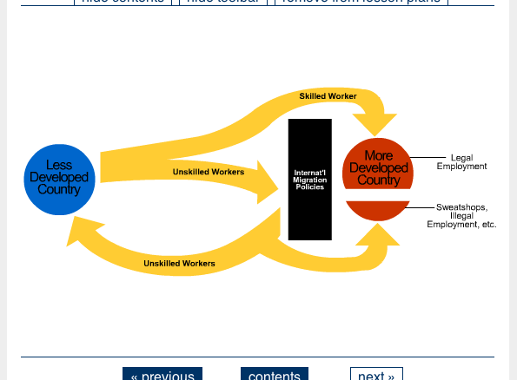

Another user who has a visual impairment and uses a screen reader may require text instead of images. To accommodate this user, it is necessary for the original image to be replaced by an alternative resource.
To achieve this, first, the original image would need the following accessibility metadata to communicate its access modes and point to an alternative resource:
<accessForAllResource>
<accessModeStatement>
<originalAccessMode=textual>
<accessModeUsage=informative>
</accessModeStatement>
<accessModeStatement>
<originalAccessMode=visual>
<accessModeUsage=informative>
</accessModeStatement>
<hasAlternative=URIofAlternative>
</accessForAllResource>
Additionally, the alternative resource would need to have the following accessibility metadata to communicate its adaptation type and point to the original resource:
<accessForAllResource>
<isAlternative>
<isAlternativeTo=URIofOriginal>
<coverage=full>
</isAlternative>
<adaptationStatement>
<adaptationType=textRepresentation>
<originalAccessMode=visual>
<representationForm=longDescription>
<language=eng>
</adaptationStatement>
The metadata above describes a resource that contains an English language long text description of the original image. The ‘coverage’ indicates that this text file is meant to be used as a complete alternative to the original image.
The final requirement is for the user to have a PNP file stating his/her needs or preferences relating to his/her vision requirements. The user edits a PNP file using a preference wizard as shown below in Figure 8.2:
Figure 8.2 TILE screenshot of Alternatives to Visual preference editing
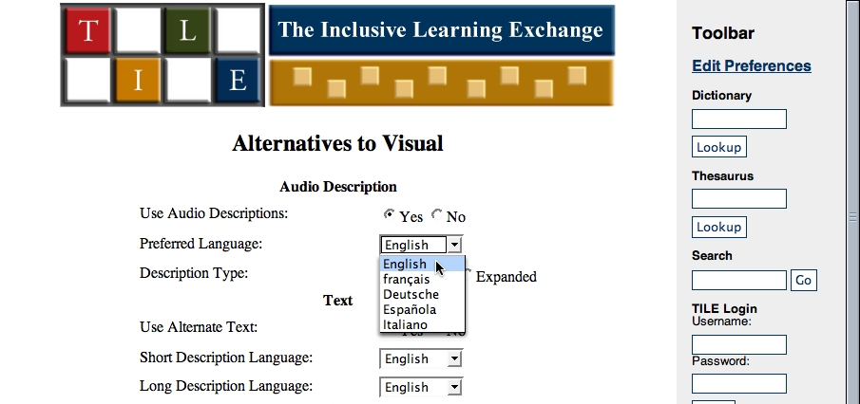

The user specifies a requirement for text alternatives to visual elements. The user's PNP could be the following XML instance document:
<accessForAllUser>
<language=eng>
<content>
<adaptationPreference>
<adaptationType=audioDescription>
<originalAccessMode=visual>
<representationForm=standard>
<language=eng>
</adapationPreference>
<adaptationPreference>
<adaptationType=textRepresentation>
<originalAccessMode=visual>
<representationForm=alternativeText>
<language=eng>
</adapationPreference>
<adaptationPreference>
<adaptationType=textRepresentation>
<originalAccessMode=visual>
<representationForm=longDescription>
<language=eng>
</adapationPreference>
</content>
</accessForAllUser>
This document indicates that the user requests English-language standard audio descriptions and English-language “alt-text” and long descriptions.
When the user requests to view the course on Globalization and International Migration containing the image, the system recognizes that the user requires alternatives to any visual content. It checks for alternative resources and discovers that one exists with characteristics that match the requirements of the user in the PNP. The system then displays the page with the long description substituted for the image, as shown below in Figure 8.3:
Figure 8.3 TILE screenshot of resource with Flash animation substituted with text alternative
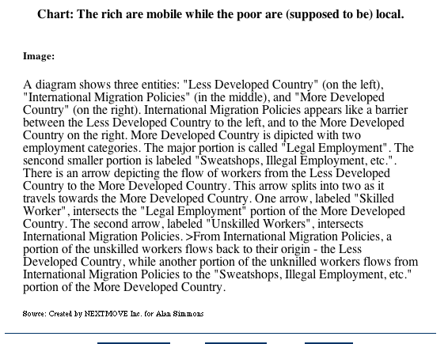

  - TILE Caption Example
The following example is from The Inclusive Learning Exchange system (TILE) developed by the Adaptive Technology Resource Centre, University of Toronto.
A learner is studying a course on Globalization and International Migration containing a video of a lecture by Professor Stephen Castles. Like most videos, it contains visual and audio information. The media type of the video could be Quicktime, Real Media, or one of many other formats. A user without a PNP file or with a PNP file, but without expressed needs or preferences concerning audio or visual content, would receive the original video as shown below in Figure 8.4:
Figure 8.4 TILE screenshot of video with no captions
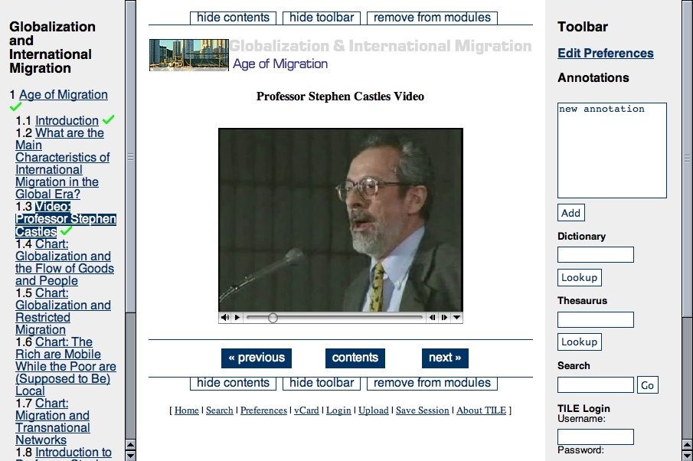

Another user who has a hearing impairment and difficulty understanding English may require captions. In this case it would be necessary for the original video to be supplemented by an alternative resource.

To achieve this, first, the video would need to have the following accessibility metadata which communicates its access mode attributes and expresses a relationship with an alternative resource:
<accessForAllResource>
<accessModeStatement>
<originalAccessMode=auditory>
<accessModeUsage=informative>
</accessModeStatement>
<accessModeStatement>
<originalAccessMode=visual>
<accessModeUsage=informative>
</accessModeStatement>
<hasAlternative=URIofAlternative>
</accessForAllResource>

Additionally, the alternative resource needs to have the following accessibility metadata to communicates its adaptation type and a relationship with the original resource:
<accessForAllResource>
<isAlternative>
<isAlternativeTo=URIofOriginal>
<coverage=partial>
</isAlternative>
<adaptationStatement>
<adaptationType=caption>
<originalAccessMode=auditory>
<language=eng>
</adaptationStatement>
</accessForAllResource>

The metadata above describes a caption file in English.. The coverage is partial, indicating that this caption file is meant to be used in conjunction with the original video.
The final requirement is for the user to have a PNP file stating his/her needs or preferences relating to his/her hearing problems and difficulty in understanding English. The user edits a PNP file using a preference wizard as shown below in Figure 8.5:
Figure 8.5 TILE screenshot of Alternatives to Auditory preference editing
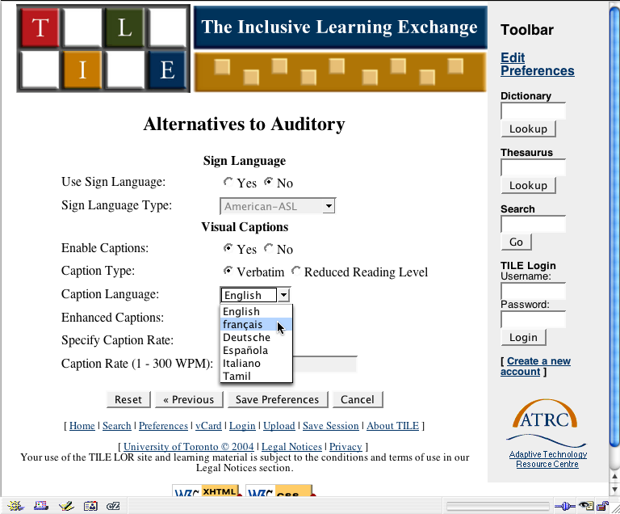

The user specifies a requirement for verbatim captions. The user's PNP profile could be the following XML instance document:
<accessForAllUser>
<content>
<adaptationPreference>
<adaptationType=caption>
<originalAccessMode=auditory>
<usage=required>
<language=eng>
</adaptationPreference>
</content>
</accessForAllUser>
When the user requests to view the course on Globalization and International Migration containing the video of a lecture by Professor Stephen Castles, the system recognizes that the user requires an alternative to the auditory components. It checks the video's equivalent resources and discovers that an equivalent exists with a caption that matches the requirements of the user. The metadata for the caption file indicates that it is a partial alternative and should be displayed with the video. The system displays the video with its supplementary captions as shown below in Figure 8.6:
Figure 8.6 TILE screenshot of video with captions

