Report of Evaluation Feedback

for

Dublin Core:

The Road from Metadata Formats to Linked Data

A NISO Webinar

August 25, 2010

Table of Contents

Introduction 1
Overall Program 1
Speakers 4
Description of Respondents 6
Comments 7

Introduction
Focusing on the dual role of Dublin Core as a format and as a Semantic Web vocabulary, this webinar examined new technologies for bridging the gap between traditional and Linked Data approaches and highlighted how old ideas such as embedded metadata have been reinvented with new web technologies and tools to solve practical problems of resource discovery and navigation.
There were 2 speakers and 136 attendees. Twenty-one of the attendees were package subscribers. There were 61 respondents to the evaluation survey, a response rate of 45%.

Overall Program
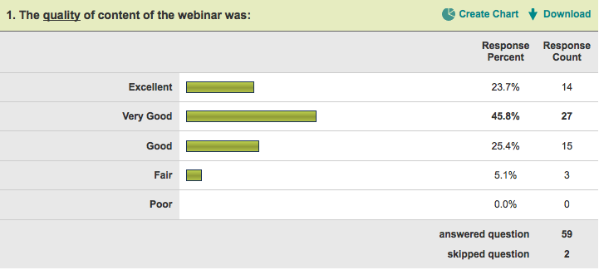

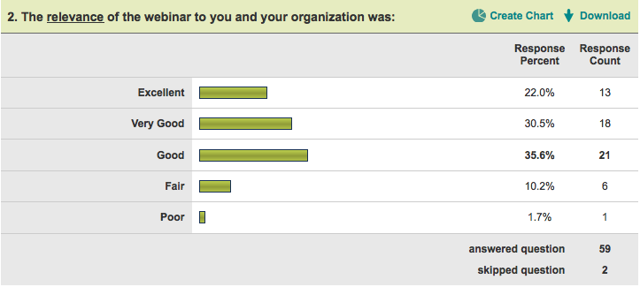

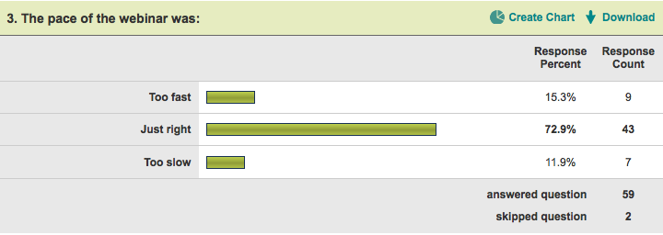

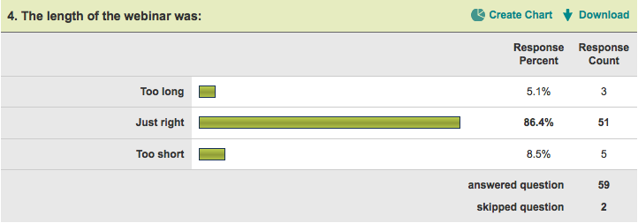

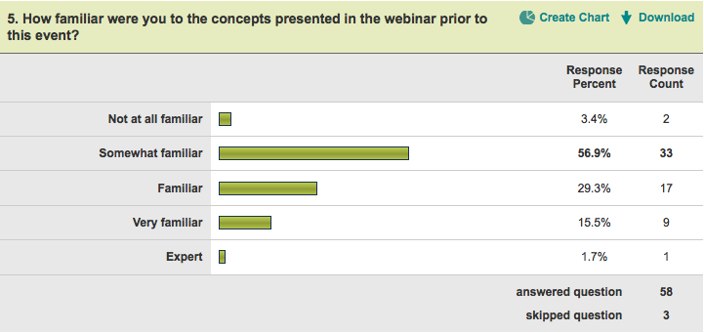

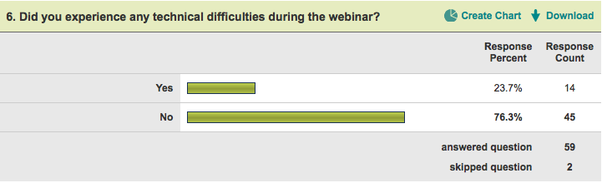

Note: Question 7 was a write-in question and is addressed in the Comments section below.

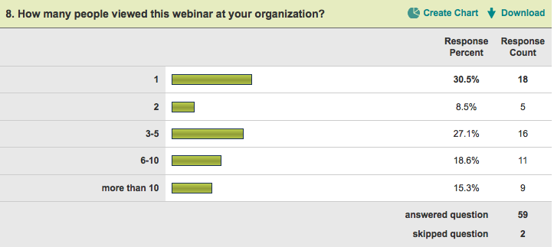

Speakers
The two speakers both gave two presentations. The average results for all of the sessions combined are followed by the individual session ratings.

Average of All Speakers
 |  | Response  Percent | Response  Count
5 – Excellent |  | 21% | 48
4 – Very Good |  | 42% | 97
3 – Good |  | 29% | 68
2 – Fair |  | 8% | 18
1 – Poor |  | 1% | 2
 | Total Responses |  | 233
Average rating across all speakers / sessions = 3.73

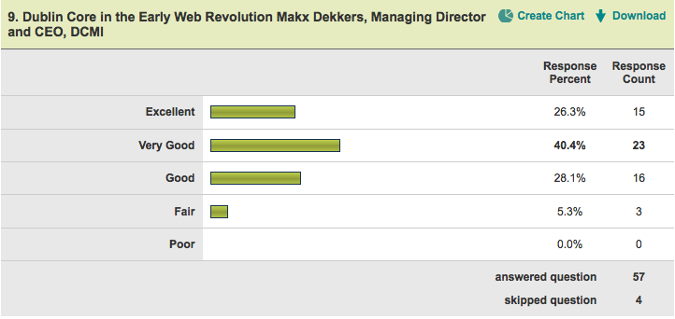
Average rating = 3.88
(highest rating)

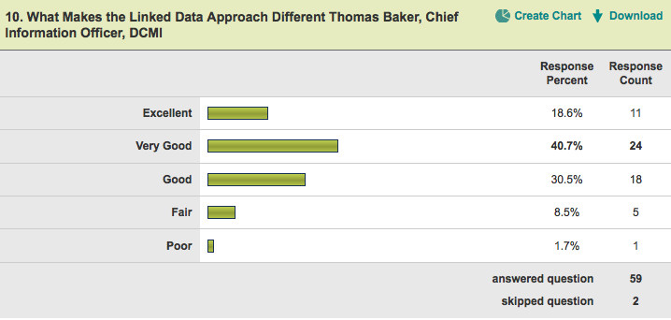
Average rating = 3.66

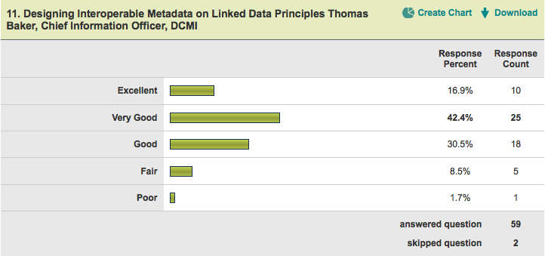
Average rating = 3.64

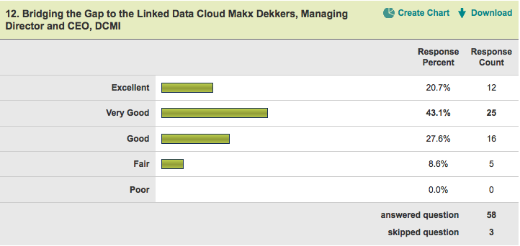
Average rating = 3.76

Description of Respondents

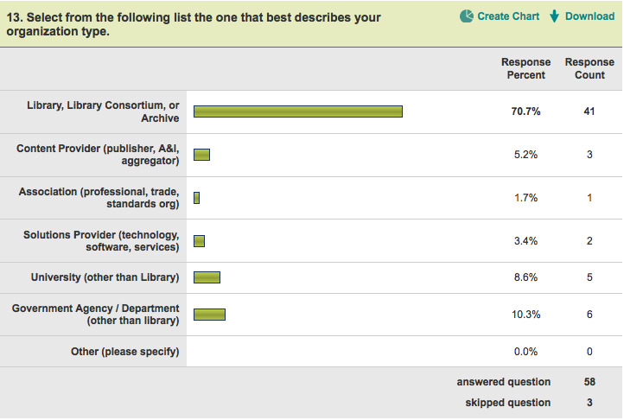

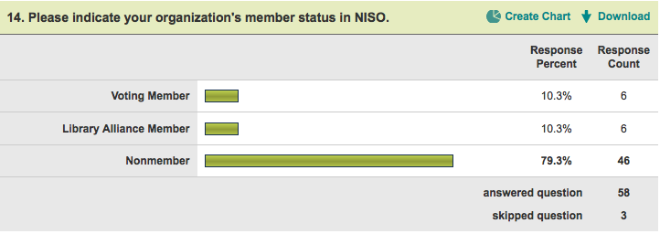

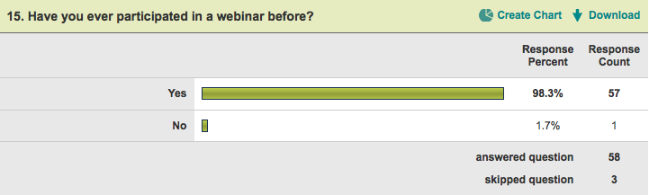

Comments

Technical Difficulties
Respondents were asked to describe any technical difficulties they experienced during the webinar.

- Lag between audio and video (slides)
- trouble dialing the phone number/entering conference id (vs. participant id sent in the email)
- Please tell folks for next meeting that Java is required to use Live Meeting. We didn't join until 2:23 because we had to install Java, and then install Live Meeting (the Web Access option would not run on our machine).
- I had problems logging in to both the video and audio portions, and thus missed the first 5 minutes or so.
- Problems getting audio started - OK once in. Confusion over definition of "leader"
- login on getting it set up through a firewall got help from a colleague
- I lost my phone connection half way through and had to re-dial.
- Missed many screen shots due to slow loading of images.
- a little trouble getting audio, but we got it ok.

- Confusion about which email link went to the correct meeting. Unclear whether questions posted in Q&A are noticed, seen by presenters, seen by other participants, etc. We were unable to post more than one question.
- local network dropped
- Audio faded in and out every few seconds.
- Doesn't work in all browsers (I use Chrome) and I had problems getting the Id and Entry Code accepted
- initially, trouble accessing audio portion - email wasn't clear that you needed to enter 2 codes to get in

Follow-Up Information
Respondents were asked, what, if any, follow-up they were interested in receiving.

- Examples where we could see triples or linked data in use
- archive copy of the presentation including audio
- slides, question answers, links to more info and discussions
- None
- 1. Examples of cultural information sites using linked data. 2. Practical information for organizations to refer to when considering whether to implement linked data (for large repositories), how to manage URIs, and the benefits and risks of linked data.
- more info on how uri are created - tools? - how to get info on existing uri's
- Can we have replay the webinar since we feel we missed too much because the slides didn't load early on and we would like to review the audio along with the slides.
- do you have a bibliography of resources mentioned in the webinar, and on linked data in general?
- More published articles. Triple store tools. Links to institutions (especially library institutions) providing Linked Data.
- More in depth information about the same subject maybe adding web design disply of the retrieved information
- Linked data initiatives, listservs, standards, example implementations, guidelines/recommendations on how to move our (U.S. National Park Service) federated search system toward the linked data model.
- Emerging tools, posted someplace or as subject of another webinar. More information about what's happening 'under the hood'
- Conversion of Dublin Core metadata to "Triples" for web exposure. Where do you start? Talk about connection or relationship to METS, MODS for linked data
- Slides and recording
- description of the Swedish National Library project on linked data.
- Just the slides

Future Events
Attendees were asked to provide any other comments or suggestions they had for future topics and/or how NISO can improve its webinars and other educational offerings.

- Deliver audio online not via telephone line
- The presenters did not speak well. They said "uh" or "uhm" at least once per sentence. This made it difficult to follow what they were saying. I was quite disappointed in this NISO seminar.
- This would have been great as a two part series - the first part being an overview of the concept of linked data including benefits and risks, and the second dealing more with the implementation and technical issues.
- Very informative. Up to date. Built on known conepts and introduced new ones of value.
- Offer option to listen to audio via computer instead of telephone.
- Just want to make sure my 2nd questions got in there: 2nd question. RDF dissolves metadata into a store of triple statements. Does RDF still have a conceptual place for descriptive records -- organized compilations of statements?
- I very much enjoyed the webinar and welcome other similar ones
- Not sure what you asking in question 15. I have participated in many webinars before, but not in any from DCMI/NISO.
- It was cool that you called me instead of vice versa - haven't experienced that before. Hope you can soon go to voice over the net so I can use my headphones - in a cubicle so have to hold the phone for the entire time.
- Content started out a little slow, got great by the middle/end! Would have liked to see more examples of linked data in use, such as BBC site.
- Very timely; thanks. Would be useful to know about barriers to having this happen too, such as conflict of business interests for those who "own" metadata silos.
- Would prefer the option to avoid requiring a phone.
- Presenters might have shortened the prefatory material: their acknowledgement to DC and NISO, history of DC.

