**5100197260/20**

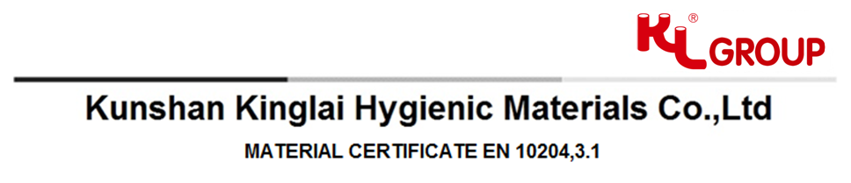

**Messer:** TOP LINE PROCESS EQUIPMENT CO.old_1_1

**Load No.** 5100197260

**Customer Order No.** MAR02258

**Customer Part No.** 327530

**KL Part No.** A1514003ZZ0003002F

**Part Description.** 14AMP FERRULE 3” 304L

**Material.** 304/304L

**Lot No. 0000526786** **Date of Certificate.** 2016.01.20

**Raw Material Heat Analyze and Specification (weight%)：**

|  |  |  |  |  |  |  |  |  |  |  |
| --- | --- | --- | --- | --- | --- | --- | --- | --- | --- | --- |
| Heat Number‎ | C | Si | Mn | P | S | Ni | Cr | N | Mo | Material Standard |
| **M15D138** | **0.013** | **0.470** | **1.050** | **0.033** | **0.011** | **8.130** | **18.220** | **0.000** | **0.000** | **ASTM A182 F304L** |

**Mechanical Test‎‎‎**

|  |  |  |  |  |  |  |  |  |  |  |
| --- | --- | --- | --- | --- | --- | --- | --- | --- | --- | --- |
| Heat Number | Yield | Rp 0.2 | Yield | Rp 1.0 | Tensile | Strength | Hardness | Reduction of Area | Elongation  ( l ) | ImpactTest |
|  | MPa（N/mm2） | KSI | MPa  (N/mm2) | KSI | MPa  (N/mm2) | KSI | HB/HRB/HV | % | % | 20℃-J |
| **M15D138** | **220.000** | **31.900** | **N/A** | **N/A** | **560.000** | **81.200** | **80.000HRB** | **51.000** | **44.000** | **N/A** |

**Mechanical Test Continuation**

|  |  |  |  |  |  |
| --- | --- | --- | --- | --- | --- |
| Heat Number‎ | Eddy Current Test | Flaring  Test | Flattening  Test | Bend Test | Intergranular  Corrosion Test |
| **M15D138** | **N/A** | **N/A** | **N/A** | **N/A** | **N/A** |

**Other Analysis And Inspection**

|  |  |  |
| --- | --- | --- |
| Visual & Dimensional Test | Material  Identification Test | Ra Max Value  (ID/OD) |
| **OK** | **OK** | **0.56/N/A** |

**Statement of Certificates of Conformance :**

KINGLAI is authorized by the ASME for manufacturing BPE fittings and tubings in accordance with ASME BPE Current Standard, certificate No. is BPE-104.Expires: June 5, 2018.

We certify Process Contact Surface SF1 meets Ra 0.51µm max; SF4 is electropolished and meets Ra 0.38 µm max.Ext. Ra 0.8 µm max.

We certify that this information is a true representation of the data that has been furnished by our raw material.

We have no knowledge of any mercury of low melting contamination.

Examined according to quality system BS EN ISO 9001:2008 by BSI. Certification number: FM 85641.

All products have heat treatment process except some specified products per customer order, the temperature is 1040~1100℃, and quick cooling.

This certificate is made by SAP system and is valid with electronic signature.

The materials listed herein have been tested for radioactivity and the tests confirm that the values are within the limits of the background radiation.

China Jiangsu province sanitation and safe product, approval number:0098, Jiangsu province(2012)

KL fittings and tubings are in compliance with PED and relative standards.

