Station 1 protocol
The primary aim for the proposed testing protocols is to define a comprehensive procedure to validate wearable eye tracking technology for real life applications. This will be achieved through a rigorous testing pipeline, consisting of a set of testing stations and accompanying testing protocols and analysis software that allows to quickly provide a representative set of quantitative performance metrics of a wearable eye tracking system. This document describes the protocol for Station 1, where participants sit in an artificially lit room under controlled lighting conditions. Stimuli are presented on a large tv (see Figure 1 for an overview of the room setup). Here we focus on:
- Data quality (accuracy, precision and data loss) as a function of fixation eccentricity.
- Pupil size artefact (apparent gaze offsets due to changes in pupil size).

Method

Participants
Adult participants with normal or corrected-to-normal vision.

Apparatus
Measurements are conducted in a windowless, small room (Figure 1, left) without ambient light except that coming from the screen. Stimuli are presented on a 50-inch TV (model: Samsung QM50C, width: 109.8 cm, resolution: 3840 x 2160 pixels, refresh rate: 60 Hz) at a viewing distance of 63 cm using PsychoPy (v. 2023.2.3). Participants’ heads were stabilized with a chinrest (Figure 1, right).
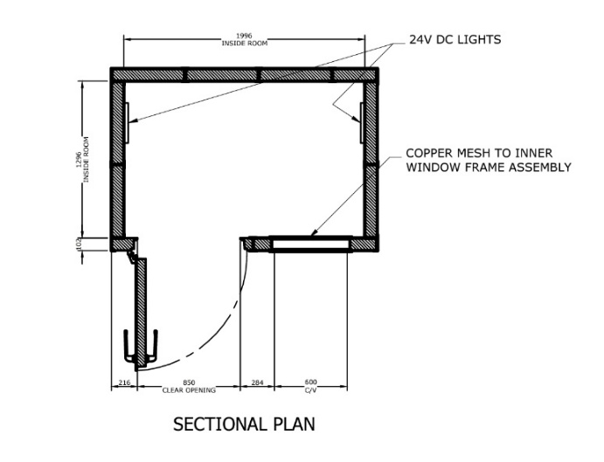 | 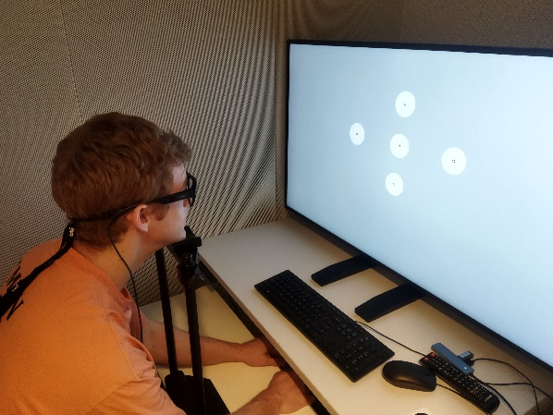
Figure 1. Sectional plan of the recording room (left) and picture of the setup including the screen and the chinrest (right).

Each eye tracker may have specific set up requirements. Below are set ups for eye trackers that have been used when defining and testing this protocol. If you start testing with a new eye tracker, add it to the table below and carefully note any settings that may be needed for reproducibility.

Eye trackers
Table 1. Eye tracker settings.
Eye tracker | Sampling frequency (Hz) | Settings
Tobii Pro Glasses 3 | 50 | Recording mode: Full Analysis  Exposure setting: Scene
Pupil Labs Neon | 200 | Gaze mode: Binocular (default)  Scene Camera Exposure: Highlights
Viewpointsystem VPS19 | 60 Hz | Default
Pupil Lab Invisible | 200 Hz | Default

User setup and calibration
Careful setup and calibration of a wearable eye tracker are critical to be able to record data with high accuracy, precision, and a low amount of data loss. In the following, procedures to set up and calibrate the selected wearable eye trackers are detailed. These should be updated when the document is extended to a new eye tracker. Prior to calibration, the operator should first apply the settings in Table 1 to the eye tracker. A head strap is used to prevent slippage of the eye tracker on the head. Calibrations are conducted in the enclosed room while a mid-gray image is presented on the screen in the otherwise dark room. Prior to performing a calibration, a visual check is performed to ensure that the eyes are correctly positioned according to the eye tracker and that the gaze marker presented on the scene video seems to indicate reliable tracking. Changing the nose piece may be necessary to enable stable tracking.
Tobii Pro Glasses 3
The Tobii Pro Glasses 3 is set up and calibrated in accordance with the instructions in sections 8.1, 8.2, and 8.4.2 of the Tobii Pro Glasses 3 user manual (v. 1.20). Since the physical calibration marker is not clearly visible in the scene camera when held against the screen, a calibration marker is added to the PsychoPy script for recordings with the Tobii. To show the calibration marker on the screen, press ‘t’ on the keyboard when the validation screen is shown (and ‘t’ to return to the validation screen after calibration is completed). Recordings are performed at 50 Hz, as the 100 Hz mode has known data quality issues (Niehorster et al., 2020).

Pupil Labs Neon
For each participant, a new profile is made in the companion app. For the participant, the inter eye distance measured and set (https://docs.pupil-labs.com/neon/data-collection/measuring-ied/) using a Pupillary Distance Meter.
Pupil Labs Invisible
For each participant, a new profile is made in the companion app.
Viewpointsystem VPS 19 Eye Tracker
The Viewpoint system is calibrated using the default (one-point) calibration available in the recording unit software.

Stimuli
Visual stimuli consist of fixation targets, ArUco markers, and red dots presented on a gray background. The fixation target is described in Thaler et al. 2013 (target ABC) and has an outer diameter of 0.7 degrees. The diameter of the small, central disc in the center of the fixation target is 0.1 deg. The ArUco markers and red dots are included to facilitate the transformation of gaze from a head-fixed coordinate system to a world-fixed coordinate system (see Niehorster et al., 2025). Specifically, the red dots (with diameters of 1 deg) are useful in situations where the ArUco markers cannot be easily detected (e.g., when the image quality in the scene camera is not good enough due to, for instance, motion blur or poor lighting conditions).

Initial check of accuracy
Participants are asked to look at an image on the screen where fixation targets enclosed in a circle with a radius of 3 degrees are presented at five different locations (the center, +- 15 degrees horizontally, and +-10 degrees vertically).

Task 1 – VOR sync: Fixate a target while moving the head side-to-side
This task is conducted to estimate the temporal offset between data recorded from the scene camera and the eye camera(s), such that these can be appropriately synchronized. The fixation target is presented at location (0, 6) deg on top of a red circle (3 deg diameter, Figure 2). The location (0, 0) deg corresponded to the center of the screen. Head movements are performed smoothly and slowly (0.5 Hz) side-to-side.

Figure 2. Stimuli for Task 1.

Task 2 – Fixating multiple targets one-by-one at different locations on a gray background
The normal ranges of eye movement have been reported to be 44.9 ± 7.2° in abduction (away from the nose), 44.2 ± 6.8° in adduction (towards the nose), 27.9 ± 7.6° in elevation (up), and 47.1 ± 8.0° in depression (down, Shin et al., 2016). However, in most cases, eye movements are smaller than 10 degrees when performing everyday tasks that require combined trunk, head, and eye movements (Land, 2006). To cover a range representative of both everyday tasks as well as tasks that require larger eye movements (or the larger gaze angles that may be required for putative gaze-interactive interfaces on smart glasses), targets are positioned along concentric circles placed at 10, 20 and 30 degrees eccentricity (the center target is located at [0, 6] deg, see Figure 3). As 30 degrees eccentricity exceeds the maximum upward gaze angle, the upward targets were placed at 10, 15 and 20 degrees instead. White placeholder circles (1 deg diameter) are placed at the location of all targets. The location of the next target is cued with a red circle (0.7 deg diameter) and the fixation target is smoothly animated between fixation target locations. Once it arrives at the upcoming fixation location it decreases in diameter from 1.5 deg to 0.7 during 0.4 s, after which it stays at the small size for 1 s. The data during this 0.4 s is used for determining data quality for the given target.
To be able to automatically decide when a particular target is displayed in an eye tracker recording, two of the central ArUco markers in Figure 3 are replaced by other, unique ones, which are presented for each fixation target during the 0.4 s interval when the fixation target is small and data should be used for further analysis.
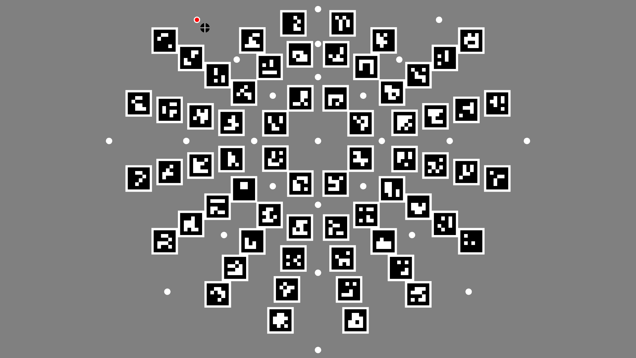
Figure 3. Stimulus used during Task 2. The next fixation target is cued with a red circle, and the fixation target is smoothly moving towards it.
Task 3 – Fixation targets are presented at three different locations, one at the time, while the background changes from white to black
The fixation target is located at position (0, 6) deg, (-15, 6) deg, and (15, 6) deg. The white background (grayscale intensity 255, 8 bits) is presented for two seconds and the black background (grayscale intensity 0) for eight seconds (cf. Hooge et al., 2025), for six white-and-black cycles. The fixation target is drawn on top of a gray (grayscale intensity 86) disc (1.5 deg diameter), to make it clearly visible on both the white and black backgrounds. To facilitate automatic mapping of gaze to the stimulus screen and enable automated determination of apparent gaze shifts, several 1 deg red dots (concentrically arranged at 6, 12, and 18 deg eccentricity around the central fixation target) are presented as illustrated in Figure 4.
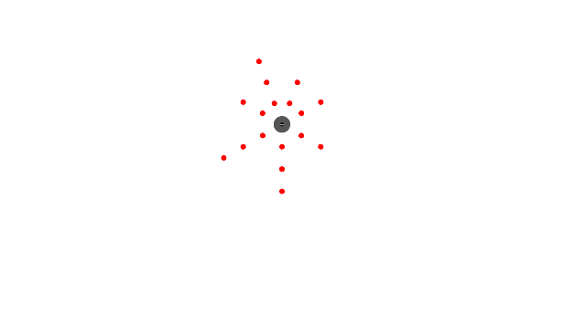 | 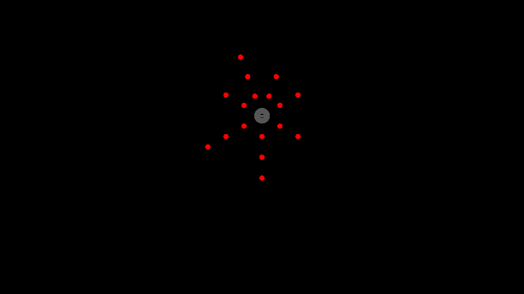
Figure 4. Stimuli for Task 3 for the central fixation target with a white background (left) and a black background (right).

Procedure
The whole procedure takes about 10-15 minutes per eye tracker including set up.
First, the participants are introduced to the tasks. In all tasks, participants are instructed to look exactly at the center of a fixation target for as long as it is shown on the screen. If required, a short version of the experiment is run for participants to familiarize themselves with the tasks. Second, an eye tracker is fitted to the participant and a calibration is performed followed by a visual check of the calibration accuracy (see below). Participants are asked to place their heads on the chinrest and remain seated in the same position throughout the tasks (with the exception of the VOR-sync).

Initial check of accuracy
Directly after the calibration is completed, an initial, visual check of the accuracy is conducted by the operator. This initial check is similar for all eye trackers. During this check, participants are asked to look at an image on the screen where fixation targets enclosed in a circle with a radius of 3 degrees are presented at five different locations (the center, +- 15 degrees horizontally, and +-10 degrees vertically). If the operator judges (e.g. using the live gaze view of the eye tracker) that the gaze is within the circles in all five locations, the recording is allowed to start. Otherwise, the calibration procedure is repeated to try to achieve higher accuracy. If the accuracy check fails after three calibrations, the recording is started anyways. The operator takes a note of how many calibration attempts (1, 2, 3, or failed) were needed to reach the accuracy criterion, and the total calibration time in seconds.

Task 1 – Fixate a target while moving the head side-to-side (VOR sync)
Participants are asked to fixate a target in the center of the screen while slowly moving the head side-to-side (see Hooge et al, 2022). The following instructions are given to the participants:
“A black-and-white fixation target will appear on top of a grey circle. Carefully look at the center of this fixation target. After a while, the grey background circle will turn red. When the circle is red, slowly and continuously move your head side to side (like shaking "no") five times while you keep looking at the center of the fixation target. When the background circle turns grey again, stop moving your head but keep looking at the fixation target.”

Task 2 – Fixating multiple targets one-by-one at different locations on a gray background
The participant is asked to place the head in the chinrest and to keep the head as still as possible during the recording. The head/chinrest position is adjusted such that the whole stimulus is visible in the scene camera of the eye tracker. If it is not possible to have the whole stimulus visible in the scene camera, the participant is positioned such that the center target is approximately in the center of the scene camera’s image.
Fixation targets are then presented one at the time in random order. To help participants locate the next target, fixation targets are moved smoothly between locations, and the next target location is cued with a red circle. Participants are instructed as follows:
“A black-and-white fixation target will appear in the center of the screen. Carefully look at its center all the time. After a while, it will start moving. Once it starts moving, follow the fixation target around, and keep carefully looking at its center all the time.”
Task 3 – Fixation targets are presented at three different locations, one at the time, while the background changes from white to black
Participants are placed with their heads in the chinrest. Fixation targets are presented at the center, left, and right positions of the screen in random order while the background changes between black and white (2 s white, 8 s dark) for six white-to-black cycles per target position. Participants are instructed to:
“A black-and-white fixation target will appear on top of a grey circle. Carefully look at the center of this target at all times.”

Data processing and analysis
Task 2: fixations
Accuracy, precision (RMS-S2S, STD), data loss, and sampling frequency are estimated from the recordings. Accuracy is operationalized as the distance between a target and the median of the gaze position data recorded in a 1-s window starting directly after the fixation target shrunk to its minimal size after arriving at the target position. See Niehorster et al. (2025) for operationalizations of RMS-S2S, STD, and data loss. Sampling frequency is operationalized as the average number of samples (reported as valid or invalid by the eye tracker) per second.
Task 3: PSA
Gaze shifts due to PSA is operationalized as the median distance between gaze position data recorded 200 ms before the offset of the dark and bright stimuli. This gives the pupil enough time to dilate and constrict prior to estimating the gaze position. The mean of the six consecutive dark/bright distances are used to compute the average gaze shift due to the PSA.

References
Hooge, I. T., Hessels, R. S., Niehorster, D. C., Andersson, R., Skrok, M. K., Konklewski, R., ... & Nyström, M. (2025). Eye tracker calibration: How well can humans refixate a target?. Behavior Research Methods, 57(1), 1-10.
Hooge, I. T., Niehorster, D. C., Nyström, M., & Hessels, R. S. (2024). Large eye–head gaze shifts measured with a wearable eye tracker and an industrial camera. Behavior Research Methods, 56(6), 5820-5833.
Land, M. F. (2006). Eye movements and the control of actions in everyday life. Progress in retinal and eye research, 25(3), 296-324.
Niehorster, D. C., Hessels R. S., Nyström, M. Benjamins, J. S. & Hooge, I. T. C. (2025). gazeMapper: A tool for automated world-based analysis of gaze data from one or multiple wearable eye trackers. Behavior Research Methods.
Niehorster, D. C., Santini, T., Hessels, R. S., Hooge, I. T., Kasneci, E., & Nyström, M. (2020). The impact of slippage on the data quality of head-worn eye trackers. Behavior research methods, 52, 1140-1160.
Shin, Y., Lim, H. W., Kang, M. H., Seong, M., Cho, H., & Kim, J. H. (2016). Normal range of eye movement and its relationship to age. Acta Ophthalmologica, 94.
Thaler, L., Schütz, A. C., Goodale, M. A., & Gegenfurtner, K. R. (2013). What is the best fixation target? The effect of target shape on stability of fixational eye movements. Vision research, 76, 31-42.

