Station 2 protocol
The primary aim for the proposed testing protocols is to define a comprehensive procedure to validate wearable eye tracking technology for real life applications. This will be achieved through a rigorous testing pipeline, consisting of a set of testing stations and accompanying testing protocols and analysis software that allows to quickly provide a representative set of quantitative performance metrics of a wearable eye tracking system. This document describes the protocol for Station 2, which aims to test how wearable eye tracker performance is affected by eye-tracker movements and changes in viewing distance. Specifically, we focus on two potential problems encountered while recording from freely behaving participants:
- Slippage (motion of the eye tracker with respect to the head)
- Parallax error (inaccuracy of recorded gaze point in the world due to changes in viewing distance).
Below we present a protocol for station 2 that assesses sensitivity of a wearable eye tracker to both slippage and parallax.

Method

Participants
Adult participants with normal or corrected-to-normal vision.

Apparatus
Measurements are conducted in an artificially lit room under controlled and constant lighting conditions. Stimuli are presented on a 55-inch TV (model: Samsung QM55C, width: 121.2 cm, resolution: 3840 x 2160 pixel, refresh rate: 60 Hz) at a viewing distance of 30, 100 or 200 cm using PsychoPy (v. 2023.2.3). The TV is placed in a room where there is enough space available for participants to view the TV at a 2 m distance.

Eye trackers
See the protocol for station 1 for eye tracker settings and calibration instructions.

Protocol
First, the eye tracker to be tested is calibrated (same eye-tracker specific instructions, protocol for accuracy check, etc., as for Station 1). Then, after calibration, the below tasks are performed in the indicated sequence. Note that parallax error is assessed before slippage because it would be undesirable if any residual slippage affects the parallax tasks.

Initial calibration check
Like in station 1.

VOR sync
Like in station 1.

Parallax error
The participant is asked to sit in front of the TV with the center of the stimulus at eye level. Make sure the eye tracker is robustly attached to the head using a head strap.
- The participant is positioned at 30 cm viewing distance from the TV. Five points are shown to the participant in random order (one straight ahead, and one each at 8 deg left, right, up and down from the center point), five times each (Figure 1, left). To ensure a correct viewing distance between the screen and the participant, the participant is asked to place the head such that the face touches a string attached to a stick mounted to the screen (see Figure 1, right).
- The participant is positioned at 200 cm viewing distance. Five points are shown to the participant in random order (one straight ahead, and one each at 8 deg left, right, up and down from the center point), five times each.
- The participant is positioned at 100 cm viewing distance. Five points are shown to the participant in random order (one straight ahead, and one each at 8 deg left, right, up and down from the center point), five times each.
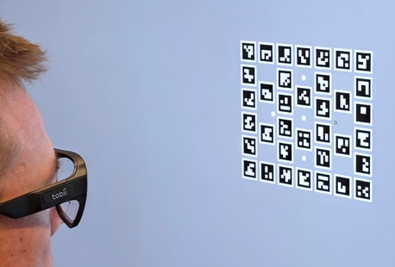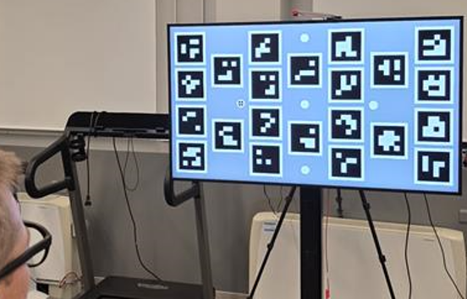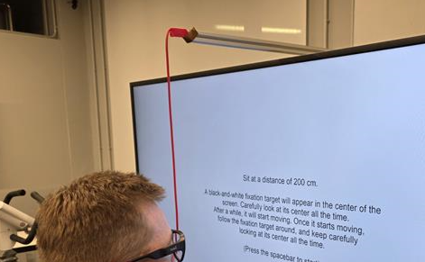

Figure 1. Parallax error is investigated at three different distances: 30 cm (left), 1 m, and 2 m (middle). A string used to unsure a 30 cm viewing distance (right).

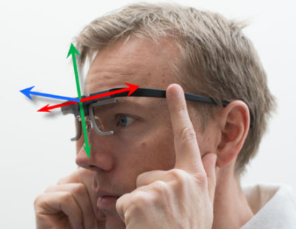
Figure 2. To induce slippage, the glasses are moved side-to-side, up-and-down, and towards and away from the face (left).

Slippage
Remove or loosen the head strap. Participants are positioned 1 m in front of the TV wearing the eye tracker glasses. Throughout all the tasks below, the participant is presented with a single fixation point that they are instructed to fixate at all times. While fixating, the participant is instructed to perform the following tasks for 10 seconds each (Niehorster et al., 2020, Figure 2). A short break is given between each task.
- Placing the glasses between two fingers and moving them side-to-side.
- Placing the glasses between two fingers and moving them up-and-down.
- Placing the glasses between two fingers and moving them away and toward the face.
Participants are instructed to move the glasses about 1 cm.

Data analysis
ArUco markers are placed on the screen at sizes suitable for robust detection at each of the viewing distances (Figure 1). These will be used to map gaze to the TV plane using gazeMapper (Niehorster et al., 2025) and then determine offsets between the gaze position and the fixation target locations throughout the tasks.

Parallax error
Since each target is fixated five times, we get five offset values in the horizontal (x) and vertical (y) directions between the recorded gaze position and the fixation targets. Offset is computed as the median value of these values for each fixation target and viewing distance.
The parallax error is computed per target as the difference in offset between the 200 cm and 30 cm viewing distances.

Slippage
Gaze offset due to slippage is computed separately in the horizontal and vertical direction as the difference between the 5th and 95th percentiles of the gaze position signal within a window of 2 s. The overall gaze offset is computed as the median difference over multiple sliding windows. The duration of each slippage task was 12 seconds, of which the first 2 seconds are excluded from analysis to exclude any delays in the participant starting the task.

References
Hooge, I. T., Niehorster, D. C., Hessels, R. S., Benjamins, J. S., & Nyström, M. (2023). How robust are wearable eye trackers to slow and fast head and body movements?. Behavior Research Methods, 55(8), 4128-4142.
Mansouryar, M., Steil, J., Sugano, Y., & Bulling, A. (2016). 3D gaze estimation from 2D pupil positions on monocular head-mounted eye trackers. In Proceedings of the ninth biennial ACM symposium on eye tracking research & applications (pp. 197-200).
Mardanbegi, D., & Hansen, D. W. (2012). Parallax error in the monocular head-mounted eye trackers. In Proceedings of the 2012 acm conference on ubiquitous computing (pp. 689-694).
Niehorster, D. C., Hessels, R. S., Nyström, M., Benjamins, J. S., & Hooge, I. T. (2025). gazeMapper: A tool for automated world-based analysis of gaze data from one or multiple wearable eye trackers. Behavior Research Methods, 57(7), 188.

