**Digital to binary (integer):**

Continually divide by two, keeping the remainder as the binary digit.

192 / 2 = 96 rem 1 🡨 last binary digit

96 / 2 = 48 rem 0

48 / 2 = 24 rem 0

24 / 2 = 12 rem 0

12 / 2 = 6 rem 0

6 / 2 = 3 rem 0

3 / 2 = 1 rem 1

1 / 2 = 0 rem 1 🡨 1st binary digit

Result:

**Digital to binary (fractional):**

Multiply the digital expansion digit by 2, keeping the integer part of the quotient as the binary digit.

0.875 x 2 = **1**.75 🡪 1

0.75 x 2 = **1**.5 🡪 1

0.5 x 2 = **1** 🡪 1

Result:

**Quick Modulus Calculation**

1. Divide by the modulo. Find:

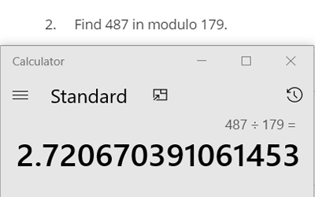



1. Subtract the integer from the quotient, leaving only the digital expansion.

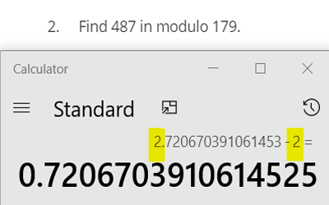

1. Multiply by the original modulo. Result:

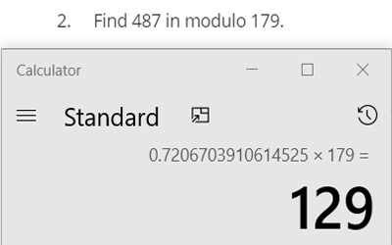



**Identities and Inverses mod k**

**Additive identity**

The additive identity is 0. The sum of two numbers that equal 0 in mod k.

**Additive inverse**

A number that when added to another number, will result in the sum of 0 mod k.

*Problem: Find the additive inverse of 554 (mod 256)*.

1. Find the number that results in 0 (mod 256)
3. What smallest integer added to 42 will result in 0 mod 256.

1. 214 is the additive inverse for this problem.

**Multiplicative identity**

The multiplicative identity is 1. The product of two numbers that equal 1 mod k.

**Multiplicative inverse**

A number that when multiplied by another number, results in 1 mod k.

*Problem: Find the multiplicative inverse of 5 (mod 7).*

1. Find the number that results in 1 (mod 7) when multiplied by 5.
2. **3** is the multiplicative inverse of 5 (mod 7)

**Modular Exponentiation**

Prove:

1. Find the powers of 2 for the exponent
2. Remove exponent and simplify to
3. Calculate . (256 is the largest power of 2 from our exponent in step 1a). Increasing the exponent each time will eventually be too large for a calculator to display. Instead, use the previous equations result to find the next calculation.
4. Multiply the results of each power of two number that we got from the original exponent. 256 is 7, 32 is 7, 8 is 20. So,

Used from notes by Sebastian Levoie

**The nth term of an arithmetic sequence:**

= first term, = common difference

**The nth term of a geometric sequence:**

= first term, = ratio

**Sum of the first nth terms of an arithmetic sequence:**

**Sum of the first nth terms of a geometric sequence:**

= first term, = ratio, = number of terms

**Finite sums of series**

**Kinematics SUVAT formulas**

*s =* displacement

*u* = initial velocity

*v* = final velocity

*a = acceleration*

*t = time (s)*

SUVAT Example 1:

A particle moves with constant acceleration 5. Its original velocity is 3. Find the distance in meters the particle has travelled after 10*s*.

S = ? 🡨 we need to find this.

U = 3

V 🡨 we don’t need this

A = 5

T = 10

Choose the SUVAT formula that does not include V, because V is not needed to answer this problem.

🡪 🡪

S = 280

SUVAT Example 2:

A particle moves with constant acceleration. Its original velocity is , and its final velocity is . Find the time taken to cover 22 meters.

S = 22

U = 3

V = 8

A 🡨 we don’t need this.

T = ? 🡨 find this

Since we don’t need A, use . First, isolate t and then plug in the numbers.

⬄ ⬄ ⬄ ⬄

t = 4

Quadratic Formula

**Trigonometry**

1 radian 57.3 6.28 radians 360

Degrees 🡪 radians:

radians

Radians 🡪 degrees:

**Pythagoras’ Theorem**:

Finding length of one side given two sides. Use only on right angle triangles.

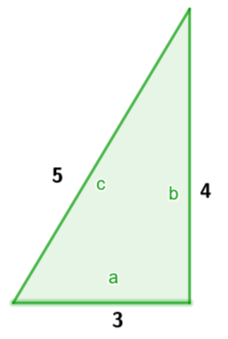

*a = 3, b = 4, c* = 5

**⬄****⬄**

**🡪**

**Triangle Inequality Theorem**

The sum of any two lengths must be greater than the third length.

**Sine rule**:

Use when you know two angles and one side, or two sides and a non-included angle (an angle that is not in-between the two known sides).

**Cosine rule**:

Use then 3 sides are known, or two sides and an included angle are known.

e.g. Find angle A when side and .

To find angle A use:

**Two Possible Triangles?**

When given two sides with a non-included angle (SSA), there may be two triangle possibilities.

* 1. 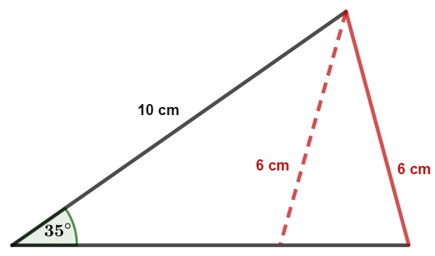Find the unknown angle.
  2. Subtract the new angle from 180 to find the second possible angle (visualize the unit circle, first angle in Q1, second possible angle in Q2, acute and obtuse angles).
  3. Add the new angle to the original angle from the given SSA values. If their sum is less than 180, then a second triangle exists. If the value is over 180, a second possible triangle does not exist.

**Polar vs. Cartesian Coordinates**

Cartesian coordinates = (*x, y)*

Polar coordinates = (radius, angle)

**Converting from Cartesian to Polar**

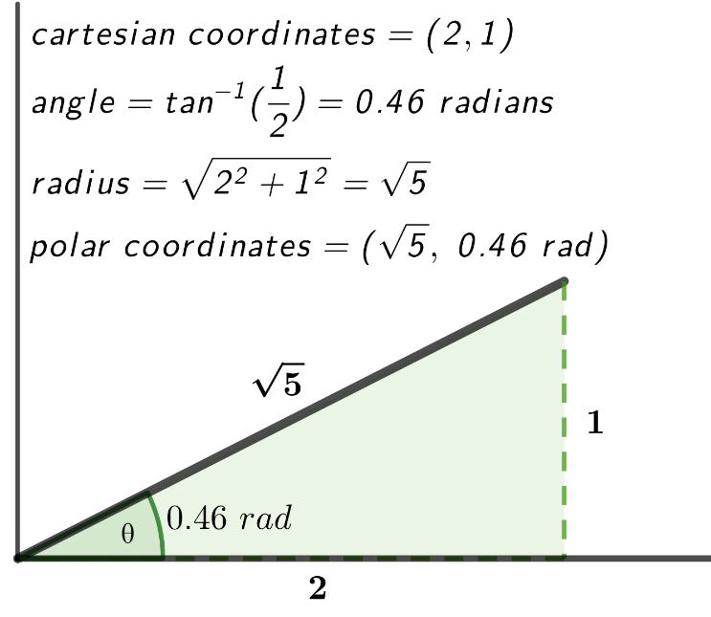The radius will be the hypotenuse length, which is found from Pythagoras’ theorem using the x and y cartesian coordinates.

Find the angle from

In Q1 the angle will be .

In Q2 the angle will be .

In Q3 the angle will be .

In Q4 the angle will be .

Note, angles are written as radians, but degrees can be used as well.

**Converting from Polar to Cartesian**

Polar (radius, angle) 🡪 Cartesian (radius cos(angle), radius sin(angle)).

Remember, adjust the angle degree according to the current quadrant. Do this before calculating the conversion.

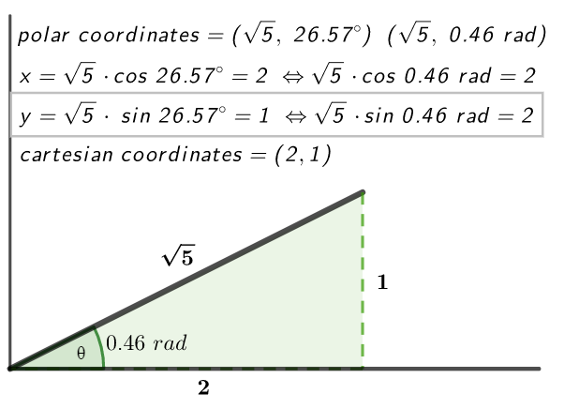In Q1 the angle will be .

In Q2 the angle will be .

In Q3 the angle will be .

In Q4 the angle will be .

If this image were mirrored to the left, thereby placing it in Q2, then take 26.57 from 180 and use that angle to calculate x and y.

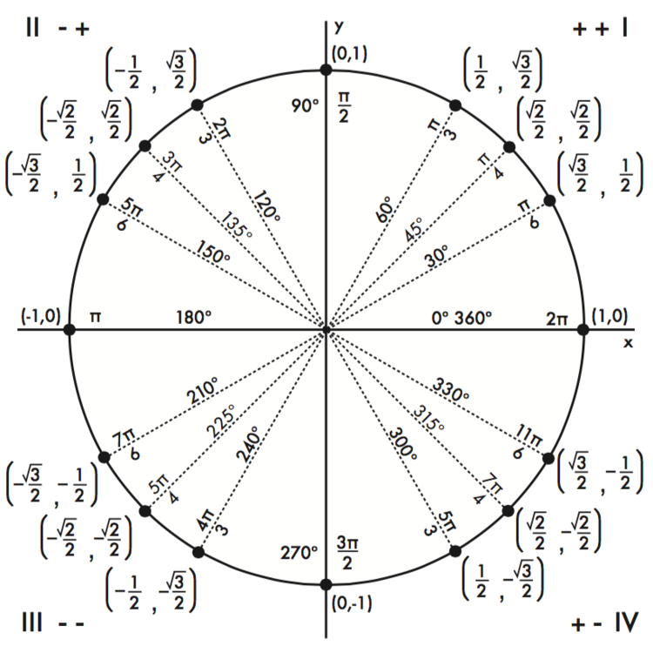

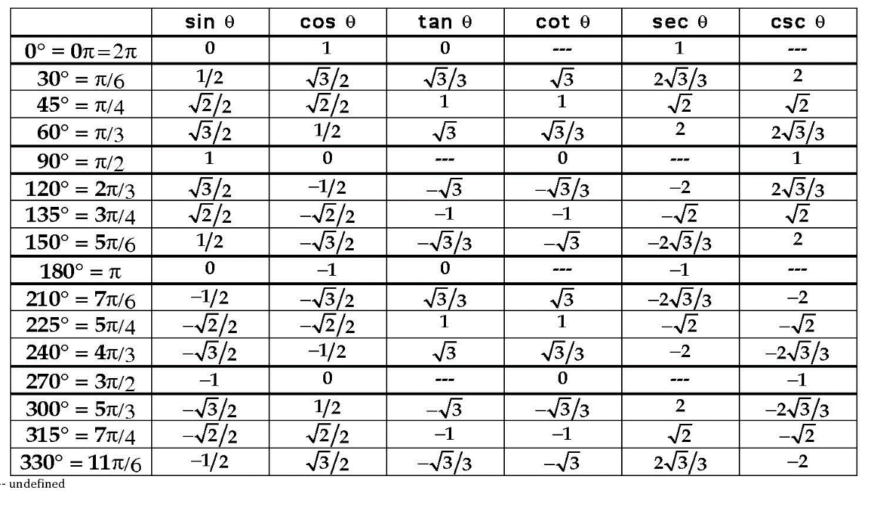

Unit circle and chart from free-largeimages.com

**Transformations**

1. Shift up 3
2. Shift down 3
3. Shift right 3
4. Shift left 3
5. Reflect about the x-axis
6. Reflect about the y-axis
7. Stretch vertically by a factor of 3
8. Shrink vertically by a factor of 3
9. Stretch horizontally by a factor of 3
10. Shrink horizontally by a factor of 3

**Laws of Indices**

The laws of indices are used in week 11.

1. 🡪
2. 🡪
3. 🡪

**Laws of Logarithms**

1. **Log A + log B = log AB** 🡪

🡪

1. **Log A – log B =**  🡪
2. **n log A = log**  🡪

🡪

If then These two equations are equivalent.

**Factorizing a Quadratic**

Find two numbers that when added together give you the middle number, and when multiplied will give the last number. -2, 6 🡪

⬄ ⬄

**Differentiation**

Given a function that produces a curved graph, we can find the gradient of the curve on an exact point by using the **gradient function**. The gradient function can be found by using a formula or applying a rule to the original function. The gradient function is denoted with or . This is known as the derivative or “rate of change”.

* 1. If then ⬄
     + If  *then* ⬄
     + If  *then* ⬄

**Vectors**

The unit vectors in the ***x*** and ***y*** directions are denoted by ***i*** and ***j*** respectively.

**Writing the coordinates of a vector:**

A vector with starting coordinates of (1,4) and ending at (3, 8) is written as *a = 2i + 4j,* ()

**Magnitude (scaler)**

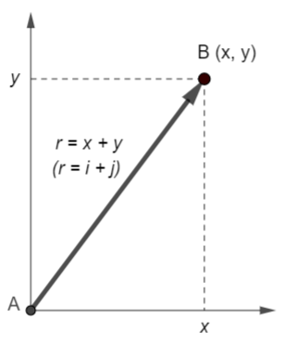The magnitude (scaler) of a vector is shown as (any letter can be used to denote the vector). We use Pythagoras’ theorem to find the magnitude of ***i*** and ***j***.

If , then

For the figure on the right: 🡪

then

**Dot product (scaler product) of two vectors.**

Given two vectors, denoted by ***a b***, the dot product is found by:

e.g.  **⬄**

**Finding the angle between two vectors.**

e.g.

dot product of and :

Find magnitude of both vectors:

So, using **,** then

**Cross product of two vectors**

The cross product of two vectors is denoted by . The two vectors must be 3D (contain x, y and z coordinates).

⬄

Quick formula:

= **()**

Step by step:

Formula:

Note: When multiplying vector coordinates, remember that j is a negative, i and k are positive.

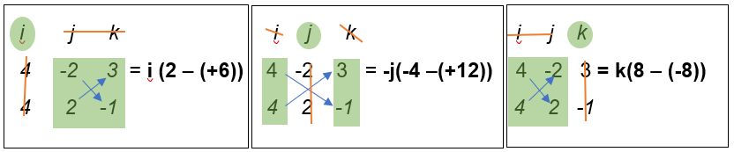

**Matrices**

Addition:

Subtraction:

Multiplication by a number:

Matrix multiplication. ***AB***, ***A***’s number of columns must match ***B***’s number of rows, otherwise they cannot be multiplied together. Multiply each digit in A’s first row by each digit in B’s first column, then go through A’s first row again but this time multiply by B’s second column. Repeat for A’s second row.

The inverse formula for a 2x2 matrix. Inverse is denoted by superscript ‘-1’, as in .

If

* The elements of the leading diagonal are swapped (a and d)
* The remaining elements change sign (b and c changed to -b and -c)
* The resulting matrix is multiplied by

e.g. If then

Using the inverse formula stated above, we find the inverse of

Verify that by =

**Probabilities**

Percentage of total = how many

Percentage change

Independent events

If events A and B are independent, then the probability of obtaining A and B is given by:

v.2 added Writing coordinates of a vector

added Cross product of two 3D vectors