Test Production Suite
User’s Manual

Index

Index
Introduction
Architecture
Installation procedure
How to use TPS

Introduction

Test Production Suite (as knows as TPS) is an environment to check the connectivity of the boards produced in a factory. This environment was originally designed to test the boards specifically designed for Open Hardware Repository but it can be adapted to test other boards.

This project started to cover the needs of CERN groups which want to be sure that the boards produced by external companies follow a minimum quality in matters of soldering, mounting and fabrication process of the PCB.

Note: This test is functional. It is not intended to cover verification & validation tests of the design.

Architecture

The environment has an architecture described in this section.

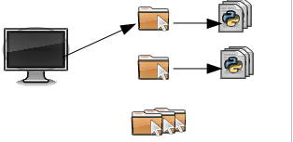
The Test Production Suite (TPS) contains a main program and separate directories where are placed the testing files for each kind of board. It provides a layer (test library) to communicate between test files and a generic driver used to talk to the board’s firmware.

Main program
Test files
Test library
Driver
VHDL
Hardware

Test Production Suite uses a generic driver called gnurabbit which allows the communication between the board and the test programs. This gnurabbit driver only allows to communicate with only one PCI-board of the computer.

TPS generates a bunch of log files which contains the results for each test and for each execution. When there is a critical error, this message is also displayed on the screen. Sometimes the error allows to continue the execution or, even, ask to the user what to do.

Installation procedure

Before to use the TPS environment, there are some requirements that need to be fulfilled:

- GNU/Linux operating system with kernel 2.6.24 or higher.
- GCC, kernel sources and related stuff to compile the gnurabbit driver.
- Python 2.4 or higher.
- Download the latest version of the Test Production Suite from the official website OHWR: http://www.ohwr.org

Before executing the TPS program, the user should compile the provided gnurabbit driver for the first time.

Once it is compiled, the user should load the compiled driver in the target machine using insmod command as root:

# insmod $PATH_DRIVER/gnurabbit.ko

After that, the user can run TPS. For example: $PATH_TPS/tps.py -h

Next step is to check if the board to test is properly plugged, the corresponding test files are downloaded and the required elements are satisfied.

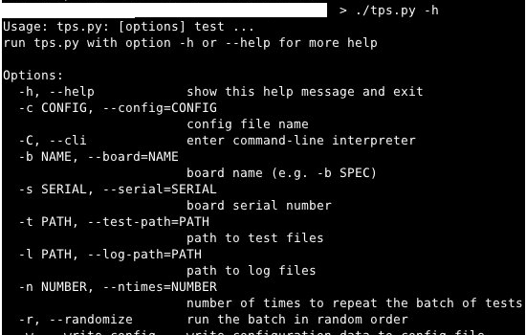

How to use TPS

The TPS program is a command-line utility. Its behavior is determined by the command-line arguments supplied. As a bare minimum, the user must specify the board type to test, its serial number for identification purposes, and paths to the directories for test programs and log outputs. Moreover, a sequence of test case numbers has to be provided.

With this information at hand, TPS proceeds to run the enumerated tests in the specified order (or a random order if the --randomize option was provided), until successful completion. However, if any of the tests fails, TPS will, according to the severity of the error
- abort the suite immediately
- report the error and continue with the following tests
- ask the user what to do

In addition, a repetition number can be provided with the –ntimes option, causing the sequence to be performed a prescribed number of times.

A typical (actually, quite complete) run of TPS is started as follows:

$ ./tps.py -b SPEC -s 0314159265 -t ./tests/ -l ./logs/ \
-r -n 100 00 02 test04 test05 01

This test will refer to a SPEC board (-b SPEC) with serial number 0314159265. The test programs for this run will be found under ./tests/, and should be named test00, test02, test04, test05 and test01. The prefix test is optional in the list, but the filenames must have this structure. The specified sequence of programs will be run in a random permutation (option -r) one hundred times (-n 100). Logs of the run will be found under ./logs/.

During the run, no information will be printed to the console, except in case of test case failure. Such failures are reported to the console as explained above.

The complete log of the execution of tests and their results is found under the specified log path with a name pattern
tps_run_{runid}_{timestamp}_{board}_{serial}.txt
and the standard outputs of the test programs with a pattern
tps_tst_{runid}_{timestamp}_{board}_{serial}_{testnumber}.txt
like
tps_run_f5cd678_20110527.102727.243708_SPEC_000000.txt
tps_tst_f5cd678_20110527.102727.248371_SPEC_000000_51.txt
This makes spotting of particular test runs quite straightforward in directory listings.

A complete explanation of the command-line options of TPS follows

-h, --help
Show a help message and exit
-c CONFIG, --config=CONFIG
Config file name. Default options will be read from the config file. Command-line options override the settings specified in it.
-w, --write-config
Write configuration data to config file
-C, --cli
enter command-line interpreter
-b NAME, --board=NAME
This specifies the board name. The parameter is mandatory
-s SERIAL, --serial=SERIAL
This specifies the serial number of the board being tested. This parameter is mandatory
-t PATH, --test-path=PATH
Path where test files will be looked for (see below).
-l PATH, --log-path=PATH
Path where the whole log set will be written to. Write permission to the (already existing) PATH should be granted; otherwise, the whole suite will abort. Log files stored here will belong to three categories: a run log file (named tps_run_*)
-n NUMBER, --ntimes=NUMBER
Number of times to repeat the batch of tests
-r, --randomize
Run the batch in random order
test, test...
The remaining command-line arguments are interpreted as test cases, and are specified either by a two-digit number (e.g., 05) or by a string testXX. Files named testXX must be present in the test directory; otherwise, the suite will be aborted.

http://www.ohwr.org
Check the documentation provided for test each board. For SPEC boards is recommended to use Python 2.7 or higher because it needs some modules that are integrated in this version.
Read the User’s Manual to test each board for further information.

