Simple PCIe FMC carrier
test using
Test Production Suite
User’s Manual

Index
Index
Introduction
Requirements
Preparing the test
Software
Hardware
Running the test

Introduction
Simple PCIe FMC carrier (SPEC) is a simple 4-lane PCIe carrier for FPGA Mezzanine Cards (VITA 57). It has memory and clocking resources and supports the White Rabbit timing and control network.

This document explains the needed components and the requirements to test the production of this board.
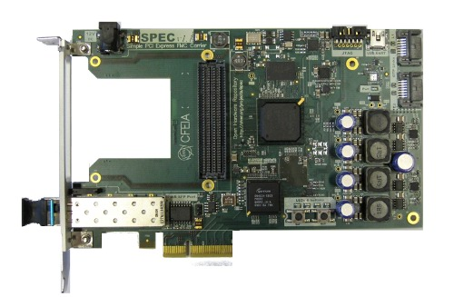
SPEC board

Requirements
- Computer with motherboard that supports PCIe bus, ethernet network card.
- GNU/Linux operating system, kernel version as of 2.6.24.
- Python 2.7 installed.
- SATA cable.
- FMC carrier tester
- Network connection.
- Recommended: Git to download the latest version of the TPS environment.

List of tests

Test | Short description | User Intervention
00 | Checks voltage of the power pins in FMC connector. | No
01 | Checks the low speed pins of FMC connector (low pin count connector). | No
02 | Checks the EEPROM of the GENNUM chip. | No
03 | Loads a firmware file to Flash memory and boots from it. The FW just blink the LEDs present on the front panel. | Yes
04 | Not available yet. It will be SFP connectivity test. | -
05 | Checks SATA ports and high speed pins on FMC connector (low count connector). It will ask to unplug the cable from SPEC’s SATA 0 and plug it again to SPEC’s SATA 1 connector | Yes
06 | Checks Silabs SI570 oscillator. | No
07 | Checks data and address lines of DDR memory. | No
08 | Checks PLL and rest of oscillators present on SPEC board. | No

Preparing the test

Software
Before to doing anything with the hardware is recommended to download the latest version of Test Production Suite (TPS). This software can be downloaded directly from the website (http://www.ohwr.org) or using GIT from the provided repository in OHWR.

As “Test Production Suite, User’s Manual” indicates, it is needed to compile the driver gnurabbit to the target machine.

Hardware
Grab FMC carrier tester and plug it into the corresponding slot on the SPEC board to test. Once you are done, switch off the target computer and plug the SPEC+FMC carrier tester into one available PCIe slot.
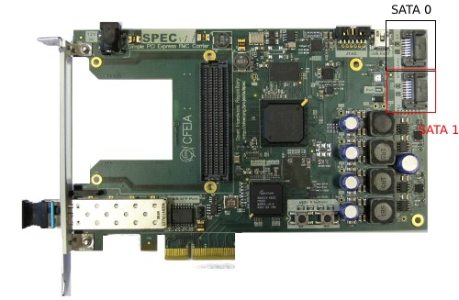

Finally, connect the SATA cable between SPEC’s connector SATA 0 (is the SATA connector on the top right of the board) and the SATA connector of the FMC carrier tester that is placed in the front panel.

Once you switch on the computer, it should be switched on one LED in the SPEC and three LEDs on the FMC carrier tester that indicate the board is properly plugged and there is power supply to feed both boards.

If some of this LEDs are not on, there is a problem with the corresponding power supply lines of the board.

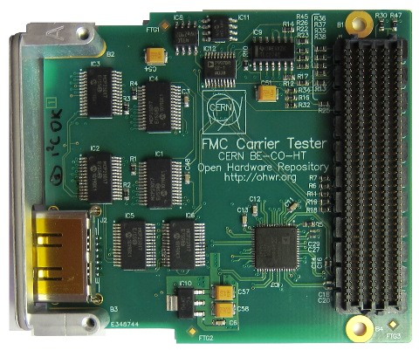
FMC Carrier tester

Running the test
Before start the test, it is needed to load the driver gnurabbit using the following instruction as root:
# cd $PATH_DRIVER
# insmod rawrabbit.ko

Meaning $PATH_DRIVER the folder that is placed the file gnurabbit.ko.

At this moment, you can run the tests:

# cd $PATH_TPS
# ./tps.sh

The log files will be saved in /tmp. If there are some errors, they will appear on the screen.

NOTE: there are two tests that ask for user intervention: test03 and test05.

More information on: http://www.ohwr.org/projects/spec/
http://www.ohwr.org/projects/fmc-conn-tester

