GitHub Copilot Enterprise

AI Enablement
  - Exact onboarding sequence for GitHub Copilot, the desktop app, VS Code, and GitHub Copilot CLI
Identity & Azure Fundamentals | 15 July 2026
Prepared for Cloud Solution Architect AI Enablement
Resource Referenced: https://github.com/dcodev1702/GitHub-Copilot-How-To

Executive Summary
The CSA started from a clean workstation and no personal GitHub account to a validated GitHub Copilot Enterprise experience across three surfaces: VS Code, the GitHub Copilot desktop app, and GitHub Copilot CLI running from PowerShell 7. The enabling dependency was not the application installation by itself. It was the identity chain: a secured personal Gmail identity (w/ MFA) created a personal GitHub account (w/ MFA), that account was linked to CSA’s Microsoft corporate identity (w/ MFA), resulting in an GHCP enterprise license, consumed by each client.
OUTCOME | Final outcome  The CSA could sign in with the linked personal GitHub account, see the enterprise Copilot entitlement, select the target model and context settings, and use both Microsoft Learn and Work IQ MCP tools from VS Code and the CLI.

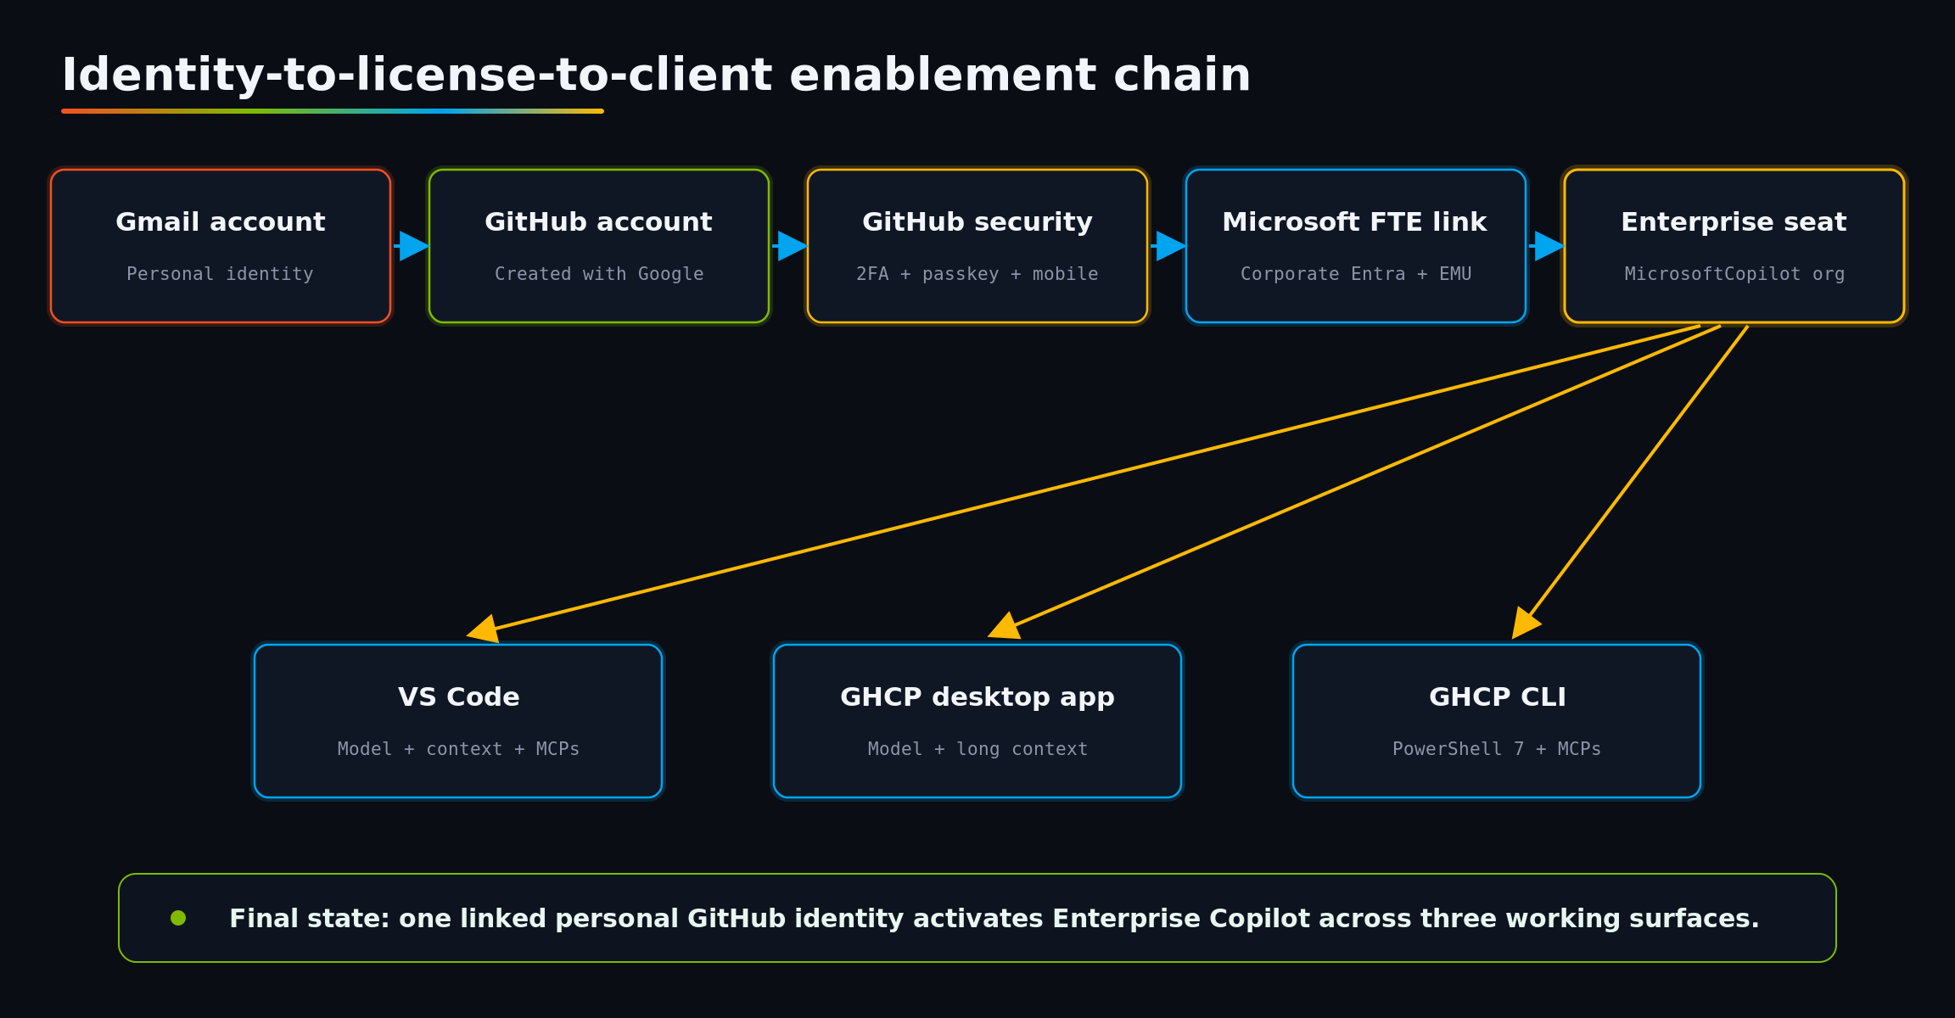
Figure 1. The linked identity is the control point that activates the Enterprise license across all three Copilot clients.

Implementation sequence

1. Establish the workstation baseline
- Opened Windows Terminal and installed PowerShell 7 from the walkthrough. After installation, Windows Terminal settings were reopened and PowerShell 7 was selected as the default profile.
- Opened a new PowerShell 7 tab and removed the older Windows PowerShell tab from the active workflow.
- Installed the Az PowerShell module for later Azure command-line authentication and management.
- Installed Visual Studio Code from the GitHub walkthrough by copying the winget command into the PowerShell 7 terminal.
VERIFY | Validation signal  A new terminal opened into PowerShell 7, VS Code launched successfully, and the Az module installation completed.

winget install --id Microsoft.PowerShell --source winget --silent --accept-package-agreements --accept-source-agreements
Install-Module -Name Az -Repository PSGallery -Scope CurrentUser -Force
winget install Microsoft.VisualStudioCode --source winget --silent --accept-package-agreements --accept-source-agreements

2. Create and secure the personal Gmail identity
- Because the CSA did not already have a personal GitHub account, they created a dedicated Gmail account for developer and GitHub use.
- The Gmail account was protected with multi-factor authentication. A passkey was mapped through Microsoft Authenticator as the preferred secure sign-in method.
- The Gmail credentials then became the personal identity used for GitHub sign-up via “Continue with Google.”
VERIFY | Validation signal  The new Gmail identity could complete MFA and was ready to act as the durable personal identity for GitHub.

3. Create the personal GitHub account
- On GitHub, selected Sign up and then Continue with Google.
- Selected a personal GitHub username and corrected the country/region presented by the sign-up flow.
- Completed account creation, then immediately opened GitHub Settings rather than beginning repository work.
VERIFY | Validation signal  The personal GitHub home page loaded under Kendra’s new username.

4. Harden GitHub authentication
- Navigated to Settings > Password and authentication and enabled two-factor authentication.
- Scanned the GitHub QR code with Microsoft Authenticator and entered the one-time code to verify enrollment.
- Downloaded and saved the GitHub recovery codes.
- Added a passkey and gave it a recognizable nickname.
- Installed GitHub Mobile, signed in to the personal GitHub account, added GitHub Mobile as a second-factor method, and selected it as the preferred 2FA method.
VERIFY | Validation signal  GitHub showed 2FA enabled, a passkey configured, and GitHub Mobile available as an authentication method.

5. Link the personal GitHub identity to the Microsoft FTE identity
- Opened the Microsoft GitHub Copilot enablement page and authenticated to the Microsoft Enterprise Managed User account. The session explicitly distinguished the corporate alias_microsoft profile from the personal GitHub profile.
- Selected the option to use Copilot with the personal GitHub account, chose “Link your personal GitHub account,” and authenticated to the new personal GitHub account.
- Reviewed the confirmation screen showing the personal GitHub username and the Microsoft corporate identity, then created the link.
- Opened the Copilot organization invitation, requested/joined the Copilot seat, and returned to the personal account.
- Signed out of all GitHub accounts, signed back in to the personal account, then opened Settings > Billing and licensing > Licensing.
VERIFY | Validation signal  Licensing showed a GitHub Copilot Enterprise seat managed by the MicrosoftCopilot organization.

IDENTITY | Why this step is pivotal  The personal account is the portable working identity. The Microsoft corporate link supplies the enterprise entitlement. Every downstream client must sign in with that same linked personal GitHub account to consume the seat.

6. Configure VS Code
- Opened VS Code and selected Sign in > Continue with GitHub. Verified the browser prompt was using the linked personal GitHub account, then chose Always Allow and returned to VS Code.
- Applied the available VS Code update and opened the Copilot Chat panel.
- Selected GPT-5.6 Sol as the demonstrated model, set reasoning/effort to Max, and set the context window to 1M.
- Changed approvals to Autopilot for the active session so the agent could complete multi-step configuration without repeated prompts.
- Prompted Copilot to add the Microsoft Learn MCP, accepted the generated mcp.json change, selected Update Tools, and validated the tool by requesting five sentences and two Microsoft Learn links about Microsoft Foundry.
- Prompted Copilot to add Work IQ MCP, approved the required registry access where available, selected Update Tools, and used “Am I logged into Work IQ? If not, prompt me to log in using Entra ID.”
- Validated Work IQ by asking “Who is my manager?” and receiving the enterprise-grounded answer.
VERIFY | Validation signal  The model selector, 1M context, Autopilot approval mode, Microsoft Learn MCP, and Work IQ MCP all operated in VS Code.

7. Install and configure the GitHub Copilot desktop app
- Returned to the GitHub walkthrough, opened the Copilot app download page, downloaded the Windows x64 package, and installed the desktop application.
- Signed in with the linked personal GitHub account and authorized the application.
- Opened the model selector and changed the model to GPT-5.6 Sol.
- Hovered the model entry and enabled Long context. This was the desktop-app equivalent of selecting the 1M context in VS Code.
- Selected Autopilot as the operating mode for agentic work.
VERIFY | Validation signal  The desktop app displayed Kendra’s personal GitHub identity, enterprise model choices, Autopilot, and long-context settings.

8. Install and validate GitHub Copilot CLI in PowerShell 7
- From VS Code, prompted Copilot to enable GitHub Copilot CLI and add the Microsoft Learn and Work IQ MCP configurations. The process installed or repaired the CLI and wrote the user-level MCP configuration.
- A stale PATH and older VS Code shim were identified during validation. A fresh terminal session resolved the plain copilot command to the current standalone installation.
- Opened Windows Terminal in PowerShell 7, entered copilot, accepted the requested trust prompt, and ran /login.
- Selected github.com, completed the browser/device authorization flow with the linked personal GitHub account, then returned to the terminal.
- Ran /update, accepted the update, and reopened the CLI experience.
- Ran /model, selected GPT-5.6, used Tab to select the 1M context window, and increased reasoning effort to High/maximum with the arrow keys.
- Used Shift+Tab until the CLI displayed Autopilot.
- Asked “Who is my manager?” to force a live Work IQ call and verify Microsoft Entra authentication, MCP loading, and enterprise data access.
VERIFY | Validation signal  The final validation showed the plain copilot command working, GitHub authentication active, Microsoft Learn and Work IQ registered, and a live Work IQ response returned from the CLI.

copilot
/login
/update
/model
# During the session: Tab -> 1M context, arrow keys -> High effort,
# Shift+Tab -> Autopilot

Configuration parity across the three clients
Surface | Identity | Model | Effort | Context | Mode | MCPs | Proof
VS Code | Linked personal GitHub | GPT-5.6 Sol | Max | 1M | Autopilot | Microsoft Learn + Work IQ | Live Learn response; manager lookup
GHCP desktop app | Linked personal GitHub | GPT-5.6 Sol | Model-dependent | Long context | Autopilot | Client/tool availability | Enterprise models visible; long context enabled
GHCP CLI in PowerShell 7 | Linked personal GitHub via /login | GPT-5.6 | High / maximum | 1M | Shift+Tab to Autopilot | Microsoft Learn + Work IQ | Live MCP calls; plain copilot command works

How the components produce the final outcome
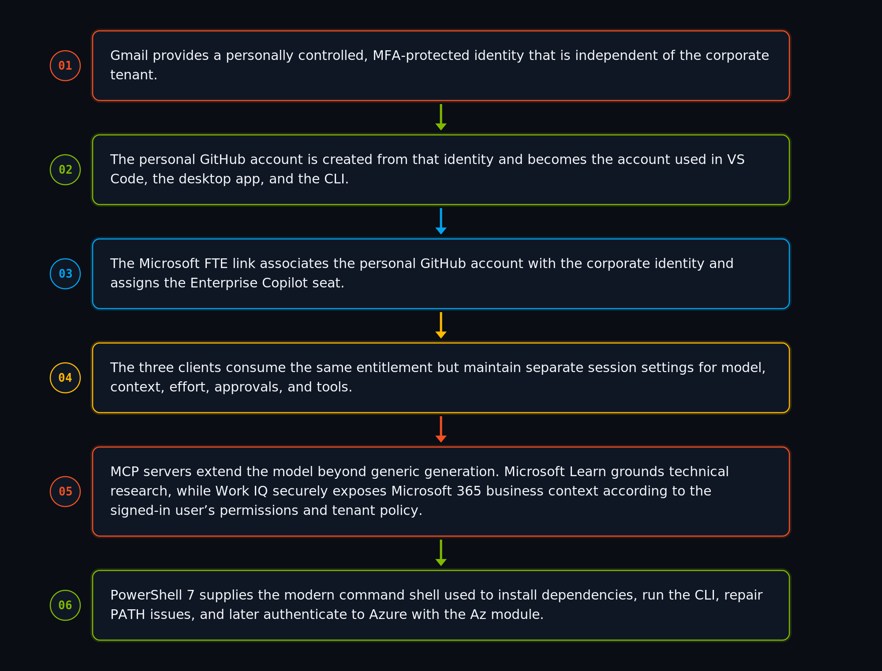

Operational checklist for repeatable onboarding
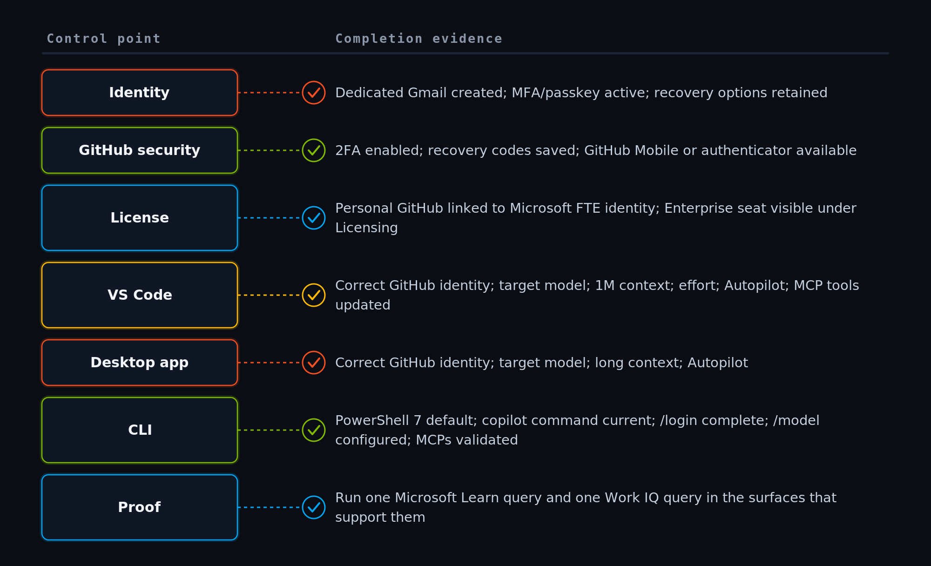

Sources and reference material
- GitHub Copilot Enterprise and CLI for Microsoft FTEs — Primary repository provided in the meeting and used as the setup walkthrough.
- Set up GitHub Copilot in VS Code — Official VS Code setup reference.
- Adding MCP servers for GitHub Copilot CLI — Official GitHub documentation for CLI MCP configuration.
- Connect GitHub Copilot CLI to Work IQ — Official Work IQ and Entra authentication reference.
- Identity & Azure Fundamentals meeting — Transcript and shared-screen evidence for the exact sequence performed.
Scope note: Product interfaces, model names, and enterprise policy can change. This recap intentionally reflects the steps and settings demonstrated in the 15 July 2026 recording, with the repository listed above as the authoritative setup guide.

