headroom

building high in manhattanville

**Jacky J and Hood Marauders**Jacquilene Jacob (jj2442)  
Colin MacAllister (dm2241)  
Mengu Sukan (ms3774)

# **Abstract**

We designed a system for architects to use as a means to view the available air rights, lot area and building heights for buildings in Manhattanville.

The architects generally need tools and a system to play with the different buildings with varying height and different available air rights to calculate how high can they construct an existing building or use the available air rights from the neighboring buildings to construct higher structures.

headroom provides this facility to architects for them to use an Augmented Reality system that can work both indoors and outdoors. Architects can use headroom to view buildings with information related to their location, air rights, zone, lot etc, select them, manipulate them and view the manipulations in the virtual world as well as in the real world.

# A Tutorial

1. Print the ground marker array and the pointer marker given for our system.
2. Mount the iPhone on the case we designed and mount the pointer marker array on it. This makes the wand set up.
3. Keep the ground marker array in view of the camera either mounted on the lazy suzan or the cylindrical handle for easy use.
4. You can see the buildings in the area of your interest well highlighted.
5. Use the wand to point at the building that you want to work with.
6. Change the mode on the airmouse by making the appropriate gesture.
7. You can get into edit mode after selection of the building when the selected building changes color and a zoomed version is placed on the work area.
8. The data with respect to this building is shown on the screen.
9. The user can use the wand to rotate the data object to view the information he needs to see.
10. The user can now work on the editable building to manipulate. Use the handle to pull the building upwards to add floors or use the handle in the bottom corners to scale the building in area width wise.
11. The user can also view at the air graph on top of each building that show the remaining available air rights and also indicates if the building has exceeded its air right limits.
12. The user can fix this as manipulated and move on to another building by changing the mode using the airmouse which show different menu icons.

The system can be used in the above mentioned steps any number of times and as per one’s requirements and interest.

# **Design Choices**

We have designed a very friendly system that can be used with ease and comfort by users to efficiently view and manipulated data.

## The Ground

The users can have the flexibility of holding the ground in their hands mounted on a cylindrical tube or mounting the ground on a lazy susan table where the ground could be rotated in any angle to have a clear view of a building in all directions. The idea to enable the facility of managing less items in the users hands when outdoors and also have the facility of walking around with the base.

The ground contains the highlighted area or buildings where users would want to concentrate on working. The ground also contains a working board which helps the user to view the manipulations he makes on the building or lot on a larger scale and clearly see the changes. It replicates an area for rough work.

## Selection techniques

The selection techniques that we used in headroom are quite simple and easy to handle by the user. The user has a facility of holding an iPhone with a wand attached to it which enables the user to make selection of buildings or lot to begin with. The idea of using iPhone was to enable easy and convenient use since iPhones are increasingly used by users these days, they are sleek, light, easy to carry and have many compatible applications such as ‘airmouse’ which enables wireless access to the system by carrying a small device which can be used to select as well as manipulate and do a lot more.

### Airmouse

Using an iPhone, the user can make gestures to choose from a variety of options. This is done by the use of the *Airmouse* application, which allows the user to treat the surface of their phone like a trackpad.

The user brings up a menu by tapping once with their thumb on the screen. By making gestures “up”,” down”, “left” and “right” they can reveal new menus or execute commands. The up-down tracking of the iPhone facilitates both right and left handed users by reorienting itself to the “new up.”

### The Wand

We have designed a Lucite holder for the iPhone to keep it secure and firm in the user’s hand. The idea of designing the wand was to help the user to move his hand around freely to point at the building or lot he wishes to work on. This also makes the ground area less crowded and obstructions are minimized.

### Marking Menus

The marking menus are one of the most interesting features in our system. The ‘airmouse’ can enable marking menus which are menus which define themselves by the icons and which when selected by gestures made by the user as mentioned above will select an option in the menu. The menu structure is hierarchical in design. When the user selects a menu, the options with respect to the menu are displayed. The menus are meant for enabling the system to get into selection mode, deletion mode, and manipulation mode, undo mode and many more.

The idea of designing the marking menus was to enable easy view and better usability of the system. This also accounts for the aesthetic design of our system. When the ‘airmouse’ is enabled, the mouse on the system is disabled in order to reduce error or misuse of the system. Hence the user control and freedom of usability is accounted for by this design choice.

## Data Display Techniques

### Translucent data planes

The data with respect to each building is shown to the user in translucent planes with data rendered on all sides. The user has the freedom to turn the model to any angle in order to view the relevant data he needs to view. The data is fetched from a excel sheet which is the database for all the building and its relevant information. The user can get data of location, address, air rights, owner’s information, lot area to name a few. When the selected building is chosen for editing, the changes made are reflected on the data model as well. This information can be used to fetch for later use.

The choice of making the data model translucent was to make it possible for the user to view a lot of data in a small area and as this is translucent; it does not hinder the view of the buildings or the work area. We referred to the paper by Lisa Strausfeld on Financial viewpoints for this design choice.

### AirGraph

The AirGraph is a representation of data with respect to the air rights for a building. The AirGraph denotes the varying available air rights on top of every building which shows the indication of how high one can build above the existing building. This shows the user the transferable air rights of building in the neighborhood as well by which the user can get an idea of the estimate of how many floor to be added or subtracted. Buildings in compliance with their development rights are shown by green columns; when a building has or would have exceeded its air rights, the color of the indicator changes to red.

This choice was made in order to view the air rights information in a quick glance and make calculations faster. This is flexible and efficient to use.

## Manipulation Techniques

### Handles

The handles are points on each building top or on the bottom corners provide the facility to hold the building and extend the width or height for manipulation. The wand is used to turn into the edit mode to help the user hold the handle on the building or beneath them to manipulate the height or the lot area.

This design choice was made by us in order to let the user view clearly the point of manipulation when handled. This also helps the user to pull or extend the buildings width and height with at most ease and this makes it error free and the results are accurate.

## Plein Air

This system can be used outdoor in a similar way. The ground is held by the user and the larger ground is placed on a comfortable stand outdoors at the base of the building. The user can wear the visor provided and view the buildings on the ground in his hand and make selections as required. He can view the corresponding selection made in the real world on the building. The building has data information shown and the air graph shows the available air rights. The user can look up through his visor to view the changes he makes with respect to the manipulation on the ground in his hand. He can add or subtract floor using the handle and also increase or decrease the area of the building.

Our system helps the architects in having the freedom to walk around freely and experience a new technique of making selections and manipulations by interacting with the real and virtual world at the same time. The user can sit indoor and work or use the whole system outdoors to see the same results. Our system incorporates all the ten heuristics such as discussed in class. headroom is efficient, easy to use, flexible and less prone to errors. It gives all the information the user needs and also gives him the choice of viewing what he needs. headroom is designed to give the architects a “work with fun” feel and helps to pave way for a new technique to bring out in the market of design systems for architects. headroom is also extensible can be extended to be used for various blocks in Mahattanville and can be extended to do many more manipulation with respect to buildings and their air rights.

# Addendum

## Chief Persona: Renzo Piano

From http://rpbw.r.ui-pro.com:

Renzo Piano was born in Genoa (Italy) on September 14, 1937. He graduated in 1964 from the school of Architecture of the Milan Polytechnic.

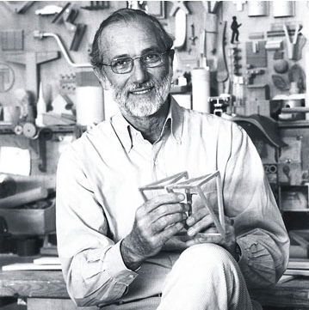As a student, he was working under the design guidance of Franco Albini, while also regularly attending his father’s building sites where he got a valuable practical experience. Between 1965 and 1970, he completed his formation and work experiments with study travels in Britain and America.

In 1971, he founded the “Piano & Rogers” agency with Richard Rogers, his partner on the Centre Pompidou project in Paris. In 1977, he founded “l’Atelier Piano & Rice” with the engineer Peter Rice, who would work with him on many projects, until his death in 1992.

He then founded Renzo Piano Building Workshop, with offices in Paris and Genoa. Some 100 people worked with him (among which are architects, engineers, specialists…) in close collaboration with some associated architects, linked to him by years of experience.

## Concepts

A development includes the construction of a new building or other structure on a zoning lot, the relocation of an existing building to another lot, or the use of a tract of land for a new use.

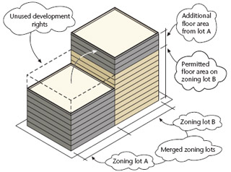**Development rights** are defined as the maximum amount of floor area permissible on a zoning lot.

**Air rights** are defined as the difference between the maximum permitted floor area and actual floor area is referred to as “unused development rights.”

A **zone lot merger** is the joining of two or more adjacent zoning lots into one new zoning lot. Unused development rights may be shifted from one lot to another, as-of-right, only through a zoning lot merger.

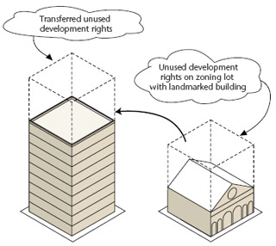

A **transfer of development rights** (TDR) allows for the transfer of unused development rights from one zoning lot to another in special circumstances, usually to promote the preservation of historic buildings, open space or unique cultural resources.

An **enlargement** is a built addition to an existing building that increases the floor area of the building.

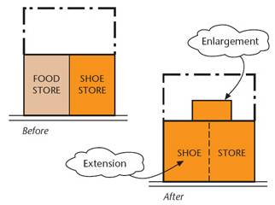An **extension** is an expansion of the existing floor area occupied by an existing use.

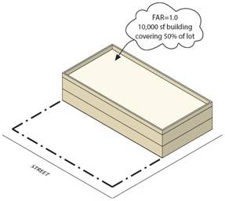The **floor area** of a building is the sum of the gross area of each floor of the building, excluding mechanical space, cellar space, floor space in open balconies, elevators or stair bulkheads and, in most zoning districts, floor space used for accessory parking that is located less than 23 feet above curb level.

