# Professor,

If you can, please run this program from a Windows command-line. It creates files in the directory it is run in (but not sure if it would work in unix/linux). I imported an additional module [OS] to do this.

Also, I ran the script from Windows and captured the results to the Assignment2-Results.docx Word file. It shows the following:

* It shows what happens if you don't supply a URL
* It shows what happens if you don't provide a URL with good data.

If you pass the link for the assignment, it will prompt the user for a ID #.

* It shows what happens if you put in something <= 0 (closes the program)
* It shows what happens if you put in a good ID # (prints out “Person with ID # is <name> with a birthday of<date>”) - no time
* It shows what happens if you put in a bad ID # - like 999. (prints an error and logs a message to 'errors.log')

**STARTING DIRECTORY**

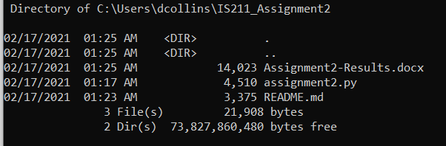

**RUN SCRIPT WITHOUT A URL**

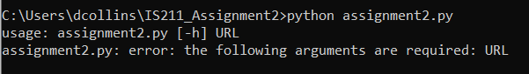

**RUN SCRIPT WITH BAD DATA SOURCE (**[**http://www.google.com**](http://www.google.com)**)**

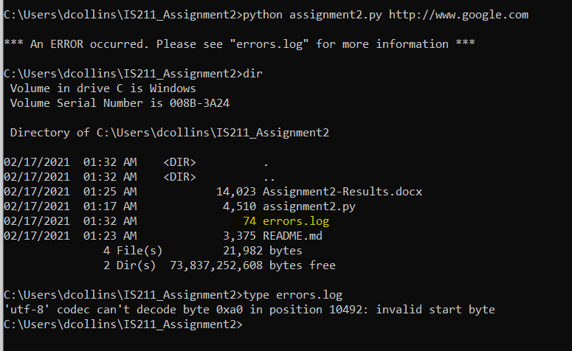

**RUN WITH ASSIGNMENT-2 DATA SOURCE:**

<https://s3.amazonaws.com/cuny-is211-spring2015/birthdays100.csv>

**Entering a 0 for the ID # …**



**Entering a valid ID # …**

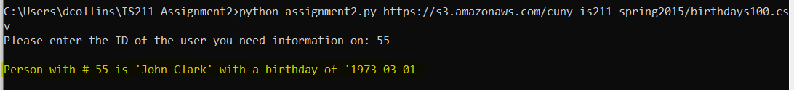

**Entering a bad ID # …**

