**Project Initiation – Library Management API**

This document provides an overview of the high-level requirements, their priorities, and estimates of their size.

1. **Actors**

Provide a numbered list that names and briefly describes each actor in the system.

1. Actor 1 – descriptions
2. …
3. **Use Case Diagram**

Provide a use case diagram where the use cases are uniquely numbered.

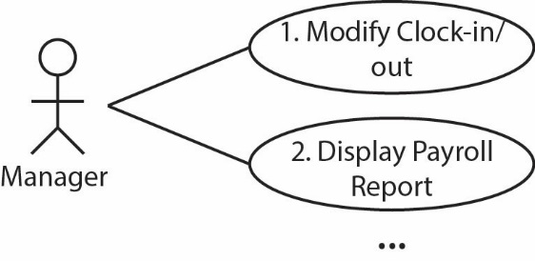

1. **User Stories**

Provide a user story for each use case in the format shown below. Remove sub-sections (Functional…, Non-…, Notes) if not needed. The numbers (*e.g.* US 1) should correspond to the use cases above.

US 1 – *Title*

*Description…*

**Functional/System Requirements**

*Description…*

**Non-Functional Requirements**

*Description…*

**Notes**

*Description…*

US 2 – *Title*

…

1. **User Story Prioritization & Size Estimates**

You will do two independent tasks here. First you will prioritize the user stories then you will estimate their size with *story points*. Neither task should influence the other, thus the order you do them is not important. However, the prioritization will probably be quicker.

|  |  |  |  |
| --- | --- | --- | --- |
| US ID | Title | Priority | Size (Story Points) |
| 4 | Clock-in/Clock-out | 1 |  |
| 6 | Login | 2 |  |
| 1 | Modify Clock-in/out | 3 |  |
| … | … | … | … |

Write a paragraph explaining the rationale behind your prioritization. You don’t have to explain every single US, but should give some general idea why some are prioritized higher.

Write a paragraph explaining the technique you used to determine your story point estimates. Also explain the difference in points between at least two user stories of your choice