Appendix – table vs CSS layout

North Carolina Central Homepage with table cells displayed using the Web Developer Toolbar

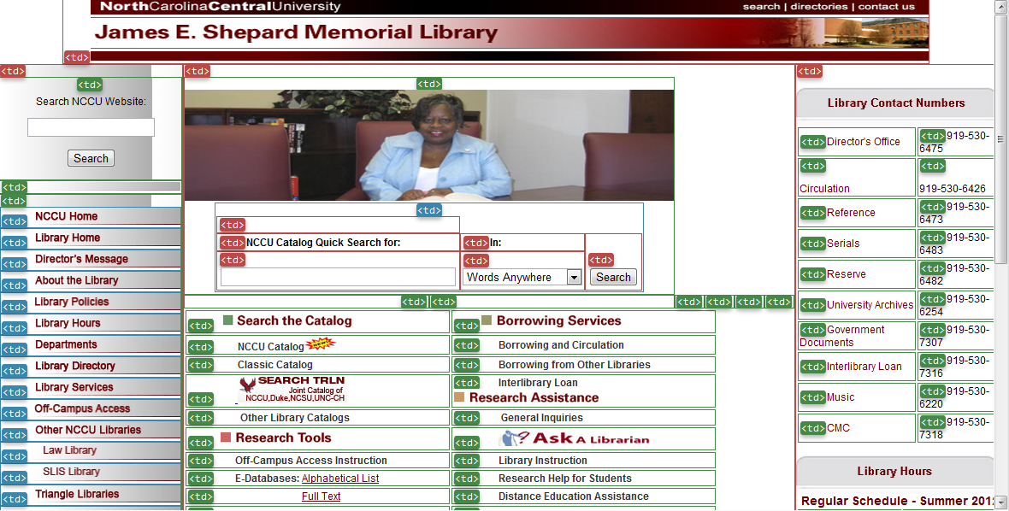

University of Washington Homepage with table cells displayed using the Web Developer Toolbar

