# Accessibility 2010

## Research Questions

1. How accessible are the major library Web sites on the campuses with SLIS schools in 2010?

2. Has Web site accessibility changed over the past 4 years? Is there a discernible trend?

3. If there are changes in accessibility, are there recognizable patterns?

a. How strong was the tendency for the 2006 accessibility leaders (laggards) to remain leaders (laggards) in 2010?

b. Is there a connection between Web site redesign and its accessibility?

c. Have there been changes with regard to the relative frequency of the various types of accessibility barriers?

4. How many library sites use "Skip Navigation" links and does their use correlate with accessibility?

5. How does the method of page layout (table-based or CSS-based) correlate with accessibility?

6. Does the use of a Content Management System (CMS) correlate with accessibility?

## Research Methodology

#### Research Questions 1-3

56 academic library websites were analyzed. Bobby (version 3.1.1) was used as the primary data gathering tool for research questions 1 through 3. Bobby 3.1.1 was chosen, and employed in the same manner, so that the data gathered in this study would be comparable to the data gathered in the 2002 and 2006 studies. The home pages and pages linked from the home page were analyzed from late November of 2010 through February of 2011. Several accessibility parameters were studied including total errors per site, average errors per page and percentage of approved pages. For a complete list of data gathered and more information about the information captured by Bobby, see the Data Gathered appendix.

### Research Question 4 - Are Skip Navigation Links included?

In the previous study, the lead author relied heavily on the Web Accessibility Toolbar extension to identify sites using skip links. However, a large number of false positives and negatives discovered led the author to manually analyze the source code of each page in addition to using the toolbar’s check.

For this study, the author relied entirely on a manual examination of the source code to make this determination. The home page and at least one internal page, (usually the “About” page, if one could be found, or the “Services” page if no “About” page was found) was thoroughly examined. First, the word “Skip ” was typed into the text search box. If “skip“ was found, the author verified that it was indeed a skip navigation link. If “skip“ was not found, the first screens of source code were visually examined for any internal links which may have been intended as skip links.

#### Research Question 5 – Table or CSS-based Layout

For research question 4, the lead author utilized the Web Developer toolbar, an extension developed by designer Chris Prederick (<http://chrispederick.com/work/web-developer/>). At least two pages from each site (the home page and usually the “About” page) were analyzed. First the presence of tables was tested using the Outline > Outline Tables > Table Cells option. This feature, as you’d expect, draws an outline around each table cell. With this view, it is fairly easy to judge whether tables are used as the primary means of layout. For example, the yellow and blue squares in the image below show clearly how the table cells structure the page.



If using the Outline Table Cells tool did not reveal a significant presence of table cells, the Information > Display Div Order tool was used. This tool outlines each div element, reveals its name, and indicates its numerical order in the page code. As the image below shows, it was easy in most cases to judge if a site’s layout was primarily CSS-based.

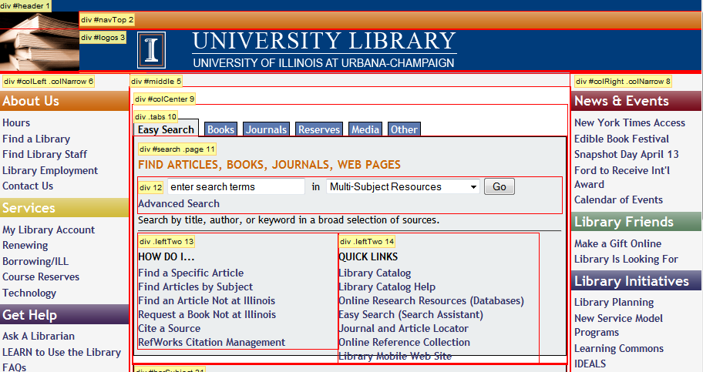

Unfortunately, not every site was as clear-cut as these two examples. Some sites use a combination of CSS and table-based layouts, and in a few cases it was difficult to categorize which was the primary design element. Florida State, for example, clearly uses table-based elements as a significant aspect of page design, as shown below with Table Cells highlighted.

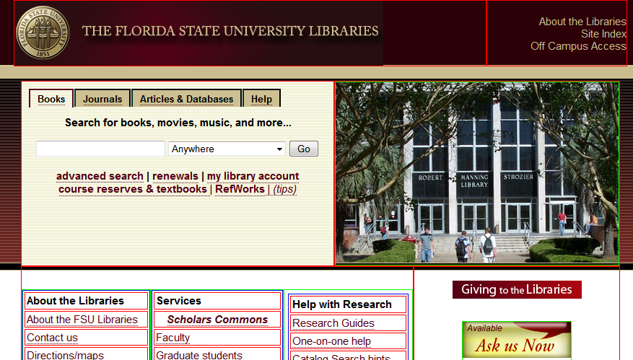

However, it also has a significant portion of its design specified with div elements, as shown in this image with Div Order highlighted.

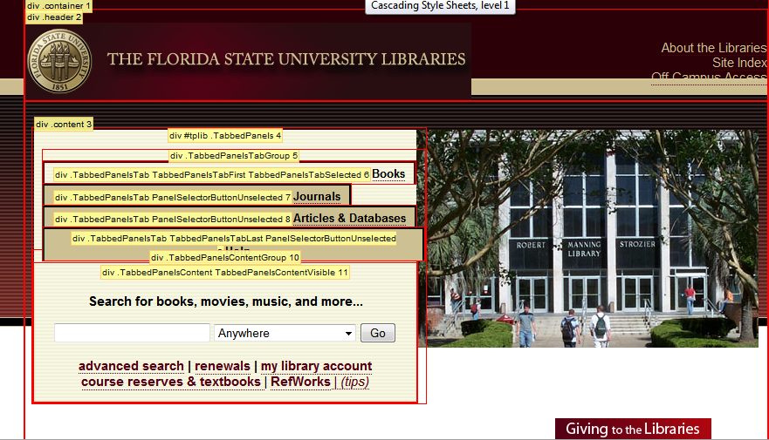

Ultimately, for this purpose of this study, the lead author decided that any site that relies significantly on tables for its layout would be categorized as table-based. Therefore FSU was placed in the table-based layout group.

#### Research Question 6 – Site built with CMS?

Sites were categorized as CMS or not based on an analysis by the lead author. This is possible because a CMS uses standard code base which result in source code with an identifiable structure. The lead author is very familiar with the code generated by Drupal, the most commonly used open-source Content Management system. Drupal sites are very easy to identify based on the application’s rigid directory structure. In other cases, the CMS was identifiable based on the "Name" Meta tag; e.g. <meta name="generator" content="Plone - http://plone.org" />. In other cases, the CMS name was visible in other areas in the page's source code. In one case the author contacted the university for clarification.

It is very possible that more sites use CMSs that could not be readily identified. This is particularly true for "home-grown" systems, which are unlikely to leave any readily discernable source code. Because of the difficulty of proving conclusively if a site is CMS-based, the authors were conservative in this regard, and chose to only categorize sites with an identifiable CMS such as Drupal as CMS-based.

## Results

### How accessible are the major library Web sites on the campuses with SLIS schools in 2010?

Overall, 61% of the web pages tested were Bobby-approved. Eight of the 56 sites were 100% approved. An additional 13 sites had approval percentages above 90%. 11 more had approval percentages of 80% or more. On the down side, six sites had no approved pages, and seven more had percentages of less than 10%. The Canadian library sites had a slightly lower percentage of approved pages (57 per cent), but significantly lower average barriers per page at 1.31.

### Has Web site accessibility changed over the past 4 years?

The overall percentage of approved pages is the same as in 2006. However, the average number of errors per page has decreased considerably to 2.28 per page. When comparing the 2002 data, a clear improvement is apparent, particularly with regards to the number of barriers per page.

Table 2  
Change over time

|  |  |  |  |
| --- | --- | --- | --- |
|  | **2002** | **2006** | **2010** |
|  |  |  |  |
| **% Approved** | 46% | 61% | 61% |
| **Errors/Page** | 4.8 | 3.56 | 2.28 |

### If there are changes in accessibility, are there recognizable patterns?

#### How strong was the tendency for the 2006 accessibility leaders (laggards) to remain leaders (laggards) in 2010?

To answer this question, we performed a Pearson correlation using Microsoft Excel. Pearson correlations are a statistical means of evaluating how closely two groups of numbers match. The correlation is measured on a scale from -1 to 1, with -1 indicating no correlation at all, and 1 indicating a perfect match. The value is typically denoted as *r*.

We compared the 2006 data to the 2010 data using both the percentage of approved pages and the average errors per page. We looked at the entire North American sample, and also looked the U.S. and Canadian sample separately.

For the North American sample as a whole, there were mixed results. Comparing percentage of approved pages, the *r* is .25, which is typically considered a low correlation. Comparing the errors per page, however, *r* is .76, which is usually considered high correlation.

The U.S. component reveals very similar numbers. This is not surprising, as the U.S. schools make up 87.5 per cent of the overall sample. Comparing percentage of approved pages, the r is.30, which is typically considered a low correlation. Comparing the errors per page, the r is .81, which is rather high.

The Canadian sample shows no significant correlation at all. Comparing percentage of approved pages, the r is -.08, which is usually considered no correlation. Comparing the errors per page, r is .19, which is very low correlation.

#### Is there a connection between Web site redesign and its accessibility?

In our earlier studies, sites were observed to determine whether a redesign had occurred since the previous set of data had been gathered. Accessibility data was then compared to see if redesigned sites had higher or lower accessibility ratings post-redesign.

However, the authors have observed that the vast majority of sites have been redesigned in the four years since our previous study. This is not surprising given the fast pace of technology change. We decided that little would be gained by comparing the handful of sites that appear to not have been redesigned.

#### Have there been changes with regard to the relative frequency of the various types of accessibility barriers?

There have been discernable trends in the relative frequency of errors reported. One notable trend has been the decrease in errors related to image maps. In 2002, over 22 per cent of errors reported were missing alt tags for image maps. In 2010, it has dropped to 6.45%. Another notable trend has been a very significant upsurge in errors related to image buttons. Comprising less than a tenth of a per cent of errors in 2002 and 2006, image button errors comprised nearly 7.5% of total errors in 2010.

Table 3  
Relative Frequency of Barriers

|  |  |  |  |
| --- | --- | --- | --- |
|  | 2002 | 2006 | 2010 |
|  |  |  |  |
| **Alt-text images** | 75.92% | 90.56% | 85.79% |
| **Alt-text imaps** | 22.28% | 7.71% | 6.45% |
| **Alt-text buttons** | 0.05% | 1.10% | 7.49% |
| **Alt-text-object** | 0% | 0% | 0.15% |
| **Alt-text applets** | 0.03% | 0% | 0% |
| **Title each frame** | 0.30% | 0.55% | 0.12% |
| **Read. w/o frames** | 0.56% | 0.03% | 0% |
| **Red txt ss-imaps** | 0.86% | 0.05% | 0% |

### How many library sites use "Skip Navigation" links and does their use correlate with accessibility?

We found that 25 library sites (44.6 per cent) used skip navigation links. This is very significant increase from 2006, when only 8 library sites used skip links.

As the use of skip links is associated with some significant level of awareness about accessibility, the question of whether sites using skip links have higher overall accessibility figures is an interesting one. To determine this, we looked at the percentage of approved pages and average barriers per page for the 25 sites with skip links and the 31 without.

Of the sites with skip links, the average percentage of approved pages is 66 per cent. This compares quite favorably to the group with skip links, which average 56 per cent. The difference in average barriers per page is quite significant. Sites with skip links average only 1.65 barriers per page, compared to 2.79 barriers per page for the sites without skip links.

Table

Skip Navigation

|  |  |  |
| --- | --- | --- |
|  | With Skip Links | Without Skip Links |
|  |  |  |
| % Approved | 65.92% | 56.48% |
| Avg. Barriers per page | 1.65 | 2.79 |

### How does the method of page layout (table-based or CSS-based) correlate with accessibility?

#### Background

When web design was in its infancy, pages consisted mainly of lists of links with little structure. Soon, designers learned to manipulate HTML tables to give them some measure of design flexibility. However, tables can be tricky to use as a design mechanism, as they were never intended for this purpose. Therefore, designers often resorted to inserting precisely-sized images in table cells to force pages to display as intended. Since these images do not convey meaning, it is understandable that designers would neglect to include alt tags. However, screen readers read them and are a significant annoyance to screen reader users.

In 1996, the World Wide Web Consortium (W3C) released Cascading Style Sheets, level 1, (CSS1), as a recommendation for web designers. CSS1 enabled designers to determine the visual style of web page elements with more specificity and more efficiency than before. CSS1 caught on quickly, and soon designers largely abandoned font tags when styling web content. However, CSS1 offered no significant advancement in regards to site layout, so tables continued to be the principal means used to determine web page layout.

With the introduction of Cascading Style Sheets, level 2 (CSS2) in 1998, designers were afforded a new toolset for structuring pages. CSS2 includes a visual formatting model known as the “Box model.” Block-level elements, such as the<div>, <p> and <ul> elements, could be given properties such as height, width, and a variety of visual characteristics that made them more effective as page design elements. Block-level elements, primarily the <div> element, became an alternative means of structuring web pages. With a div-based layout, spacer images were no longer necessary to force HTML tables to bend to the will of a designer’s vision.

In the 2006 study, the lead author observed that a high percentage of errors were due to missing alt tags for “spacer” images, and suggested further study. Therefore, in this study, the question of whether div-based sites were more accessible was systematically evaluated.

#### Evaluation

There were 9 sites (out of 56, or 16 per cent) that were judged to rely significantly on tables for page layout. By all measures, these sites exhibited significantly higher accessibility barriers. Only two of the nine sites (22 per cent) had approved home pages. The percentage of approved pages was only 42 per cent, compared to 64 per cent for div-based sites. The difference in average errors per page was even more pronounced. The table-based sites averaged 5.85 errors per page, compared to only 1.59 for the div-based sites. This number was skewed by the extraordinarily high number of errors found on two web sites: North Carolina Central (1057) and Southern Mississippi (490). Nonetheless, there is very strong evidence that table-based layouts are considerably more likely to result in accessibility errors than CSS-based layouts.

Table

Table or CSS Layout

|  |  |  |
| --- | --- | --- |
|  | Table-based | CSS-based |
| % Approved | 42.11% | 64.26% |
| Avg. Barriers per page | 5.85 | 1.59 |

### Does the use of a Content Management System (CMS) correlate with accessibility?

#### Discussion

A Content Management System (CMS) is a web-based software application that uses a programming language to assemble web pages from content stored in a database. A CMS offers many advantages. The most often cited advantage that impacts accessibility is the use of template files to build pages. The content displayed on a page is pulled from a database, and then positioned as dictated by the template. Layout is determined with CSS2 with HTML div elements as building blocks, rather than tables. As noted in the previous section, this practice is associated with higher accessibility results. CSS is also used for visual formatting, such as applying fonts and colors. Thus a significant measure of consistency across pages is virtually ensured.

The use of a CMS has proliferated in the web design world. This appears to be true in academic libraries as well. Bundza et al. (2009) conducted a survey of web development practices in academic libraries. They found around half of responding libraries use a CMS as part of their web development process. They also found that the most popular CMS was Drupal, with 15 responses. The next most popular were systems developed in house.

That the use of a CMS can promote accessibility has been suggested in the library literature. Dunlap (2006) writes that a major reason that web sites fail to implement accessibility standards is because of a heavy reliance on "static" code. On a static site, content exists on discrete web pages encoded in HTML. Making a change to a common area such as a header involves changing every page on the site. For sites constructed this way, making changes to improve accessibility can prove excessively time-consuming.

Database-driven sites, such as those created by CMSs, promote accessibility because of their reliance on consistent templates. A change can be implemented once to a template file and be immediately implemented site-wide. In addition, the transition to a database-driven site provides an excellent opportunity to improve accessibility. As web content is prepared for loading into a database, it is an ideal time to strip the content of unnecessary and poorly-formatted code.

Likewise, Kane and Hegarty (2007) emphasized the critical role of the CMS template system in easing the process of meeting accessibility standards. Because the developers can focus on only one template file, rather than examining hundreds of individual files, the task of making that template fully accessible is vastly simplified. Also, they mention the absence of "confusing layout tables" and "excess images" (p. 281) as factors promoting accessibility.

#### Findings

The lead author identified 14 sites that were clearly built using a CMS. It is likely that there were more sites that use home-grown systems, but as this is difficult or impossible to verify from examining code alone, only sites with an identifiable CMS such as Drupal were categorized as CMS-based.

The percentage of approved pages and errors per page were compared to the 42 that were not positively identified as using a CMS. The difference is remarkable. The CMS sites average 71 per cent approved, compared to 57 per cent for the non-CMS sites. The difference in errors per page is even more considerable. The CMS sites average just 1.17 errors per page, compared to 2.64 for the non-CMS sites.

Table

CMS or Not

|  |  |  |
| --- | --- | --- |
|  | CMS | Not CMS |
| % Approved | 71% | 57% |
| Avg. Barriers per page | 1.17 | 2.64 |

References Cited

<http://www.w3.org/TR/2008/REC-CSS1-20080411/>

<http://www.w3.org/TR/2008/REC-CSS2-20080411/>

Bundza, M, Vander Meer, P, & Perez-Stable, M 2009, 'Work of the Web Weavers: Web Development in Academic Libraries', Journal of Web Librarianship, 3, 3, pp. 239-262, Library, Information Science & Technology Abstracts with Full Text, EBSCOhost, viewed 10 April 2011.

David Kane, Nora Hegarty. New web site, new opportunities: Enforcing standards compliance within a content management system. Library Hi Tech, Volume 25, Number 2 (June 2007), pp. 276-287, <http://ejournals.ebsco.com/direct.asp?ArticleID=47C1B983C9641ECC1849>

Dunlap, I 2006, 'How Database-Driven Web Sites Enhance Accessibility', Library Hi Tech News, 23, 8, pp. 34-38, Library, Information Science & Technology Abstracts with Full Text, EBSCOhost, viewed 3 April 2011.

Macken, D 2008, 'Get Accessibility Right from the Start', Managing Information, October, Library, Information Science & Technology Abstracts with Full Text, EBSCOhost, viewed 3 April 2011.

Content Management Systems (CMS) <http://www.libsuccess.org/index.php?title=Content_Management_Systems_(CMS)>

[http://www.scarecrowpress.com/Catalog/SingleBook.shtml?command=Search&db=^DB/CATALOG.db&eqSKUdata=0810856921](http://www.scarecrowpress.com/Catalog/SingleBook.shtml?command=Search&db=%5eDB/CATALOG.db&eqSKUdata=0810856921)